Operation controls and modes

The Faraday P100 Series unit has only 2 controls: Power switch and Toggle switch.

The power switch disconnects the power to the unit.

The toggle switch sets the burden resistance at the secondary circuit of the measuring Current Transformers (CTs) connected to the box*, allowing two modes of operation:

* Position 10-100% provides rated burden that shall be used when the CT primary current is between 10% and 100% of its rated value.
* Position 1-10% provides higher burden when CT is operating below between 1% and 10% of its rated current.

The user shall know the current to be measured before connection and to select the suitable position. If position is selected incorrectly, the signal will be too high (saturated) or too low (lack of resolution), meaning that the recorded data will be useless.

Initial assessment of the current being measured can be made using the Scope mode of the Faraday Software. Please refer to the Software manual for more information.

Rating of the toggle switch: AC 250V 6A / Insulation Resistance: 1000MOhm at DC 500V / Dielectric Strength: AC 1kV/1 min, AC 1.2kV/1s

* Both sets of Current Transformers have the same secondary rated current and they are interchangeable. The toggle switch position is independent on the CT model selected.

**Location**

Make sure the Faraday P100 Series unit is placed out of walking path. If possible, locate it near the Motor Control Center (MCC) to avoid hitting the unit with the feet and/or to avoid other personnel to crash with it.

The power switch is located at the top corner and sudden disruption of the unit could happen if the switch is activated by mistake.

**Instructions for connection to measuring circuits**

Please follow the steps mentioned in this section for connecting and using Faraday P100 unit. Failure to do so may result in damaging the unit or injuring the user.

Faraday P100 Series unit will be temporally connected to the Motor Control Center (MCC), always under the supervision of the electrically authorised person from site. All electrical connections and disconnections shall be carried out with the MCC powered down. In some situations, the connections can be made online using special accessories* and always under the supervision of the electrically authorised person from site.

*Ask Faraday Predictive for more information on special accessories.

Please note that the Faraday P100 Series unit will be connected to the motor supply or to the monitoring/protection system within the MCC cabinet and thus it may be necessary to leave the door of the cabinet open whilst the equipment is running.

The Faraday P100 Series unit shall not be disconnected during the Test to avoid losing information. The unit itself is not capable of recording data, and all measured signal are transferred across the USB port to the Laptop or PC.

The Faraday P100 Series unit will be left near the MCC during the test, connected to the MCC on the measuring terminals, to the Laptop or PC via the USB port and to a mains socket via the Input power connector and power cord. Note that both The Faraday P100 unit and the Laptop or PC require an AC mains power source; it is advised to organize this with site in advance for allowing a quick and neat test.

The Faraday P100 Series unit includes two sets of 3 Current Transformers, intended for using in different situations.

The 300A to 10mA model is intended for measuring on motor supply cables directly. Ask the electrically authority on site for more information about motor supply cables and its location.

The 10A to 10mA model is intended for measuring into existing protection or monitoring systems. Large, high voltage or critical equipment usually require protection or monitoring CTs with 1A or 5A secondary rated current. Ask the electrically authority on site for more information about protection or monitoring systems and its location.

**NOTE**: Faraday CTs have a built-in diode for overvoltage protection. This allows to leave them in open circuit without creating a hazard, i.e. disconnect them from the P100 box while measuring motor current.

**NOTE:** CTs must be installed downstream of any other device fed by the MCC other than the motor itself. If the CTs are measuring current drawn by more than one equipment (e.g. the motor plus a single-phase transformer) the results will not be valid. Make sure you have checked drawings and found suitable connection points before the test is carried out.

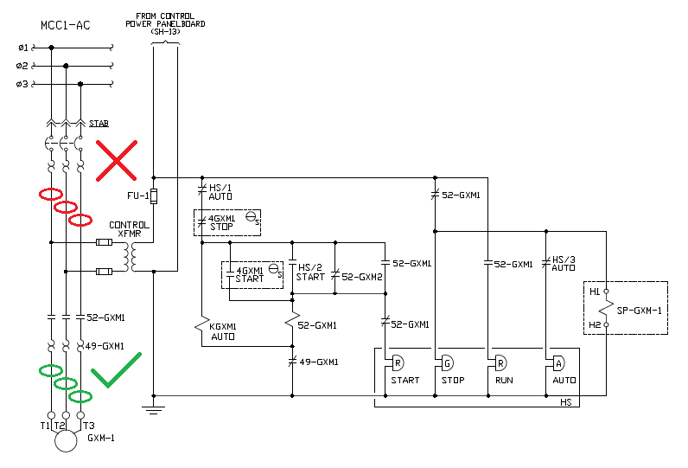

Figure 1 Typical MCC wiring diagram: on the top left there is a three phase bus bar supply to the MCC; on the middle left there is a single phase transformer to feed a control panel; on the bottom left there is an induction motor; on the right is the control panel. Circles in RED indicate the WRONG location of CTs; in GREEN, the RIGHT one.

**NOTE:** For MCCs with Star-Delta starters CTs MUST be connected outside the Star-Delta circuit.

Voltage probes use Dolphin clips for connection to motor voltage supply or to existing monitoring or protection systems. Motor low voltage supply is usually 400V Line to Line in Europe, and 110V Line to Line for existing protection or monitoring systems.

Do not attempt to connect voltage probes to mains with rated voltage greater than 400V or into installations of overvoltage CAT IV. Unless your P100 Series unit is rated higher – for example the P480 unit.

**STEPS FOR CONNECTING AND TESTING WITH FARADAY P100 System**

Please, follow carefully the steps listed below when using Faraday P100 Series unit for testing:

1. Get the following information before conducting any tests:
   * There is an available power socket for the Faraday P100 Series unit and for the PC,
   * Where to connect the voltage probes and CTs; check connection points on the electrical drawings,
   * Motor/s rated values as follows:
     + Motor Rated Current
     + Motor Rated Voltage
     + Motor Rated Speed
     + Motor Winding Configuration (Star or Delta)
     + Motor Rated Frequency or Range of Frequencies (only for Inverter driven equipment)
   * Type of equipment to be monitored (Pump, Fan, etc)
   * If the motor is High Voltage and have existing Protection or Monitoring systems, the ratings of the Protection or Monitoring CTs and VTs as follows:
     + CT Rated Primary Current and VT Rated Primary Voltage
     + CT Rated Secondary Current and VT Rated Secondary Voltage
     + CT and VT Classes
     + VT Windings Configuration (Dd1, Yy3, etc)
2. Carry out a method statement and follow site safety rules.
3. Decide the CT model to be used as follows:
   1. If the motor has existing Protection or Monitoring systems or Motor rated current is below 10A use Spring Clamp CT model (10A to 10mA).
   2. Otherwise, if the motor is low voltage (400V) and have no existing Protection or Monitoring systems use Split Core CT model (300A to 10mA).
4. Once on site, start by placing the Faraday P100 box in a suitable location, out of the walking path and near the MCC cabinet.
5. Connect the Faraday P100 Series unit to the power source using the BS 1363 power cord cable provided.
6. Connect the Faraday P100 Series unit to the computer using the USB cable Type B to A provided.
7. Connect the voltage and current probes to the Faraday P100 box.
8. Connect the Dolphin clips and the selected CTs to their test leads.
9. Select the Toggle Switch Position according to the maximum expected current to be measured:
   1. If the motor has existing Protection or Monitoring systems of 1A, use the 1-10% position (toggle facing up)
   2. If the motor has existing Protection or Monitoring systems of 5A, use the 10-100% position (toggle facing down)
   3. Otherwise, if motor rated current is below 30A, use the 1-10% position (toggle facing up)
   4. If motor rated current is above 30A and below 330A, use the 10-100% position (toggle facing down).
   5. In any other case, please contact with Faraday Predictive for more information about special CTs and probes.
10. Power on the Faraday P100 Series unit and the PC.
11. Connect the CTs and the dolphin clips on the selected connection points.
12. Check Software manual for more information about proceeding further with test and assessment.