Device operation overview

# Application

The 200 Series device is either a P100 portable system or an S200 installed system.

The P100 system is controlled from the software application running on the supplied laptop PC. The laptop PC is connected to the P100 data unit by means of the supplied USB cable, although the application can be used with stored data without a connection to a data unit.

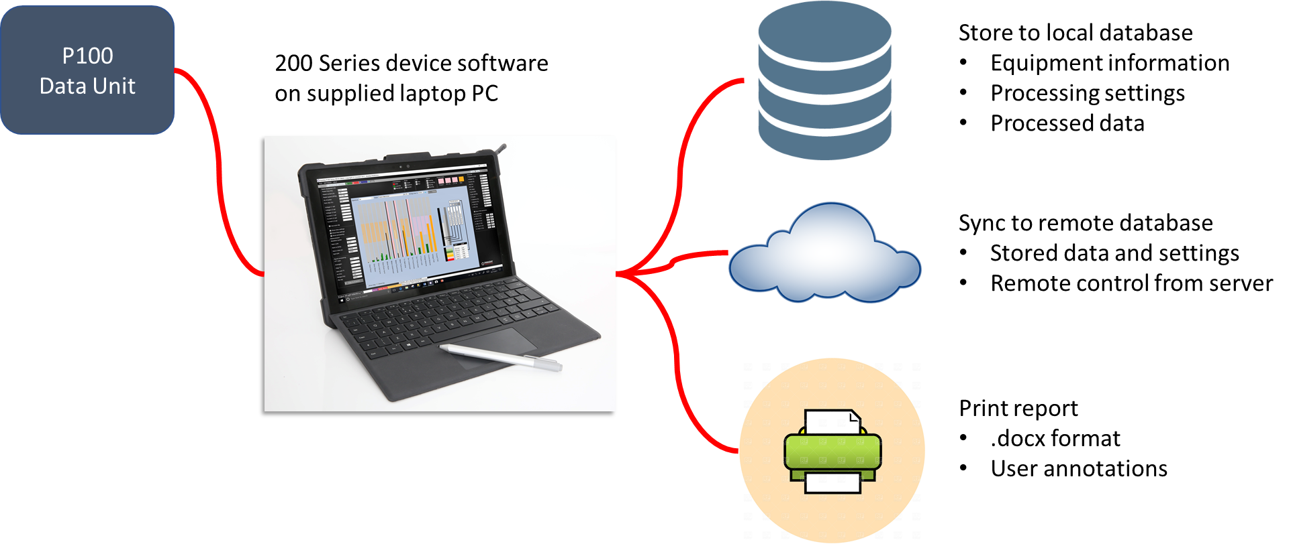

The S200 system is controlled from the software application running on the S200 itself. Since the S200 has no display or keyboard local control requires connection of a monitor (to HDMI or USB) and a keyboard/mouse (to USB). Alternatively, remote desktop software can be used on a PC connected to the S200 through a network connection.

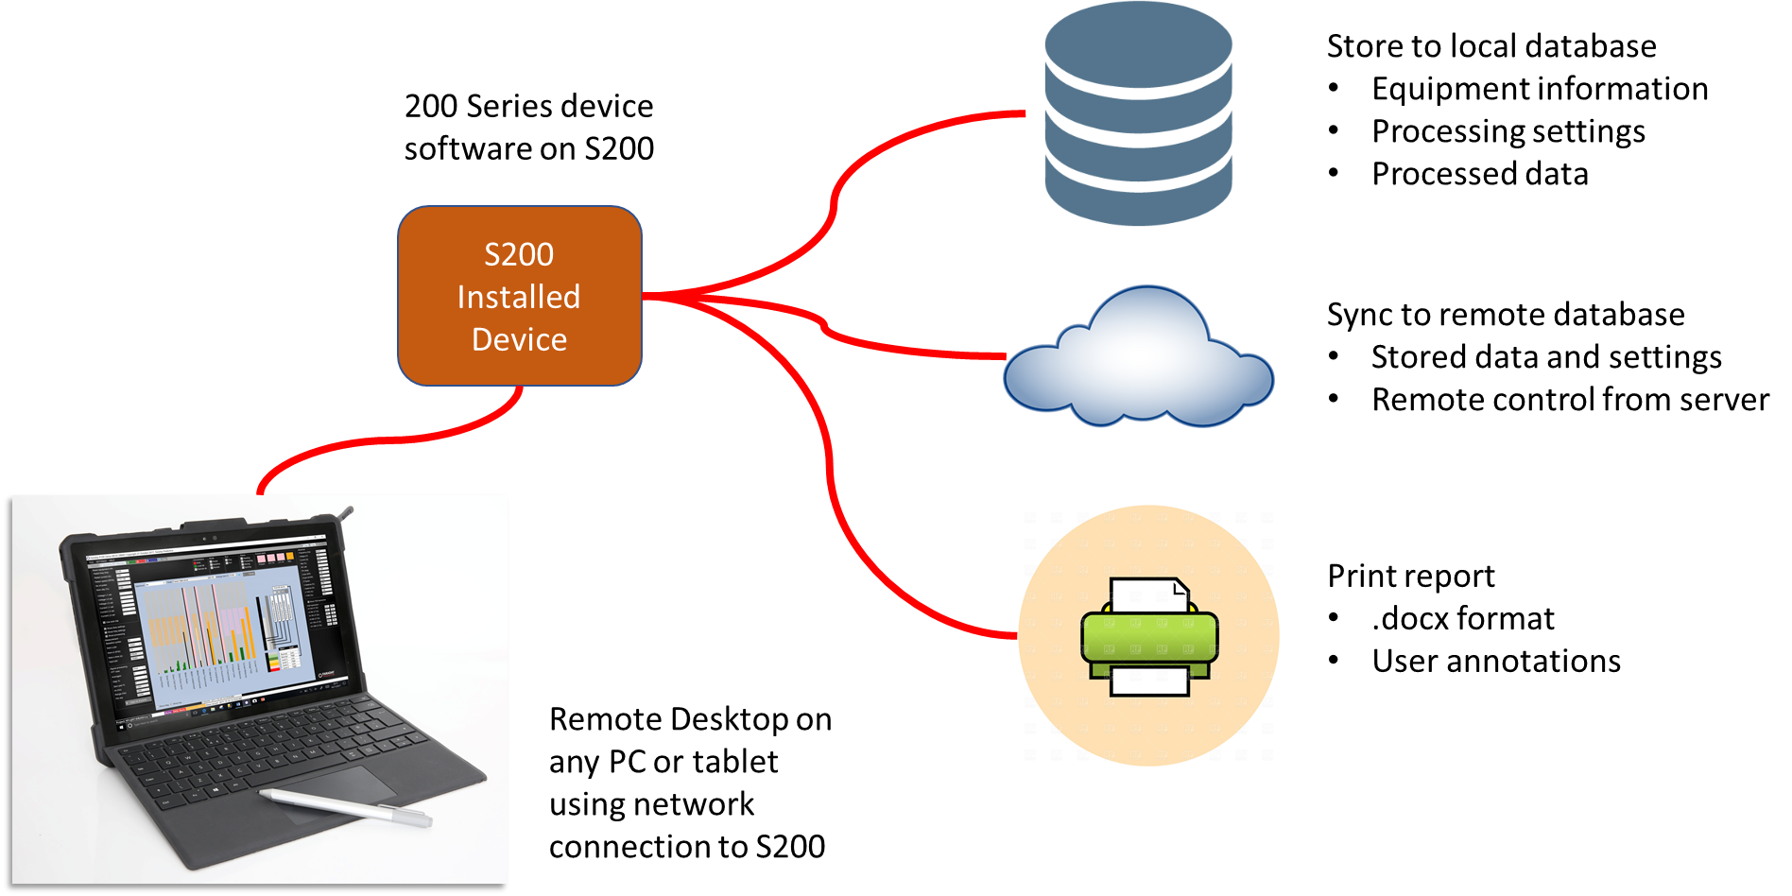

All setup information and measured data is stored in a local database, organised into projects. All setup information and measured data can also be synchronised to an external server.

Any set of results can be used to create a detailed report in .docx format. This allows the user to annotate and modify the report later if required.

# Device processing

The 200 Series device (portable or installed) captures data, analyses it, and provides equipment health assessments that can be stored locally and then synchronised to a remote server:

# 200 Series device software

The 200 Series device software can be used in a number of different ways to give a complete picture of equipment health:

## Health Assessment

Using Scope Mode, the 200 series device software allows you to carry out an assessment of your equipment’s health in less than 10 seconds.

## Health Monitoring

Using Baseline Mode, the 200 Series device software allows the system to learn the incipient faults of your equipment, and then to monitor them over time using Monitor Mode.

## MCSA

Motor Current Signature Analysis is a widely use tool for assessing the condition of rotor bars.

## Auto Slip

Auto Slip estimates the slip (for induction motors only) and allows an accurate assessment of incipient faults with minimal user intervention.

# P100 Series Additional Tools

## Bearing database

When setting up specific equipment information, the user has access to the bearing database for configuring all rolling element bearings. Most widely-used bearing models are available, also allowing the user to customize the bearing based upon the number of rolling elements or directly selecting the bearing frequencies.

## Diagnostic info

The user can access a large number of diagnostic information sheets to assist with analysis. Each sheet focuses on a specific fault type and provides information about the fault and recommended actions.

## Connection data

Contains the parameters required for connection to the local database, as well as those for the remote database when synchronisation is required.

## Last database

Contains the name of the last project used, which is used whenever the system is restarted.

## Startup settings

Allows the user the option of always starting the device with a connection to the remote database. This is typically true for an installed system, and not for a portable system. The user can also insist that the device will only start when the data unit is connected. This is always true for an installed system, and is never true for a portable system.