Project settings

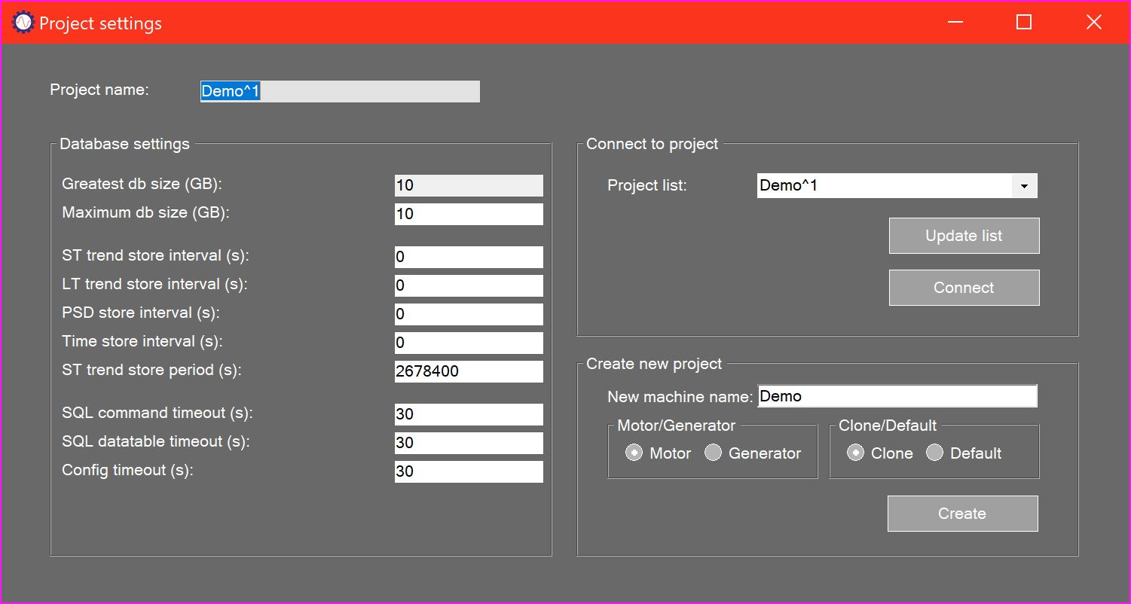

# Settings summary

The Project settings form allows the user to set up the local database in which analysis projects are stored.

# Database settings

Greatest db size: Displays the maximum possible size for a project based on the installed database type. In most installations this will be 10GB.

Maximum db size: Allows the user to enter the maximum project size, which must be less than the Greatest db size.

ST trend store interval: Allows the user to enter the interval in seconds between storage of short-term trend values.

LT trend store interval: Allows the user to enter the interval in seconds between storage of long-term trend values.

PSD store interval: Allows the user to enter the interval in seconds between storage of spectrum data.

Time store interval: Allows the user to enter the interval in seconds between storage of time history values.

ST trend store interval: Allows the user to enter the period in seconds for which short term data will be retained in the database.

The database is automatically managed for total size, and old records are deleted to avoid exceeding the maximum size and to maintain performance. Database availability is shown on the fill bar in the status strip.



# Connecting to an existing project

All available projects are listed in the Project list drop down. The list can be updated at any time by pressing the Update list button. This might be required if backed up projects are restored to the database for example. To connect to a project just select it in the Project list drop down and press the Connect button.

Connection to the project is confirmed when the project name in the status strip updates.



# Creating a new project

Enter the machine name in the New machine name text box. The system will check for existing projects with this machine name and add a suffix to the new project. Select either Motor or Generator according to the equipment type. Select Clone to make a copy of the present project (with no measurement data) or Default to reset to default values. Then press the Create button. Connection to the newly-created project is confirmed as above.