S200 Series Quick Start Guide

# Important information

It is assumed that you have read the installation manual before using the S200 Series unit and that it is installed and ready to start testing. If you do not know how to install it, or you haven’t done it yet, please refer to Hardware Manual for more information about installation set up. Please follow safety guidelines mentioned in relevant sections.

# Tips:

* When changing a value within a text box, make sure you press Enter to update value. If the text box remains pink means that the value hasn’t been updated yet. In this case, press Enter to set the new entry.
* Click buttons for Modes (SCOPE, BASELINE, MONITOR)and Charts (TIME, FREQ, COND) become grey when selected, i.e. they merge with the background.
* You can recall default settings at any time. Just go to FILE/RECALL SETTINGS.
* STORE and RECALL ADHOC is used for Scope mode data only.
* RECALL MEAS is for that data that has been taken after a baseline, and it is stored under the Monitor mode. Please bear in mind that not all Monitoring data is saved; this can be customized under Project settings.

# Connecting to S200 for set up

The S200 system is controlled from the software application running on the S200 itself. Since the S200 has no display or keyboard local control requires connection of a monitor (to HDMI or USB) and a keyboard/mouse (to USB). Alternatively, remote desktop software can be used on a PC connected to the S200 through a network connection.

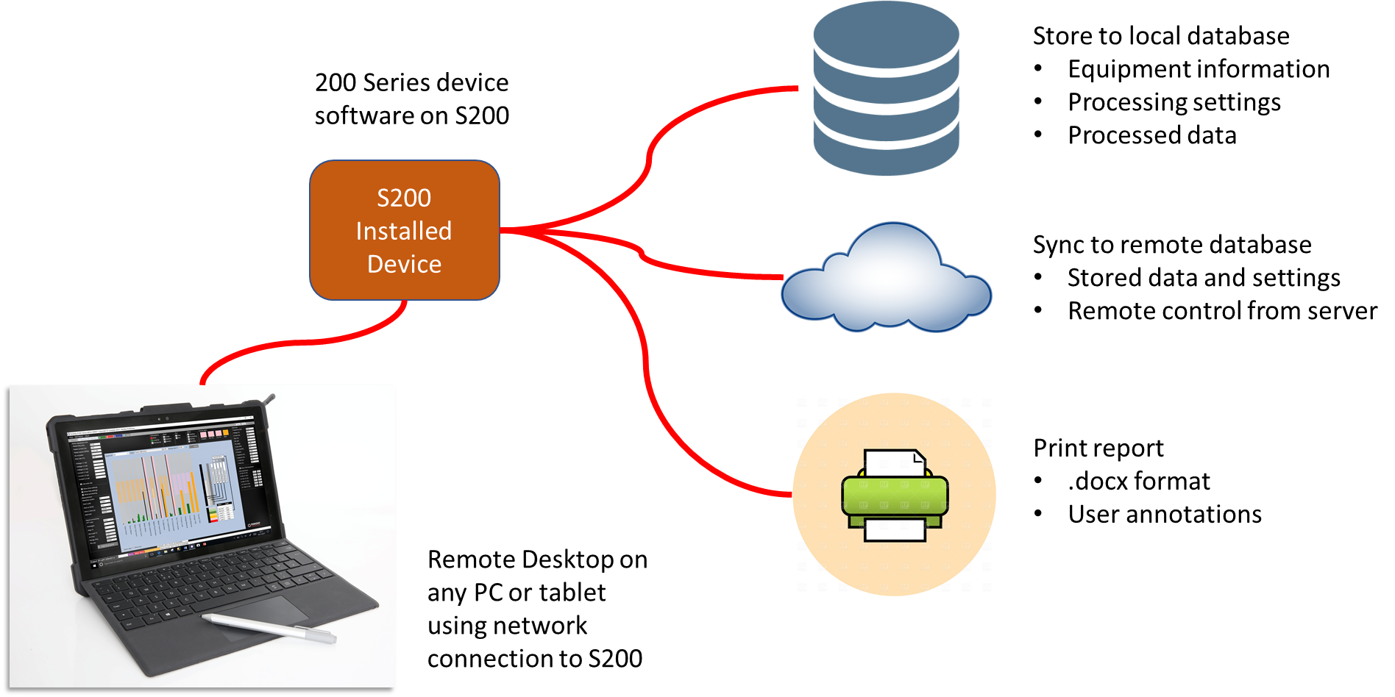

# Software set up

If you have already made a project and would like to connect to it, select SETTINGS/PROJECT. Under the block *Connect to a project* select one of the list and click *Connect*. You can now start assessing the health of your equipment. Otherwise, you must create a new project.

* Create a new Project
  + Go to SETTINGS/PROJECT. Under the block *Create new project* enter the name of your new project, select whether your machine is a *Motor* or a *Generator* and use *Default* settings. If you select *Clone* then the settings for the new project will be copied from the present project.
  + The project will be created, and a blank chart will appear. Close the *Project settings* window.
* Type in Basic Equipment Information
  + Go to *Basic Equipment Info.* This is located in the left hand panel of the main form.
  + Enter motor rated frequency (this is independent of whether the motor is driven by an inverter or not).
  + Enter motor rated current and speed (please refer to *Hardware manual – Installation* for information on how to read a motor plate). The system will then automatically set the number of poles and rated slip of the motor.
  + Enter calibration factors, which will depend upon the selected hardware set up. If you haven’t connected the P100 Series Unit yet, please refer to *Hardware manual – Installation.*
* Enter Equipment Information
  + Go to SETTINGS/EQUIPMENT.
  + Enter mechanical related information such as bearing types, belt drives dimensions, etc. Make sure you enable the relevant component by clicking on the tick box next to it. Click on *Specific* under *Select fault table* to allow the software to use those values for diagnostic interpretation. If no mechanical information is available, click on *Generic* instead.
  + On the text box *Other information*, enter motor rated values (Voltage, Frequency, Current and Speed), type of equipment (Pump, Fan, etc) and any other relevant information about the equipment and/or the site.
  + Click on *Save other info.*

The system is now ready to start assessing the health of your equipment. It usually makes sense to take a few snapshot measurements on your equipment before starting routine monitoring both to check present condition and to find the best settings for monitoring. These snapshot measurements are taken in Scope mode.

# Equipment health assessment (Scope mode)

The following steps will allow you to take a snapshot of your Equipment’s health within a few minutes.

* Select Scope mode and click the Startbutton*.* The software will now carry out a measurement loop which takes around 6 seconds.
* Once finished, have a look at the electrical waveforms and measured electrical parameters to make sure they look correct:
  + Click on Time chart.
  + Select V1, V2, V3 and I1, I2 and I3 to be displayed on the chart. Those should have a sinusoidal shape, and should be out of phase by the same amount. Have a go at playing with them to make they look like a 3-phase system of voltages and currents.
  + Have a look at the *Electrical* measured parameters in the right hand panel of the main form. Compare those against the motor rated values to make sure they look correct.
* If you click on Spectrumbutton you will see the frequency domain of the measured electrical waveforms. Every single peak has a meaning, although not all of them represent an incipient fault.
* If you click on the Condition button you will see an overview diagnostic of your equipment’s health. If you click on any of those bars, you will find a description of the fault type below the chart.
* The measurement will be stored automatically as an AdHoc measurement.
* Click the Report button to get a full report of your equipment’s condition based on this measurement. You can now carry out more measurements or learn the pre-existing condition of your equipment and monitor it.

# Equipment health monitoring (Baseline and Monitor Modes)

For monitoring the health of the equipment over time, it is required to learn its present condition with Baselinemode. This allows to identify incipient faults on the equipment and to measure their present level for future comparison.

* Set the number of iterations for Baseline mode. For doing so, go to Scopemode. Click on the tick box *Show processing* (in the left hand panel of the main form), and a list of settings will appear below. The first one is called *Baseline* and is under the *Measurement settings* block. Type in the number of iterations to create the Baseline (30 recommended).
* Select Baselinemode and clickthe Start button*.* Wait for the process to complete, where the total time required depends on the number of iterations selected (each iteration takes roughly 6 seconds).
* Once the Baseline measurement completes, Monitor mode will start automatically. You are now monitoring your equipment. It is advised to select the Condition chart for looking at the condition bars. Those will display the number of Standard Deviations of any existing faults from the baseline. You can click on any of those at any time to see their trend over time.
* You can stop monitoring at any time by clicking the Stop button.

# Synchronisation to remote server

First click the Stop button to enable the Sync button.

Check that the configuration file for the connection strings for your remote server have been stored correctly (see the Configuration files Help page).

The Sync button is located on the left-hand side of the toolstrip. It is greyed out when off:

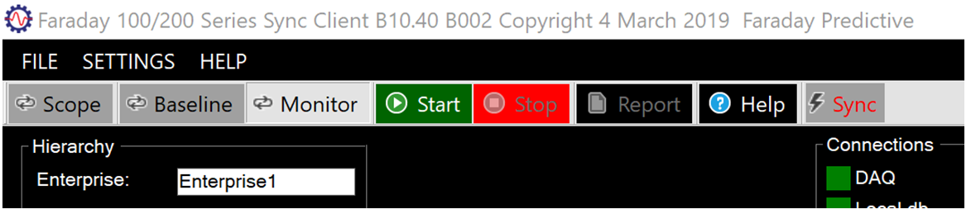

The full range of functions is available, and results will be stored in the local database in projects. Click the Sync button to enable synchronisation, resulting in the Sync button back colour changing to white:

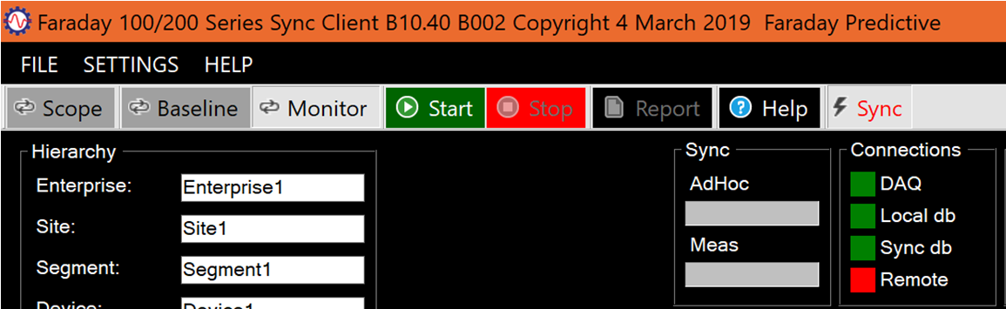

A new group of sync controls appears. Operation of the system remains the same, but now there will be a periodic check on whether the remote server contains data as recent as that on the device. If not, the system sends the new data from the device to the server. While this is completing, the two progress bars in the sync group show what proportion of device data has been transferred and what still has to be transferred. The AdHoc progress bar shows transfer of measurements taken in Scope mode, and the Meas progress bar shows transfer of measurements taken in Monitor mode (during which new Baseline data is also transferred). During sync, the progress bars are read to show that transfer is not yet complete and then change to green when the transfer is complete. In normal operation new measurements are transferred in each measurement cycle.

If the connection to the server is interrupted, the system will continue to store measurements locally and will then catch up when the next periodic check is made. This eliminates vulnerability to poor network connections (especially when a mobile network connection is being used). The time to transfer new data depends on the volume of unsynchronised data on the device and the speed of the connection, so it is important to sync frequently if possible to avoid delays.

The S200 Series device can now be controlled by the server system and the local monitor can be disconnected.

# Motor Current Signature Analysis (MCSA)

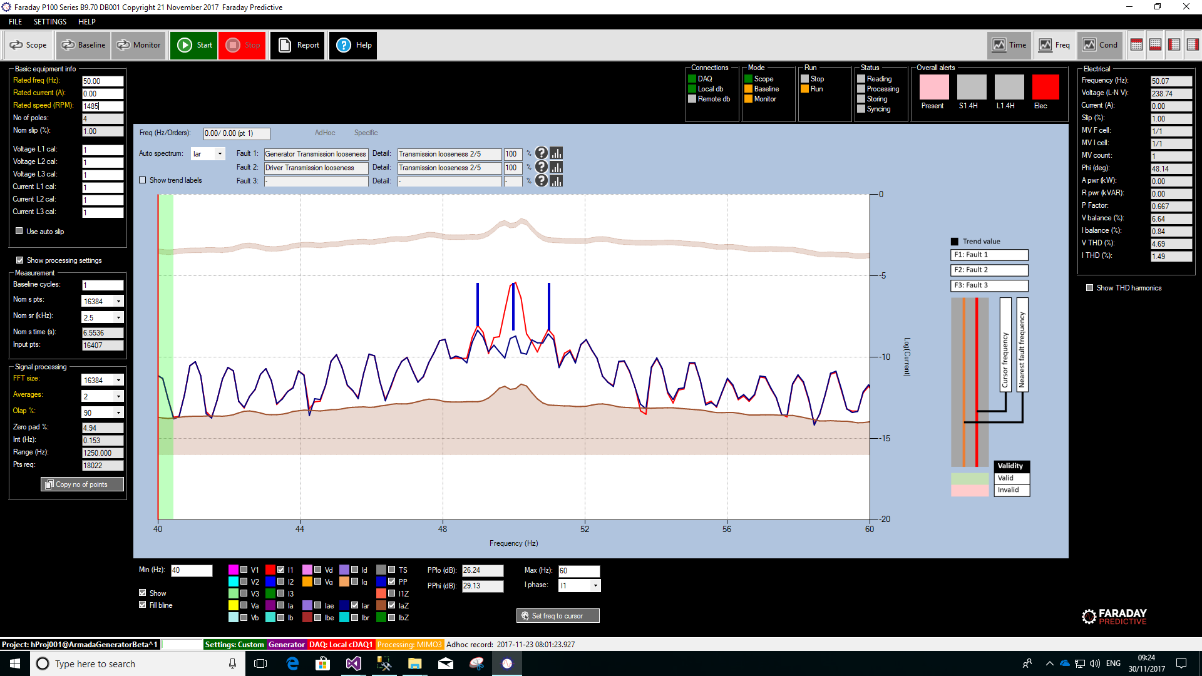

MCSA measures the spectrum at high resolution, to identify peaks related with rotor bar deterioration. This technique can only be used in Induction Machines, where slip is present and inherent to the machine performance.

When an induction motor is connected to the three-phase electrical supply, the rotating field created on the stator induces an electro motive force in the rotor, which in return creates a current that flows through the rotor bars. The amplitude and frequency of this current is maximum on the start-up, and reduce as the rotor increases in speed. The rotor will never reach the synchronous speed, and the difference is called slip, which depends upon the load applied on the machine.

If one or more of the rotor bars is developing cracking or other deterioration, the electrical resistance of this bar increases with respect to the others, creating a pulse pattern in the stator current as the bar crosses the synchronous field. This pattern can easily be analysed in the frequency domain, appearing as sidebands of the main frequency supply. Those sidebands will depend upon the slip of the machine, being further apart as the slip increases (as load increases).

# Analysing Sidebands

MCSA analysis is usually performed using the measured current, although it is easier to spot those sidebands when displaying the residual current as well. The range where those sidebands can be found is within +-20% of the frequency of the supply, as sideband of this and depending upon the slip present on the machine at the time when the data was taken.

Using Auto slip will simplify the identification process. This estimates the slip of the machine, using a linear approximation between the motor rated current and the current being drawn at the time when the data was collected.

The process to identify and measure rotor band responses is as follows:

* Take a measurement using SCOPE Mode, with a high number of Nominal sampling points to allow high resolution spectral analysis (32768 or 65536 points are recommended). Make sure the number of Baseline cycles is set to 1, and that Auto slip is checked.
* Nominal sampling rate should be set to a low value (where 2.5 kHz is recommended).
* Select the maximum FFT size and Overlap (16384 and 90% respectively). Then select the maximum number of Averages that gives you a low Zero padding value. A value below 10% is suitable for MCSA purposes.
* On the Frequency Plot, you now need to select the view range for spotting the pole pass sidebands. The maximum and minimum frequency are usually within +-20% of the supply frequency. For a 50Hz supply the viewing range shall be set from 40Hz to 60hz.
* On the same plot, select now either of the measured currents (I1, I2 or I3), either of the residuals (Iar or Ibr) and the Pole Pass (PP). If modelling is not available the residual currents will not be shown, but this does not present a problem for carrying out MCSA.
* Selection Pole Pass (PP) causes two bars to appear at sidebands of the fundamental frequency. If Auto Slip is enabled, those should lie on top of the pole pass peaks. Two values will be displayed below the frequency Chart, on the text boxes PPlo (Pole Pass Low) and PPhi (Pole Pass High). Those values will give an indication of the rotor bars condition as per the table below.

|  |  |  |  |
| --- | --- | --- | --- |
| Category | I (line) / I (pole pass) | Assessment | Action |
| 1 | 60dB or more | Excellent | None |
| 2 | 54-60dB | Good | None |
| 3 | 48-54dB | Moderate | Continue surveys, trend |
| 4 | 42-48dB | Rotor bar crack developing or high-resistance joints | Reduce survey interval, trend closely |
| 5 | 36-42dB | 2 bars likely to be cracked or broken, high resistance joint likely | Perform vibration tests to confirm problem source |
| 6 | 30-36dB | Multiple cracked/broken bars or end rings indicated | Overhaul asap |
| 7 | < 30 dB | Multiple cracked/broken bars or end rings very likely; severe problems throughout | Overhaul or replace asap |

If you think the pole pass bands are incorrectly located, you can change those by modifying the Rated speed of the motor.