Scope mode

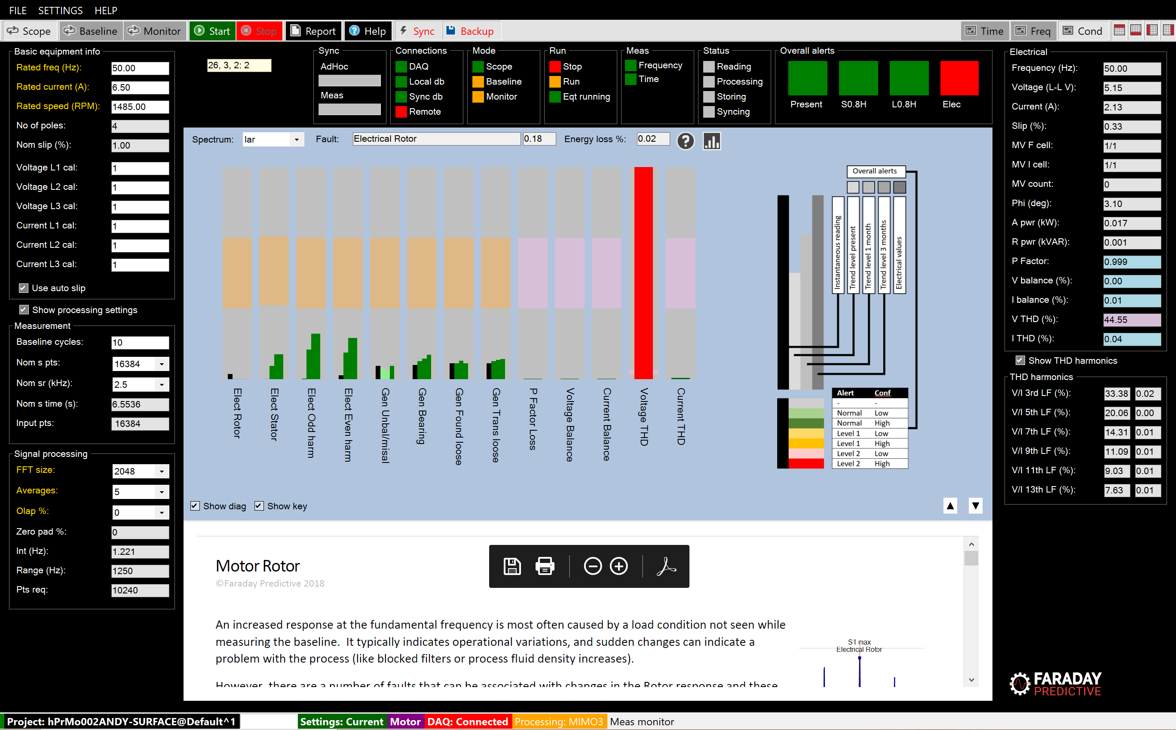

# Mode summary

Scope mode is the default mode of operation. Typically used in conjunction with the condition chart it allows the user to get the quickest possible assessment of the condition of their equipment.

# Operation

From startup, Scope mode can be used with default values in most situations. Measurements are made by clicking the Start button. When the measurement is complete:

* A full set of electrical parameters is shown
* All charts are updated, and by default the condition chart is shown to give a quick assessment of condition
* If stored trend values are available, the system uses them to provide predictive alarms
* A complete set of AdHoc data measurements is stored in the local database so that they can be recalled later for analysis

From the condition chart, information about individual faults can be selected by clicking on the information symbol or the condition bar itself.

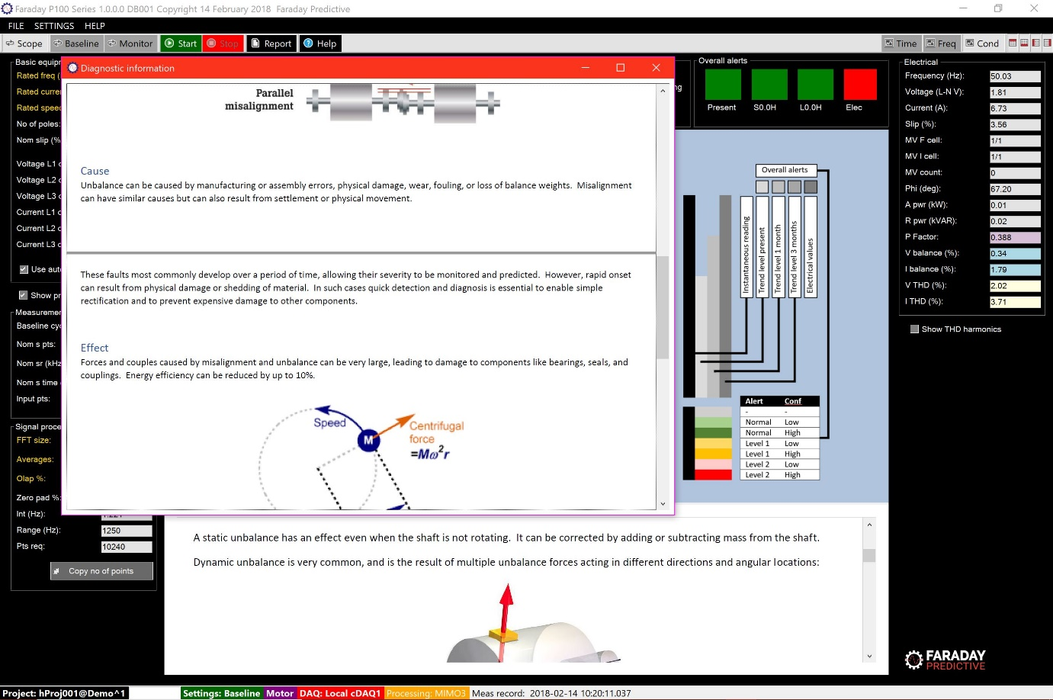

# Print report

Once the Scope measurement is complete, an editable .docx condition report can be produced by clicking the Report button.