Auxiliary measurement settings

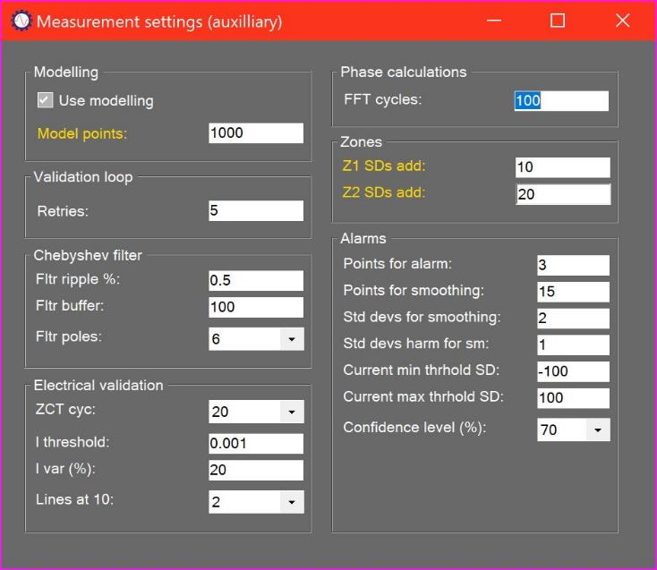

# Settings summary

To simplify the user interface, some measurement settings are presented in the Auxiliary settings form. These settings will not normally be required for operation of the system, and assistance from a support engineer should be sought before making changes.

# Modelling

Modelling can be turned off temporarily, typically while checking connections to a new system. This allows the user to review basic current and voltage waveforms and spectra without the risk of the measurement failing because of modelling errors.

The user can define the number of points that will be used for modelling. A higher number of points will improve accuracy but reduce performance.

# Validation loop

If a problem occurs during the measurement cycle (for example if a cable connection is broken) then the system will retry for the number of times specified in the Retries text box.

# Chebyshev Filter

The system makes extensive use of a built-in Chebyshev digital filter package, which includes a custom filter designer. Filter characteristics should not be changed without the assistance of a support engineer.

# Electrical validation

During the measurement cycle, the system continuously updates measured frequency and current as well as variations in frequency and current. These calculations are based on Zero Crossing Time calculations throughout the measured time histories, averaged over a number of cycles. The number of ZCT cycles, the minimum current threshold, the maximum current variation, and the permitted range of frequency variation expressed as the number of FFT lines at the 10th line harmonic are set in this section. They should not be changed without the assistance of a support engineer.

# Phase calculation

Phase calculations are carried out using a Frequency Response Function method over a fixed number of FFT cycles defined in this section. This should not be changed without the assistance of a support engineer.

# Zones

Alarm zones are defined by a number of Standard Deviations above the baseline (default or measured). They should not be changed without the assistance of a support engineer.

# Alarms

Alarm calculations make use of statistical analysis of past data using settings defined in the section. They should not be changed without the assistance of a support engineer.

Processing

Clicking on this tab allows to see the software internal processes. It is particularly helpful for troubleshooting.

### Log

Shows what the software is doing at all times.

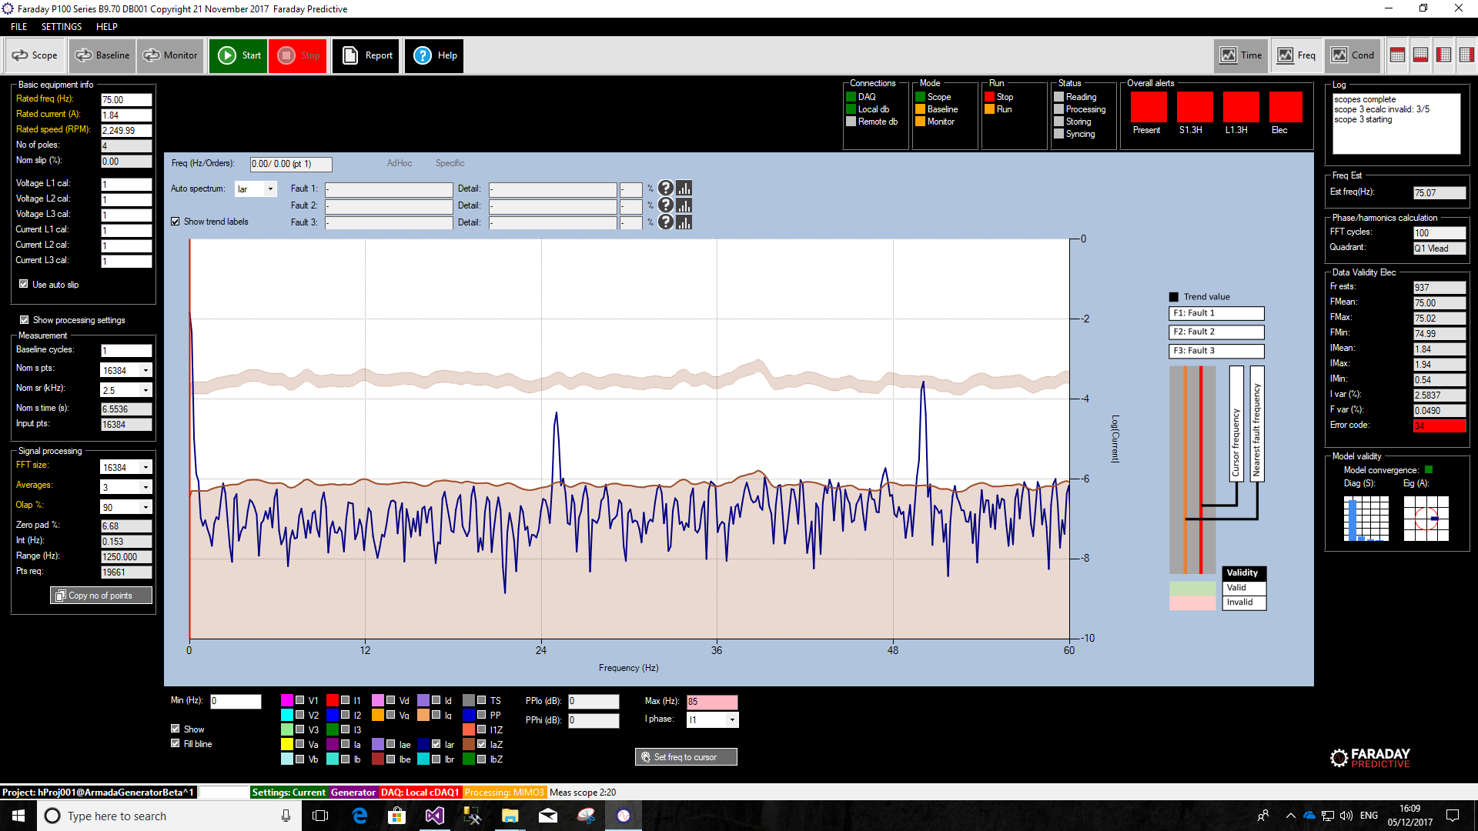

### Phase/harmonics calculation



### Frequency Estimation

This is the estimated frequency at the beginning of the processing.



### Phase/harmonics calculation



### Data Validity Electrical

Provide information on how stable the measured data is.



### Model Validity

Provides indication on the linearity and convergence of the model created. The Diagonal of S indicates the linearity of the model, i.e. how good the model is. The Eigenvalues of A indicates the stability of the model, i.e. how well it will fit the measured data.



Measurement and Signal Processing Settings

Those are found on the LHS of the main form when clicking on Show Processing Settings tick box. They are required to configure the acquisition part of the measuring process.

## Measurement Settings

### Baseline cycles

Its value should be set to 1 when using the software in Monitor mode, and to a higher number in Baseline Mode.

This sets the number of measurement cycles the software carries out after clicking *Start*. In Scope mode, the software will carry on doing measurements, but those will not be stored unless the customer stops the process and saves the last measurement. Older measurements that have not being saved cannot be recalled.

In Baseline Mode, the fingerprint or Baseline of the equipment will be created. This is an average of a number of cycles set by the user.

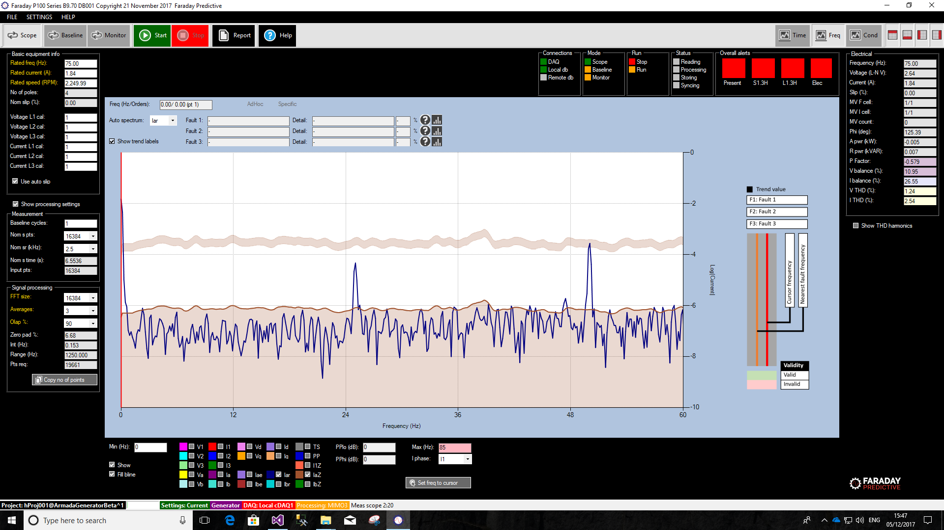

### Nominal Sampling Points (Nom s pts)

This refers to the number of points gathered within 1 measurement cycle. As greater the number of points, the longer the Nominal sampling time becomes. Default value is 16384 and it is recommended to keep it unless you are carrying out an MCSA.

Increase in nominal sampling points leads to higher resolution in the FFT if other parameters are kept constant.

### Nominal Sampling Rate (Nom sr)

This refer to the sampling rate, i.e. the frequency at which the data is chopped or sampled. As greater the value is, the lower the Nominal Sampling Time becomes, considering a fixed number of points.

Increase in sampling rate leads to higher frequency range in the FFT if other parameters are kept constant.

### Nominal Sampling Time (Nom s time)

It is calculated depending upon the Nominal Sampling Points and Sampling Rate selected.

Nominal Sampling Time = Nominal Sampling Points / Nominal Sampling Rate

Make sure you select a good balance between Sampling rate and Points that gives you a reasonable sampling time.

### Input Points (Input pts)

It is calculated depending upon the Nominal Sampling Points and Sampling Rate selected. This will normally be the same as the user selected Nominal Sampling Points, although it can be slightly different depending on the measuring conditions.

## Signal Processing Settings

Those set the number of points used to generate the Fast Fourier Transform (FFT) or Spectrum for data analysis and fault assessment.

### FFT size

The FFT size sets the number of points for the Fast Fourier Transform (FFT). This value needs to be greater than the Nominal Sampling Points selected on the Measurement Settings.



### Averages

If set to 1, the software will create only one FFT with the available data. If set to 2 or more, the software will create two or more FFTs using the available data, and will provide an averaged spectrum using the calculated FFTs.

### Zero Padding (Zero pad)

This value should aim to be as low as possible. It is not an user selected parameter, but it can be modified by changing any of the other three parameters above.

### Interval (Int)

Resolution achieved as a result of the values set above.

### Range

Maximum frequency range available as per values set above.

### Points Required (Pts Req)

Number of points required to process the signal as per the values set above.