Channels settings

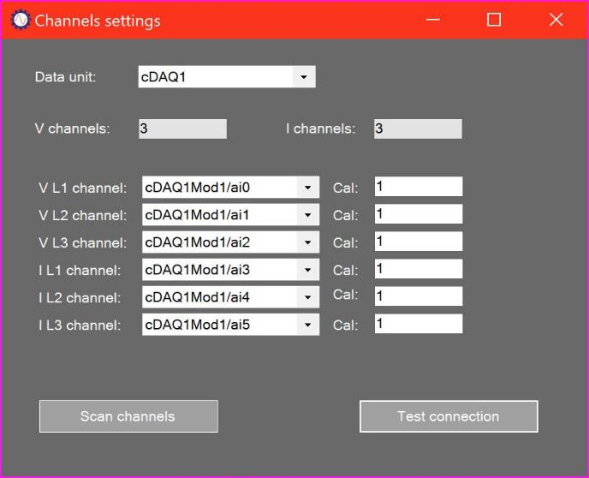

# Settings summary

The Channels Settings form is used to set up each of the measurement channels of the P100 Series system. In addition to specifying measurement channels for each individual measurement it also allows the user to set up a calibration factor for each channel.

# Selecting measurement unit

Each P100 Series system normally has one measurement unit. When this is connected, its name is presented in the Measurement unit drop-down box.

# Default channels

A single P100 Series measurement unit has six channels. By default, these channels are assigned as shown above.

# Scanning and selecting available channels

Under certain circumstances it may be necessary to assign different measurement channels to each measurement. To do this, the user can click the Scan channels button and then select any measurement channel from the individual drop-down boxes.

# Calibrations

Calibration factors should be entered as Parameter unit/Measured volts. For example, for a current channel the calibration factor will be Amps/Volt. Polarity of any channel can be reversed by entering a negative value.

# Processing options

The P100 Series system is normally used with all 6 measurement channels connected (3 voltage and 3 current phases). The processing used in this case is known as MIMO3 (Multiple Input Multiple Output 3 phase) processing.

If one voltage or current phase is not available for measurement, then that phase can be deselected by setting the measurement channel to “None” for that measurement. The system will then calculate the missing phase from the other two. The processing used in this case is known as MIMO2 (Multiple Input Multiple Output 2 phase) processing.

In each MIMO case, the system calculates residual and alarm zone data for Ia and Ib data which is calculated from the measured I1, I2, and I3 data. Automated fault identification can be carried out based on I1, Ia (residual), or Ib (residual) data.

If only one measurement phase is available, then V1 is set to the available voltage phase and V2 and V2 set to “None”. The system will carry out processing for that single phase, which is then labelled as I1 and which has residual and alarm zone data that replaces the normal Ia results. Automated fault identification is carried out for this channel only. The processing used in this case is known as SISO (Single Input Single Output) processing.

If no voltage measurements are available, all voltage channels can be set to “None”. The system will then carry out processing on available current measurements only. No modelling is carried out, and automated fault identification is based on the I1 measurements only. The processing used in this case is known as MCSA (Motor Current Signature Analysis) processing.

The type of processing is selected only by means of the voltage channel settings, and the type of processing is displayed in the Status Strip:

