Charts

# Charts summary

A range of charts is available to present information to the user. Often a simple chart is required in order to show results in the most concise form. But at other times it is necessary to drill down into the data to understand problems better.

# Condition chart

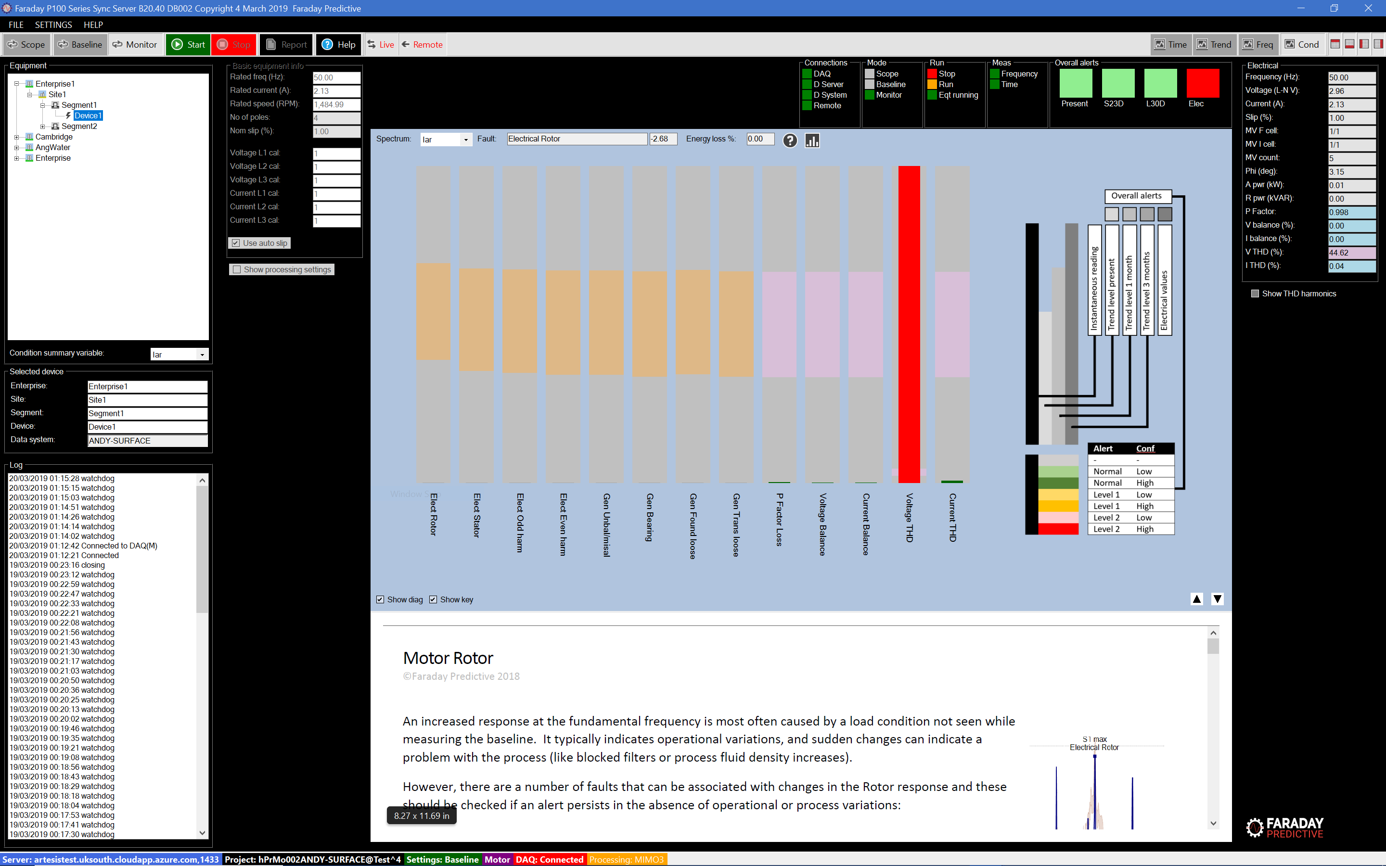

The Condition chart provides a quick look at the present condition of the equipment. Each set of bars represents the present and future levels of a specific fault identified in the equipment. The bar sets are plotted against a background indicating alert levels and are colour-coded to indicate severity level.

Worst case alert levels are presented in the status bar above the Condition chart.

By clicking on any set of bars, the user can show detailed analysis sheets describing the fault and what should be done to manage it.

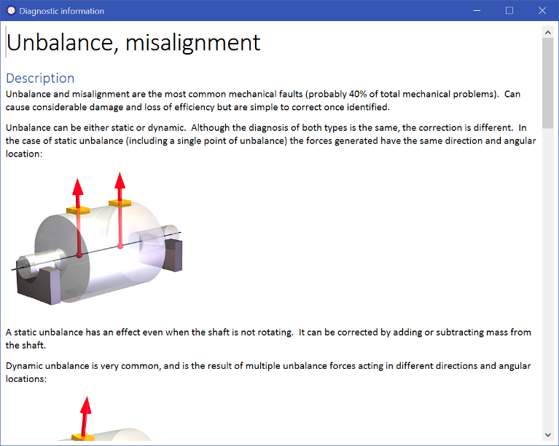

# Frequency chart

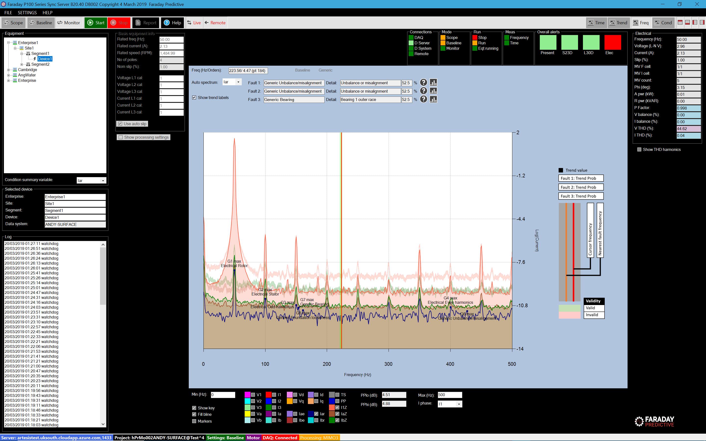

The Frequency chart provides a deeper level of information for the more experienced user. A wide range of processed parameters can be plotted against frequency in order to show the level of different fault peaks. Most commonly this chart shows the residual current spectrum measured during Scope or Monitor measurements overlaid on the Baseline (or default Baseline) measurement.

An intelligent cursor allows the user to click on each peak to see which fault it represents, along with an assessment of the probability that this identification is correct. The largest value in each fault group is labelled on the Frequency chart, and these values are the same as those used in the Condition chart. The user can show the diagnostic sheet for any identified fault.

For advanced users, the Frequency chart allows the addition of custom markers to help identify specific frequency peaks so that unusual or complex faults can be analysed.

# Time chart

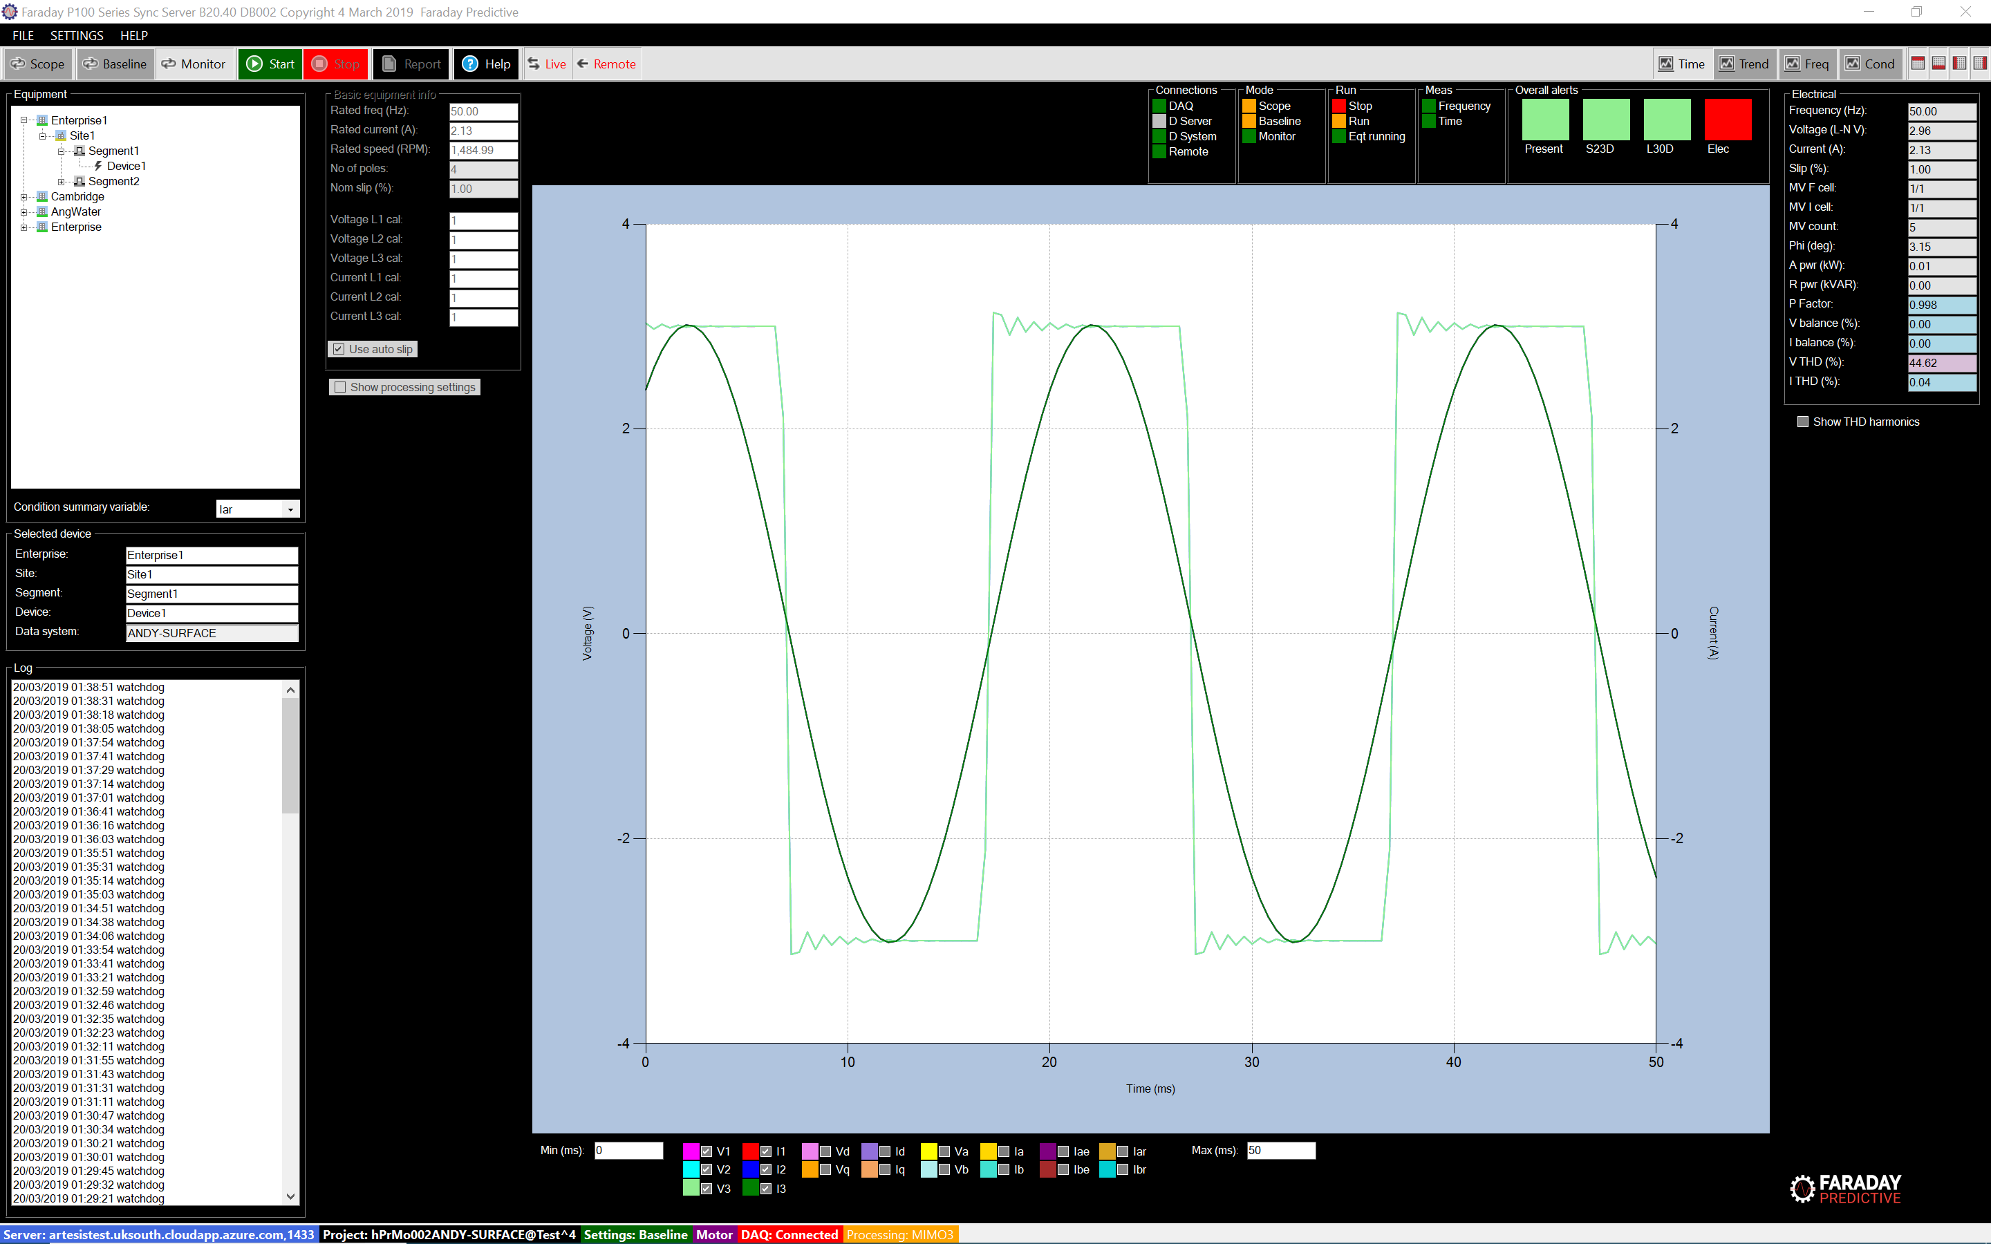

The Time chart allows the user to check the time waveforms for the raw measured signals, and all processed results.

# Trend analysis chart

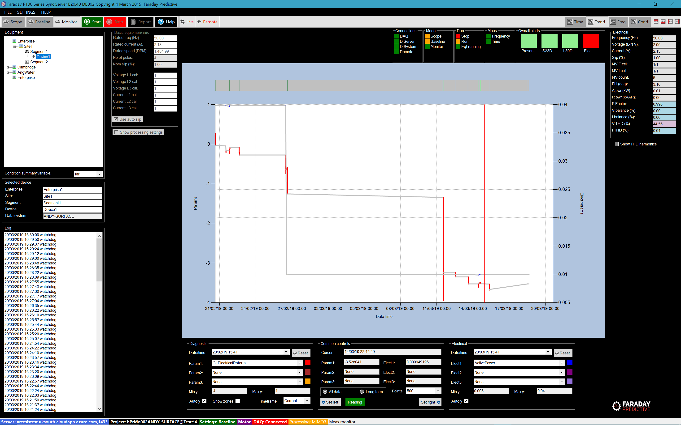

The Trend analysis chart shows how faults have developed over time. At the top of the chart is a bar showing alarm values over time, and the main chart shows up to three diagnostic parameters and up to three electrical values at the same time.

# Trend chart

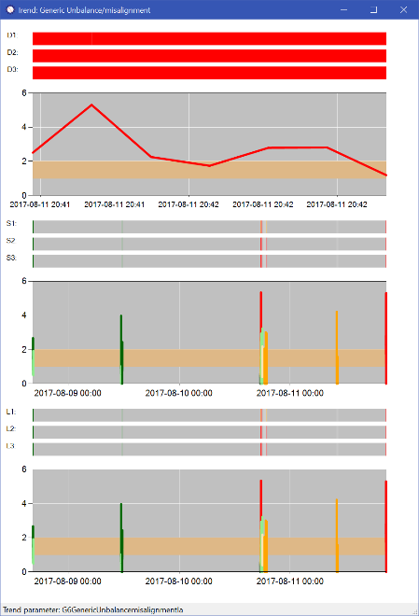

From either the Condition or Frequency charts the user can show trend data for any selected fault. Trends are shown over three periods: up to the last day, up to the last month, and up to the last three months. In each case, three alert bars show alert state at the measurement time, alert state in the short-term future (up to one month) and long-term future (up to three months). The trend plots themselves are colour-coded to show alert levels and are shown overlaid on alert levels.