Condition overview chart

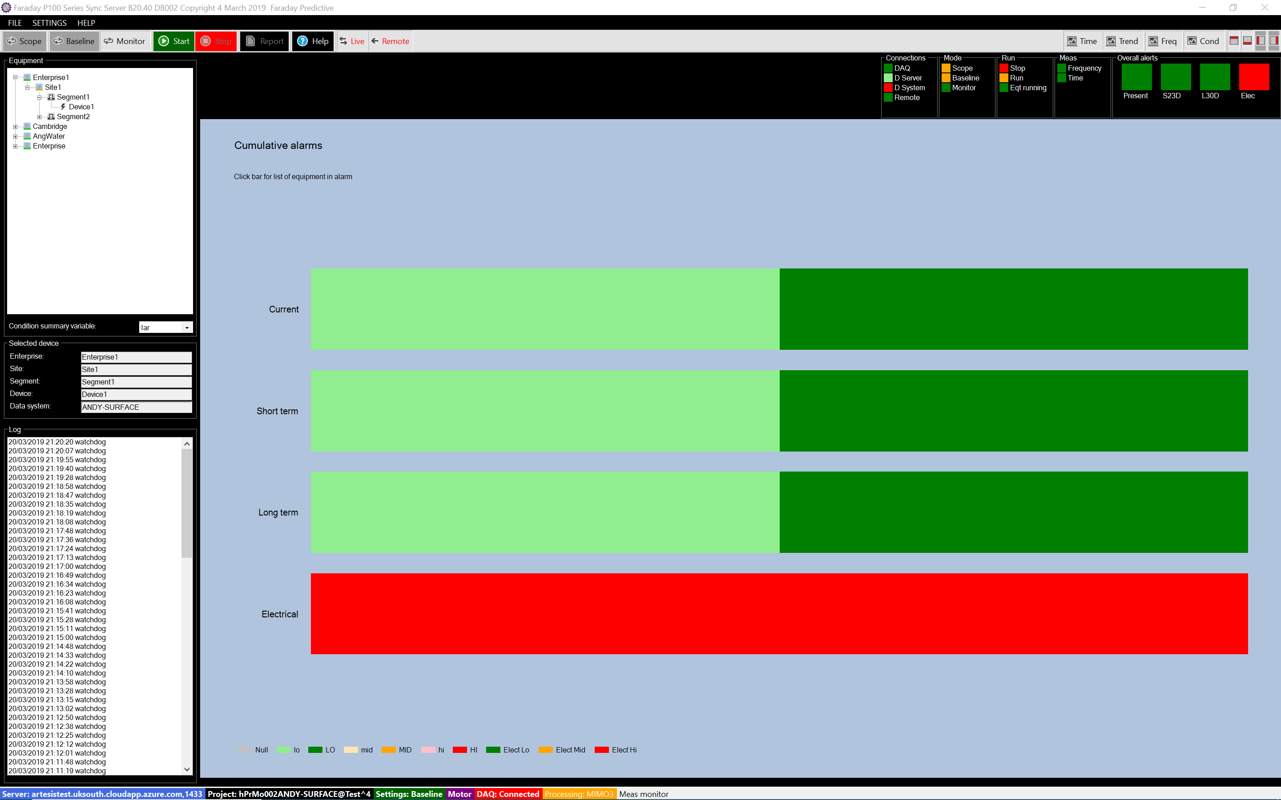

# Chart summary

The Condition overview chart is the only chart shown when an enterprise, site, or segment is selected in the Equipment treeview. It presents cumulative condition information for all devices in the selected enterprise, site, or segment.

The chart consists of four bars, each of which shows the proportion of devices in each of a number of condition states. The top three bars show current conditions, short term predicted conditions (up to one month), and long term predicted conditions (up to three months). The condition states shown in these bars are: normal with low confidence (light green), normal with high confidence (dark green), alert with low confidence (light orange), alert with high confidence (dark orange), alarm with low confidence (pink), and alarm with high confidence (red).

The bottom bar shows current electrical condition. The condition states shown in this bar are: normal (green), alert (orange), and alarm (red).

# Lists of equipment in alarm

Clicking on any of the four bars brings up a summary form listing the equipment presently in alarm (pink or red) within the selected enterprise, site, or segment:

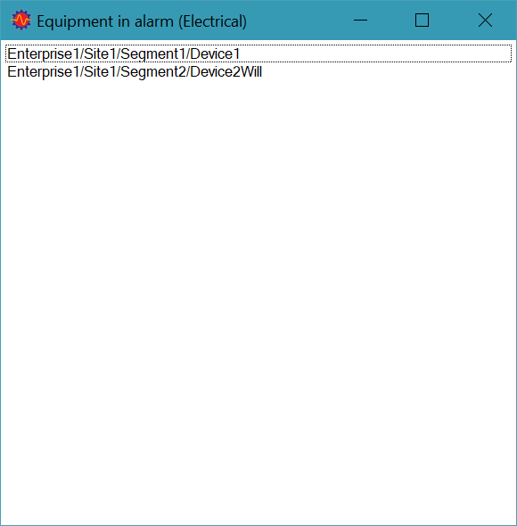

This information can then be used to guide maintenance priorities, or to indicate equipment requiring more detailed analysis.