Basic Equipment information

Basic Equipment Information is located at the LHS of the main form. It is the minimum required information for doing a measurement. This contains motor rated parameters and calibration factors.

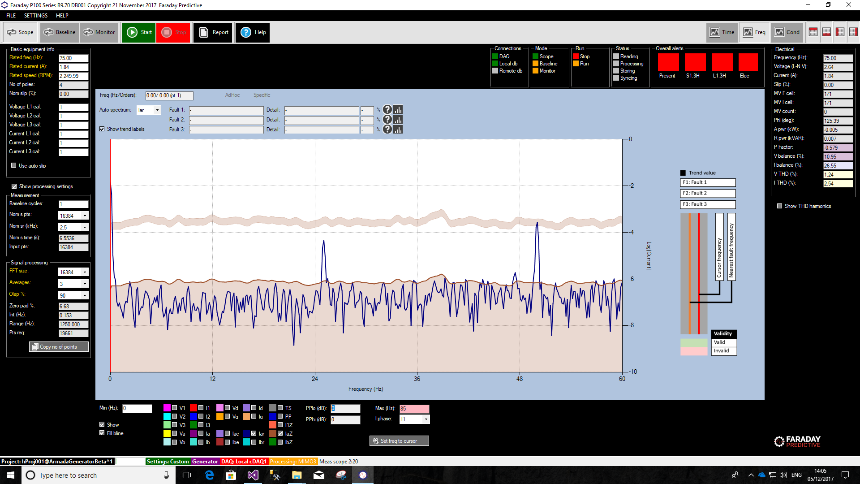

## Motor Rated Parameters

Knowing the **frequency** and the **voltage** of the motor 3-phase supply, you will find all motor rated values onto the motor plate. Below an example for a 50Hz, 230V Line to Line supply.



The motor configuration (Star or Delta) rated voltage must match the voltage supply. This is applicable for all motors, including those with Delta/Star starter and those driven by Inverter. The rated voltage under inverter driven equipment is that achieved at the rated speed of the equipment application.

## Calibration Factors

The calibration factors depend upon the selected hardware configuration as shown in table below. For more information about the hardware set up, please refer to the Hardware manual.



*NOTE: Protection Current Transformer (CT) and Voltage Transformer (VT) ratios can be easily calculated by dividing its primary rated value by its secondary rated value.*

Motor rated parameters can also be found in Equipment Information settings. Calibration factors can also be found in Channels settings.

## Auto Slip

The Auto Slip tool allows the software to estimate the slip on every measurement depending upon the power drawn by the motor. For this tool to be effective and accurate, the motor rated values need to be those found on the motor plate. If they differ, the estimated slip will not be accurate and so the ability of the software to identify faults.

Equipment information

## Motor

The equipment is driven by an Induction or synchronous motor.

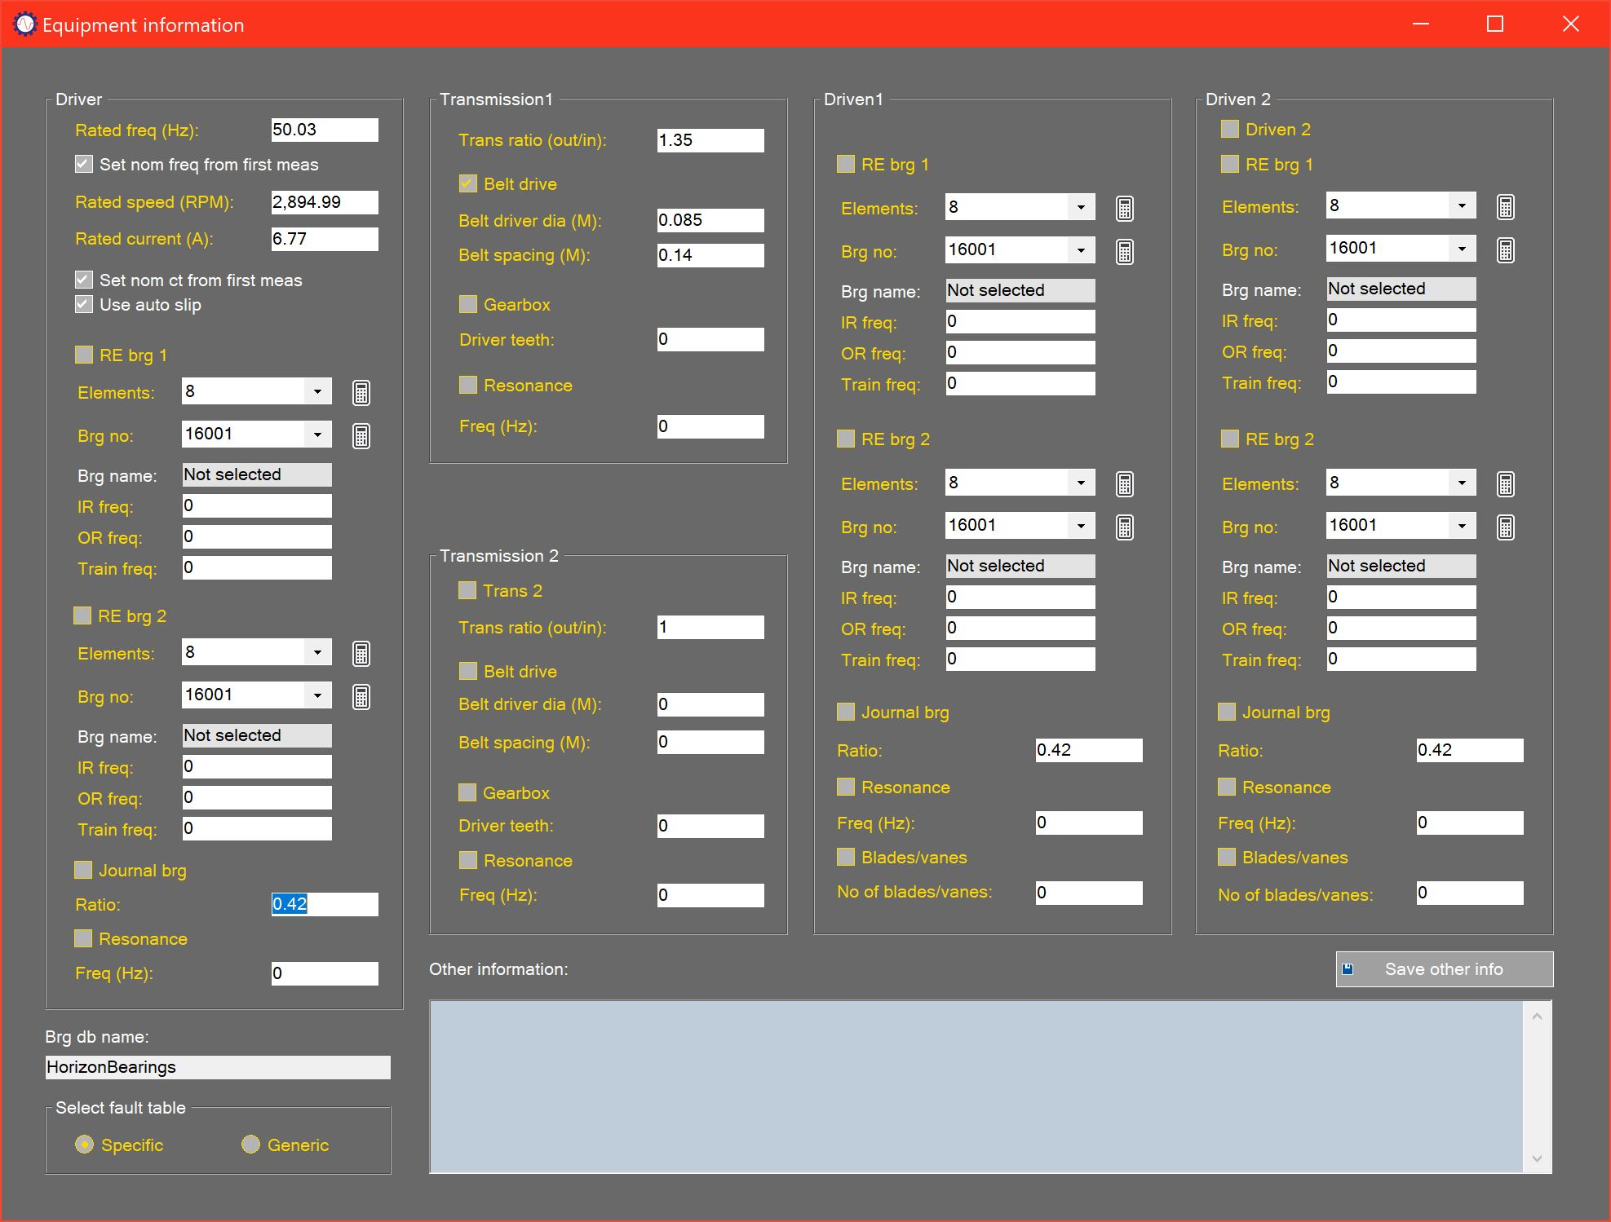

# Settings summary

In order to carry out automated fault identification, the P100 Series system needs to have information about the configuration of the equipment being monitored. This equipment information can be generic, in which case the system calculates a wide range of most-likely configuration values based on equipment type, number of poles, and slip only. This basic information can be entered either on the Equipment information form or on the Main form:

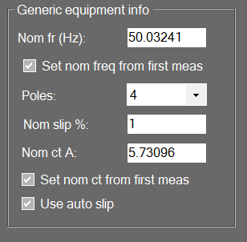

For more detailed and accurate analysis, the user can enter full equipment configuration details using the Equipment information form.

# Motor settings

If the selected project is for a motor-driven system, the Equipment information form will be configured to collect information appropriate to this equipment only.

Driver

The user can enter the nominal frequency for the equipment or check the Set nominal frequency box to have the system set nominal frequency to the first measurement. Nominal current is set in the same way, with the option to use the first measured current. Number of poles and nominal slip must also be entered, with the option to adjust slip automatically based on the change of measured current from the nominal value.

Up to 2 rolling element bearings can be specified for the driver. Characteristic frequencies (shown as orders) can be calculated based on the number of elements, the bearing number (using the built-in bearing database), or by entering the frequencies manually (from a data sheet for example). For the first two methods the user selects the appropriate value from the drop-down box and then clicks the calculator key next to the box to calculate the characteristic frequencies. The Bearing name text box then shows the source of the bearing information.

If the driver has journal bearings then the characteristic response ratio for that bearing can be entered in the text box below the Journal bearing check box.

If the resonant frequency of the driver is known this can be entered in the text box below the Resonance check box.

Transmission 1

Transmission 1 is always selected, and its transmission ratio is entered in the Trans ratio text box.

Belt drive and gearbox details are then entered using the appropriate text boxes, along with the resonant frequency if this is known.

Driven 1

Driven 1 is always selected, and characteristic frequencies are calculated based on the transmission ration for Transmission 1.

Settings are as for the Driver, with the addition of a Blades/vanes option to cover equipment such as pumps and fans.

Transmission 2

Transmission 2 must be selected by the user if required, and is otherwise set up in the same way as Transmission 1.

Driven 2

Driven 2 must be selected by the user if required, and is otherwise set up in the same way as Driven 1.

# Generator settings

If the selected project is for a generator system, the Equipment information form will be configured to collect information appropriate to this equipment only.

Driven

Generator information is entered in the same way as driver information for motor-driven equipment.

Transmission

For generator systems, only one transmission is specified.

Driver

For generator systems, only one driver is specified.

# Selecting generic or specific processing

The user can select either generic or specific fault identification by means of the radio buttons in the Select fault table panel:

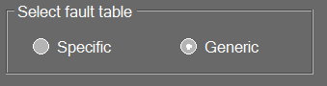

# Other information

General notes can be entered in the Other information text box. This information will be stored with the project and presented when the project is recalled.