Login

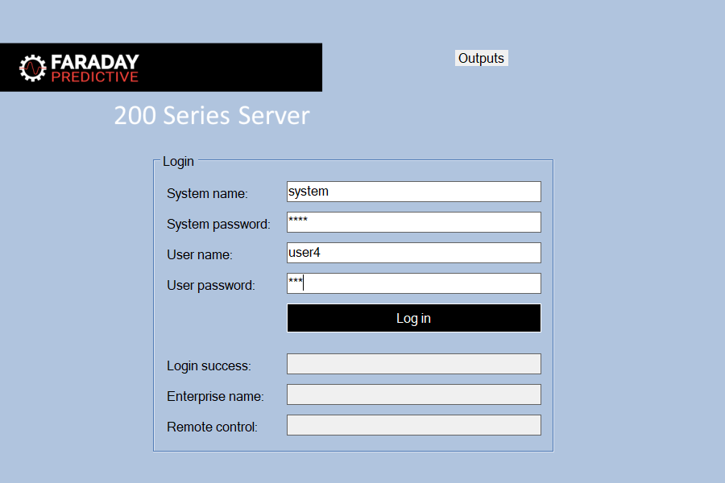

# Login file

During system configuration, Faraday Predictive sets up an encrypted file containing a list of users. Each user has a name and password, and is associated with a specific Enterprise name (so that only devices for that Enterprise will be shown when the user is logged in). Some users are permitted to control devices remotely, and some can only view data. This permission level is also stored in the encrypted logins file.

# Login screen

The user must enter the system password, their user name, and their password. These credentials will all be provided by Faraday Predictive during system configuration. Clicking the login button (or pressing Return) tests these credentials and enters the system if they are valid. System name will usually be “system”, but Faraday Predictive may change this during system configuration.

After login, the user name is presented in the Status Bar. White text indicates that the user has permission for remote control, and yellow text indicates that the user has no permission for remote control:

