Monitor mode

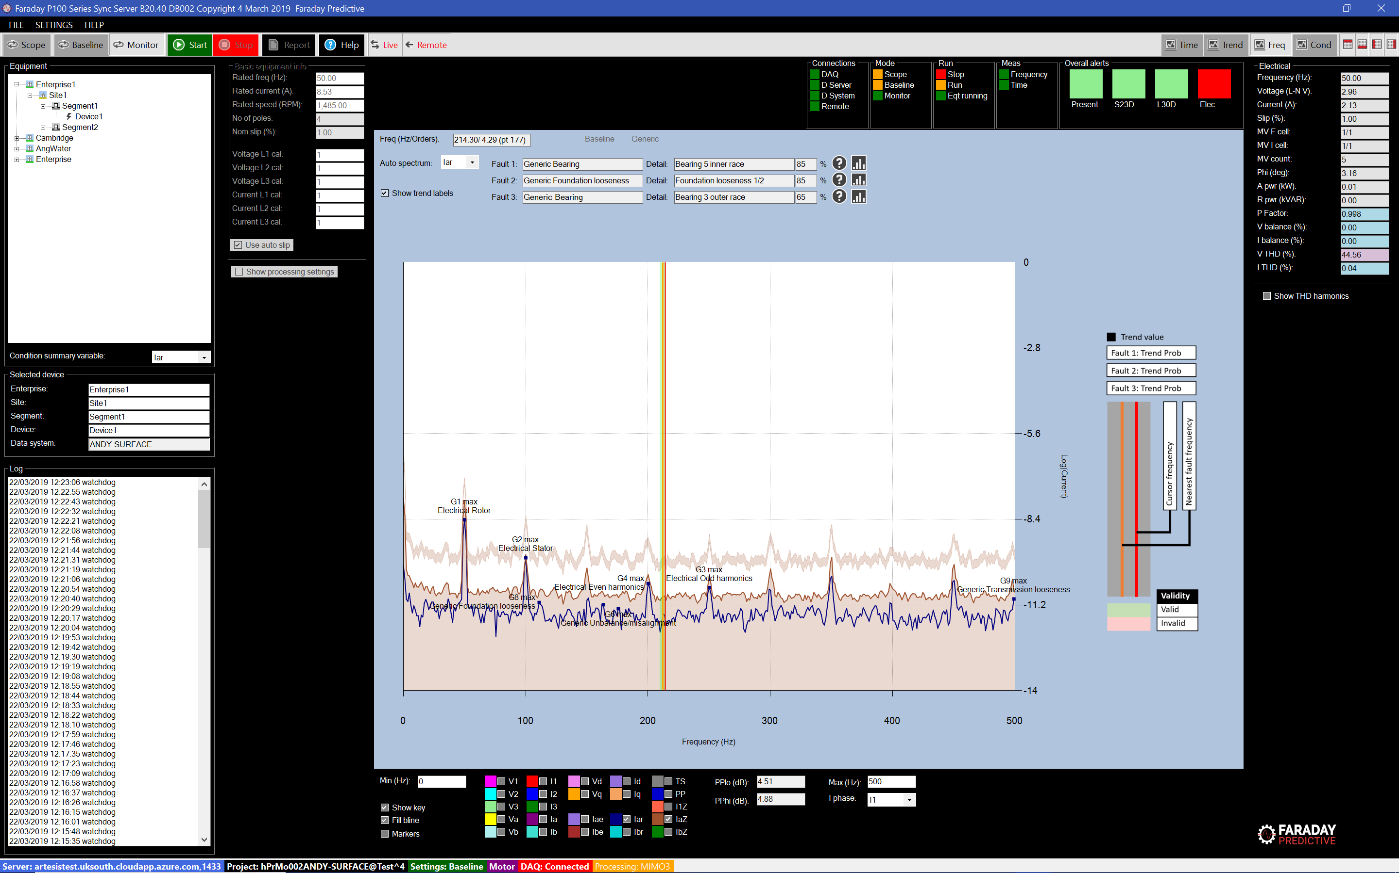

# Mode summary

Monitor mode is used once a baseline (or set of baselines) has been established in Baseline mode. It allows the user to check deterioration of the equipment over time, so that the need and timescale for intervention can be established.

# Operation

The user starts monitoring by selecting Monitor mode and then clicking Start. The system will then continue taking measurements until the user selects Stop, storing data according to the Project Settings form.

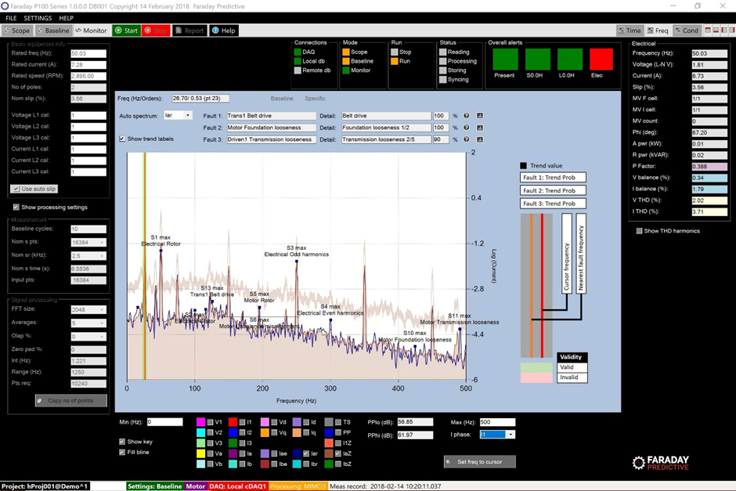

With each new measurement, the system assesses the present condition level of the equipment. This condition level is then shown in the Present traffic light in the Overall Alerts panel below the toolstrip. This indicator shows both level and confidence of condition level, so dark green indicates a high confidence that condition is normal but light green indicates that condition is normal but with reduced confidence (typically as a result of wide measurement variation). Similarly, a warning condition is shown by light or dark orange and alarm by pink or red. So a red alert indicates a clear fault alarm with high confidence and should be investigated further. As the number of stored measurements increases, the system is able to predict the future condition level. These predictions are shown on the S (short term) and L (long term) traffic lights, which also show the time period for which the prediction is valid. A red long term indication gives a clear warning that a fault is predicted for this equipment as much as three months in advance, allowing preventive actions to be taken. The Elect traffic light shows electrical condition, where red indicates that an electrical measurement is abnormally high, orange indicates that an electrical reading is higher than expected but not necessarily abnormal, and green indicates normal operation. Details of specific electrical alerts are shown in the Electrical panel on the right hand side of the display.

Monitor mode can be used with the Frequency chart for detailed review of updating values, or with the Condition chart for a concise overview of developing condition:

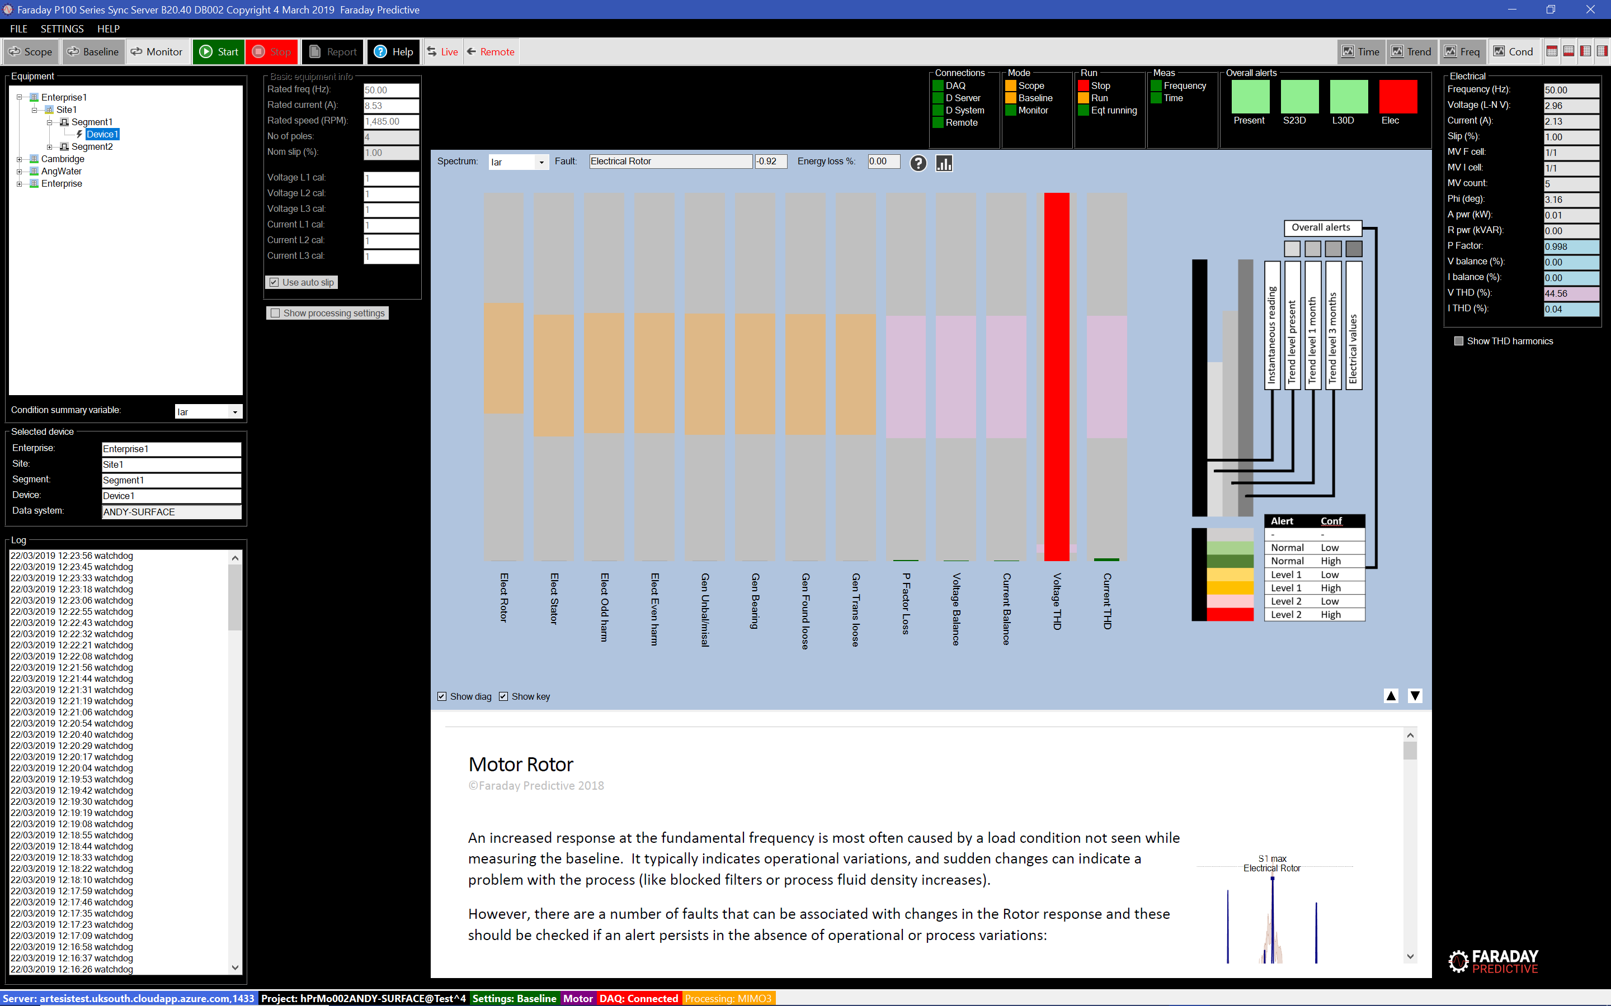

As trends develop during monitoring, the Trend chart can be used to review them over short and long terms:

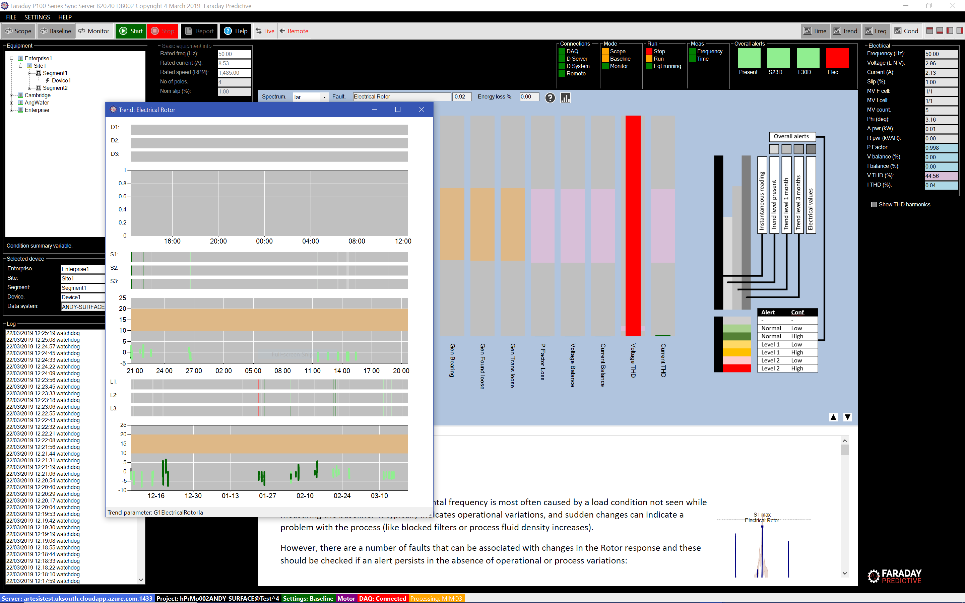

Details about individual faults and recommended actions can be selected by clicking on the information symbol (question mark):

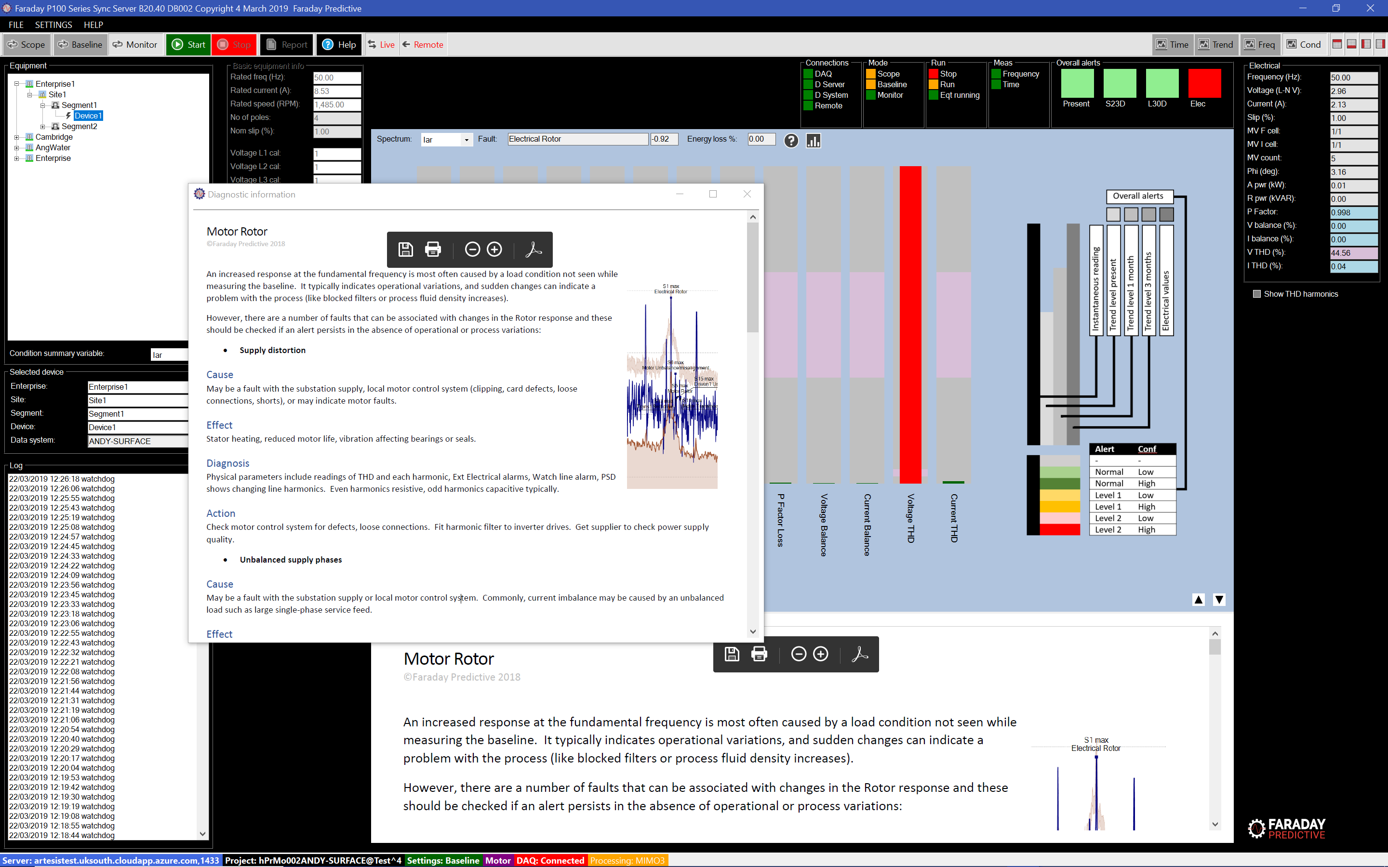

Trends can be examined in greater detail by selected the Trend analysis chart:

