Multivariate settings

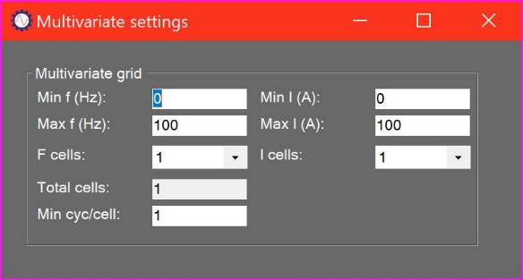

# Settings summary

The P100 Series system is designed to be used with both fixed-speed, single-load machines as well as variable-speed and variable-load machines. Because the response profile of the equipment changes with speed and load it is necessary to set up a number of baselines to handle each range of frequency and current. This greatly improves the accuracy of the system within each range. This process of splitting the operating envelope into a grid of cells defined by frequency and current is known as multivariate processing, and is set up using the Multivariate settings form.

# Defining multivariate grid

The user enters the minimum and maximum frequency and current for the machine, and the number of cells to be used by the system across that range. More cells will increase the accuracy of the system, at the cost of increased storage size and slower performance.

Measurements falling outside the maximum and minimum values are rejected.

The user also enters the minimum number of measurements required to validate each cell. At the end of the Baseline process any cells with a number of cycles below this value will be assigned interpolated baseline values from neighbouring cells.