Reports

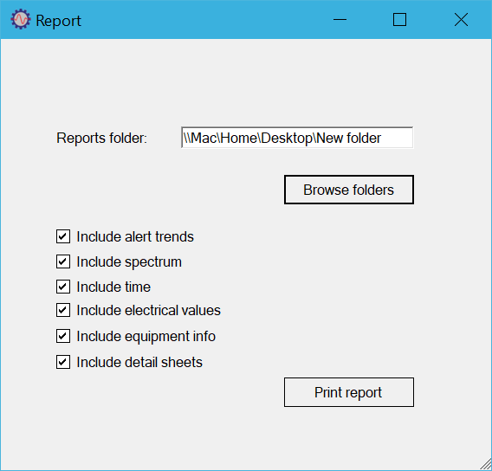

# Reports summary

In Scope mode, the user can produce an automated condition report by pressing the blue Print report button. The report consists of a summary sheet followed by individual fault sheets, one for each identified fault.

The system presents a selection screen where the user can browse to the folder where the report will be stored. At this stage they can also select the content level for the report:

* Include alert trends: If checked, the full set of alert trends is shown, if there is trend data available in the project, i.e. Baseline was created and equipment was monitored.
* Include spectrum: If checked the detailed Spectrum plot is shown, using the same settings as the on-screen Spectrum chart.
* Include time: If checked the Time plot is shown, using the same settings as the on-screen Time chart.
* Include electrical values: If checked the full set of electrical parameters is shown.
* Include equipment info: If checked equipment information is shown in the individual fault sheets.
* Include detail sheets: If checked, diagnostic information is shown in the individual fault sheets.

The report is created in .docx format and can be edited using any application that can read this format (such as Microsoft Word).

