Time chart

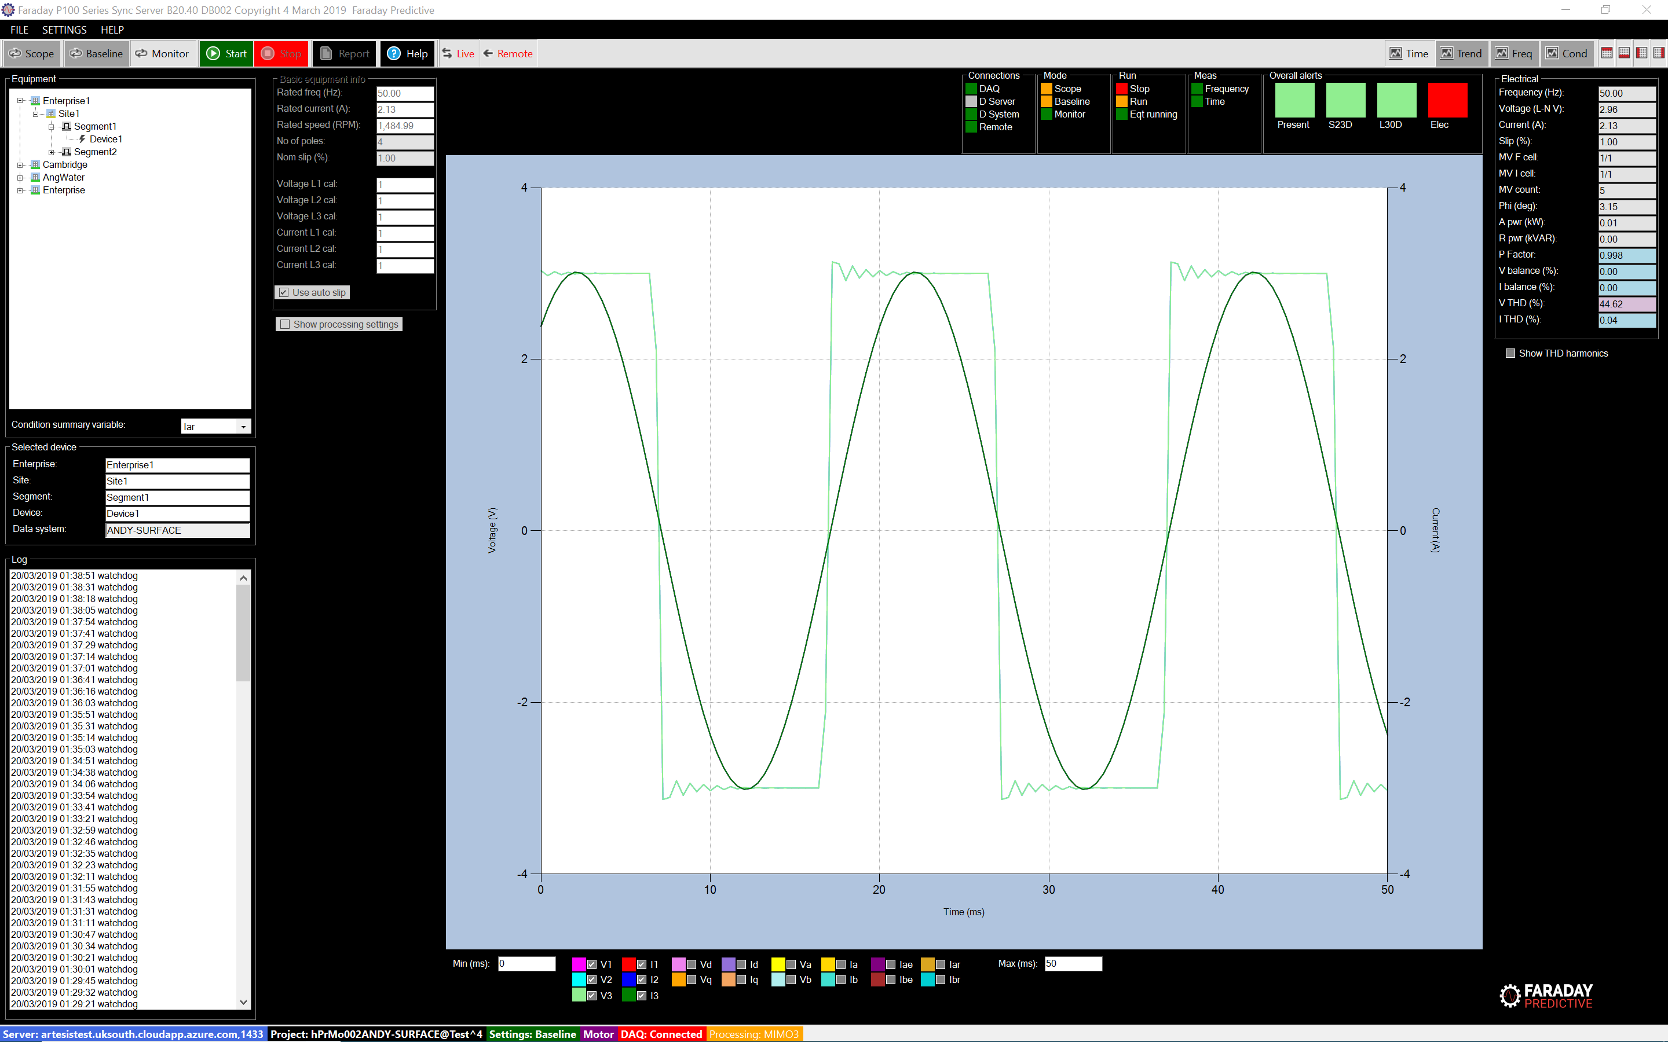

# Chart summary

The Time chart allows the user to plot electrical parameters in the time domain.

# Controls

Minimum and maximum times in milliseconds can be entered in the appropriate text boxes below the chart.

Measured parameters can be selected/deselected for display using checkboxes, and the colour of each plot can be changed by clicking on the colour label for that parameter.

# Axis

The x axis represents time in milliseconds. A 50Hz electrical waveform has a cycle of 1/50Hz = 0.02s. The y axis represents the instantaneous value of the voltage (left hand side) or current (right hand side).

# Parameters

|  |  |  |
| --- | --- | --- |
| Type | Parameter | Description |
| Raw Measurements | V1 | Raw voltages (Phase 1, 2 and 3), with applied analogue (25kHz) and digital (5KHz) low pass filtering. |
| V2 |
| V3 |
| I1 | Raw currents (Phase 1, 2 and 3), with applied analogue (25kHz) and digital (5KHz) low pass filtering. |
| I2 |
| I3 |
| Combined Measurements | Va | Raw voltages and currents in the Alpha-Beta reference frame. They contain the same information than the raw parameters but on a two phase system. |
| Vb |
| Ia |
| Ib |
| Vd | Raw voltages and currents in the Direct-Quadrant reference frame. They contain the same information than the raw parameters but on a two-phase system. This D-Q refence rotates following the line frequency. |
| Vq |
| Id |
| Iq |
| Modelling estimates | Iae | Estimated currents in the Alpha-Beta reference frame after applying the model. |
| Ibe |
| Residual measurements | Iar | Residual currents in the Alpha-Beta reference, calculated as the difference between the Combined measurements minus the modelling estimates. |
| Ibr |

