Trend analysis chart

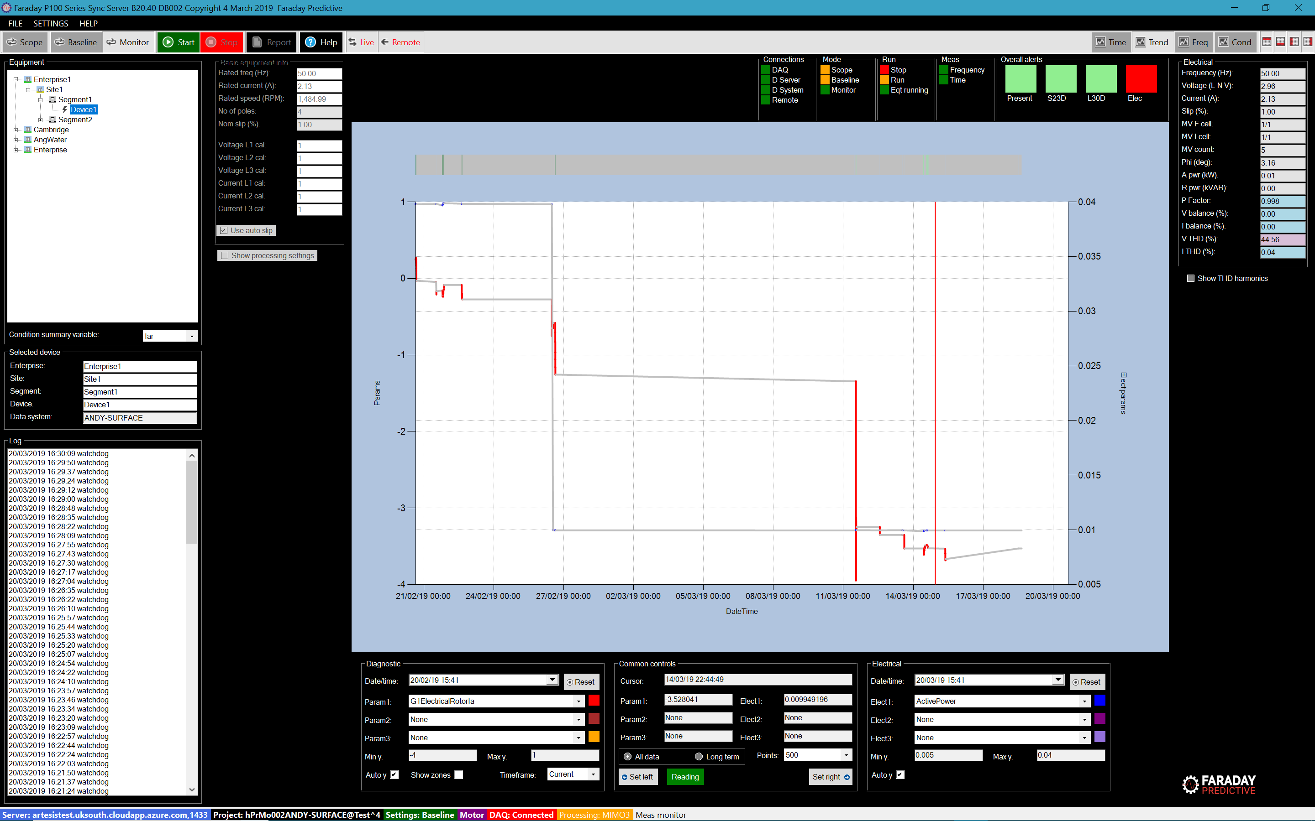

# Chart summary

The Trend analysis chart shows how faults have developed over time. At the top of the chart is a bar showing alarm values over time, and the main chart shows up to three diagnostic parameters and up to three electrical values at the same time. By default, the x-axis covers the time period from 1 month ago to the present time.

# Controls

Controls are grouped into three panels. Common controls cover settings for both diagnostic and electrical measurements, where Diagnostic and Electrical controls are specific to those measurements.

## Common controls

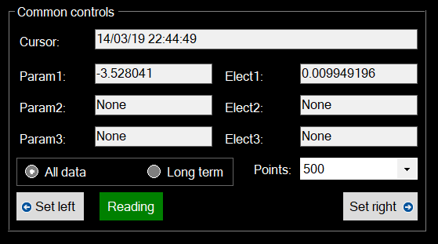

The cursor text box shows the date and time for the present cursor position. Param 1 to 3 and Elect 1 to 3 text boxes show the values of each selected parameter at that date and time.

When new measurements are stored in the database they can be tagged as Long term measurements and are retained preferentially when the size of the database is managed. The All data/Long term radio buttons are used to show either all measurements or just those tagged as Long term, in order to reduce the number of points in the plot. Alternatively, the Points drop down box allows the user to define the number of points in the plot by simple decimation.

The Set left and Set right buttons are used to set the left and right hand date and time limits to the present cursor position:

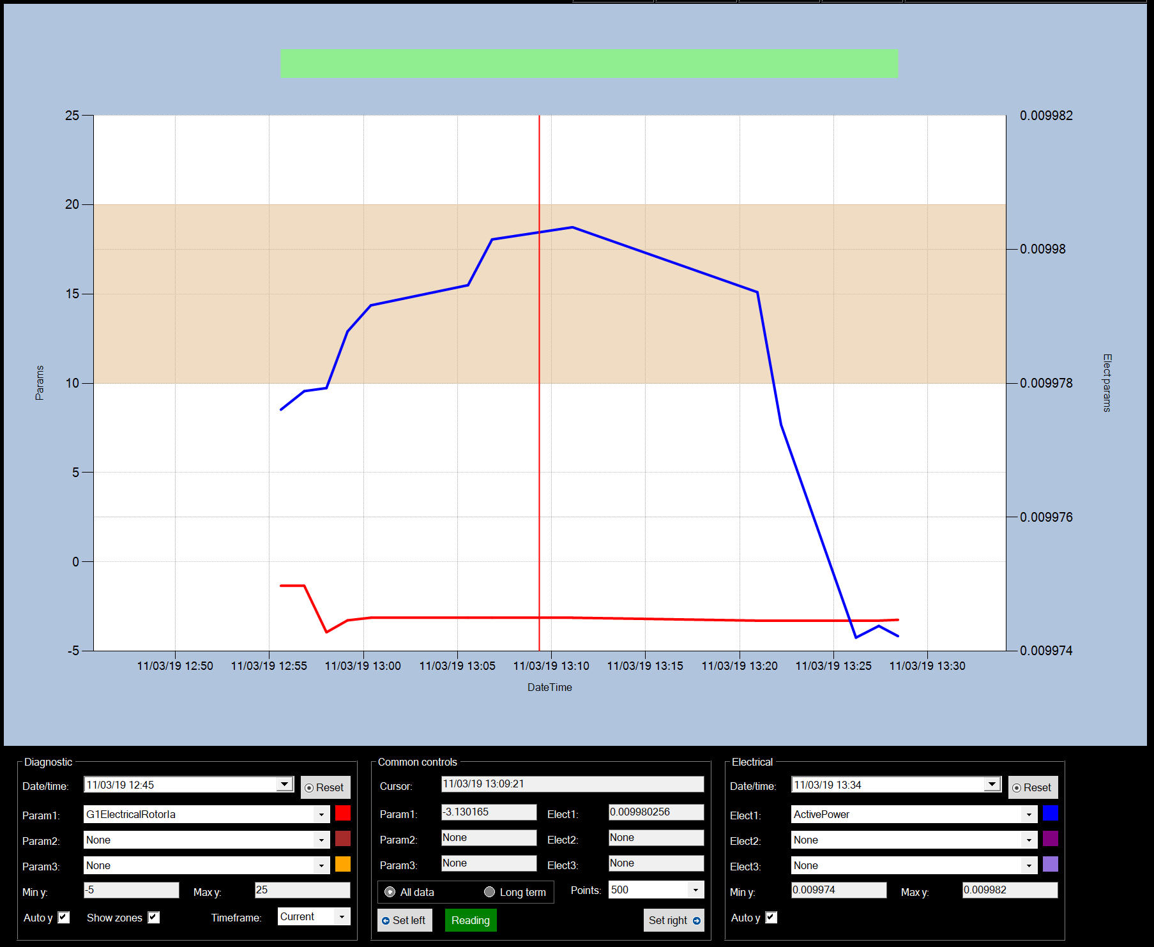

## Diagnostic controls

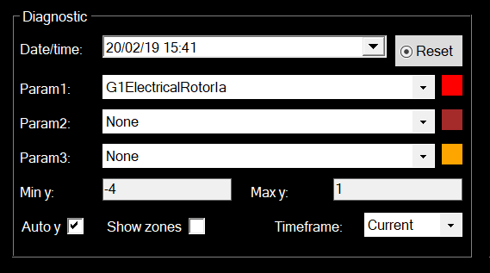

The Date/time text box shows the data and time for the left hand axis, and can be changed by clicking on the down arrow to access the datetime picker. Clicking the Reset button will reset this start date and time to the default (one month before the present date and time).

The Param 1 to 3 drop down boxes allow the user to select the diagnostic parameters to be shown. The colour label next to each of these sets the colour of the trend line.

Maximum and minimum Y values can be set using the Min y and Max y text boxes only if the Auto y check box is unchecked.

The Show zones checkbox will show alarm zones if checked, allowing assessment of fault condition against reference alarm levels:

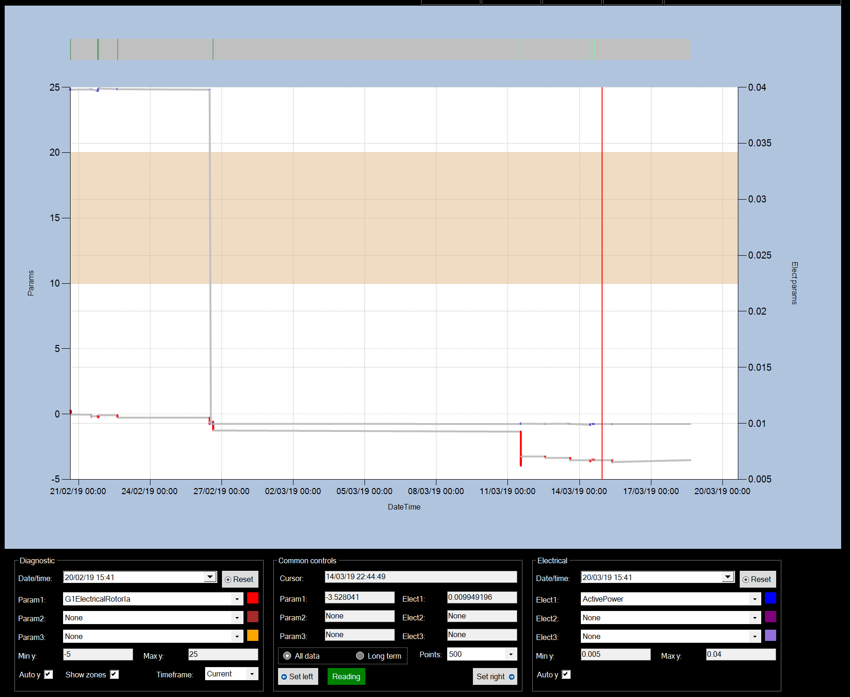

The Timeframe drop down box allows the user to select the type of measurement to be plotted:

Raw shows the instantaneous parameter measurements with no smoothing or extrapolation.

Current shows the smoothed value of the parameter measurement at the indicated measurement date and time, based on the measurements leading up to that date and time.

Short and long show the extrapolated values of the parameter measurements at a future time, where short is up to one month and long is up to three months. This provides a predictive capability allowing the user to assess the future state of each fault type.

## Electrical controls

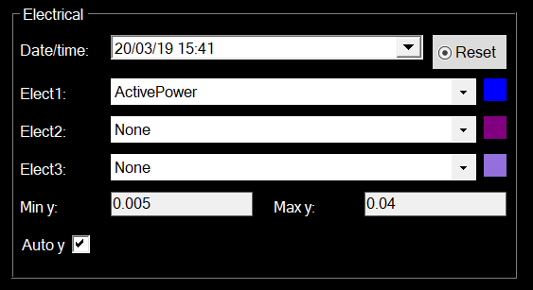

The Date/time text box shows the data and time for the right hand axis, and can be changed by clicking on the down arrow to access the datetime picker. Clicking the Reset button will reset this start date and time to the default (the present date and time).

The Elect 1 to 3 drop down boxes allow the user to select the diagnostic parameters to be shown. The colour label next to each of these sets the colour of the trend line.

Maximum and minimum Y values can be set using the Min y and Max y text boxes only if the Auto y check box is unchecked.