User interface

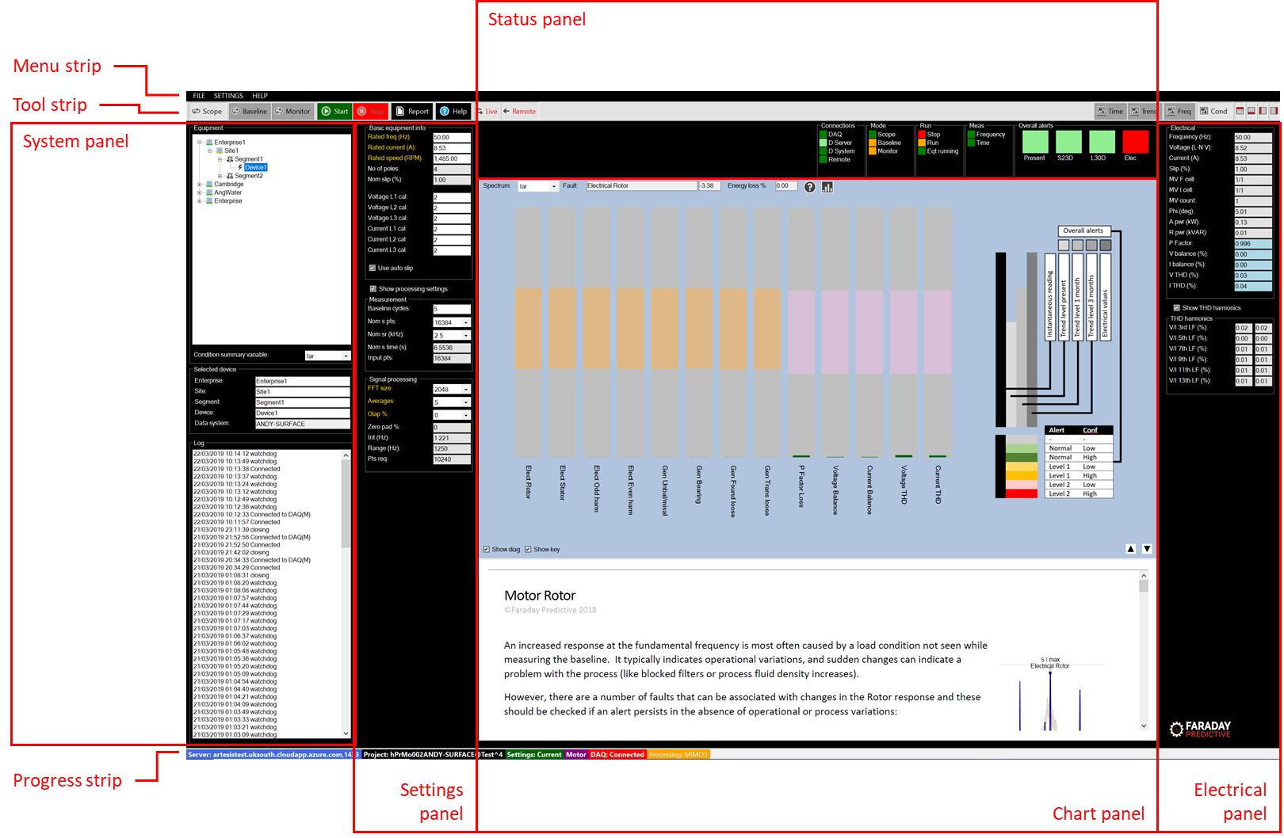

# User interface summary

The user interface consists of a set of elements that are selected for display according to the operating mode and user preference. When the screen resolution of the connected monitor is low, some elements may use scroll bars to fit the whole content onto the screen.

# Menu strip



The menu strip consists of three sets of drop down menus. Unavailable menu options are greyed out.

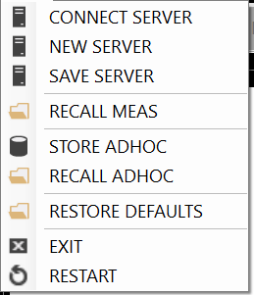

The FILE drop down menu contains the following menu controls:

CONNECT SERVER shows a form that allows the user to connect to a new server using a connection string text file

NEW SERVER shows a form that allows the user to create and save a new connection string text file

SAVE SERVER shows a form that allow the user to save the present server connection details in a new connection string text file

RECALL MEAS shows a form that allows the user to recall stored measurements from the database

STORE ADHOC shows a form that allows the user to store the existing measurement in the database as an adhoc measurement (the same measurement type as used in Scope mode)

RECALL ADHOC shows a form that allows the user to recall stored adhoc measurements

STORE SETTINGS shows a form that allows the user to store the present displayed settings in the database

RESTORE DEFAULTS shows a form that allows the user to restore default values to present displayed values

EXIT closes the application

RESTART restarts the application

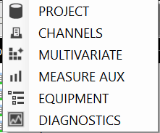

The SETTINGS drop down menu contains the following menu controls:

PROJECT shows a form that allows the user to change to selected project, and to create a new project. It also allows the user to change the storage settings, determining what data is stored in the database

CHANNELS shows a form that allows the user to set up the measurement channels, and to connect to the measurement system

MULTIVARIATE shows a form that allows the user to set up a measurement grid when speed and load are variable

MEASURE AUX shows a form that allows the user to make changes to detailed measurement settings that are normally left at their default values

EQUIPMENT shows a form that allows the user to define the specific equipment from which measurements are being made in order to provide more detailed diagnostics

DIAGNOSTICS shows a form that allows the user to change settings used in the automated diagnosis. These are rarely changed, and changes will required support from Faraday Predictive specialists

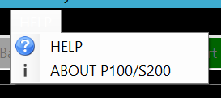

The HELP drop down menu contains the following menu controls:

HELP enters the Help system

ABOUT P100/S200 presents information about the system version

# Tool strip

## Control buttons



The Scope, Baseline, and Monitor buttons set the operating mode of the system

The Start and Stop buttons start and stop measurements in the selected mode

Clicking mode or start/stop buttons cause the system to send a request to the selected device. When this request is sent, the Status panel will update by showing the request in a pale colour. When the request has been carried out by the selected device it will send an acknowledgement to the server and the Status panel will update to confirm that the action has been completed by showing the change in a dark colour.

The Report button shows a form that allows the user to publish a condition assessment report in .docx format

The Help button enters the Help system

The Live button connects the system to the server and updates displays as new measurements are collected by the selected device

The Remote button enables remote control of the selected device

## Display control buttons



The Time, Trend, Freq, and Cond buttons select the chart type

The four right-hand display selectors allow the user to remove interface elements from the screen to simplify presentation, especially on lower-resolution displays

# Status strip



The Status strip shows the following information, from left to right:

User: the current system user name (white shows remote control enabled, yellow not enabled)

Server: the selected server name

Project: the selected project name

Settings: the present settings type

Motor or generator

DAQ: the connected measurement hardware

Processing: the number of input and output channels selected for processing

Record: the source of the data currently presented

# System panel

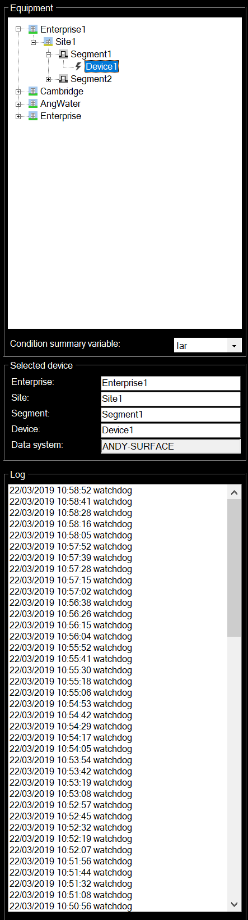

The System panel contains three groups.

## Equipment group

The Equipment group contains a tree view showing all connected devices and their location in the equipment hierarchy (defined by their enterprise, site, and segment names). Branches of the tree view can be expanded or collapsed for clarity. Clicking on any node in the tree view selects that node. If the selected node represents an enterprise, site, or segment then the Condition overview chart is displayed and the display is configured to simplify this summary information. If the selected node represents a device then the Condition chart is displayed and the full range of controls is made available.

The Condition summary variable drop down box allows the user to select the variable type (Ia, Ib, I1) to be used in the Condition overview chart.

## Selected device group

If the selected node is a device, then the Selected device node shows the enterprise, site, and segment names for that device. If remote control has been selected, these names can be changed in this group. The Data system name is the internal name of the device (set up during initial system configuration) and cannot be changed.

## Log group

The Log group contains a Log list box that updates continuously when synchronisation has been selected. Entries in the Log list box are copied from the selected device Log during the synchronisation cycle. This allows the user to monitor changes occurring on the selected device.

# Settings panel

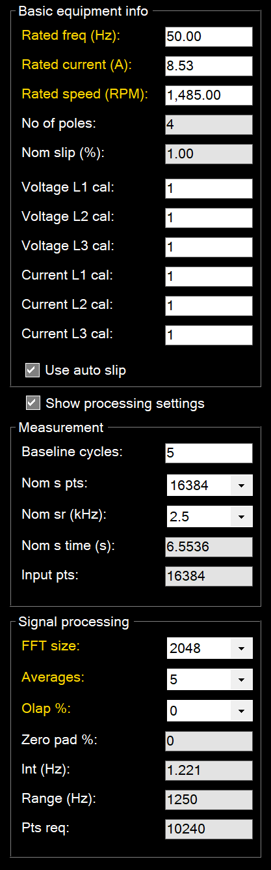

The Settings panel contains basic equipment information (the settings most commonly requiring changing when starting a new project). Additional settings can be shown by checking the Show processing settings checkbox.

# Status panel

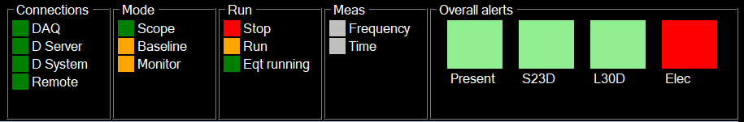

The status panel contains four groups of status lights, and the overall alerts panel.

## Connections

The Connections group indicates all system connections:

DAQ indicates connection to the measurement system

D Server flashes to show the connection cycle to the server when Live is selected

D System indicates the connection status of the selected device (where red indicates not connected and green indicates connected)

Remote indicates whether remote control is active when synchronisation is selected

## Mode

The Mode group indicates the selected operating mode

## Run

The Run group indicates whether measurements are being taken or not, and also whether the connected equipment is running

## Meas

The Meas group indicates whether the present measurement is selected for storage of frequency or time data

## Status

The Status group indicates the progress of the measurement cycle

## Overall alerts

The Overall alerts group show overall equipment condition:

Present: the present alert status, where light green indicates no alert with low confidence, dark green indicates no alert with high confidence, light orange indicates alert with low confidence, dark orange indicates alert with high confidence, pink indicates alarm with low confidence, and red indicates alarm with high confidence

S: the short term alert status (up to one month, where the timeframe is shown in the alert label). This alert is predicted from stored measurements and indicates the future alert status for the equipment with the same colour coding as present alerts

L: the long term alert status (up to three months, where the timeframe is shown in the alert label). This alert is predicted from stored measurements and indicates the future alert status for the equipment with the same colour coding as present alerts

Elec: the present electrical alert status, where green indicates no alert, orange indicates alert, and red indicates alarm

# Chart panel

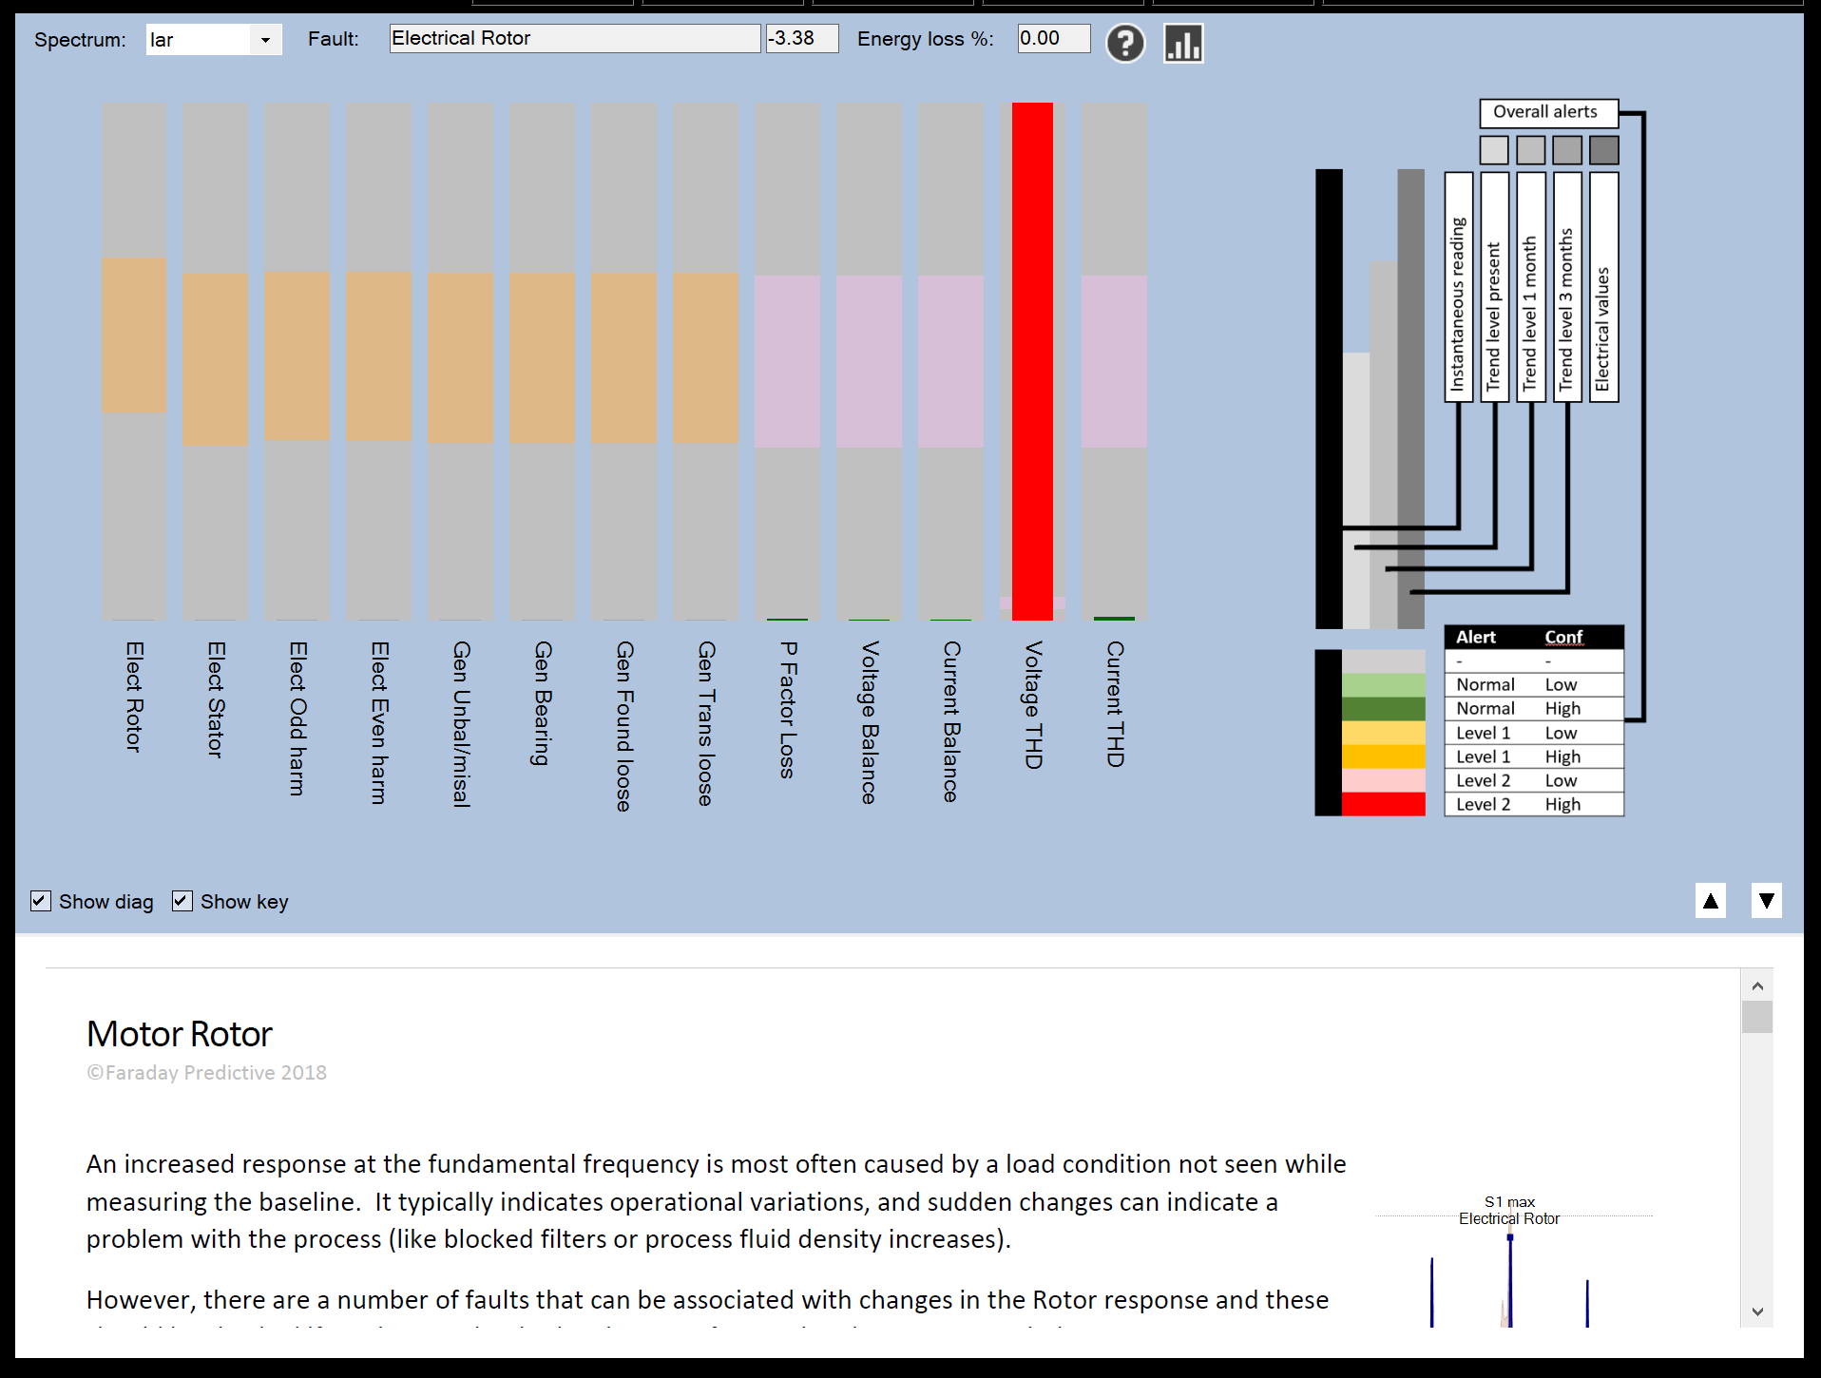

The Chart panel shows the chart type selected using the Chart buttons in the Tool strip.

# Electrical panel

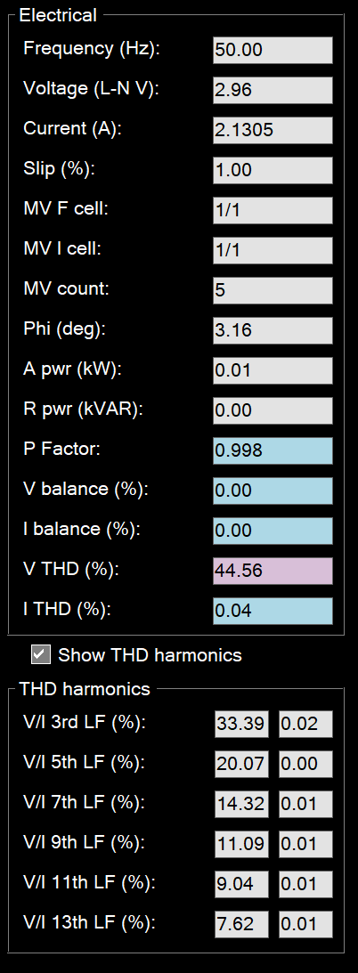

The Electrical panel shows the complete set of electrical readings, with alert colours for parameters included in the Electrical overall alert assessment. If PROCESSING has been selected in the SETTINGS menu, this panel is replaced with the Processing panel.