Trend chart

# Chart summary

The Trend chart is used to track changes in fault levels (bands) over time.

# Structure

There are three parts to each Trend chart:

* Top: Last 24 hours (but never longer than the timespan of available trend data)
* Mid: Short-term (up to 1 month but never longer than the timespan of available trend data)
* Bottom: Long-term (up to 3 months but never longer than the timespan of available trend data)

Each of these consists of three bars and one plot. The bars present the overall alert status for the equipment being monitored:

* Present alert status bar chart
* Short-term predicted alert status bar chart (up to 1 month but never longer than the timespan of available trend data)
* Long-term predicted alert status bar chart (up to 3 months but never longer than the timespan of available trend data)

The plot shows the instantaneous values for the selected band. The colour of the trend shows the Band alert status at the time the point was created. This is the same colour found at the Condition chart present value bar (at the RHS of the instantaneous value – black bar). Please not this colour is different from the Overall Alert status which refers to the whole equipment, considering all band alert status.

The orange stripe (plot background) represents the range between 10 and 20 standard deviations. Above this range, the instantaneous value is high. For the Band alert status to become high as well, the past data points average value must be high as well.

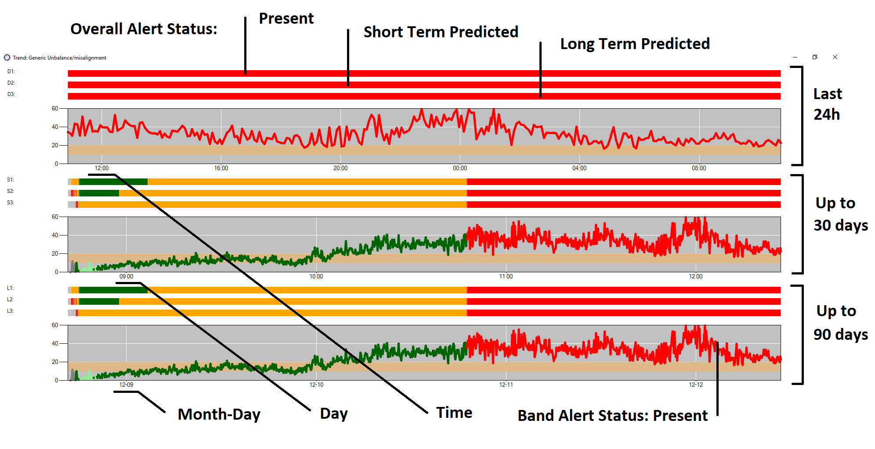

The colour of the trend at a point is the same as the colour of the 2nd bar (Trend Level present). This is calculated as a regression, and the level that reaches at that point sets the colour.

The third and fourth bars are the Short term and Long term status (predicted)

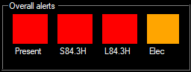

Colour codes:

