User interface

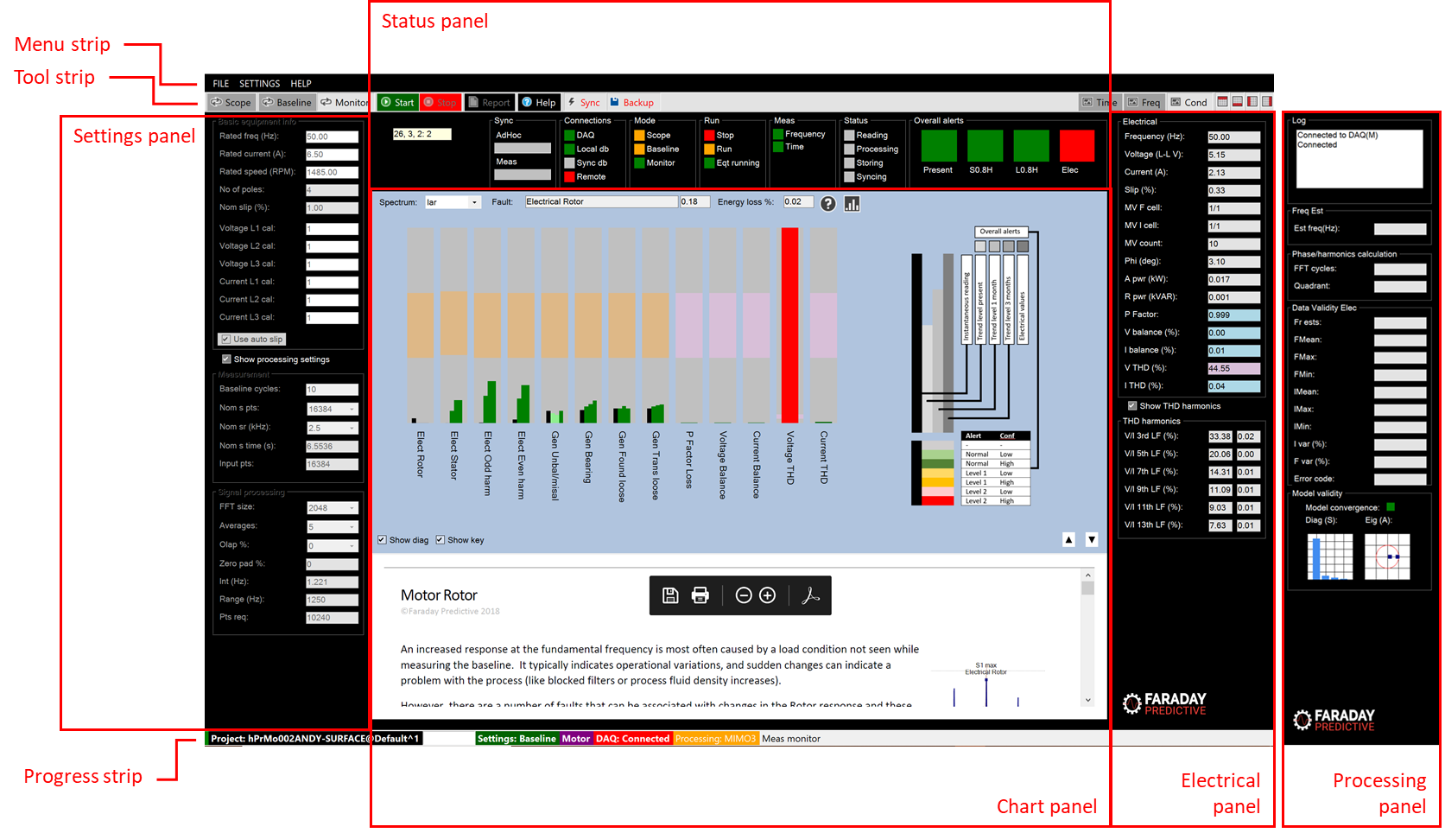

# User interface summary

The user interface consists of a set of elements that are selected for display according to the operating mode and user preference. When the screen resolution of the connected monitor is low, some elements may use scroll bars to fit the whole content onto the screen.

# Menu strip



The menu strip consists of three sets of drop down menus. Unavailable menu options are greyed out.

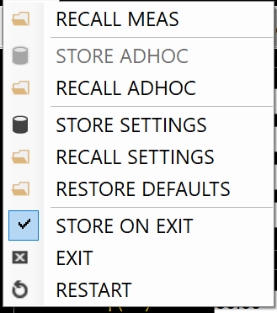

The FILE drop down menu contains the following menu controls:

RECALL MEAS shows a form that allows the user to recall stored measurements from the database

STORE ADHOC shows a form that allows the user to store the existing measurement in the database as an adhoc measurement (the same measurement type as used in Scope mode)

RECALL ADHOC shows a form that allows the user to recall stored adhoc measurements

STORE SETTINGS shows a form that allows the user to store the present displayed settings in the database

RECALL SETTINGS shows a form that allows the user to recall a set of stored settings to the user interface

RESTORE DEFAULTS shows a form that allows the user to restore default values to present displayed values

STORE ON EXIT if checked, will store the present displayed settings in the database when closing the application

EXIT closes the application

RESTART restarts the application

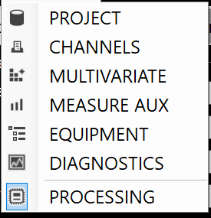

The SETTINGS drop down menu contains the following menu controls:

PROJECT shows a form that allows the user to change to selected project, and to create a new project. It also allows the user to change the storage settings, determining what data is stored in the database

CHANNELS shows a form that allows the user to set up the measurement channels, and to connect to the measurement system

MULTIVARIATE shows a form that allows the user to set up a measurement grid when speed and load are variable

MEASURE AUX shows a form that allows the user to make changes to detailed measurement settings that are normally left at their default values

EQUIPMENT shows a form that allows the user to define the specific equipment from which measurements are being made in order to provide more detailed diagnostics

DIAGNOSTICS shows a form that allows the user to change settings used in the automated diagnosis. These are rarely changed, and changes will required support from Faraday Predictive specialists

PROCESSING replaces the Electrical panel with the Processing panel for troubleshooting

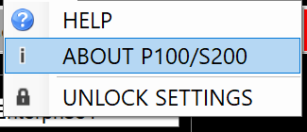

The HELP drop down menu contains the following menu controls:

HELP enters the Help system

ABOUT P100/S200 presents information about the system version

UNLOCK SETTINGS allows the user to unlock all controls for troubleshooting

# Tool strip

## Control buttons

cid:image001.png@01D54160.B192EE40

The Scope, Baseline, and Monitor buttons set the operating mode of the system

The Start and Stop buttons start and stop measurements in the selected mode

The Report button shows a form that allows the user to publish a condition assessment report in .docx format

The Help button enters the Help system

The Sync button turns synchronisation on and off to allow the system to back up data to a remote database and support remote control from that server

The Backup button turns local database backup on and off. When set to on, the system automatically backs up all databases to the default SQL Server backup location. If any database is then damaged, the system will attempt to restore it from the backup. These backups can also be copied from the device to the server for manual replication when a remote connection is not available and synchronisation is not possible.

## Display control buttons

cid:image001.png@01D4E02A.A1727C70

The Time, Freq, and Cond buttons select the chart type

The four right-hand display selectors allow the user to remove interface elements from the screen to simplify presentation, especially on lower-resolution displays

# Progress strip

cid:image001.png@01D4E02A.CC24D080

The Progress strip shows the following information, from left to right:

Project: the selected project name and a progress bar showing % full

Settings: the present settings type

Motor or generator

DAQ: the connected measurement hardware

Processing: the number of input and output channels selected for processing

Record: the source of the data currently presented

# Settings panel

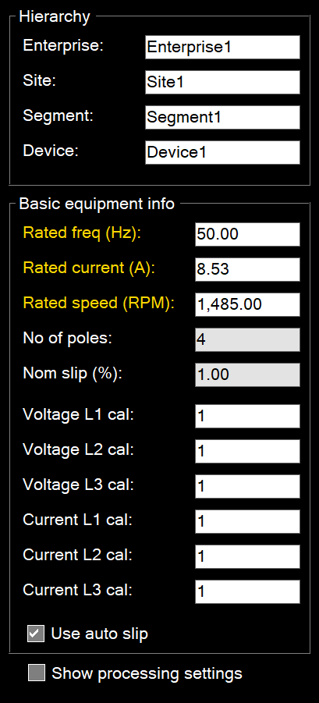

The Settings panel contains the Hierarchy settings and basic equipment information (the settings most commonly requiring changing when starting a new project). Additional settings can be shown by checking the Show processing settings checkbox, in which case the Hierarchy settings are removed to simplify the panel.

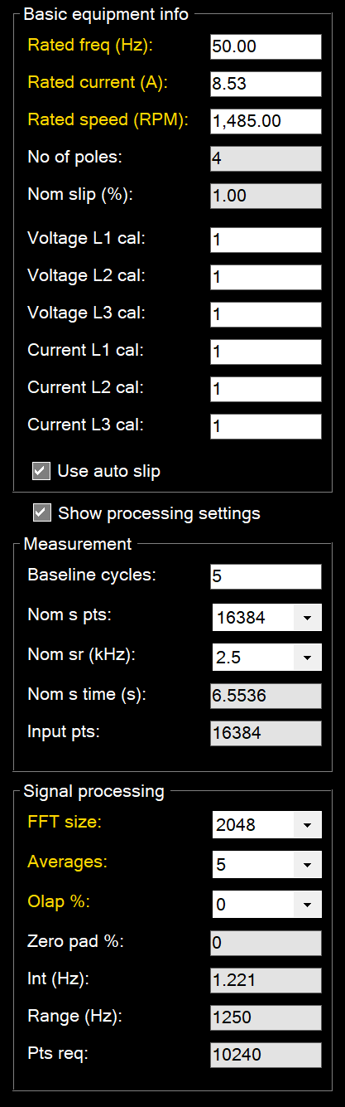

# Status panel

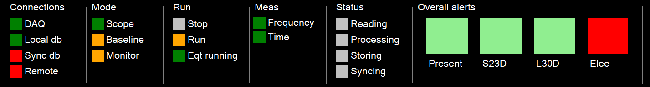

The status panel contains four groups of status lights, and the overall alerts panel.

## Connections

The Connections group indicates all system connections:

DAQ indicates connection to the measurement system

Local db indicates connection to the local database

Sync db flashes to show the connection cycle to the remote database when synchronisation is selected

Remote indicates whether remote control is active when synchronisation is selected

## Mode

The Mode group indicates the selected operating mode

## Run

The Run group indicates whether measurements are being taken or not, and also whether the connected equipment is running

## Meas

The Meas group indicates whether the present measurement is selected for storage of frequency or time data

## Status

The Status group indicates the progress of the measurement cycle

## Overall alerts

The Overall alerts group show overall equipment condition:

Present: the present alert status, where light green indicates no alert with low confidence, dark green indicates no alert with high confidence, light orange indicates alert with low confidence, dark orange indicates alert with high confidence, pink indicates alarm with low confidence, and red indicates alarm with high confidence

S: the short term alert status (up to one month, where the timeframe is shown in the alert label). This alert is predicted from stored measurements and indicates the future alert status for the equipment with the same colour coding as present alerts

L: the long term alert status (up to three months, where the timeframe is shown in the alert label). This alert is predicted from stored measurements and indicates the future alert status for the equipment with the same colour coding as present alerts

Elec: the present electrical alert status, where green indicates no alert, orange indicates alert, and red indicates alarm

# Chart panel

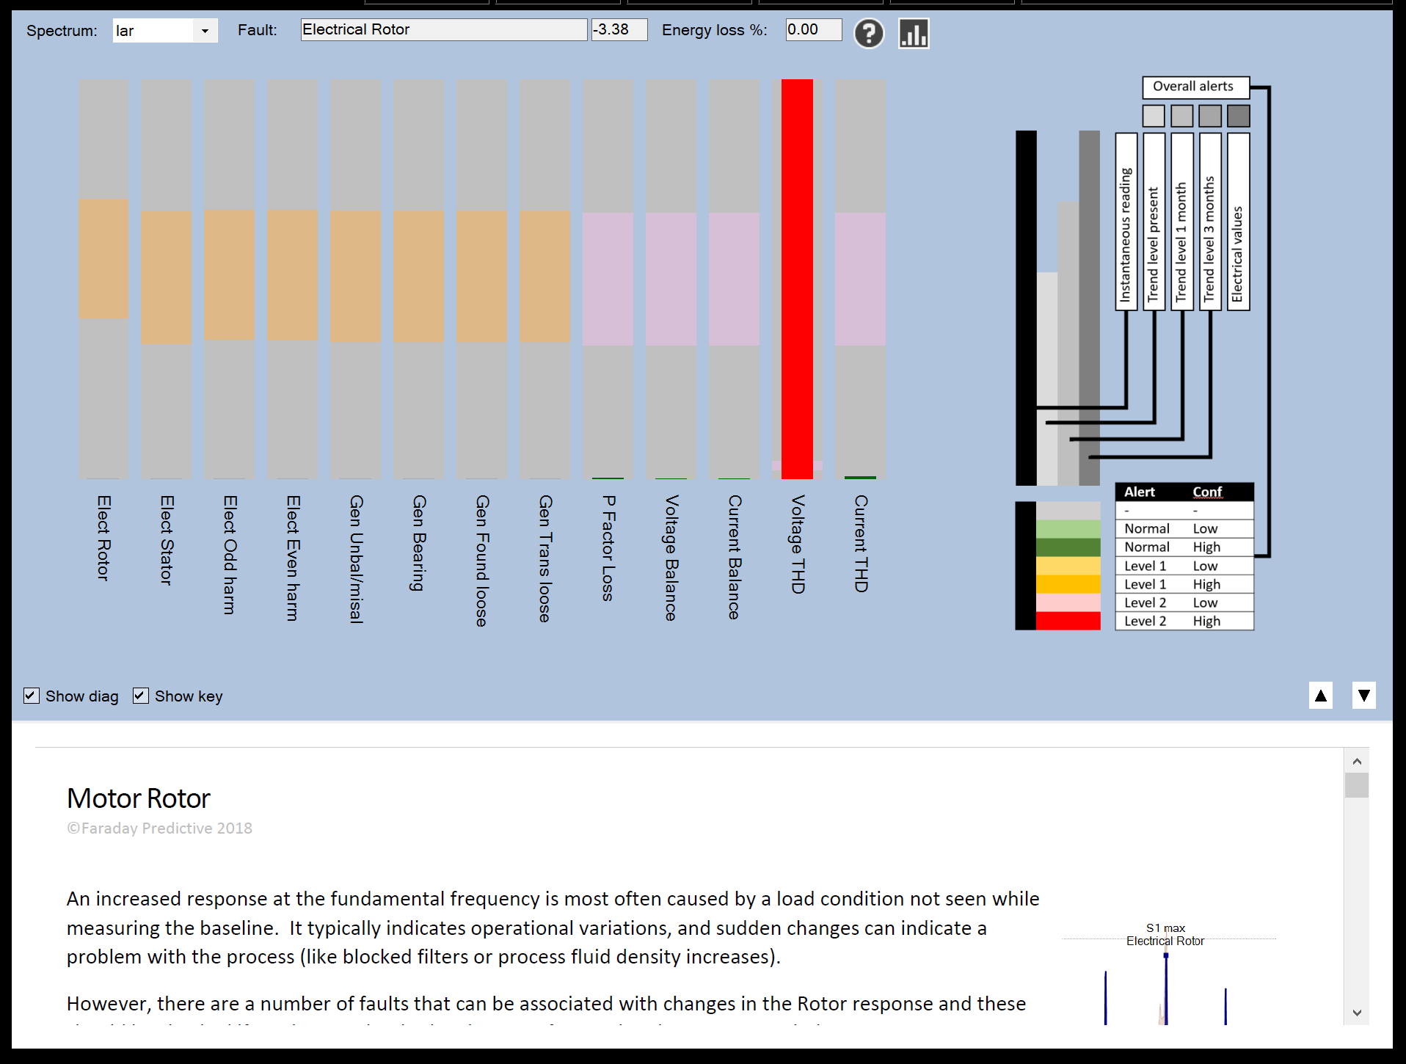

The Chart panel shows the chart type selected using the Chart buttons in the Tool strip.

# Electrical panel

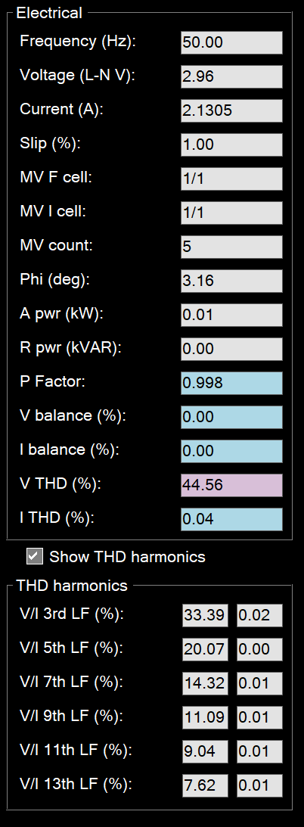

The Electrical panel shows the complete set of electrical readings, with alert colours for parameters included in the Electrical overall alert assessment. If PROCESSING has been selected in the SETTINGS menu, this panel is replaced with the Processing panel.

# Processing panel

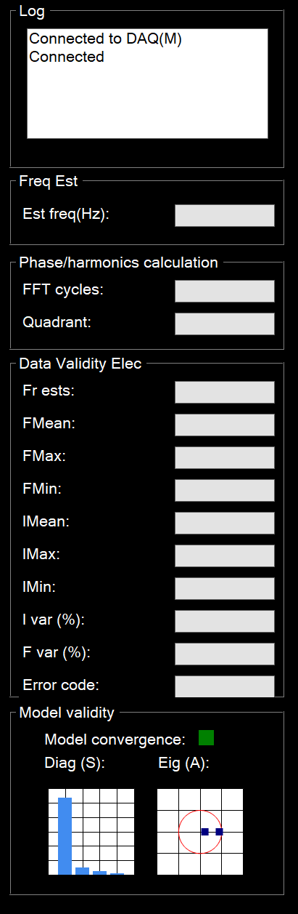

The Processing panel contains five groups of parameters that are typically used for troubleshooting:

Log: contains a running record of the actions taken by the system, as well as any errors generated during processing. If there is a problem, the log is the best place to assess it and find a correction.

Freq est: shows the line frequency calculated by the system

Phase/harmonics calculation: shows the number of processing cycles used in the electrical processing, and the quadrant calculated for the electrical results

Data validity: shows internal variables set during processing for troubleshooting. The Error codes text box is most commonly useful for checking any measurement or processing errors

Model validity: shows internal variables set during modelling for troubleshooting