Watchdog

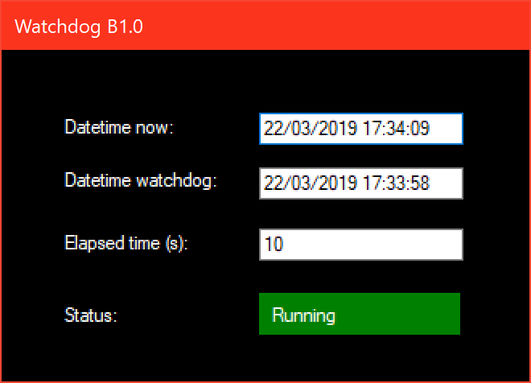

When Synchronisation is on, the system launches a watchdog application to monitor operation of the main application. If the Watchdog detects that the main application is no longer responding it will present a warning message and restart the operating system. The Watchdog application should not be stopped by the user since this would prevent its task monitoring function.