Questionnaire Item has 2 fields for questionnaire conditional branching: enableWhen, enableBehavior.

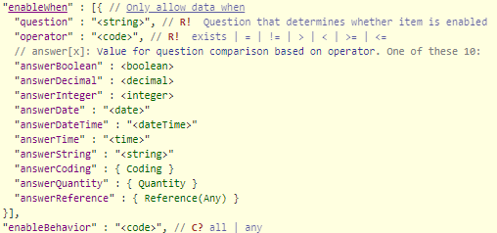

enableWhen code: 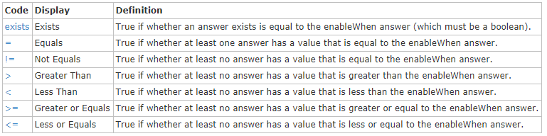

enableBehavior code:

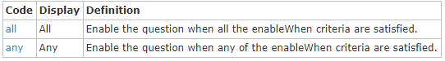

There are no fields in the Questionnaire Response Item matched to this logic.

One of possible profit libraries is json-logic-js <https://www.npmjs.com/package/json-logic-js>

Function apply take string value as operator, operands in json format and return result according to the operation.