**Practical-4**

**Aim: Introduction of Docker set-up and study of basic docker commands**

Setting up Docker on a Linux system and learning some basic Docker commands is a valuable skill for containerization and managing software applications. Perform the following tasks:

**Task 1: Install the Docker Command Line Interface Tool from:**

https://docs.docker.com/desktop/

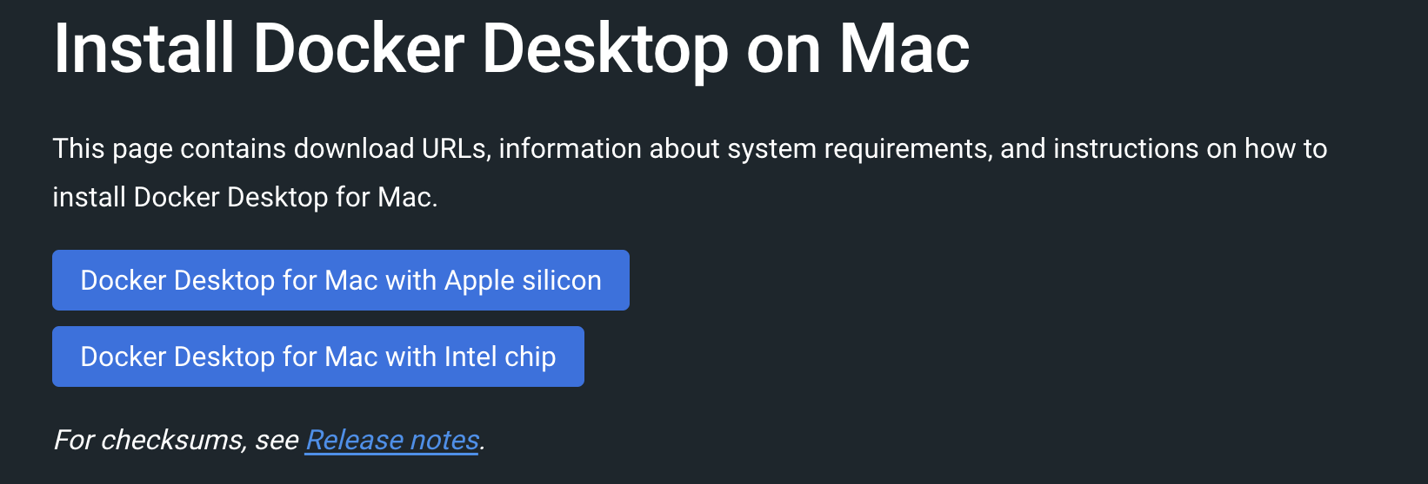

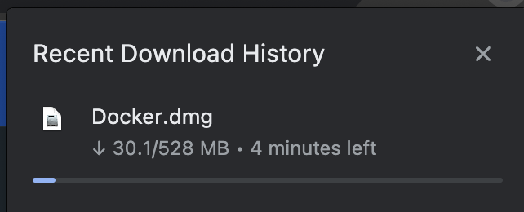

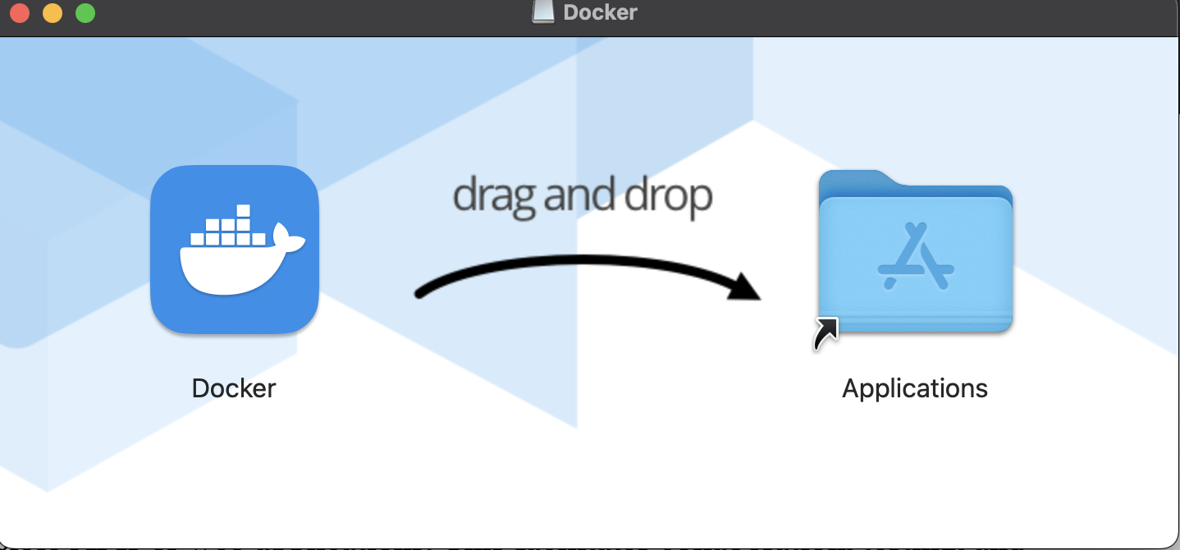

**Docker Desktop**

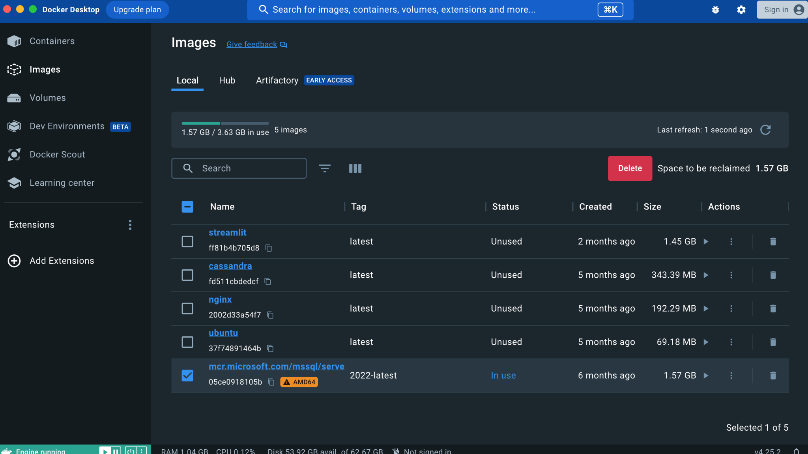

**Task 2: Hands-on on docker commands:**

* Execute the different docker commands to work pull the image from the docker hub and run the image in your local system.
* Commands to run the container with the name of your choice

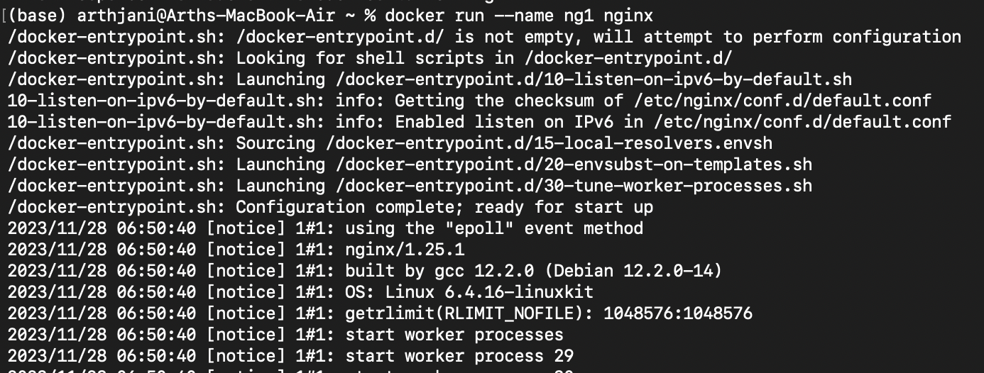

* Command to list all the images and containers

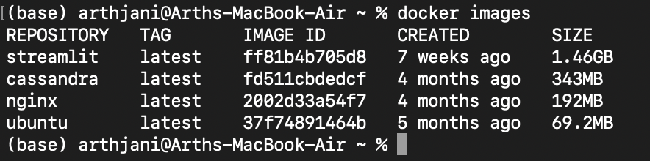

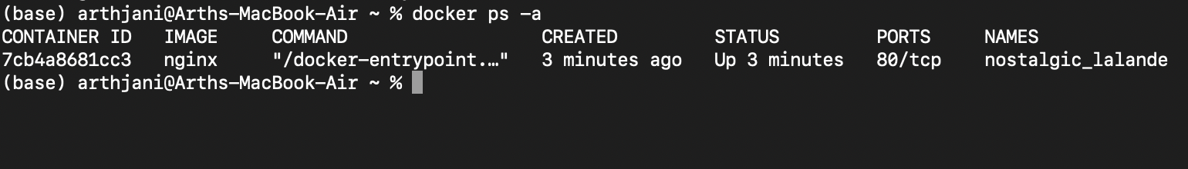

* Command to delete the specified image and containers 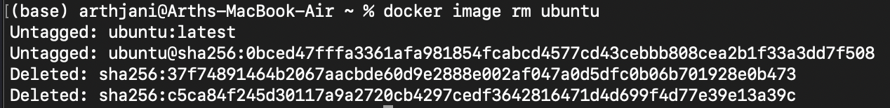



* Delete all the containers