Contents
Organization 2
Application 4
Deployment 5
Zero-Downtime Password Rotation 6
Well Architected Framework 6

Organization
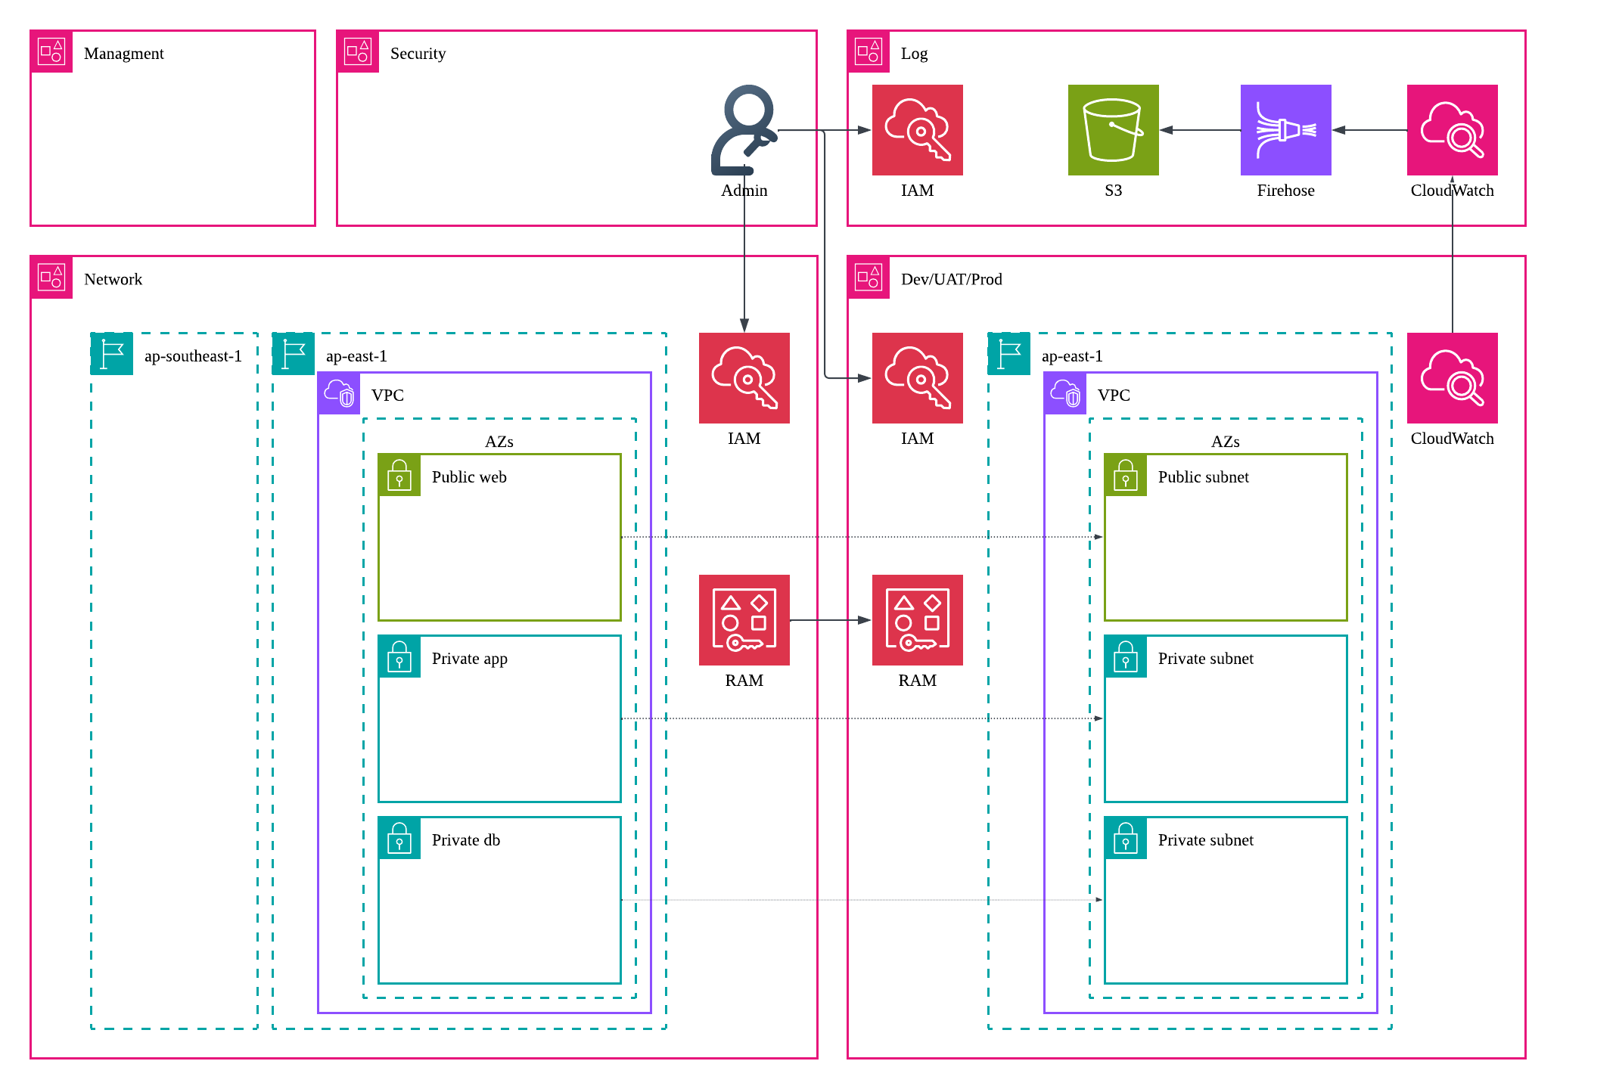
Account Topology
- Security Account: Centralizes security management where security administrators create, maintain, and govern IAM roles and policies for all member accounts.
- Log Account: Serves as an isolated central repository for storing and archiving audit logs from all organization accounts to ensure compliance.
- Network Account: Infrastructure-focused account that hosts centralized network resources, and sharing them with workload accounts via Resource Access Manager (RAM).
- Dev Account: Environment dedicated to rapid application prototyping, testing, and initial integration phases.
- UAT Account: Staging environment designed for user validation and final quality assurance.
- Prod Account: Mission-critical environment restricted to hosting live, customer-facing applications and highly secure workloads.

Team responsibility
- Security Team
- IAM Governance: Provisions and audits all cross-account IAM roles and policies.
- Least Privilege: Configures tailored, minimal-privilege permissions for the IAM roles used by Terraform deployment pipelines.
- Guardrails: Enforce permission boundaries on role creation in Terraform deployment pipelines to prevent other teams from escalating their own privileges
- Network Team
- Core Infrastructure: Provisions and maintains foundational networking components, including VPCs, NAT gateways, security groups, and route tables.
- Private Connectivity: Manages centralized Private Link VPC endpoints to secure communications with AWS services.
- Resource Sharing: Uses AWS RAM to share subnets and security groups securely down to the Dev, UAT, and Prod workload accounts
- Platform Team
- Building Foundation: Configures and maintains foundational application infrastructure shared across multiple development teams.
- Core Services: Operates critical global and regional resources, including Cognito, CloudFront, Lambda functions, Application Load Balancers, ECS Clusters, and DocumentDB Clusters.
- Service Team
- Microservice Lifecycle: Owns the application code, task definitions, and service configurations within ECS.
- Deployment Automation: Designs and manages the continuous delivery pipelines using CodeDeploy to execute blue-green deployments.

Application
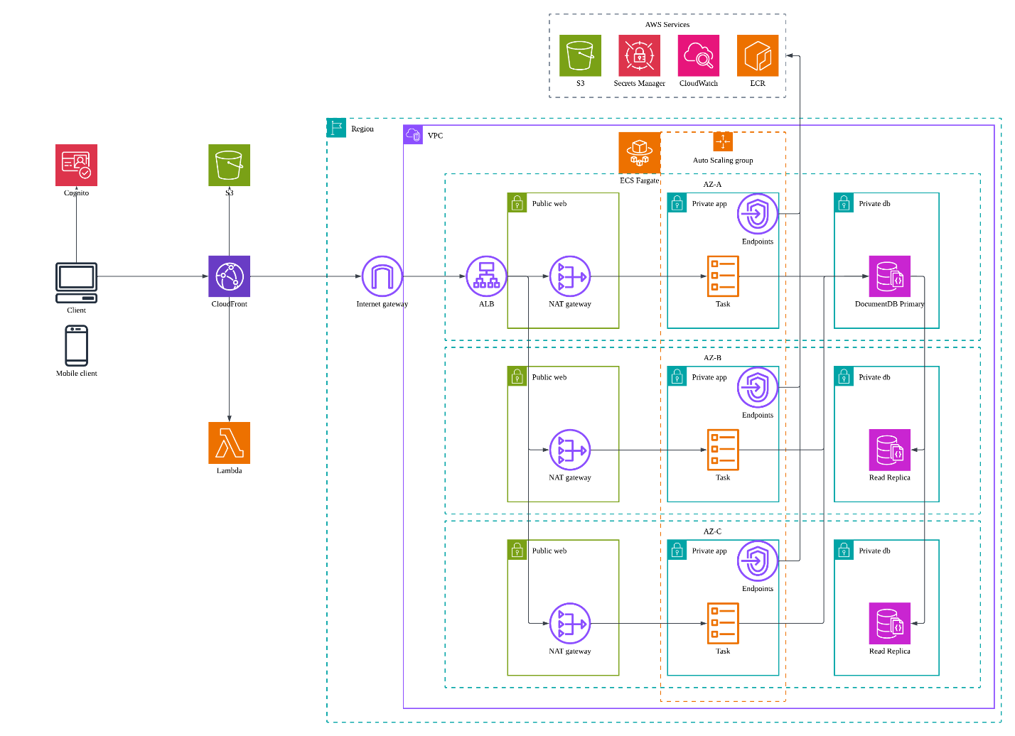
- Authentication & Identity Management: Users authenticate using Google Identity Provider (IdP) via Cognito User Pool. Cognito issues JSON Web Tokens (JWTs) to manage user sessions securely.
- Content Delivery & Request Routing: CloudFront distribution acts as the single entry point. It routes traffic based on path patterns: static web assets are served from an S3 origin, while dynamic API traffic passes to an Application Load Balancer (ALB).
- Edge Validation & Authorization: Lambda@Edge function intercepts incoming API requests to validate the Cognito-issued JWT. Upon successful verification, it extracts and injects the User ID into the request headers for downstream processing.
- Scalable Microservices Architecture: Backend microservices run on AWS Fargate within Amazon Elastic Container Service (ECS). Fargate tasks auto-scale dynamically based on target tracking policies (CPU/Memory utilization) to handle fluctuating workloads.
- Managed Document Database: Application data is hosted in a fully managed DocumentDB (with MongoDB compatibility) cluster. The cluster uses a multi-Availability Zone (Multi-AZ) architecture to ensure high availability and automatic failover.
- End-to-End Observability: Distributed application tracing and performance monitoring are implemented using the AWS Distro for OpenTelemetry (ADOT). ADOT collects and sends telemetry data to X-Ray and CloudWatch for deep observability.
- Secure Private Connection: All internal traffic stays off the public internet. The microservices communicate with S3, CloudWatch, Secrets Manager, and Amazon ECR exclusively via PrivateLink VPC Endpoints.

Deployment
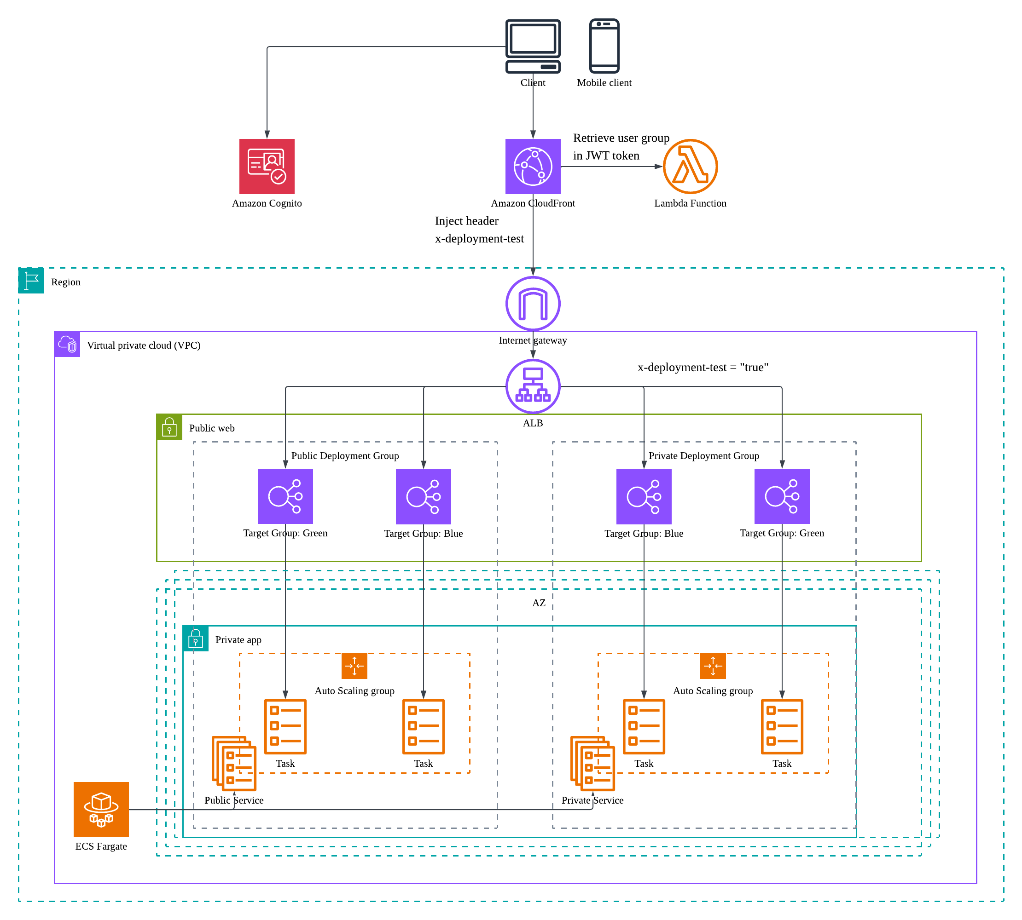
- Dual-Environment: Each microservice maintains two distinct ECS services running simultaneously within the cluster. One service is designated for general public traffic, while the other is isolated for pilot testing.
- Identity-Based Classification: Internal users are assigned to a dedicated tester group within the Cognito user pool.
- Traffic Tagging: Lambda@Edge function inspects the user's Cognito group claims during token validation. If the user belongs to the tester group, the function dynamically injects a “x-deployment-test” custom header into the request.
- Conditional Routing: Application Load Balancer (ALB) uses a pair of listener rules to evaluate incoming request headers. Requests containing the x-deployment-test header are forwarded to the pilot target group, while all other traffic defaults to the public target group
- Release Promotion: Following successful verification in the pilot environment, the release image is promoted to the public environment by switching the target groups in the listener rule pairs.
- Blue-Green Deployments: Both the public and pilot ECS services utilize CodeDeploy to perform automated blue-green deployments. This ensures deployments to either environment supports automatic rollback capabilities.

Zero-Downtime Password Rotation
- Automated Rotation Schedule: Secrets Manager is configured to auto-rotate database credentials every 3 months
- Dynamic Secret Retrieval: Microservice pulls database credential from Secrets Manager instead of relying on static configuration.
- Proactive Monitoring: Microservice use a background polling mechanism to detect database credential updates without manual intervention.
- Graceful Connection Refresh: Upon detecting a new secret version, the microservice initializes a new database connection pool using the updated credentials.
- Traffic Migration: Inbound transactions seamlessly transition to the new connection, eliminating the need for application restarts.

Well Architected Framework
Security
- Security team centralizes IAM management, enforcing strict privilege separation across network, platform, and service teams.
- Guardrails are applied to all Terraform templates to prevent teams from expanding their own privileges during role creation
- Isolated IAM roles are provisioned for Hong Kong and Singapore to eliminate accidental cross-region infrastructure access.
- Centralized log archive, with security guardrails to prevent log deletion
- Data stored in S3 and DocumentDB is secured by KMS customer-managed keys.
- App and Database subnets remain completely private, utilizing NAT gateways for secure outbound connections.
- Individual security groups are assigned to isolate each tier, explicitly controlling traffic flowing between subnets.
- Traffic destined for S3, CloudWatch, Secrets Manager, and ECR bypasses the public internet entirely via gateway endpoints and interface endpoints.
- Lambda@Edge blocks unauthorized or unauthenticated requests at the cloud edge before they consume network bandwidth and computation resources.
- Application Load Balancer strictly drops traffic lacking the valid CloudFront custom secret header and filters direct-to-IP traffic.
- CloudFront sanitizes incoming requests and forces the X-User-Id downstream, eliminating insecure direct object reference (IDOR) attempts.
- Database credentials and Google OAuth keys are managed with Secrets Manager, with scheduled rotation when applicable .

Reliability
- Core compute, and networking infrastructure are mirrored across separate Availability Zones to withstand data center failures.
- Multiple NAT Gateways are deployed across AZs in production to prevent single-point-of-failure.
- VPC interface endpoints are mapped across multiple subnets for high availability.
- Container tasks are configured with health checks under ECS Fargate, driving rapid, automated replacements upon task failures.
- DocumentDB clusters span across three AZs, offering rapid failovers alongside automated backup snapshots to meet RPO/RTO goals.

Performance Efficiency
- CloudFront sits in front of S3, routing static assets directly from edge locations to minimize global latency
- Moving JWT token validation to Lambda@Edge frees up backend computational resources
- Microservices deployed with containerization that can scale out independently.
- Fargate service configured with target tracking auto-scaling rules, reacting to unpredictable consumer demand.

Operational Excellence
- Parameter-driven Terraform modules enable predictable infrastructure deployments in new regions.
- Application connection pool to refresh database connection details during disaster recovery and password rotation
- X-Ray combined with ADOT offers pinpoint tracking across microservices and database.
- CodeDeploy handles Blue-green deployment to ensure safe production deployments with fully automated rollback triggers.
- Public-pilot setting to allow end-to-end production testing before production swaps.

Cost Optimization
- Non-production environments (Dev and UAT) share an overarching VPC network across to avoid redundant network infrastructure fees.
- Non-production environments run on single NAT gateway and single-subnet VPC interface endpoints for cost saving.
- Using VPC interface endpoints eliminates expensive NAT data processing fees.
- Event bridge schedule completely shut down DocumentDB instances during evening and weekend periods.
- ECS Fargate is scheduled to scale back task counts during evening and weekend periods.
- Standardized project and environment tags enables tracking resource consumption in Cost Explorer.

Sustainability
- Local caching on CloudFront decreases the physical distance data travels across networks, shrinking total energy footprints.
- Shifting tasks to serverless ECS Fargate matches resource allocation to exact consumption, driving up host machine utilization rates.

