**SMART PUBLIC RESTROOM**

**INTRODUCTION**  
 A **public toilet**, **restroom** ([American English](https://en.wikipedia.org/wiki/American_English)), **public bathroom** or **washroom** is a room or small building with [toilets](https://en.wikipedia.org/wiki/Toilet) (or [urinals](https://en.wikipedia.org/wiki/Urinal)) and [sinks](https://en.wikipedia.org/wiki/Sink) for use by the general public. The facilities are available to customers, travelers, employees of a business, school pupils and prisoners and are commonly [separated into male and female toilets](https://en.wikipedia.org/wiki/Sex_segregation), although [some are unisex](https://en.wikipedia.org/wiki/Unisex_public_toilet), especially for small or single-occupancy public toilets, [public toilets are accessible](https://en.wikipedia.org/wiki/Accessible_toilet) to people with disabilities. Depending on the culture, there may be varying degrees of separation between males and females and different levels of privacy. Typically, the entire room, or a stall or cubicle containing a toilet, is lockable. [Urinals](https://en.wikipedia.org/wiki/Urinals), if present in a male toilet, are typically mounted on a wall with or without a divider between them. [Local authorities](https://en.wikipedia.org/wiki/Local_authority) or commercial businesses may provide public toilet facilities. Some are unattended while others are staffed by an [attendant](https://en.wikipedia.org/wiki/Bathroom_attendant). In many cultures, it is customary to tip the attendant, especially if they provide a specific service, such as might be the case at upscale nightclubs or restaurants.

Public toilets are typically found in many different places: inner-city locations, offices, factories, schools, universities and other places of work and study. Similarly, museums, cinemas, bars, restaurants, entertainment venues usually provide public toilets. Railway stations, filling stations, and long distance [public transport](https://en.wikipedia.org/wiki/Public_transport) vehicles such as [trains](https://en.wikipedia.org/wiki/Train_toilet), ferries, and [planes](https://en.wikipedia.org/wiki/Aircraft_toilet) usually provide toilets for general use. [Portable toilets](https://en.wikipedia.org/wiki/Portable_toilet) are often available at large outdoor events.

Public toilets may be municipally owned or managed and entered directly from the street. Or they may be within a building that, while privately owned, allows public access, such as a department store, or it may be limited to the business's customers, such as a restaurant. Some public toilets are free of charge while others charge a fee. In the latter case they are also called [pay toilets](https://en.wikipedia.org/wiki/Pay_toilet) and sometimes have a charging [turnstile](https://en.wikipedia.org/wiki/Turnstile). In the most basic form, a public toilet may just be a street urinal known as a [*pissoir*](https://en.wikipedia.org/wiki/Pissoir), after the French term.

Public toilets are known by many other names depending on the country. Examples are: restroom, bathroom, men's room, women's room, powder room in the US, washroom in Canada, and toilets, lavatories, water closet (W.C.), ladies and gents in Europe.

**OBJECTIVES**

**IMPROVED HYGIENE**

Say good bye to unsanitary restrooms! Smart toilets utilize self-cleaning technology and touchless operation to minimize contact with germs. With integrated UV sterilization and anti bacterial surface,this toilets ensure a safer and health their restroom experience for everyone

**ENHANCED ACCESSIBILITY**

Smart toilets are designed with universal accessibility in mind. Featuring adjustable heights,handrail support and braille instructions, this facilities categories to individuals with it diverse needs. By promoting inclusivity smart toilets are transforming public restroom into welcoming space for everyone.

**WATER CONSERVATION**

Smart toilets are champions of water conservation.With intelligent flush mechanism and water saving mode, these toilets reduce water consumption without compromising cleanliness.By embracing sustainable practice,smart toilets contribute to a greener future.

**PURPOSES**

As an "away-from-home" [toilet room](https://en.wikipedia.org/wiki/Toilet_(room)), a public toilet can provide far more than access to the [toilet](https://en.wikipedia.org/wiki/Toilet) for [urination](https://en.wikipedia.org/wiki/Urination) and [defecation](https://en.wikipedia.org/wiki/Defecation). People also [wash their hands](https://en.wikipedia.org/wiki/Hand_washing), use the mirrors for grooming, get [drinking water](https://en.wikipedia.org/wiki/Drinking_water) (e.g. refilling water bottles), attend to [menstrual hygiene](https://en.wikipedia.org/wiki/Menstrual_hygiene_day) needs, and use the waste bins. Public toilets may also become places for harassment of others or illegal activities, particularly if principles of [Crime prevention through environmental design](https://en.wikipedia.org/wiki/Crime_prevention_through_environmental_design) (CPTED) are not applied in the design of the facility.

# **Restroom Requirements for Commercial Establishments**

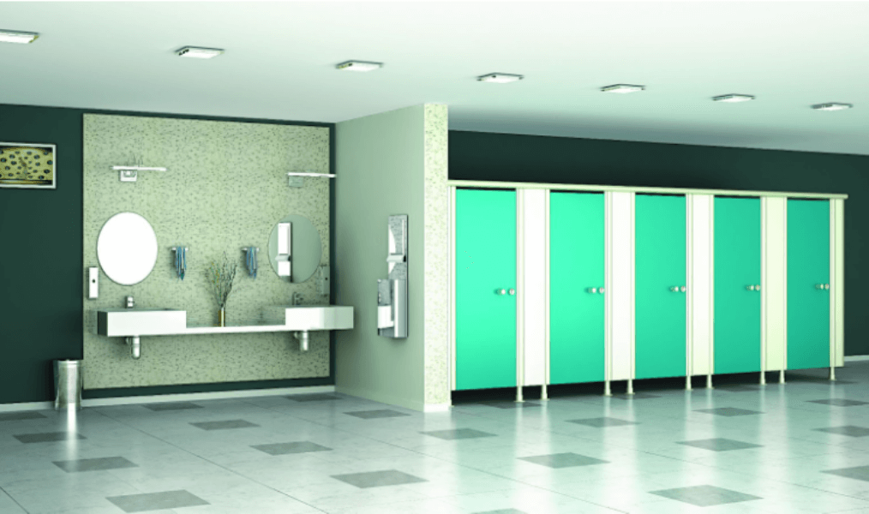

Are you in charge of running a commercial facility? If your answer is a ‘yes’, it goes without saying that you would need to adhere to legal commercial facility requirements and provide a pleasant experience to employees and guests. Following the stipulated sanitation and safety requirements not only saves you from legal trouble, it also goes a long way in deciding the reputation of your establishment. Continuing on the subject, in this blog post, we take a closer look at the [restroom](https://www.greenlamsturdo.com/) requirements for commercial establishments.

## COMMERCIAL RESTROOM REQUIREMENTS

The first step to creating a restroom that complies with regulations and standards is creating a building plan that takes this into account. Before you create a design layout, you first need to figure out how many toilets you should have, what the sanitation standards are, what is the expected number of users, and other similar factors. Let’s address one concern at a time.

Guidelines dictate a different number of required [public toilets](https://www.greenlamsturdo.com/), depending on the expected number of users. If the number is less than 15, a single toilet cubicle per gender bathroom will suffice. If the number goes over 35, you’ll have to have at least three [**toilet cubicles**](https://www.greenlamsturdo.com/restroom-cubicles) per gender.

Overall, multiple toilet cubicles are preferred over single-occupant restrooms. This is mainly due to the fact that single restroom facilities reduce access to restroom facilities, especially during heavy traffic. Additionally, single-occupant restrooms seem to result in lower user satisfaction.

If you want your restroom to comply with all regulations, being inclusive is a must. For specially abled users, a lack of appropriate facilities can be a matter of concern. It is therefore advisable to have at least one stall for the specially abled and seniors.

When it comes to [commercial restrooms](https://www.greenlamsturdo.com/), you need to ensure that your facilities are clean and that you are providing the necessary tools to maintain hygiene. This means having at least one designated space for handwashing and storage space for cleaning equipment.

In addition, when several people use the same bathroom facilities, diseases can be spread easily. For this reason, it is vital that you strictly follow sanitation regulations.

**PROJECT ANALYSIS**

Smart toilet restroom are one of the latest innovations in public restrooms. These smart toilets are equipped with sensors that can detect when someone is approaching. Prompting them to automatically open the toilet seat and flush the toilet after use. In addition to improving user comfort and convenience, these features help to keep the restroom clean and sanitary by reducing the amount of bacteria spread by people’s hands.

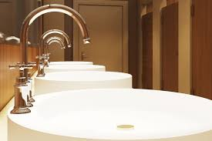

Toilet systems for towns and communal areas, motorway services and industry / trade / transport - we have exactly the right solution for everyone’s individual requirements: made-to-measure toilet facilities. The toilets can be free-standing or integrated into a building, you can have one or multiple cubicles, and opt for a fully automated, self-cleaning toilet system or use our cleaning service. You can make the most of our wide range of products and put together your toilet system on a modular basis.

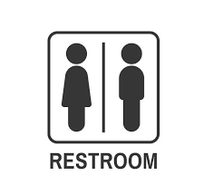 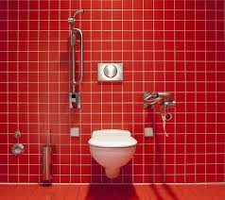

**DESIGN ARCHITECTURE**

Modern public toilets may be designed with a labyrinth entrance (doorless entry), which prevents the spread of disease that might otherwise occur when coming in contact with a door. Doorless entry provides visual privacy while simultaneously offering a measure of security by allowing the passage of sound. Doorless entry also helps deter vandalism; fewer audible clues to another person entering discourages some vandals. Doorless entry may also be achieved simply by keeping an existing door propped open, closed only when necessary.

People often expect a high level of privacy when using public toilets. Privacy expectations may include toilet cubicles, cubicle doors, urinal partitions and similar.

The [World Health Organization](https://en.wikipedia.org/wiki/World_Health_Organization) states that toilets should be "suitable, private and safe to use for all intended users, taking into consideration their gender, age and physical mobility (e.g. disabled, sick etc.)" and "All shared or public toilets should have doors that can be locked from the inside, and lights".

Sensor-operated fixtures (faucets, soap dispensers, hand dryers, paper towel dispensers) prevent the spread of disease by allowing patrons to circumvent the need to touch common surfaces. Sensor-operated toilets also help conserve water by limiting the amount used per flush, and require less routine maintenance. Each sensor views through a small window into each fixture. Sometimes the metal plates that house the sensor windows are bolted on from behind, to prevent tampering. Additionally, all of the electrical equipment is safely behind the walls, so that there is no danger of electric shock. However, a [residual-current device](https://en.wikipedia.org/wiki/Residual-current_device) must be used for all such electrical equipment.

Some public toilets have an automatic sensor-controlled flushing system that flushes the toilet when the user steps away from the sensor. They might also have an additional button that the user can push to provide a second flush.

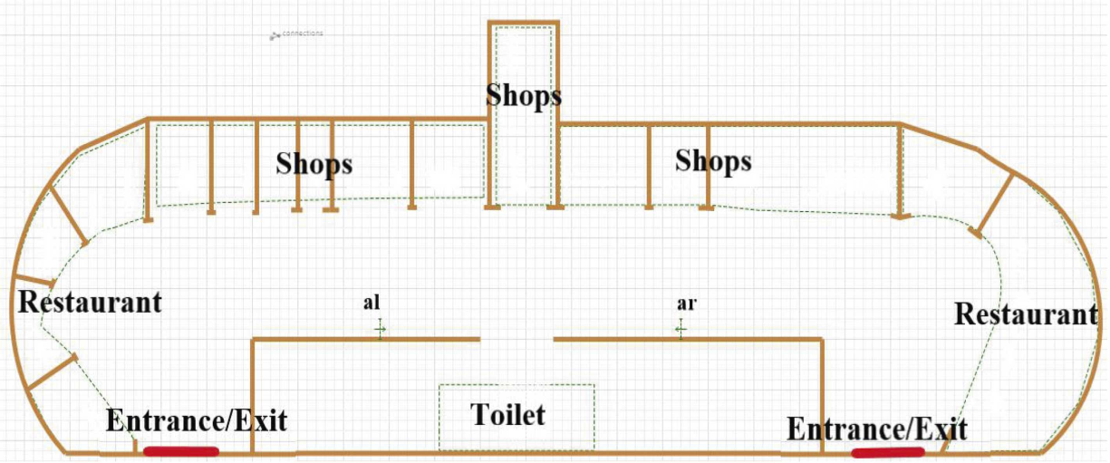

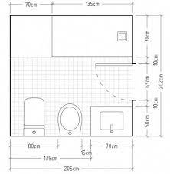

**CONCLUSION**

The aim of this research was to understand the perspective of public toilet users on the PLS, a public touristic place (Belo Horizonte, Brazil). For that, observations and interviews were carried out with people on-site and local street vendors and also analyses of comments posted at Google Maps. The results obtained showed how users used the toilet depending on its provision, accessibility, and hygiene aspect. In fact, people often had to leave, affecting local tourism and trade. In addition, chemical toilets were associated with inadequate solutions due to their temporary installation and poor conservation. In addition to the tourist target, local city planning must consider their workers and homeless people who were also toilet users. Consideration should also be given to the profile of the public outlined, particularly the time they spend on the site, rush hours, gender, and age. The study showed the importance of the population becoming aware of their role when using the public toilet for minimising misuse. In terms of behaviour, this problem could lead to vandalism, depredation, waste of material, and incorrect use of the equipment. Therefore, public authorities must also consider using behaviour change techniques to approach the new problems, and they must seek to better comprehend users’ opinions.