AARTHI K

73772126101

1. Create a local git repo with the name "MyRepo".

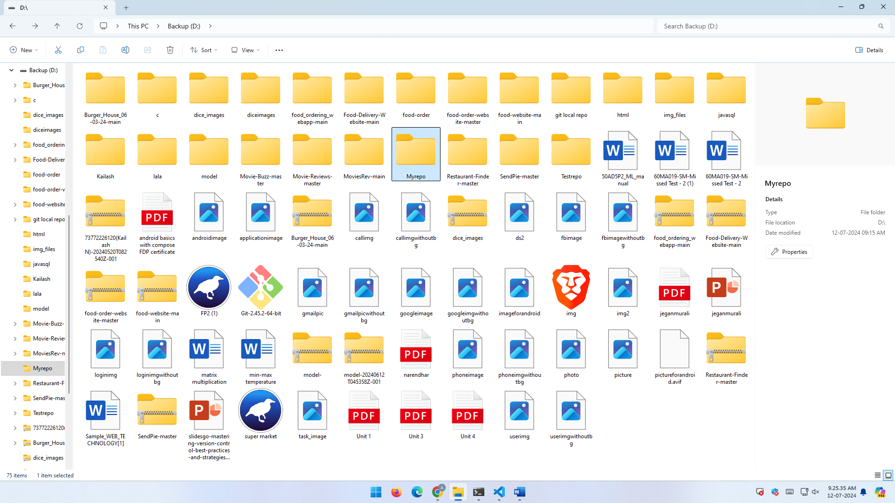

2. create one .txt file, five .c files and five .java files in the working area.

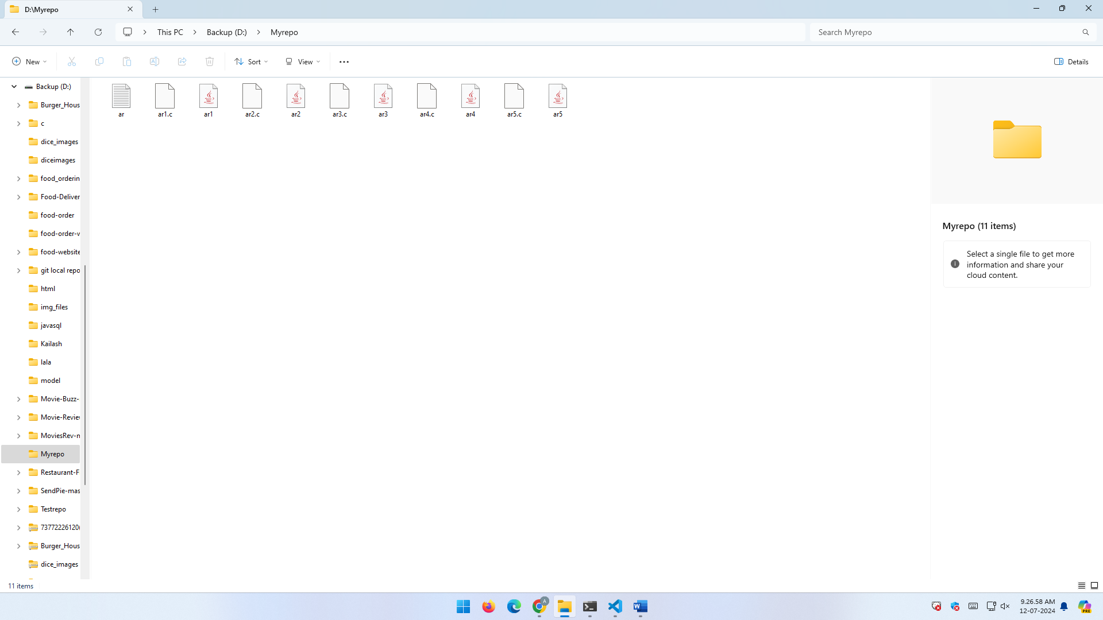

3.Verify the Git status  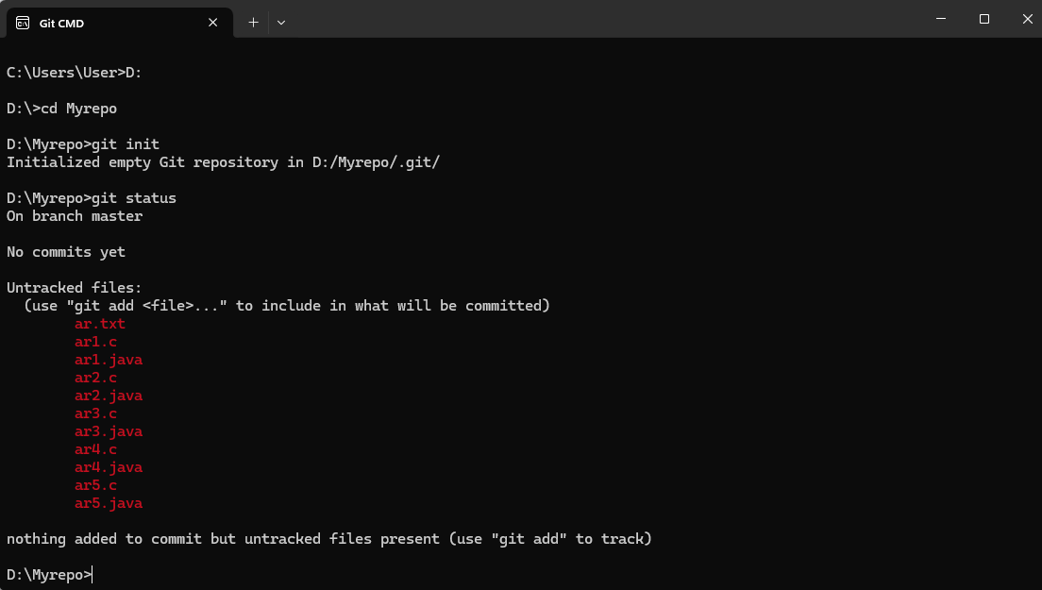

 4.Add only the .txt into the staging area

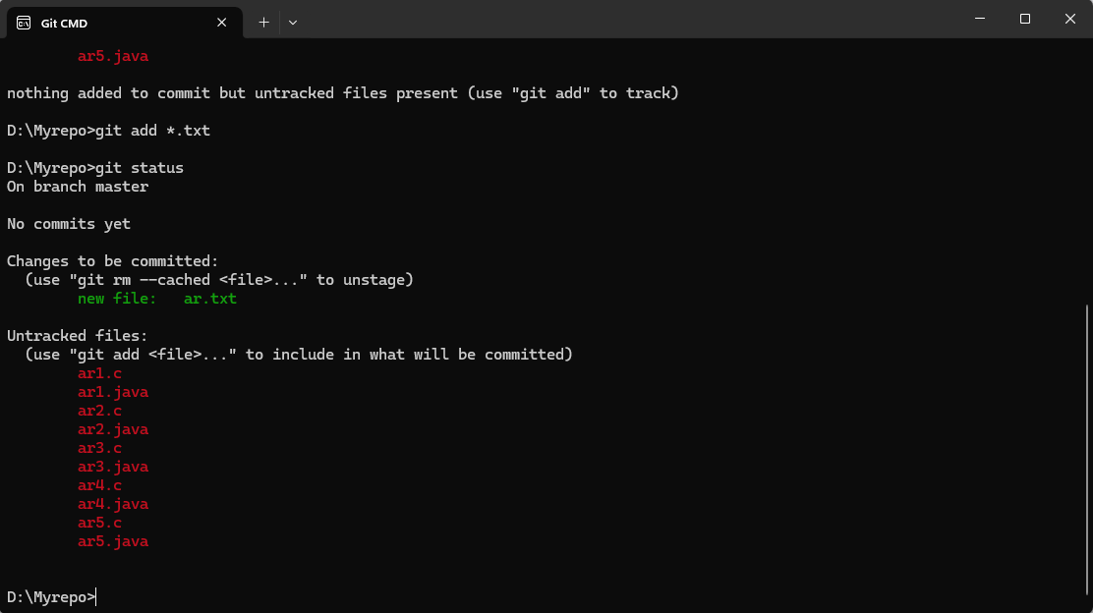

5. verify the git status



6.Make a commit with the name "TXT Commit"

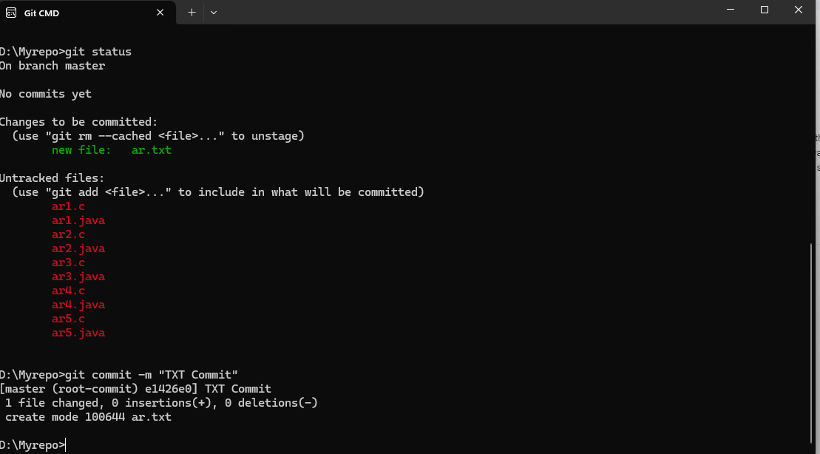

7. Add all .c files into the staging area

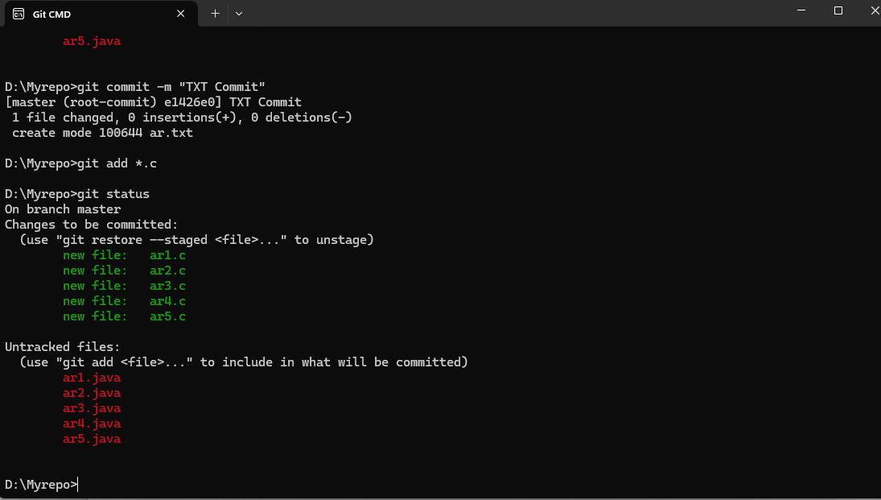

8. verify the git status



9. Make a commit with the name "C Commit"

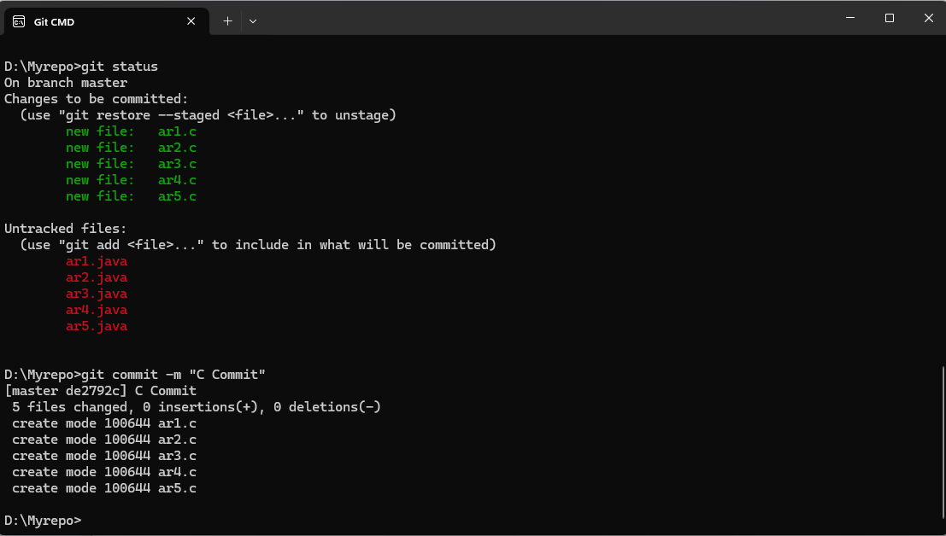

10 .Add all .java files into the staging area

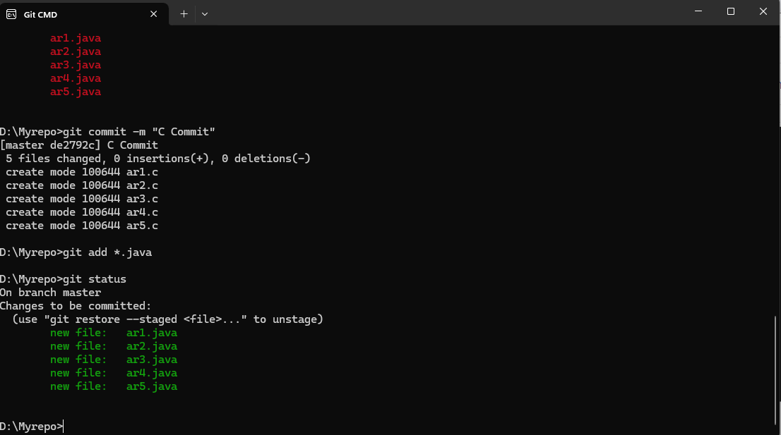

11. verify the git status



12. Make a commit with the name "Java Commit"

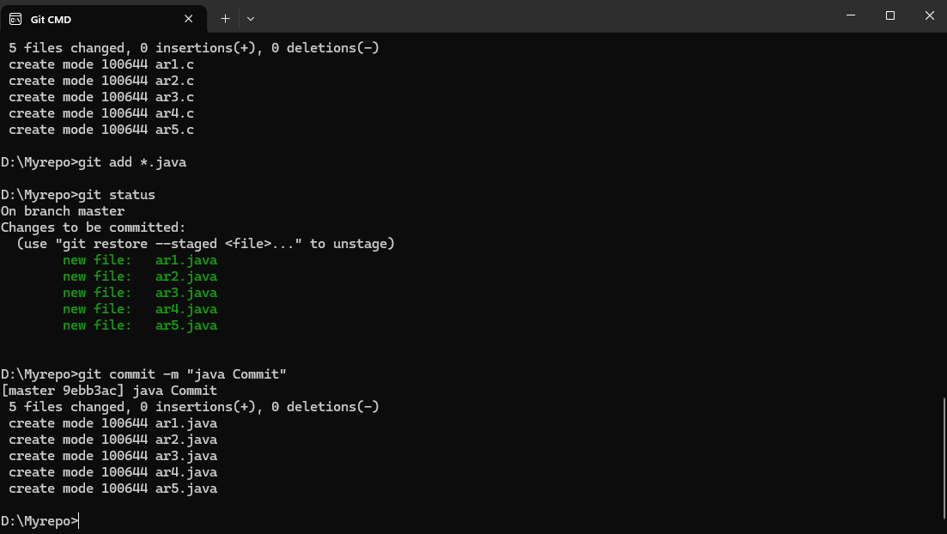

13. Delete all .java files from working area

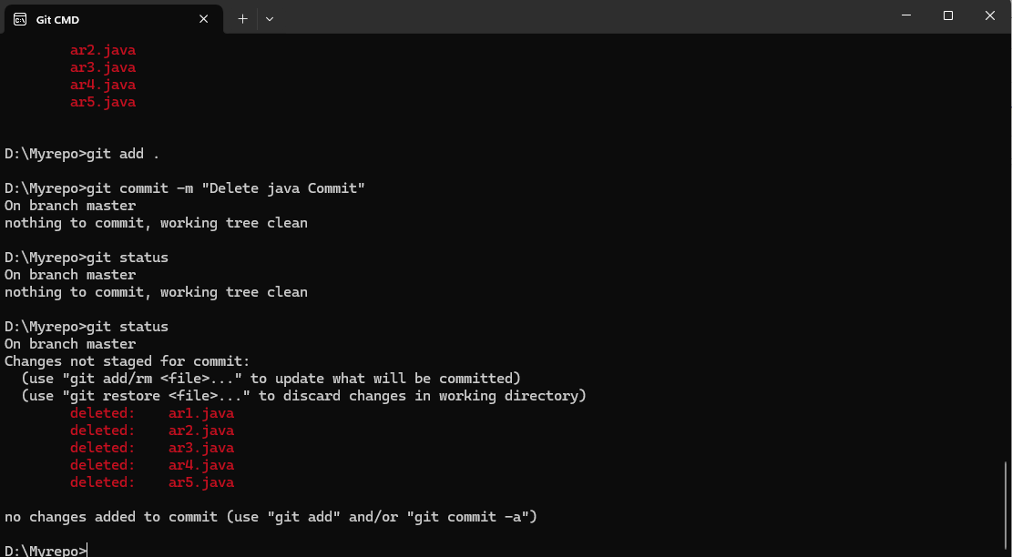

14. Now see the status



15. add the changes into the staging area

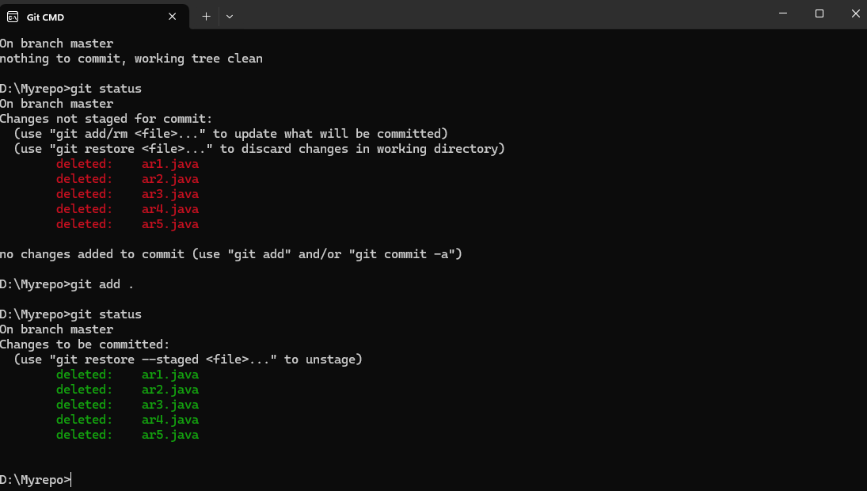

16. Make a commit with the name "Delete Java Commit"

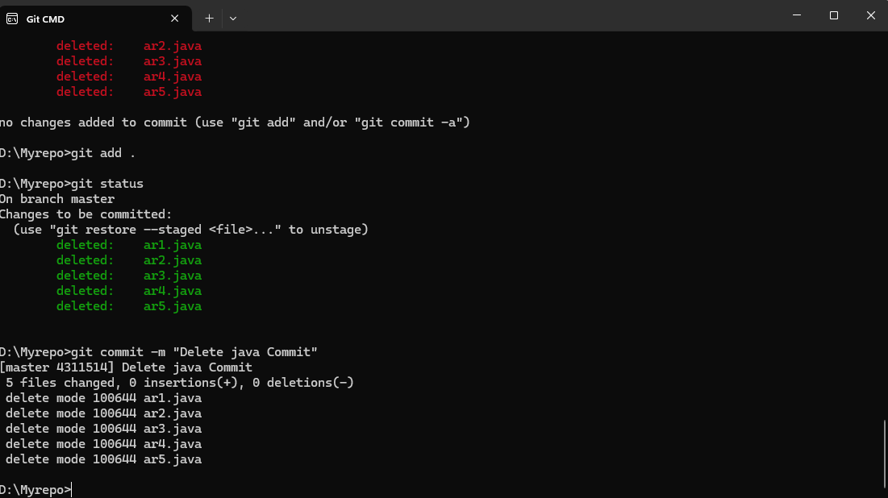

17. display all commit details

