**Phase 3: Development Part 1**



**Name: C.Arthi**

**Register Number : 312621243003**

**College Name : Thangavelu Engineering College**

**Project 3 : Future Sales Prediction**

**Project 3: Future Sales Prediction**

**Objective:**

The objective is to create a tool that enables the company to optimize inventory management and make informed business decisions based on datadriven sales predictions In this part we understand the problem statement and we created a document on what have we understood and we proceeded ahead with solving the problem. The problem is to develop a predictive model that uses historical sales data to forecast future sales for a retail company.

**Problem Definition:**

The problem is to develop a predictive model that uses historical sales data to forecast future sales for a retail company. This project involves data preprocessing, feature engineering, model selection, training, and evaluation. This model will predict sales on a certain day after being provided with a certain set of inputs.

In this section we begin building our project by loading and preprocessing the dataset as per the instructions in the project .

**Code and Explanation :**

Utilize a dataset containing historical sales data. Here a csv file is converted to a DataFrame and the pandas object is used. The This code will create a DataFrame using the provided data and column names. Remember to replace the placeholder data with your actual dataset.

This dataset seems to be related to advertising expenditures and their impact on sales. Here are the column meanings:

TV: Advertising budget spent on TV ads.

Radio: Advertising budget spent on radio ads.

Newspaper: Advertising budget spent on newspaper ads.

Sales: Sales generated as a result of the advertising campaign.

Here's how you can implement this in Python using pandas:

#Data Source utilize the dataset

import pandas as pd

df=pd.read_csv(r'Sales.csv')

print(df)

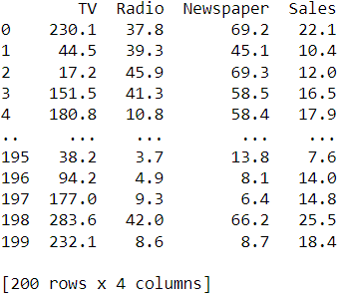

You can use df.head()

df.head() is a method used to display the first few rows of a DataFrame, which is often done for exploratory data analysis to get a quick overview of the data.

# Print the first few rows of the DataFrame

print(df.head())

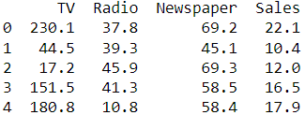

We calculate and print the summary statistics of the dataset using df.describe() function . The describe() method returns description of the data in the DataFrame. If the DataFrame contains numerical data, the description contains these information for each column such as count , mean , std , min , 25% , 50% , 75% , max .

#Check basic statistics

summary_stats = df.describe()

print("\nSummary Statistics:")

print(summary_stats)

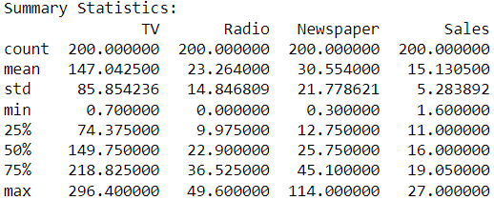

In order to check missing values in Pandas DataFrame, we use a function isnull() and notnull(). Both function help in checking whether a value is NaN or not. These function can also be used in Pandas Series in order to find null values in a series.

#checking wheather the data is available or not recorded.

missing_values = df.isnull().sum()

# Print the missing values (if any)

print("Missing Values:")

print(missing_values)

# You can also print a message based on the result

if missing_values.sum() == 0:

print("\nNo missing values found. Data is available.")

else:

print("\nMissing values found. Data may be incomplete or recorded incorrectly")

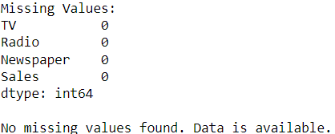

Now we set some range for each variable and performs the range checks.

#Define reasonable ranges for each variable

reasonable_ranges = {

'TV': (0, 1000), # Eg:TV budget should be between 0 and 1000

'Radio': (0, 100), # Eg: Radio budget should be between 0 and 100

'Newspaper': (0, 200), # Eg: Newspaper budget should be between 0 and 200

'Sales': (0, 100) # Eg: Sales should be between 0 and 100

}

# Perform range checks

for column, (min_val, max_val) in reasonable_ranges.items():

if ((df[column] < min_val) | (df[column] > max_val)).any():

print(f"Warning: Values in column '{column}' are not within the reasonable range of ({min_val}, {max_val}). Please verify the data.")

else:

print(f"The values in the column '{column}' are within the reasonable range of ({min_val},{max_val})")

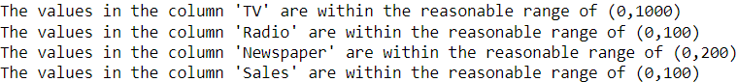

Now we are going to check wheather the given datas entered are correct or not by

By checking the non negative values in the data

Checking if sales values are non-negative

if (df['Sales'] < 0).any():

print("Warning: There are negative sales values. Please verify the data.")

else:

print("The Data contains non negative sales values")



Checking for negative or unrealistic values

if (df < 0).any().any():

print(f"Warning: There are negative values in the dataset. Please verify the data.")

else:

print("No negative values found.")



Checking if advertising budgets are non-negative

if (df[['TV', 'Radio', 'Newspaper']] < 0).any().any():

print("Warning: There are negative advertising budget values. Please verify the data.")

else:

print("The Data contains non negative advertising budget values")



The drop_duplicates() method removes duplicate rows. Use the subset parameter if only some specified columns should be considered when looking for duplicates.

#to remove duplicate values

df_dup = df.drop_duplicates()

# Display the DataFrame without duplicates

print("DataFrame without Duplicates:")

print(df_dup)

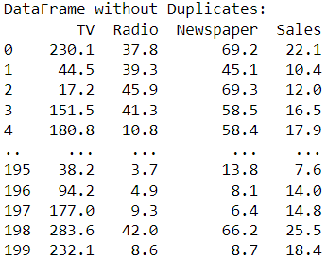

Outliers are data points that significantly differ from the rest of the observations in a dataset. They can be unusually high or low values compared to the majority of the data. In statistical terms, outliers are observations that fall outside of the typical range of values.Outliers can arise due to various reasons, such as errors in data collection, measurement variability, or the presence of rare events. They have the potential to skew statistical analyses and machine learning models, leading to misleading or inaccurate results.Detecting and handling outliers is an important step in data preprocessing and analysis to ensure that the insights drawn from the data are robust and representative of the underlying patterns.

#Check for outliers and decide whether to remove them or not.

import numpy as np

# Define a function to detect outliers using IQR method

def detect_outliers(data):

Q1 = data.quantile(0.25)

Q3 = data.quantile(0.75)

IQR = Q3 - Q1

lower_bound = Q1 - 1.5 * IQR

upper_bound = Q3 + 1.5 * IQR

return (data < lower_bound) | (data > upper_bound)

# Select the columns you want to check for outliers

columns_to_check = ['TV', 'Radio', 'Newspaper', 'Sales']

# Check for outliers in each column

outliers = df[columns_to_check].apply(detect_outliers)

print(outliers)

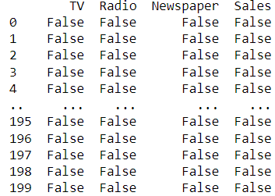

# Count the number of outliers in each column

num_outliers = outliers.sum()

# Display the number of outliers for each column

print("Number of outliers:")

print(num_outliers)

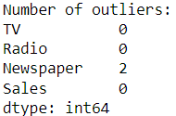

# Display the rows containing outliers

outliers_rows = df[outliers.any(axis=1)]

print("\nRows containing outliers:")

print(outliers_rows)

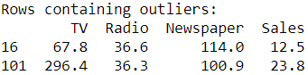

# To remove outliers, you can use something like this:

df_cleaned = df[~outliers.any(axis=1)]

print("\nOutliers removed:")

print(df_cleaned)

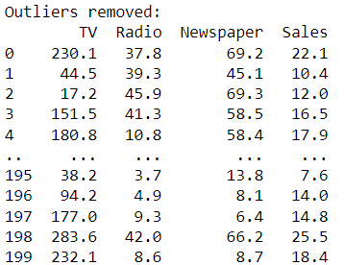

Now here we are extracting the dependent variable .The ‘sales’ is a dependent variable.

# Extracting the dependent variable 'Sales'

y = df['Sales']

# Printing the first few rows of 'Sales' to verify

print(y.head())

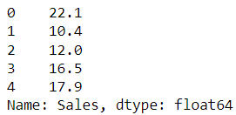

Now here we are extracting the independent variables.

# Extracting the independent variables into a DataFrame

independent_variables = df[['TV', 'Radio', 'Newspaper']]

# Printing the extracted independent variables

print("Independent Variables:")

print(independent_variables)

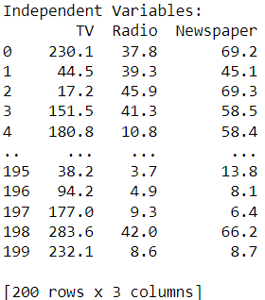

Now here the binning method is to smooth or handle noisy data. First, the data is sorted then, and then the sorted values are separated and stored in the form of bins.

#Bining the data

# Adjust the bin_edges and bin_labels as per your specific requirements

bin_edges = [0, 10, 20, 30, 40, 50, 60, 70, 80, 90, 100]

bin_labels = ['0-10', '10-20', '20-30', '30-40', '40-50', '50-60', '60-70', '70-80', '80-90', '90-100']

# Apply binning to a specific column (e.g., 'Sales')

df['Sales_bin'] = pd.cut(df['Sales'], bins=bin_edges, labels=bin_labels, include_lowest=True)

# You can choose a different column

#or adjust bin_edges and bin_labels based on your specific requirements.

# Display the DataFrame with the new binning column

print("DataFrame with Binning:")

print(df)

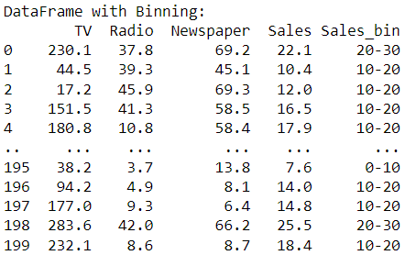

A correlation matrix is a table containing correlation coefficients for many variables. Each cell in the table represents the correlation between two variables. The value might range between -1 and 1.

# Correlation matrix

correlation_matrix = df.corr()

print(correlation_matrix)

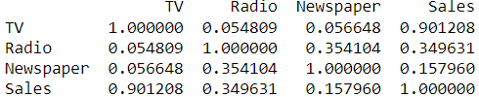

StandardScaler removes the mean and scales each feature/variable to unit variance. This operation is performed feature-wise in an independent way. StandardScaler can be influenced by outliers (if they exist in the dataset) since it involves the estimation of the empirical mean and standard deviation of each feature.

from sklearn.preprocessing import StandardScaler

scaler = StandardScaler()

numerical_features = ['TV', 'Radio', 'Newspaper']

df_cleaned[numerical_features] = scaler.fit_transform(df_cleaned[numerical_features])

print("Cleaned and Preprocessed DataFrame:")

print(df_cleaned)

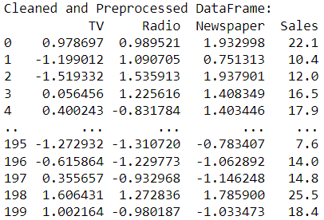

K-Means Clustering is an unsupervised learning algorithm that is used to solve the clustering problems in machine learning or data science.  groups the unlabeled dataset into different clusters. Here K defines the number of pre-defined clusters that need to be created in the process, as if K=2, there will be two clusters, and for K=3, there will be three clusters, and so on.

from sklearn.cluster import KMeans

import matplotlib.pyplot as plt

#Select the features for clustering (e.g., 'TV', 'Radio', 'Newspaper')

features = df[['TV', 'Radio', 'Newspaper']]

#Choose the number of clusters (k)

k = 3 # Adjust based on your specific analysis

#Perform K-Means clustering

kmeans = KMeans(n_clusters=k, random_state=0)

df['Cluster'] = kmeans.fit_predict(features)

#Visualize the clusters (for 2D visualization)

plt.scatter(df['TV'], df['Radio'], c=df['Cluster'], cmap='viridis')

plt.xlabel('TV')

plt.ylabel('Radio')

plt.title('K-Means Clustering')

plt.show()

# The above visualization assumes 'TV' and 'Radio' as features. You can adjust based on your specific features.

# Display the DataFrame with cluster assignments

print("DataFrame with Clusters:")

print(df)

