A CRM APPLICATION FOR SCHOOLS AND COLLEGES

1 INTRODUCTION

1.1 Overview

**Customer Relationship Management (CRM)** as the name suggests, the primary focal point is placed on the customer. The key objective is to [increase customer value](https://www.mbaknol.com/marketing-management/co-creation-of-value-in-marketing/) over time by increasing [customer loyalty](https://www.mbaknol.com/marketing-management/relationship-between-customer-satisfaction-and-loyalty/). If a company develops better customer relationships, it also improves business processes as well as its profits. In general, CRM is a more efficient automated method used to connect and improve all areas of business to focus on creating strong customer relationships. All forces are coupled together to save, improve, and acquire greater business to customer relationships. The most common areas of business that are positively affected include marketing, sales, and customer service strategies.

Customer Relationship Management (CRM)  helps create time efficiency and savings on both sides of the business spectrum. Through correct [implementation and use of CRM solutions](https://www.mbaknol.com/management-case-studies/case-study-of-global-knowledge-technology-as-an-effective-ingradient-of-customer-relationship-management-crm/" \o "Case Study of Global Knowledge: Technology as an Effective Ingradient of Customer Relationship Management (CRM)), companies gain a better understanding of their strongest and weakest areas and how they can improve upon these. Therefore, customers gain better products and services from their businesses of choice. In order to achieve better insight on CRM, it is essential to consider all of its components.

**Customer relationship management (CRM)** is a [business strategy](https://www.mbaknol.com/strategic-management/business-strategy-the-three-generic-strategies/) that spans your entire organization from front office to back-office. It is a commitment you make to put customers at the heart of your enterprise. The [right CRM strategy](https://www.mbaknol.com/management-case-studies/customer-relationship-management-crm-in-banking-a-case-study-of-icici-bank/" \o "Customer Relationship Management (CRM) in Banking: A Case Study of ICICI Bank) and solutions can help you securely, reliably and consistently:

* Delight your customers every time they interact with your business by empowering them with anytime, anywhere, and any channel access to accurate information and more personalized service.
* Reach more customers more effectively, increase [customer retention](https://www.mbaknol.com/marketing-management/what-is-customer-retention/) and boost customer loyalty by leveraging opportunities to up-sell and cross-sell and driving repeat business at lower cost.
* Drive improvements in [business performance](https://www.mbaknol.com/financial-management/evaluate-a-businesses-overall-financial-performance-using-profitability-ratios/) by providing your customers with the ability to access more information through self-service and assisted-service capabilities when it is convenient for them.
* Enable virtualization in your enterprise as more of your people and resources extend beyond your offices and around the world.
* Balance sophisticated functionality with rapid implementation and effective support for a faster return on your CRM investment.

Today’s customers face a growing range of choices in the products and services they can buy. They base their choices on their perception of quality, value, and service. Each consumer has a specific behavior. But buying habits are sometimes difficult to understand. Therefore companies always want to gain some insight about consumer behavior and habits in order to better control this behavior. Having an impact on [consumer behavior](https://www.mbaknol.com/marketing-management/consumer-behaviour-and-factors-influencing-buyer-behavior/) means being able to change consumer’s perception of the product or service, to establish a relation between the company and its clients.

Another concept which is closely related to CRM is the [Customer Relationship Marketing](https://www.mbaknol.com/marketing-management/what-is-relationship-marketing/), which is a practice that encompasses all marketing activities directed toward establishing, developing, and maintaining [successful customer relationships](https://www.mbaknol.com/marketing-management/relationship-marketing-relationship-based-marketing-strategy/). The [focus of relationship marketing](https://www.mbaknol.com/marketing-management/effect-of-relationship-marketing-on-customer-retention/) is on developing long-term relationships and improving corporate performance through customer loyalty and customer retention.

1.2 PurposeCustomer relationship management (CRM) is a technology for managing all your company's relationships and interactions with customers and potential customers. The goal is simple: **Improve business relationships**. A CRM system helps companies stay connected to customers, streamline processes, and improve profitability.

2. PROBLEM DEFINITION &DESIGN THINKING

2.1 Empathy Map

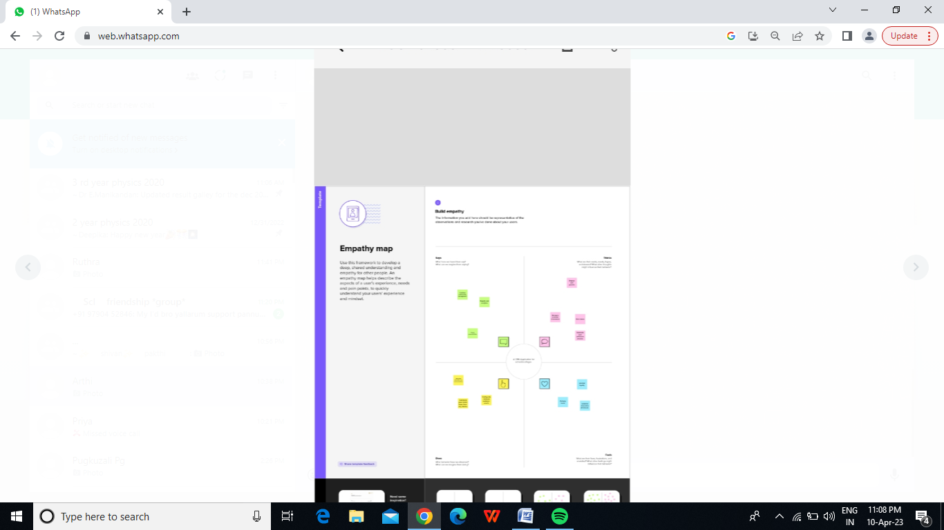

2.2 Ideation & Brainstorming Map

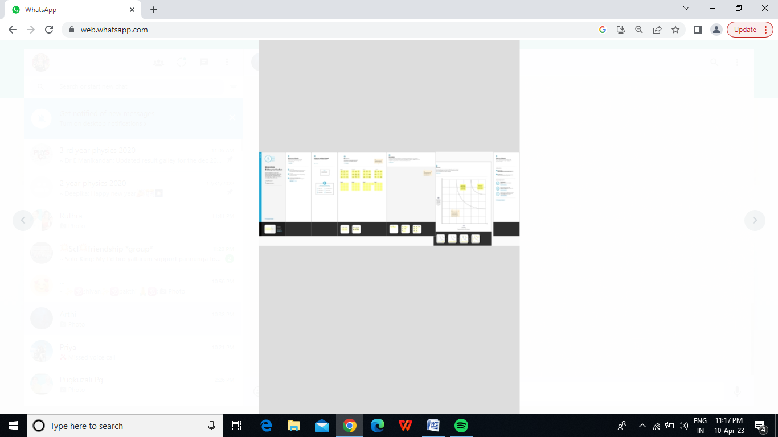

3. RESULT

3.1 Data Model:

|  |  |
| --- | --- |
| Object Name | Fields in the Object |
| School | |  |  | | --- | --- | | Field Lable | Data type | | Address | Text Area (255) | | Created By | Look Up (User) | | District | Text Area (255) | | Last Modified By | Look Up (User) | | Owner | Look Up (User,Group) | | School | Text Area (255) | | School Name  State | Text (80)  Text Area (255) | |
| Parent | |  |  | | --- | --- | | Field Lable | Data Type | | Created By | Look Up (User) | | Last Modified By | Look Up (User) | | Owner | Look Up (User, Group) | | Parent Address | Text Area (255) | | Parent Name | Text (80) | | Parent Number | Tet (80) | |  |  | |
| Student | |  |  | | --- | --- | | Field Lable | Data Type | | Mark | Number (18,0) | | Phone Number | Phone | | Result | Picklist | | School | Master-Detail(school) | | Student Name | Text (80) | |  |  | |  |  | |

3.2 ACTIVITY & SCREEN

Milestone-1:

Activity: Creation Developer Account

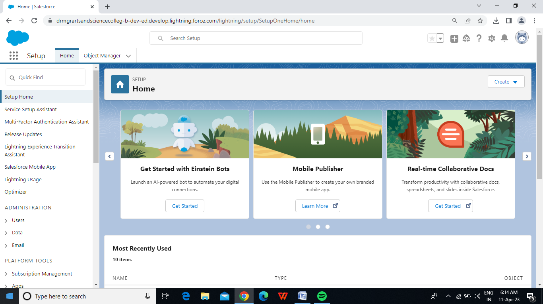

Milestone-2: Object

Activity-1: Creation of School Object

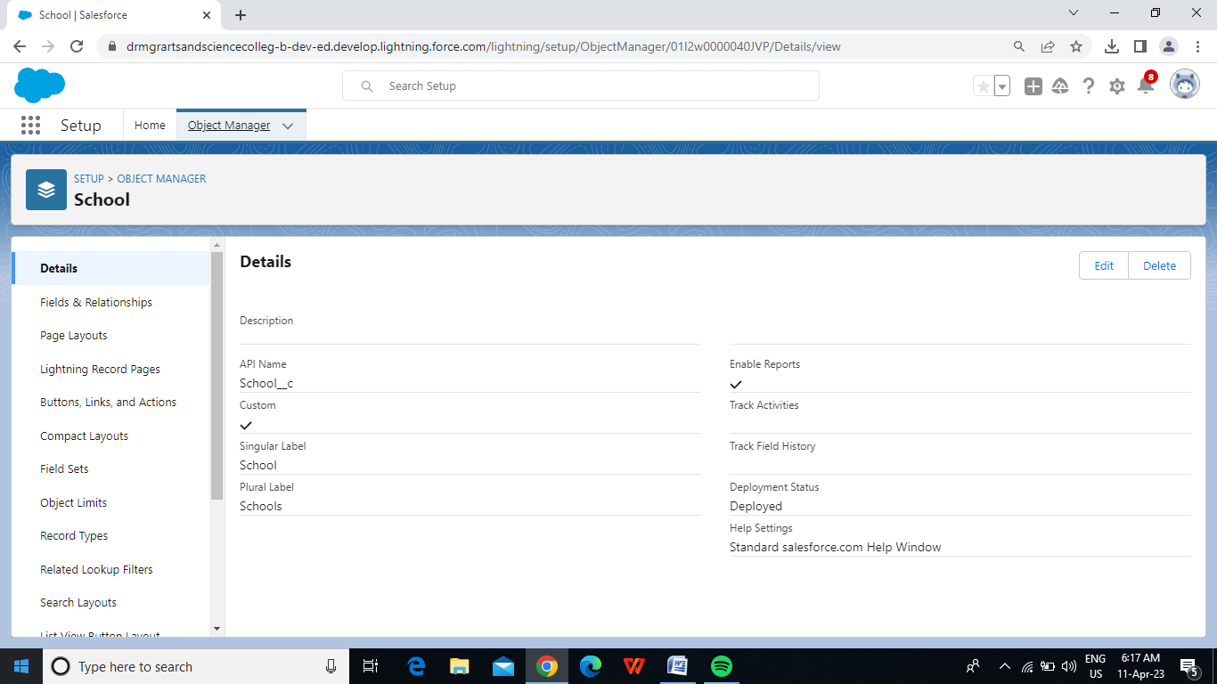

Activity-2: Creation of Student Object

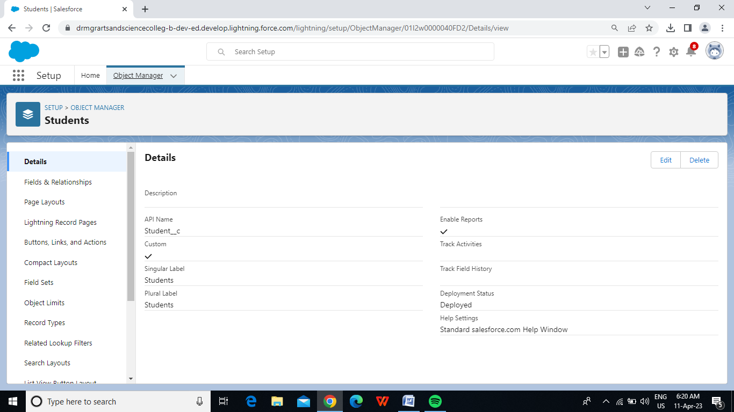

Activity-3: Creation of parent Object

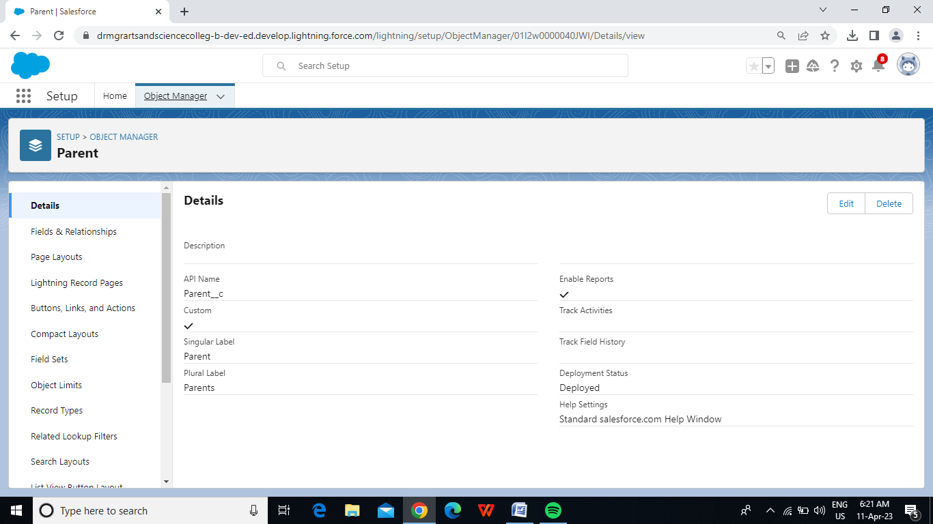

Milestone-3: Lightning App

Activity: Create the School Management app

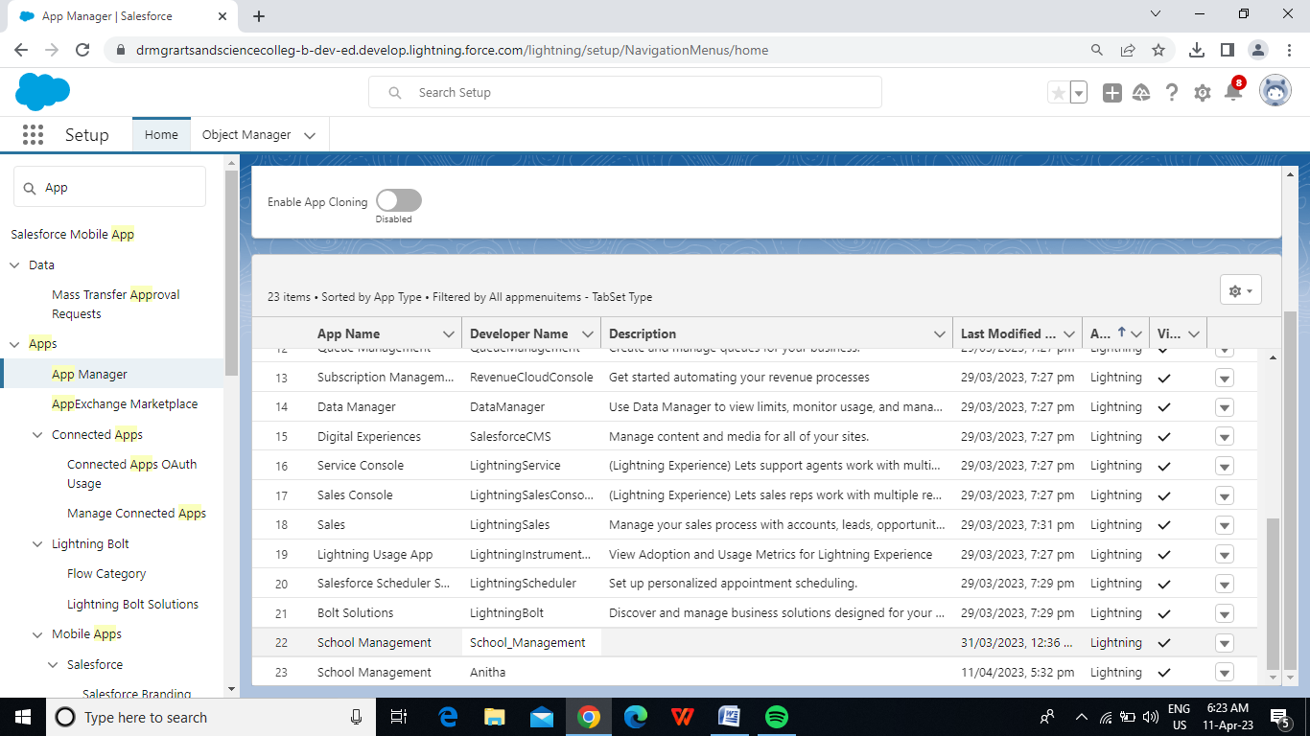

Milestone-4: Fields and Relationship

Activity-1: Creation of fields for the school object:

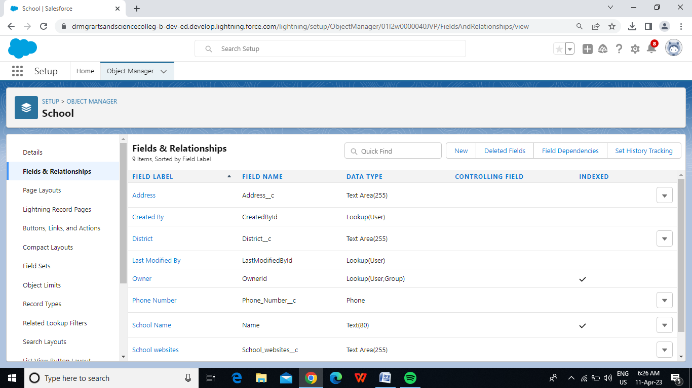

Activity2: Creation of fields for the Student Object

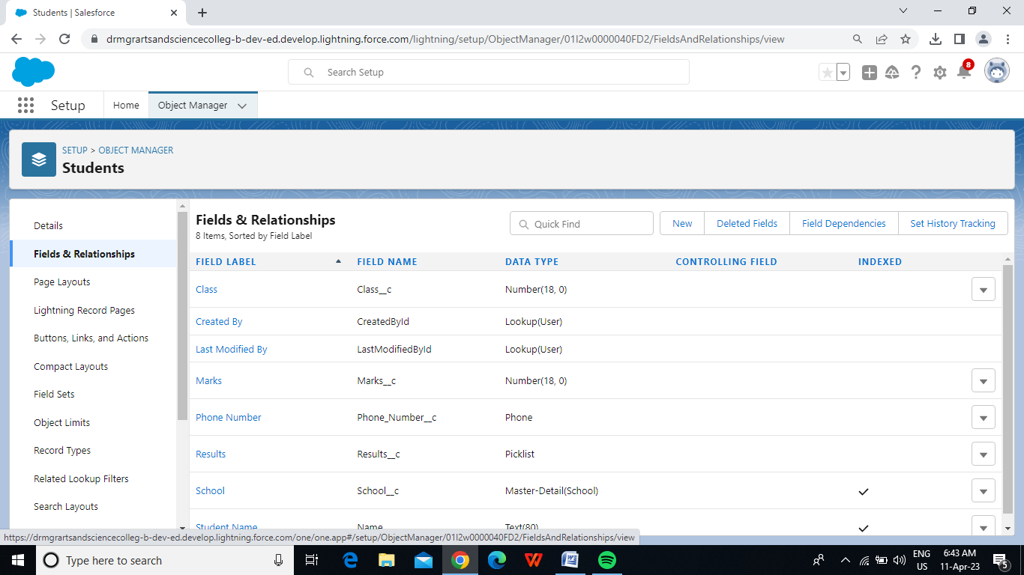

Activity-3: Creation of fields for the Parent objects

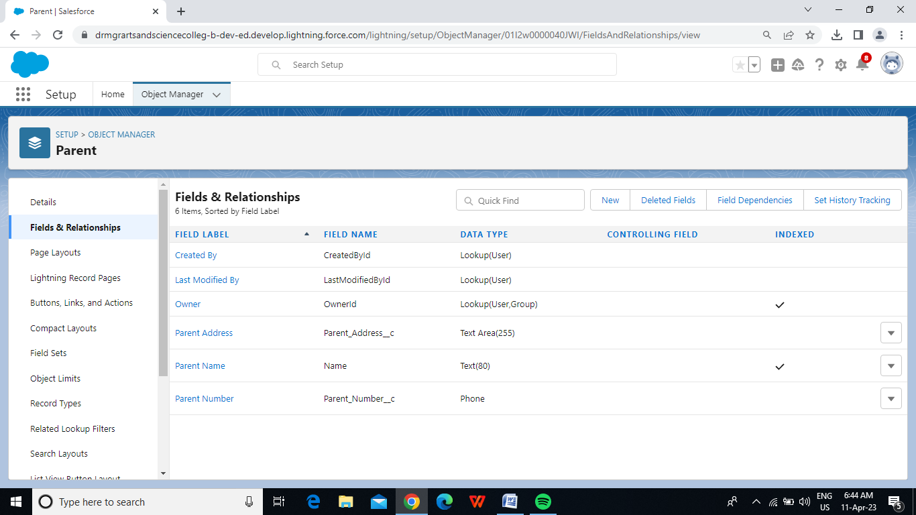

Milestone-5: Profile

Activity: Creation of Profile

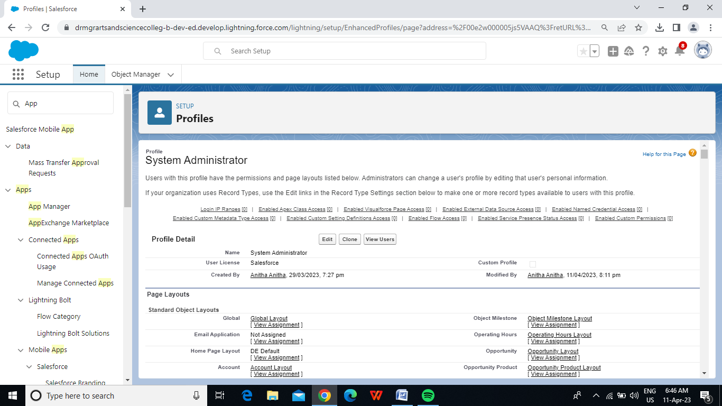

Milestone-6: Users

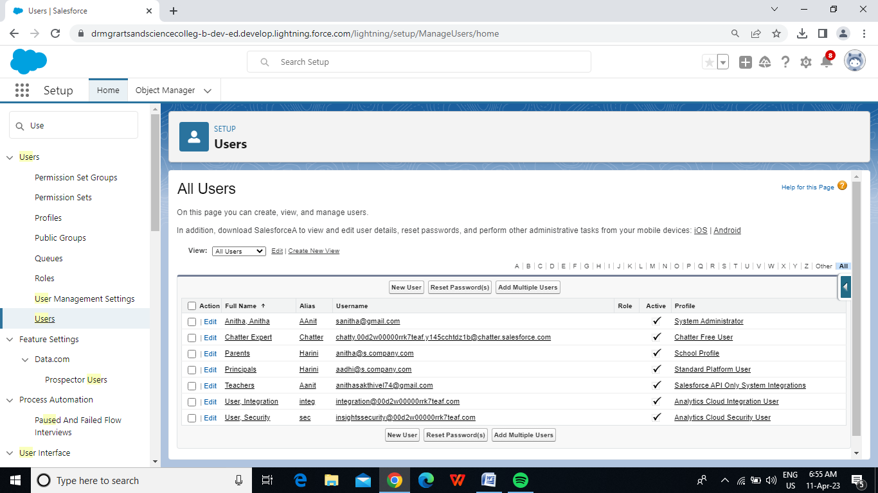

Milestone-7: Permission sets

Acitivity -1: Permission set 1:

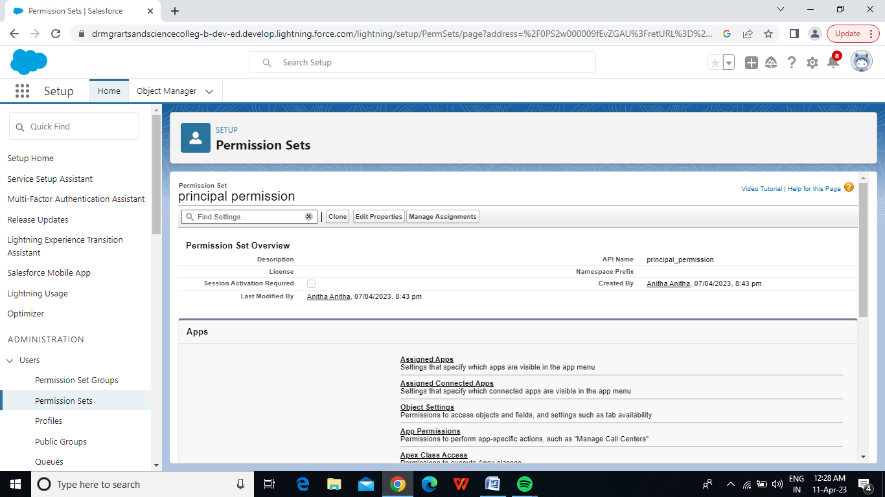

Activity-2

Permission sets 2:

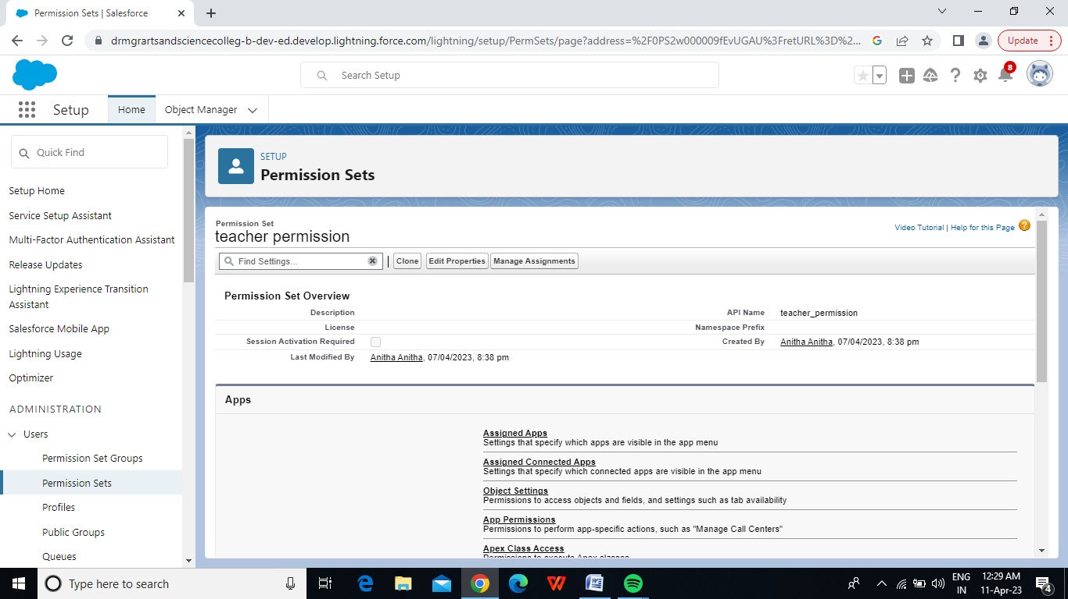

Milestone-8: Reports

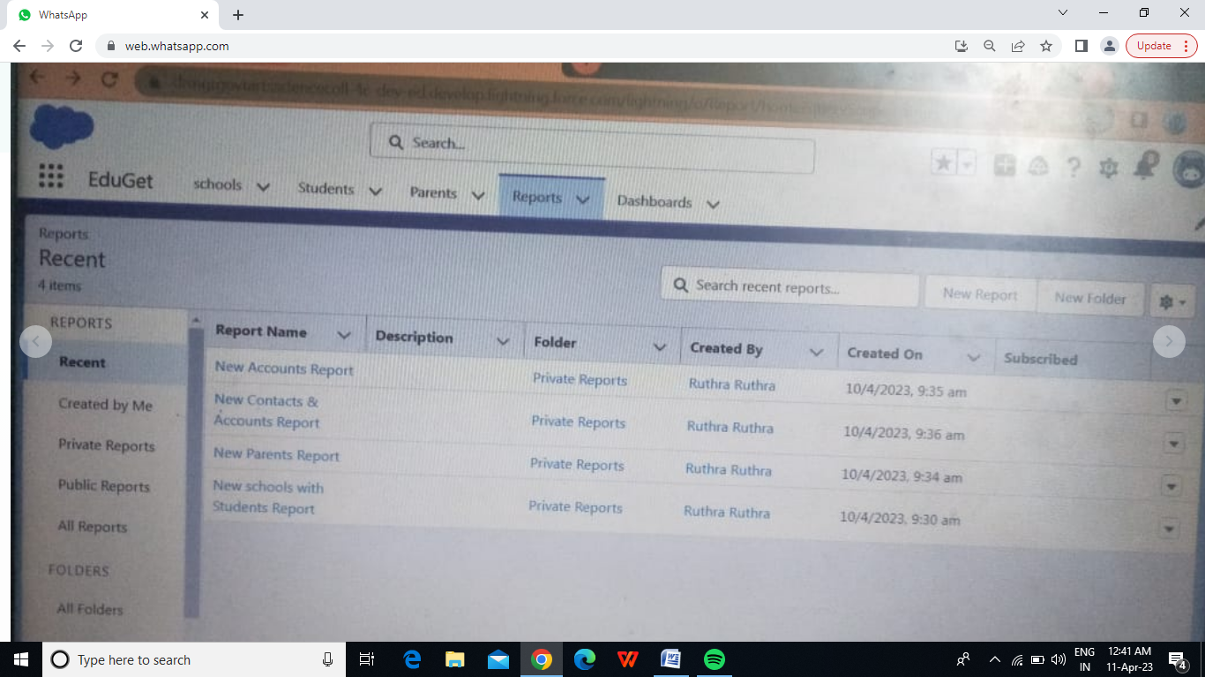

4. Trailhead Profile Public URL

Team Lead -https://trailblazer.me/id/rmarthi

Team Member 1-https://trailblazer.me/id/abinr12

Team Member 2-https://trailblazer.me/id/aadhi145

Team Member 3-https://trailblazer.me/id/asakthivel11

5. ADVANTAGES & DISADVANTAGE

ADVANTAGES:

1. **Improved Enrolments:**A CRM system can help counsellors/ sales representatives to more effectively manage and track leads, resulting in improved overall efforts and increased enrolment numbers.
2. **[Personalised Communication](https://www.nopaperforms.com/education-crm/marketing-automation-for-educational-institutions/):**A CRM system allows educational institutions to personalise communication with leads/ prospects or students, resulting in more effective communication and better relationships.
3. **[Lead Management](https://www.nopaperforms.com/education-crm/lead-management-system/?utm_source=Blog&utm_medium=cta&utm_campaign=Benefits+of+CRM):** Educational organisation to more effectively manage leads, including lead scoring, segmentation, and personalised follow-up.
4. **Automated Communication:**Automating communication works wonders for educational organisation, thus, it is one of the most beneficial features of CRM in the Education Industry. It allows counsellors/ sales representatives to communicate with leads and students, to keep them engaged and interested over time
5. **Data-driven decision Making**: A CRM system provides counsellors/ sales representatives with the data they need to make informed decisions about recruitment, marketing, and other vital areas.
6. **Improved student engagement:**CRMs help in improving student engagement by tracking student interactions and providing personalised communication.
7. **Better Communication:** One of the most beneficial reasons to use CRM in education industry is that it improves communication between different departments within an educational institution, helping to increase efficiency and collaboration.
8. **Increased Revenue**: By improving enrolment and student engagement, a CRM system can help educational organisation in increasing revenue.

DISADVANTAGES:

* CRM costs. One of the greatest challenges to CRM implementation is cost. ...
* Business culture. A lack of commitment or resistance to cultural change from people within the company can cause major difficulties with CRM implementation. ...
* Poor communication. ...
* Lack of leadership.
* 2nd Class Treatment of New Customers.
* False Rumors.
* Time Consuming.
* To Closeness Isn't Good.
* Changing Preferences.
* Require Culture Change.
* Discount Expectation.
* Training Cost.

6. APPLICATIONS

**Application 1: Tracking Customers**

**A good CRM helps you understand your market and the needs of your customers.**

**Application 2: Collecting Data for Marketing**

**A CRM saves important data in extensive customer and contact lists.**

.**Applicatin 3: Interactions and Improving Communications**.

**A good CRM helps you maintain great customer relationships with all your clients and let them know what your products and services can do for them.**

**Application 4: Streamlining Internal Sales Processes**

**A good CRM helps you streamline your internal sales processes so that there is consistency and quality across your sales team.**

**Application 5: Planning Your Operations**

**A good customer relationship management tool will help you understand your current capacity and the demand customers are likely to have for your products and services.**

7 . CONCLUTION

Customer Relationship Management **enables a company to align its strategy with the needs of the customer in order to best meet those needs and thus ensure long-term customer loyalty**.

8. FUTURE SCOPE

Customers will become a company's best sales reps through superior products and

services as well as customer_oriented messaging. The future of CRM is more than just the future

of Customer Relationship Management softwaresoftware. It is really the future of business.