Task 3: Event Management System using PostgreSQL

3 (b) Updating an event's information

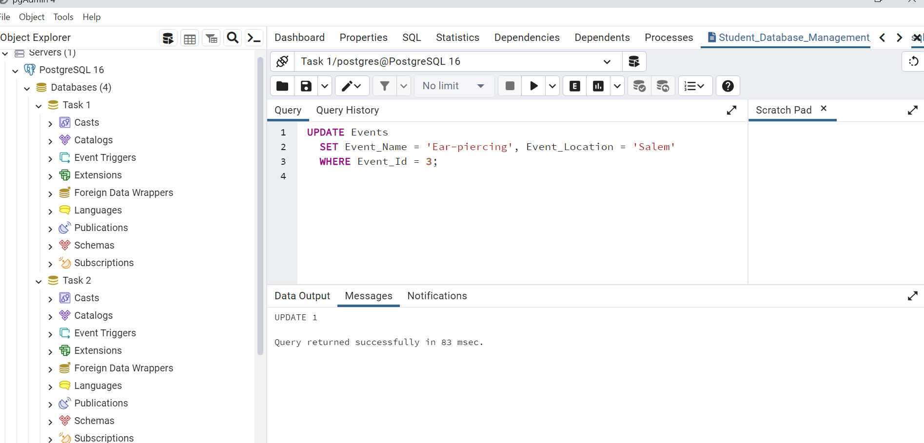

3 (c) Deleting an event

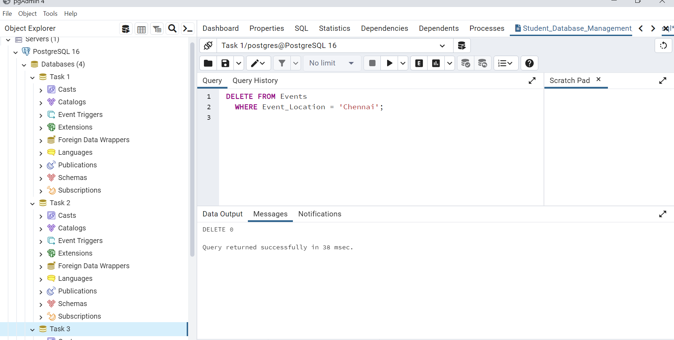

4. (a) Inserting a new attendee:

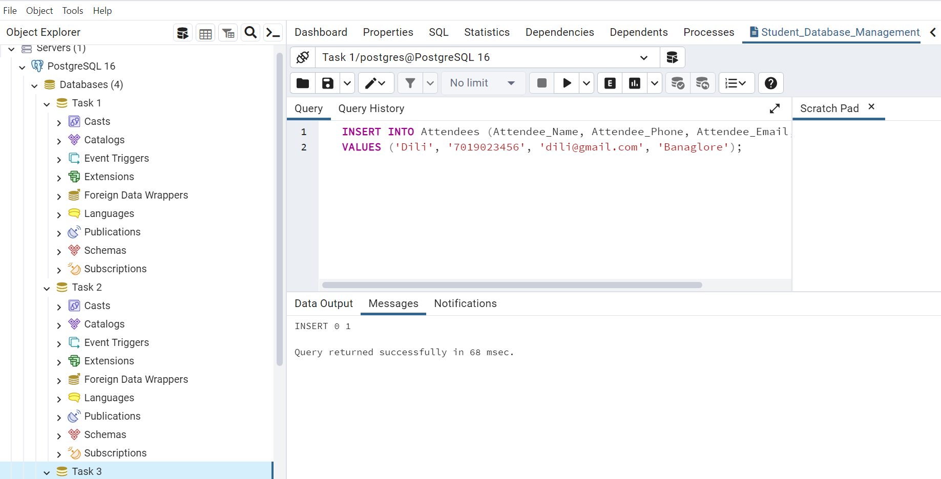

4 (b) Registering an attendee for an event

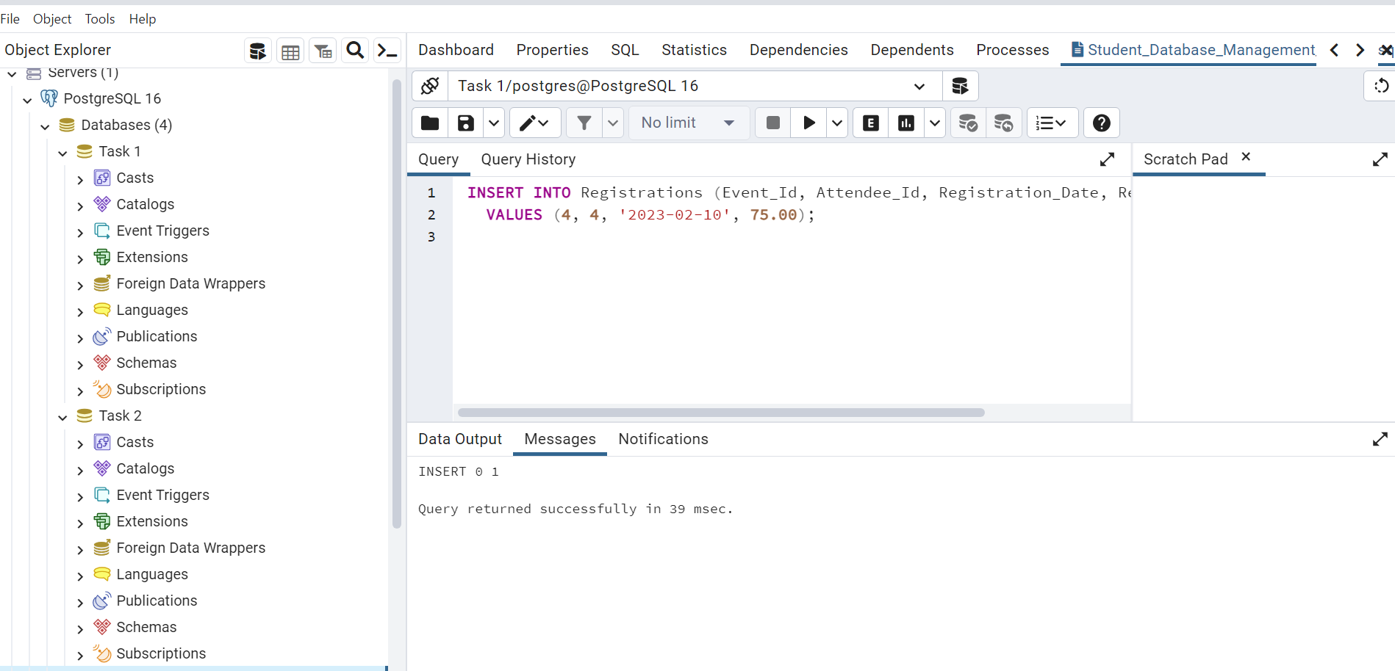

5. Develop Queries for Retrieval and Statistics

5. (a) Retrieve all events:

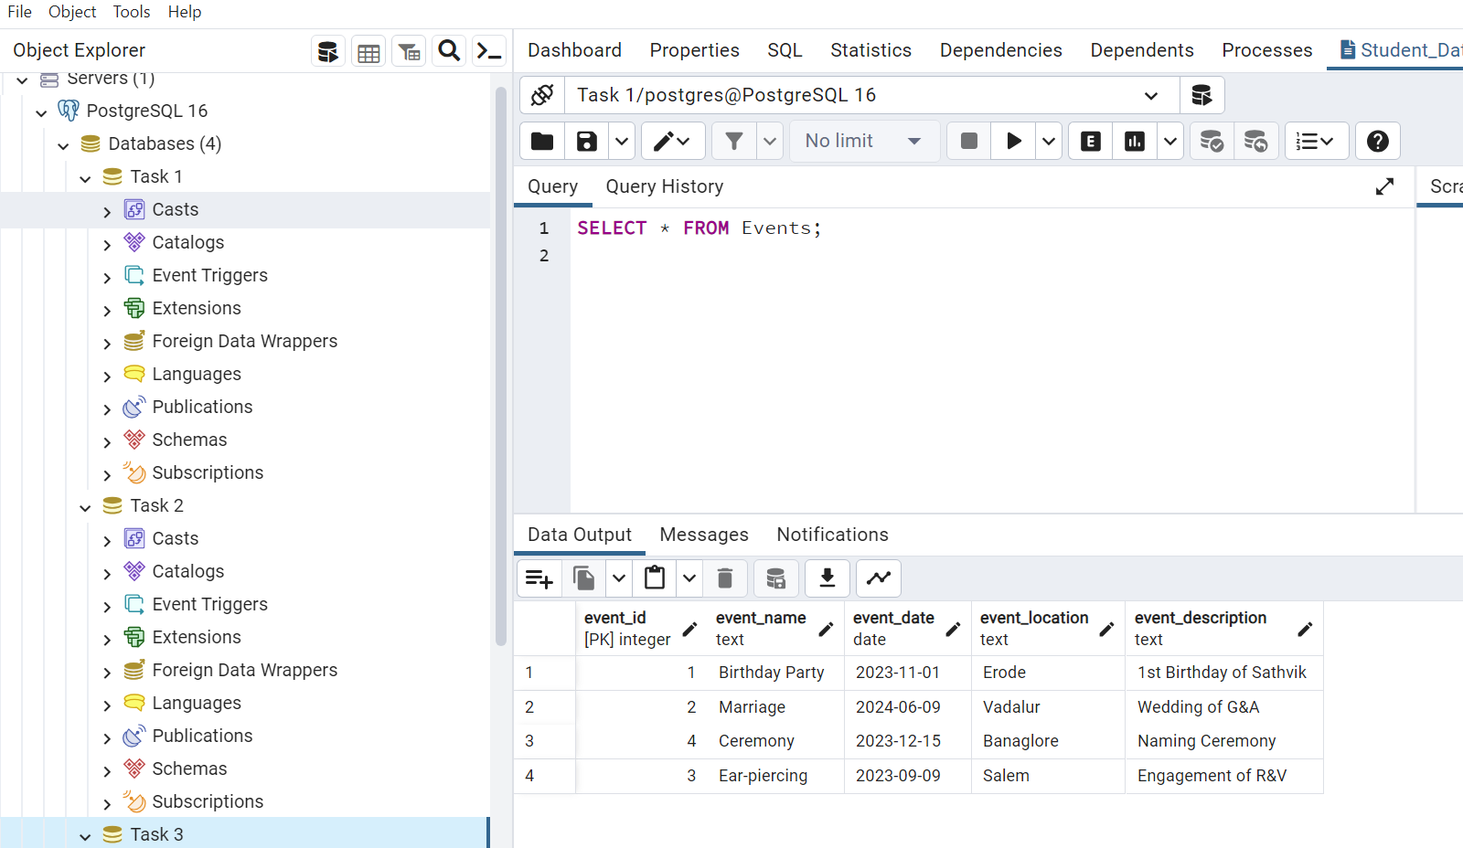

5. (b) Generate an attendee list for a specific event

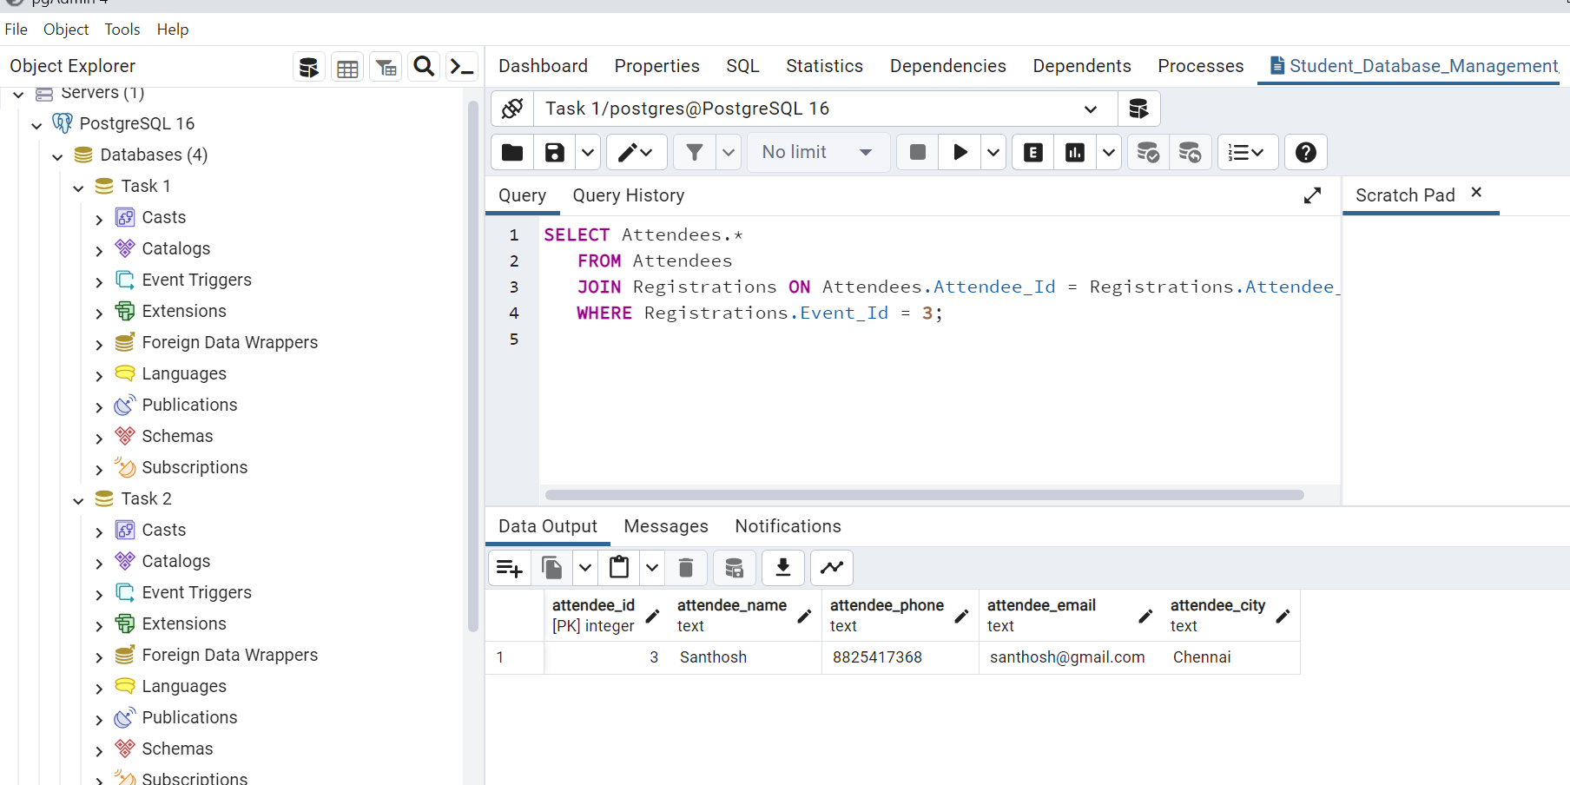

5. (c) Calculate event attendance statistics for a specific event

