**Joins in 7ways:**

1. Show first_name, last_name, salary,Department_id , department_name,Location_id, job_title, max_salary For all employees

Who joined after 2003 and

Whose are not ‘Programmer’Join HR.EMPLOYEES E and HR.DEPARTMENTS D

ALL 7 WAYS - OF QUERIES

( 2 inner, 2 right, 2 left, 1 full )

SHOW

FIRST_NAME, SALARY, DEPARTMENT_ID, DEPARTMENT_NAME

**1.Without Join:**

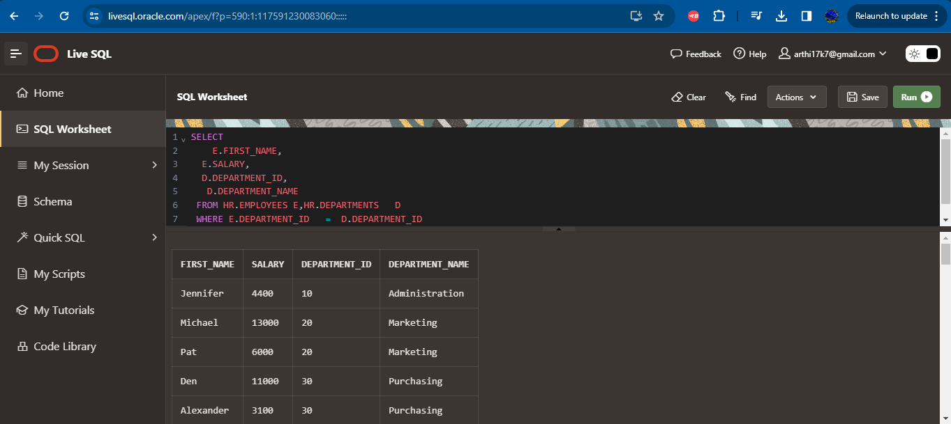

**2. Join**

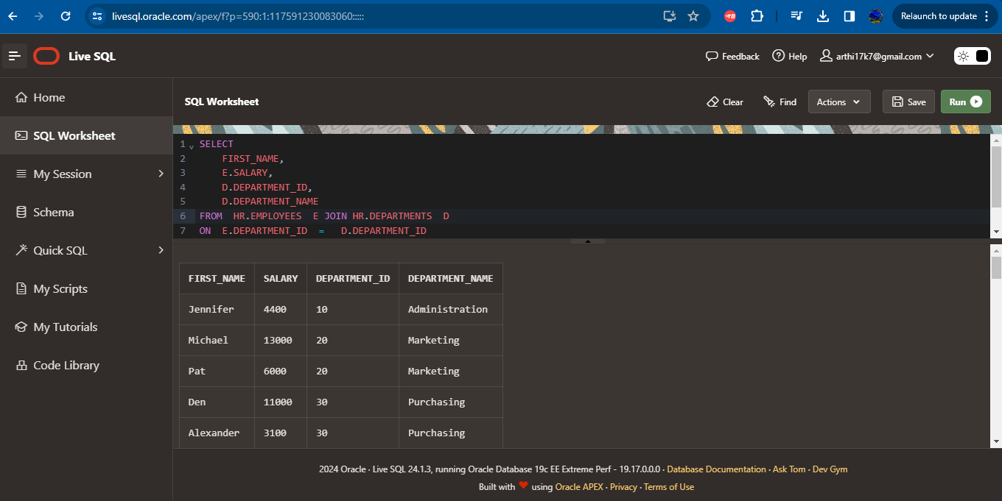

**3. Left Join:**

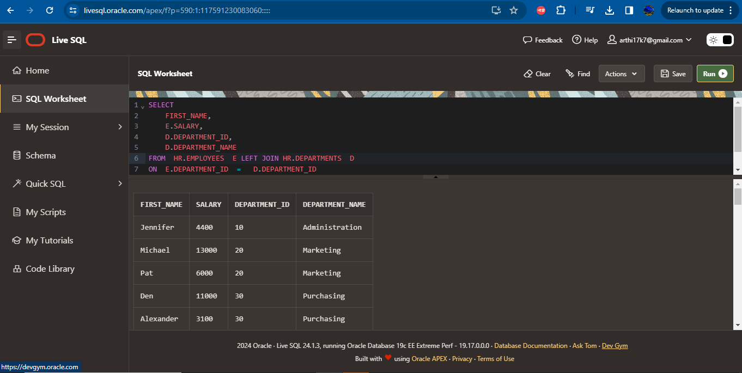

**4. Left Join using (+)**

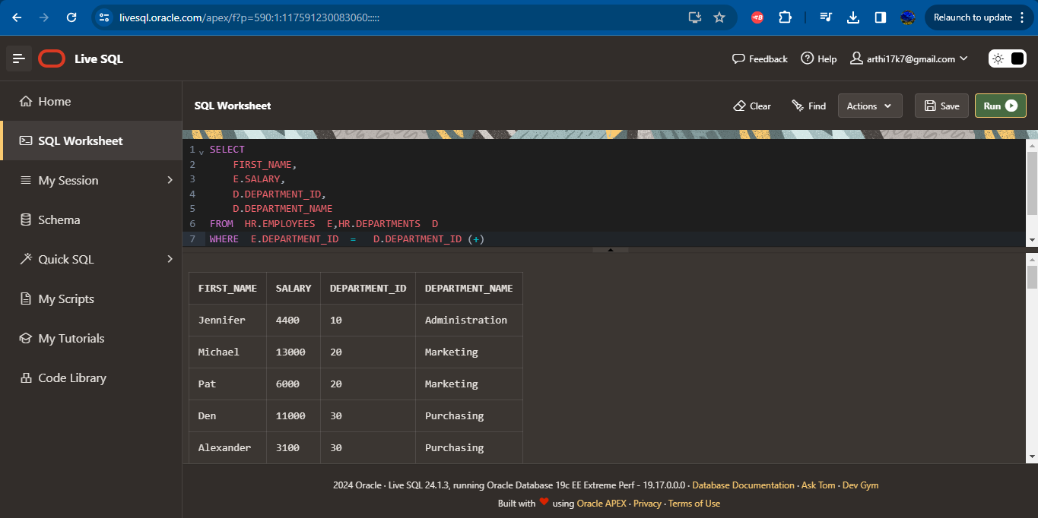

**5. Right Join**

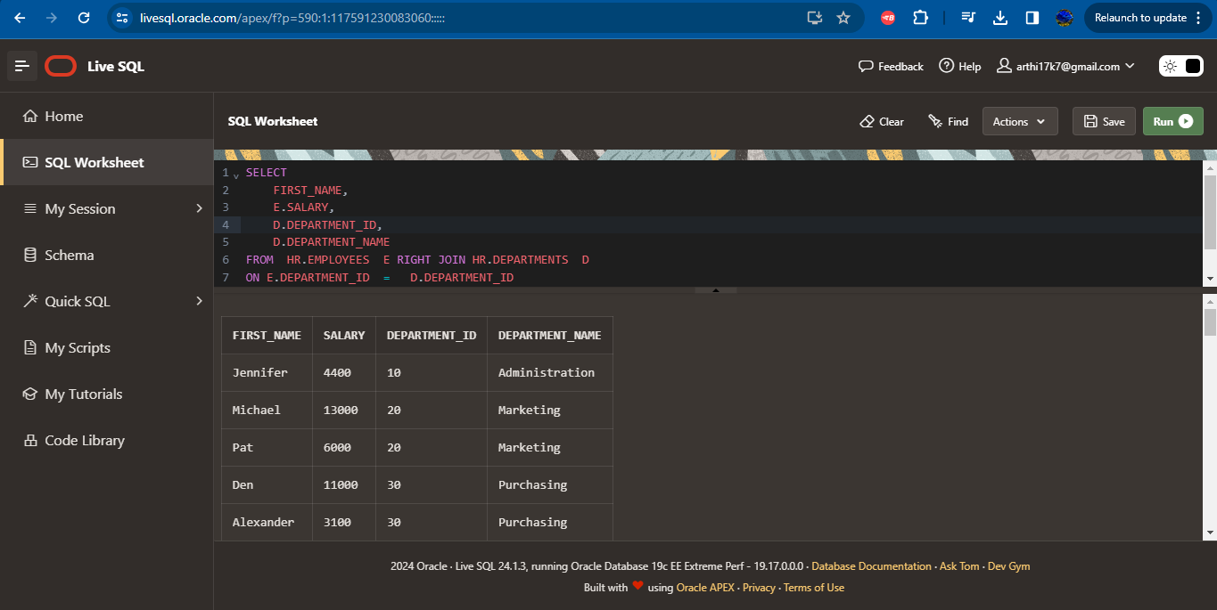

**6.Full Join using (+):**

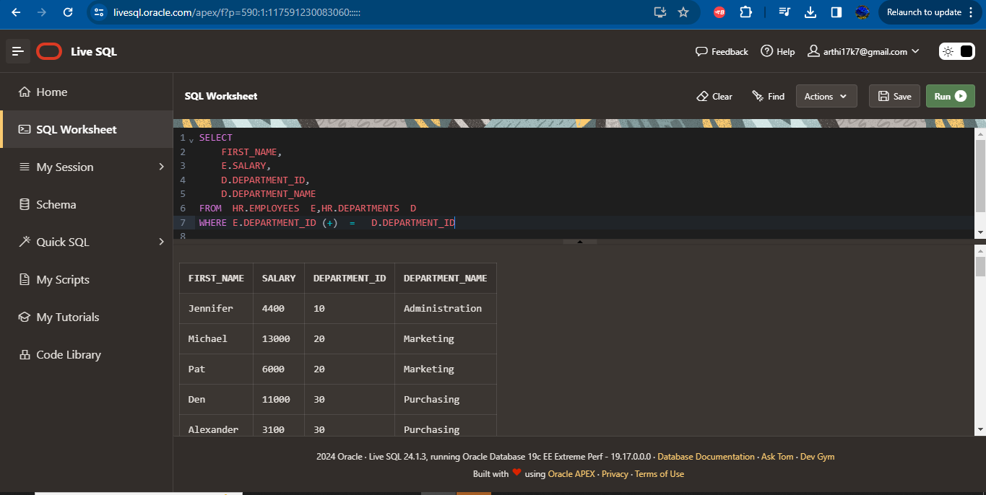

**7. Full join:**

