

IBS Integration Component
v ${Version} Release Notes

Release date ${Date}

Table of Contents
About This Document 1
Intended Audience 1
Getting Help 2
New Features and Fixed Problems in The Current Release 2
New Features and Fixed Problems for Previous Releases 3
Installation Instructions 5
Configuration Information 9
Running the DbCreate Setup and DbCreate Utilities 15
Running the DbUpgrade Utility 16

About This Document
This document provides late-breaking information about the IBS Integration Component (IC) version ${Version}. It includes information that may not available at the time the technical documentation for this product was published, as well as a list of known problems and solutions. It also contains installation and configuration instructions for this IC release.

Intended Audience
This document is intended for customers and authorized service partners who license and use the IBS IC.

Getting Help
For additional information about installing and configuring IC, refer to the Integration Component Installation and Configuration Guide for GET.

New Features and Fixed Problems in The Current Release
This section describes the new features and fixed problems associated with the current IC release. If an IBSO incident in this IC version requires a configuration change, it is noted with a pointed finger ().
IBSO | Description
- 16216 | GET logging now uses Microsoft Enterprise Library 4.1 logging methods. All database logging now involves a single table. The IC ships with predefined settings that specify when and where information is logged; however, these settings can be changed at the client site. If the client changes the logging, you MUST send Irdeto the changes; otherwise, they are overwritten in the next release. With this version, only warnings and errors log to the system application eventlog. All information, warning, and error messages log to the database table ELLOG in the CI_CENTRAL schema. The database view V_DB_TRACE_LISTENER_LOG displays the message and related event categories with which they were logged.  - See “Current IC Version” on page 10.
- 16739 | IC (OSSJ) messages can be sent to OSSJ after changes for IBSO 12603.
- N/A | Updated Core proxy DLLs to MR 11.
- 16881 | [IC] Print Distribution now correctly uses the invoice delivery method name instead of the invoice profile invoicing method to differentiate between open item and BBF invoices.
- 16932 | IC] Enable the IC to receive UC-010 Create Subscriber messages directly from event distributor. This change is required to ensure compatibility with IBS 6.2 MR11.

New Features and Fixed Problems for Previous Releases

IC Version 62.9.0.110
This section describes the new features and fixed problems associated with IC version 62.9.0.110. If an IBSO incident in this IC version requires a configuration change, it is noted with a pointed finger ().
IBSO | Description
- 12693 | GET - the IC now correctly handles exception responses that the APS\OSSJ system returns.
- 16340, 16487 | Changed PrintDistribution code to reflect changes made to version 1.5 of the IDD.
- 16189 | The IC sends the Remove Resource & Add Resource message for all types of device swops. For more information about the configuration required for this change, please read configuration instructions (item 3).  - See “IC Version 62.9.0.110” on page 11.
- 16548 | The ability to provision both HD and SD decoders is now solved by the change made for IBSO 16189.

IC Version 62.9.0.90
This section describes the new features and fixed problems associated with IC version 62.9.0.90. If an IBSO incident in this IC version requires a configuration change, it is noted with a pointed finger ().
IBSO | Description
- IBSO 16360 | The IC now reads the DbDataReader value of column LISTENER_CMD_FACTORY_TYPENAME.
- IBSO 16190 | The IC now sends entitlements for the channels in an ala carte package, not the agreement Detail ID of the package itself.  See “IC Version 62.9.0.90” on page 14.

IC Version 62.9.0.72
This section describes the new features and fixed problems associated with IC version 62.9.0.72. There are no configuration changes associated with the IBSO incident for this IC version.
IBSO | Description
- IBSO 16254 | Corrected the MailMessageListener version in the previous build by fixing the lack of message context in OSSJCommandFactory. In addition, because dependent commands are now determined by the factory as messages arrive, conditions for sending AddProduct when the worker executes have been rechecked. AddProduct now logs a diagnostic message when it detects that the CaReference value is already set.

IC Version 62.9.0.65
This section describes the new features and fixed problems associated with IC version 62.9.0.65. If an IBSO incident in this IC version requires a configuration change, it is noted with a pointed finger ().
IBSO | Description
- IBSO 14058 | Added locking mechanism to OSSJ provisioning.  - See “IC Version 62.9.0.65” on page 14.
- IBSO 15940 | For Mass Pairing, added the ability to handle records if only one serial number is in the file. This is a fix for Geriant's Python workaround.

Installation Instructions
Use the following procedure to install the current release.
  - If the IC service is running, stop it.
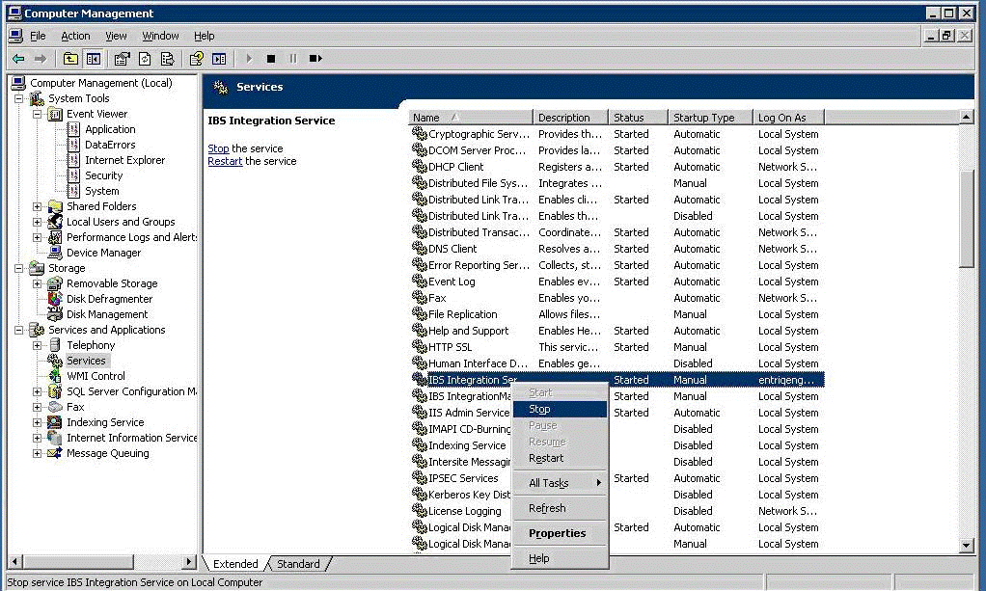
  - Create a backup copy the IC configuration file IBS.Integration.WindowsService.exe.config. You will refer to this backup copy later in this procedure.
  - Uninstall the IC service.
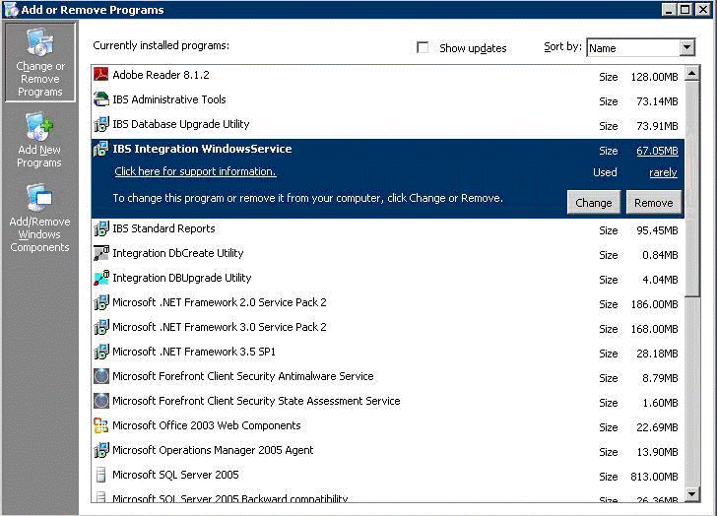
  - Confirm that the MACHINE_ANSWER_FILE is has been revised appropriately for this release (see “Editing the MachineAnswer.xml File” on page 18).
  - Back up the configuration settings in the CI_CENTRAL database if required.
  - Install the DbCreate utility (see “Running the DbCreate Setup and DbCreate Utilities” on page 17).
  - If you are installing a new database or a new schema (such as the QUEUEDATA schema) in an existing database, run the DbCreate utility. (see “Running the DbCreate Setup and DbCreate Utilities” on page 17).
  - Install and run the DbUpgrade utility (see “Running the DbUpgrade Utility“ on page 18).
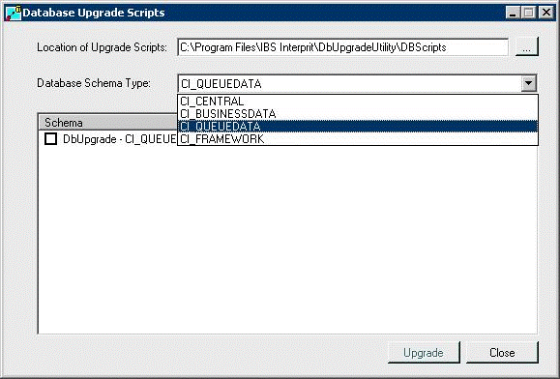
  - Install the IC service.
  - Do not restore the backup copy the IC configuration file, but use the backup copy as a reference for updating the following environment-specific settings:
- LoggingDb in the connectionStrings section. The connection string to the database used for logging should point to your CI_CENTRAL schema.
Example:
<add name="LoggingDb" connectionString="user id=CI_CN_GET_DEV; password=CI_CN_GET_DEV; data source=(DESCRIPTION=(ADDRESS_LIST=(ADDRESS=(PROTOCOL=TCP)(HOST=ENG-ORADB-03)(PORT=1521)))(CONNECT_DATA=(SERVICE_NAME=DEV)))" providerName="System.Data.OracleClient" />
- ConnectionString in the appSettings section. The connection string to the CI_CENTRAL schema, which contains the IC configuration.
Example:
<add key="ConnectionString" value="user id=CI_CN_GET_DEV; password=CI_CN_GET_DEV; data source=(DESCRIPTION = (ADDRESS_LIST = (ADDRESS = (PROTOCOL = TCP)(HOST = eng-oradb-03)(PORT = 1521))) (CONNECT_DATA = (SERVICE_NAME = DEV)))" />
- DSNsToValidateOnStartup in the appSettings section. The name of the IBS DSN defined in CSR Module to validate on startup of the IC.
Example:
<add key="DSNsToValidateOnStartup" value="UnitTest" />
  - Follow the instructions under “Configuration Information” on page 10.
  - Restart the IC service.
  - If necessary, copy PDBs to the install directory in non-production environments. PDBs contain debugging information that make troubleshooting easier; however, do not install these files in a production environment.

Configuration Information
The following sections describe configuration information for the IC releases and IBSO incident covered in these release notes.

Current IC Version
IBSO | Description
- 16216 | With the current release, IBSO 16216 changes the way messages are logged. Now informational, warning, and error messages that IC logs are more consistent. In additions, clients can configure when and where messages are logged.  Unlike previous installations, you will NOT copy your old configuration file back after installing a new version. Instead, you update the appropriate sections in the configuration file IBS.Integration.WindowsService.exe.config after you install a new version (see Installation Instructions on page 6). Table 1 below shows queries you can use when searching the new database logging tables.
Table 1. Queries for Searching New Database Logging Tables
To… | Use This Query
Get a list of categories | SELECT * FROM CATEGORY ORDER BY CATEGORYNAME
See all data | SELECT CATEGORY, LOGID, EVENTID, PRIORITY, SEVERITY, TITLE, TIMEOF, MACHINENAME, APPDOMAINNAME, PROCESSID, PROCESSNAME, THREADNAME, WIN32THREADID, MESSAGE, ACTIVITYID FROM V_DB_TRACE_LISTENER_LOG ORDER BY LOGID DESC;
See data with only important columns | SELECT CATEGORY, SEVERITY, MESSAGE, TIMEOF, MACHINENAME, ACTIVITYID FROM V_DB_TRACE_LISTENER_LOG ORDER BY LOGID DESC;
See data with only important columns, filtered for a particular category | SELECT SEVERITY, MESSAGE, TIMEOF, MACHINENAME, ACTIVITYID FROM V_DB_TRACE_LISTENER_LOG WHERE CATEGORY = 'UC_010_AddSubscriber_Cmd' ORDER BY LOGID DESC;
See data with only important columns, filtered for a particular category and severity | SELECT SEVERITY, MESSAGE, TIMEOF, MACHINENAME, ACTIVITYID FROM V_DB_TRACE_LISTENER_LOG WHERE CATEGORY = 'UC_010_AddSubscriber_Cmd' AND SEVERITY = 'Error' ORDER BY LOGID DESC;
See data with only important columns, filtered for a particular activity | SELECT CATEGORY, SEVERITY, MESSAGE, TIMEOF, MACHINENAME, ACTIVITYID FROM V_DB_TRACE_LISTENER_LOG WHERE ACTIVITYID = '5671c784-653a-4b23-862c-e427c5e147fe' ORDER BY LOGID DESC;
See data with only important columns, filtered for multiple categories, severities, and activities | SELECT CATEGORY, SEVERITY, MESSAGE, TIMEOF, MACHINENAME, ACTIVITYID FROM V_DB_TRACE_LISTENER_LOG WHERE CATEGORY IN ('OSSJBaseCommand', 'UC_010_AddSubscriber_Cmd') AND SEVERITY IN ('Information', 'Error') AND ACTIVITYID IN ('5671c784-653a-4b23-862c-e427c5e147fe', '6bb65011-c248-4bab-a9b5-d184e329ce0d') ORDER BY LOGID DESC;

IC Version 62.9.0.110
IBSO | Description
- 16189 | IBSO 16189 changes the provisioning commands for adding and removing resources. Separate commands for HSD, DTV, and MTA resources that were used previously are replaced by a single command that requires the following configuration changes.
IBS Core Provisioning
IBS core provisioning no longer needs to send separate commands for:
- UC_030_AddHsdResource_Cmd
- UC_032_AddStbResource_Cmd
- UC_034_AddMtaResource_Cmd
The single command UC_030_AddResource_Cmd replaces these commands. As a result, provisioning commands for events 5229 and 171 should now reference the new command instead of the previous resource commands.
Add Resource
A single IC worker, identified by worker condition UC_030_AddResource_Cmd, now handles add resource commands.
Remove Resource
A new IC worker, UC_230_RemoveResource_Cmd, now removes resources. The new add and remove workers are now invoked by the swap device worker UC_200_SwapDevice_Cmd, which is triggered by event 146 as specified previously.
IC Configuration Changes
The DbUpgrade utility now handles the IC configuration changes described under “Add Resource Commands” and “Remove Resources” above.
Important: This version (and all future versions) of the DbUpgrade utility replaces all current OSS/J configurations, so be sure to make a backup copy of the CI_CENTRAL database before installing this build.
Dynamically Chosen Stylesheet
The add and remove workers now choose the appropriate stylesheet based on the device model combination of the primary device and the paired-to device. This model-to-stylesheet mapping must be defined in the file ModelToTransformMap.xml in the Transformers\OSSJ folder of the IC installation. This file maps model combinations to add and remove stylesheet names. A sample mapping file called ModelToTransformMap.sample.xml is provided with this release. Copy this sample file to the file name ModelToTransformMap.xml and edit it to suit your environment.
Note: All model combinations must exist in this file. This mapping enables provisioning requirements for new models to be defined onsite.
Consistent Pairing Information
The add and remove resource workers now normalize pairing information for devices. This means it no longer matters in which direction a device was paired. Add and remove workers always rewrite the pairing information, so the primary device for which the event is received (typically, the smartcard or addressable device) is the from-device and the decoder is the to-device. This change lets stylesheets receive consistent pairing information, regardless of the pairing configuration in core.

IC Version 62.9.0.90
IBSO | Description
- 16190 | The IC now sends separate AddProductOption commands for each channel of an Ala carte (Favorite) product option.
Answer File Changes
Add three new Key sections to the <Group Name="CI_CENTRAL"> element:
<Key Name="Dsn"><Value>CI_CENTRAL</Value></Key>
<Key Name="DefaultControllerLogFolder"><Value>C:\IBS Interprit\Integration\Messaging</Value></Key>
<Key Name="OSSJ_DUMMY_ALA_CARTE_PRODUCT_OPTION"><Value>PUT APS DUMMY ENTITLEMENT HERE</Value></Key>
In these Key sections:
- The Dsn value is your environment’s CI_CENTRAL DSN.
- DefaultControllerLogFolder is a valid folder path where the IC Controller will store the enqueued and dequeued messages.
- The OSSJ_DUMMY_ALA_CARTE_PRODUCT_OPTION value is a mock (dummy) product entitlement that the IC sends to APS\OSSJ as a placeholder when provisioning Ala Carte products if a CSR has not configured all the options (channels) for an Ala Carte product.

IC Version 62.9.0.65
IBSO | Description
- 14058 | IBSO 14058 changes the way the IC queues items by adding Oracle AQ to support client APS\OSSJ requirements, as described below. Now the next OSSJ message is sent only after the APS\OSSJ responds to the prior message.
CONTROLLER Table Changes
Table 2 on page 16 lists changes to the CONTROLLER table relevant to item queuing.

MESSAGE_REPOSITORY Table Changes
Table 3 on page 16 lists changes to the MESSAGE_REPOSITORY table relevant to item queuing.
LISTENER Table Changes
All listeners MUST have a settings block that, at a minimum, has the following elements in the order shown:
<Settings><IsAddOnly>false</IsAddOnly>
<IsRetryListener>false</IsRetryListener></Settings>
Answer File Changes
Add a new groups to your MACHINE_ANSWER_FILE as set out below:
<Group Name="CI_QUEUEDATA">|
<Key Name="Dsn"><Value>CI_QUEUEDATA</Value></Key>
</Group>
In this group, the Dsn value is your environment’s CI_QUEUEDATA DSN (this is the default value and should be satisfactory).

<Group Name="EventListenerOSSJ">
<Key Name="WCFEndpointAddress"><Value>HTTP://localhost:8099/EventListenerOSSJ</Value>
</Key>
</Group>

In this group, WCFEndpointAddress is the host URL that you want the IC to listen on for Conditional Access events from IBS Core. This entry must match the IBS Host entry.

<!-- Controller, default settings -->
<Group Name="ControllerDefaults">
<Key Name="EmailHostName">
<Value>Email Server Host Name or IP goes here</Value>
</Key>
<Key Name="EmailPortNumber">
<Value>25</Value>
</Key>
<Key Name="FromEmailID">
<Value>donotreply@irdeto.com</Value>
</Key>
<Key Name="EmailErrorTemplate">
<Value>LetterTemplate\MailErrorTemplate.txt</Value>
</Key>
<Key Name="EmailDisplayName">
<Value>The Integration Component</Value>
</Key>
<Key Name="EmailSubject">
<Value>Error message</Value>
</Key>
</Group>
In this group, replace EmailHostName with the name or IP address of your email server.

Table 2. Changes to the CONTROLLER Table
Parameter | Description
MAX_DAILY_ERROR_COUNT | Maximum number of errors that can occur each day in this controller before it shuts down and stops processing messages.
MAX_HOURLY_ERROR_COUNT | Maximum number of errors that can occur each hour in this controller before it shuts down and stops processing messages.
DAILY_ERROR_COUNT | Current daily error count for the controller. This counter automatically resets each day.
HOURLY_ERROR_COUNT | Current hourly error count for the controller. This counter automatically resets each hour.
LAST_ERROR_DATE | Date/time when the last error occurred for the controller.
MESSAGE_PATH | Stores additional logging files. This path cannot be empty.
ENABLED | Set this value to enable or disable the controller  1 = enable the controller.  0 = disable the controller. If the controller is disabled, it will not process any messages.
SETTINGS | To be notified via email about IC errors, you can configure the controller SETTINGS block as follows:  <Settings><NotificationWorkerFailedToEmailID>user1@email.com,user2@email.com  </NotificationWorkerFailedToEmailID></Settings>  where NotificationWorkerFailedToEmailID is a comma-delimited list of email addresses. No comma is needed when specifying one email address. If this is blank, no emails are automatically sent when an error occurs.
Table 3. Changes to the MESSAGE_REPOSITORY Table
Parameter | Description
QUEUE_NAME | Has a new format for Oracle AQ queues. Instead of the MSMQ-style .\Private$\MyQueue, an Oracle AQ entry simply looks like MyQueue.
POISON_QUEUE_NAME | Oracle AQ queues do not have poison queues.
SETTINGS | For the new Oracle AQ queues only, this is a new column that contains configuration parameters.  Sample: <RepositoryConfigurationSettings><LockDuration>120</LockDuration><OracleConnectionDsn>CI_QUEUEDATA</OracleConnectionDsn></RepositoryConfigurationSettings>  LockDuration = set this to the number a seconds that the IC locks a customer while waiting for a response from OSSJ. While a customer is locked, the IC does not process any other messages for that customer.  OracleConnectionDsn = confirm that a valid connection string exists in the CONNECTIONSTRING table with a CONNECTION_ID that matches this value. This will be the connection string for the CI_QUEUEDATA schema that will contain the new Oracle AQ queues.

Running the DbCreate Setup and DbCreate Utilities
Before you install the IC service, run DbCreateSetup.exe to install the DbCreate utility. Running DbCreateSetup.exe installs a shortcut in the Start menu for running DbCreate. As part of this procedure, you will initialize a new database schema called CI_QUEUEDATA.
After running DbCreateSetup.exe, use the following procedure to run the DbCreate utility:
  - Click Start>All Programs>IBS Interprit>IC DbCreate Utility.
  - Complete the Oracle Administrator Login Information with an Oracle administration login for your environment.
  - In the CI_CENTRAL Schema section, enter the CI_CENTRAL login and password.
  - Leave Create CI_CENTRAL schema unchecked.
  - In the CI_QueueData Schema section, check Create CI_QUEUEDATA schema. Then enter the CI_QUEUEDATA login and password that will be used to create the CI_QUEUEDATA schema.
  - Be sure no other Create check boxes are checked.
  - Click the Create Schemas button.
The text box in the lower part of the window shows whether the new schema was created successfully or failed. All errors must be resolved before you continue with installing this release.

Running the DbUpgrade Utility
This section describes how to run the DbUpgrade utility included with this release. This utility is similar to the one Core installations use.
Before running this utility:
- If you are installing a new database, run the DbCreate utility if you have not already done so (see “Running the DbCreate Setup and DbCreate Utilit” on page 17).
- Create an answer file (see “Editing the MachineAnswer.xml File,” below).

Editing the MachineAnswer.xml File
Before running DbUpgrade, edit the MachineAnswer.xml file. If desired, use the SAMPLE_MACHINE_ANSWER_FILE.xml file as a reference. Your machine answer file must contain all sections defined in the sample file.

Running DbUpgrade Utility
After editing the MachineAnswer.xml file, run the DbUpgrade utility. When you run the utility, you are prompted for the location of the machine answer file, so be sure this file exists. The default location is C:\AnswerFile\MACHINE_ANSWER_FILE.XML. If the file resides at a different location, specify the location; otherwise, an error message appears if the machine answer file cannot be found.
  - Go to Start>All Programs>IBS Interprit> IC Db Upgrade Utility.
  - Click the Database Schema Type drop-down list and select the schema you want to upgrade. If no schemas are listed:
- Verify that the scripts executed in the Database Update Scripts folder.
- Verify the values in the machine answer file.
- Uninstall and re-install the DbUpgrade utility.
- Run the DbUpgrade utility again.
  - Upgrade the following three IC schemas:
- CI_CENTRAL
- CI_BUSINESSDATA
- CI_QUEUEDATA
  - Check the schema you want to upgrade and click Upgrade.
  - Click Run All Scripts.
If there are any errors in the scripts, the script with the errors appears in red in the window at the bottom of the screen. If this occurs, select the script and click Show Log File to see the error description.
If any errors are resolved, click Upgrade Schema Version.
When prompted, click Yes. The window closes and the main window appears. Note that the version in the schema has the new version number (62.9.0.7).
  - Continue this process for all additional schemas as required.
  - When finished, close the DbUpgrade utility.

