1/1/2024
Compiled by Rodgers Hakajika and Natasha Masamba
chirundu town council
Report on 2025 Budget Consultation Meetings for all 12 Wards for Chirundu District
25th September to 27th September 2024

- Introduction
The Council is located in Chirundu District in Southern Province of Zambia off Lusaka-Chirundu (T2) Road. The District is about 135 Kilometer (Km) south of the Nation’s capital, Lusaka. The latitudinal and longitudinal position of Chirundu District is 16.03S:28.85E. Chirundu District has a total area of 2,265 square Kilometers (km²). As at Census of 2010, Chirundu District had a population of 47,971 people. However, after the attainment of the District status the population has increased exponentially and is at 78,780 according to Census 2022. The District has (3) Chiefs namely Chipepo, Sinadambwe and Sikoongo.

Chirundu was officially declared a District by His Excellency the President Micheal Chilufya Sata in January 2012. The District was initially part of Siavonga District in Southern Province.

Chirundu Town Council was established on 31st August, 2012 through Statutory Instrument No. 41 of 2012. This Town Council has been in existence for about ten [10] years today. Its core mandate is not different from any other Local Authority enshrined in the Local Authority enshrined Government Act Cap 281 of the Laws of Zambia.

Its vision is to Provide World-Class Town Services through Operational Excellence and a
Culture of Innovation while its mission is to provide Exceptional service for an Exceptional Community. Chirundu Town Council is a body corporate established under Article 152 of the Constitution of Zambia (Amendment) Act No.2 of 2016 and Section 6 of the Local Government Act, No. 2 of 2019 of the Laws of Zambia. As a Local Authority, the Town Council administers the Chirundu Town.

MANDATE
The main function of the Council is the delivery of local public goods and services to the people in the District and discharge all or any of the functions set out in Article 147 (2) (c) of the Constitution of Zambia (Amendments) Act No.2 of 2016 and First Schedule of the Local
Government Act No. 2 of 2019 which include, among others, power to make By-Laws, power to make regulations, imposition of levies, fees and charges and to formulate local policies to promote, guide and regulate development in the district through various relevant departments of the Council.

GIZ, in collaboration with the Chirundu Town Council, held a series of 2025 Budget Consultation Meetings for all 12 wards (Chirundu west, Chirundu central, Kapululira, Sikoongo, Njame, Mushungu, kanyanga, Lusitu, Ibbwemunyama, Musaya, Ngombe ilede and Nkandabbwe) of Chirundu District from 25th September,2024 to 27thSeptember,2024.

The objective was to train members of the Ward Development Committees (WDCs) in the identification of community priorities for the 2025 annual budget and to promote inclusive citizen participation in the budgeting process. Each ward meeting was structured to equip the participants with the necessary skills to plan and implement community development projects.

2. Community Meetings Overview
Attendees:
- Ward Councilors
- Women’s Representatives on WDCs
- Zone Leaders (Ward Zones)
- Area Coordinating Committee (ACC) Chairpersons
- Extension Staff assigned to each ward
- Senior Headmen/Headwomen (for their support)
3. Training Objectives
The training sessions aimed to:
- Train WDC members to identify and prioritize community issues for the district’s annual budget.
- Promote inclusive participation from all sectors of the community in the budgeting and planning process.
- Enhance capacity to map community resources, challenges, and developmental needs effectively.
4. Training Sessions and Activities
Introduction of Participants:
Each session began with an introduction where attendees shared their names and roles within the WDC and community.
Introduction to the Integrated Development Plan (IDP):
Facilitators provided an overview of the district’s Integrated Development Plan (IDP), explaining the vision for the next 10 years and the specific provisions for each ward. This segment emphasized the link between community priorities and the district's broader development strategies.
Socio-Resource Mapping:
Participants worked in groups to draw socio-resource maps of their wards. These maps highlighted:
- Social characteristics of the community (e.g., demographics, vulnerable groups).
- Key resources within the community (e.g., natural resources, infrastructure, facilities).
- Potential problems and needs, which were later discussed in-depth.
Group Activities:
In smaller groups, participants examined previous community projects and assessed the reasons for their successes or failures. They analyzed the following key points:
- Reasons for Success: Community involvement, government support.
- Reasons for Failure: Insufficient funding, lack of community ownership.
- Lessons Learned: Strategies for avoiding previous pitfalls and improving future initiatives.
Project Identification and Prioritization
Review of Previous Projects:
Each group reviewed the success and failure of prior community projects to draw lessons for future initiatives. A few of the key projects discussed were:
- Skills Training Centre: Still under construction due to limited funding.
- Teacher Housing: Lack of funding has hindered progress.
CDF Community Project Applications:
Participants reviewed current applications for the Constituency Development Fund (CDF), comparing these with the IDP provisions and the community’s evolving needs.
Pairwise Ranking Matrix:
A pairwise ranking exercise was conducted to prioritize key community problems. Each group assessed which issues, if resolved, would have the most significant positive impact on the ward. The top-ranked priorities were as follows:

Ward | Problem identified and Ranking
CHIRUNDU WEST/CHIRUNDU CENTRAL | Access to clean water | Roads | Primary school | Clinic | Drainage system
KAPULULIRA | Access to clean water | Clinic | Road Network | Staff Houses at Kapululira Primary School | dam |  |  |  | Upgrading of Kapululira Primary School to High School
SIKOONGO/NJAME | Access to clean water | Hachibbubba Clinic | Agricultural Shelter | T. Junction Rural Health Post | Sikoongo Staff Houses | Upgrading of Sikoongo Clinic | T. Junction Staff Houses (Primary) | Hachibbubba Primary School | Sikoongo Primary School Electrification
MUSHUNGU | Access to clean water | Solar powered boreholes | Roads and bridges maintenance | Secondary school | Healthy post and mother shelter | Rural electrification | Access to market | Human animal conflict
KANYANGA | Access to clean water | Solar powered borehole | Health post | Upgrade  Nabbanda Primary school to secondary | dam | Rural electrification | Market shelter
LUSITU | Access to clean water | School (Namunyonje) | Agric shelter | Skills training center | Humps at Lusitu market | Toilets at Lusitu market | Staff houses (Lusitu primary) | Bus shelter (Lusitu Market) | Dip tank
IBBWEMUNYAMA | Access to clean water | Hospital | Houses for Extension officers (Agric/vert) | Clinic | Schools | Dam | Agric shelter | Dip tank
MUSAYA | Access to clean water | Healthy post | Road safety signs | Rural electrification | Road network | Secondary school | Business market | Houses for government officers | Mothers shelter
NGOMBE ILEDE /NKANDABBWE | Access to clean water | Rural electrification | Human and animal conflict | Road Network | Market Shelter | Staff houses | Mother shekter | Dip tank | Agriculture Shelter

These priorities were mapped onto the socio-resource map for clarity.

5. Next Steps and Actions
The key takeaway from the meetings was the need for continued engagement and follow-up. The next steps identified for each ward were:
- Follow-up Meetings: To review progress on prioritized projects and ensure that community members remain engaged.
- Capacity Building: Ongoing support and training for WDC members to increase their ability to manage and implement projects effectively.

6. Conclusion
The training sessions provided invaluable insights into the local development processes and highlighted the importance of community participation. The prioritization exercises were successful in identifying key issues facing each ward, and the discussions around the IDP ensured that these priorities align with the district’s overall goals.
Participants agreed to forward the prioritized projects to the relevant ward for implementation. The training reinforced the need for a collaborative approach between local government, WDC members, and community stakeholders to drive the district’s development agenda.
The facilitators concluded the sessions with a commitment to continuous support and follow-up to ensure that the identified priorities are effectively addressed.
This report summarizes the training meetings held across all 12 wards of Chirundu District, and will serve as a basis for the ward councils' future work in the budget and development planning process.

Appendixes:
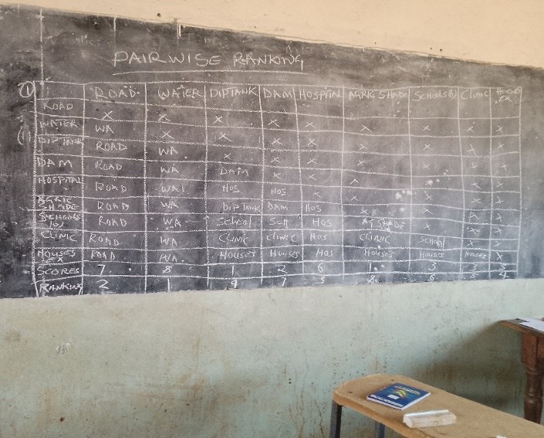 | 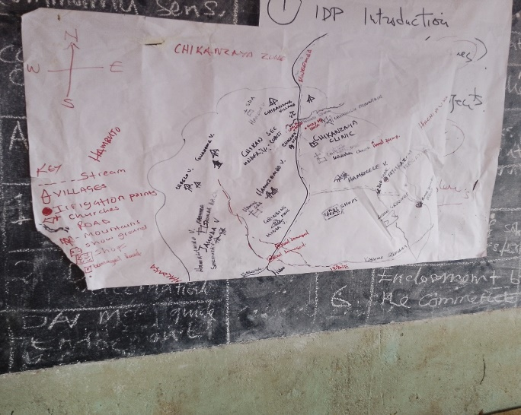
Pairwise ranking for Ibbwemunyama ward | Resource Map for Ibbwemuyama ward
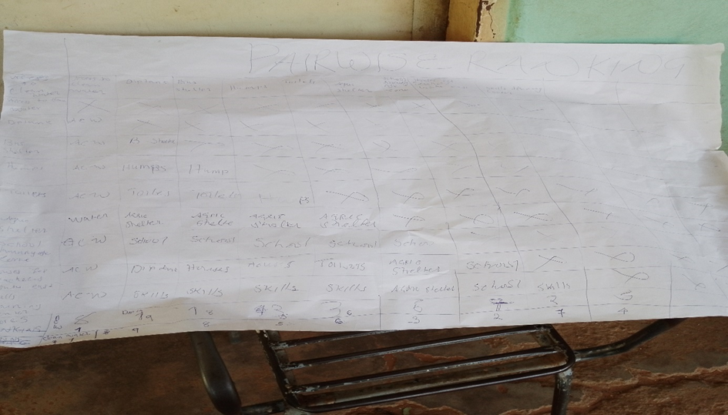 | 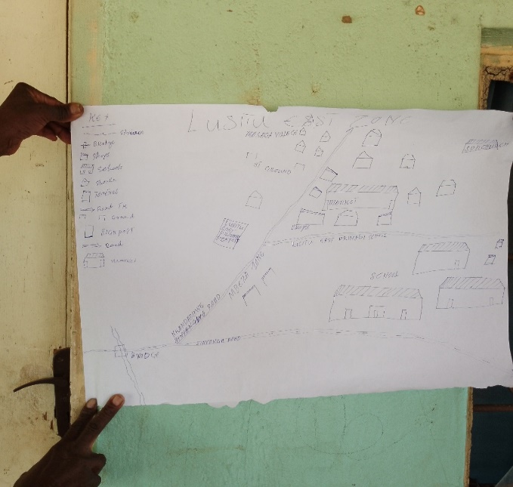
Pairwise ranking for Lusitu Ward | Resource Map for Lusitu ward
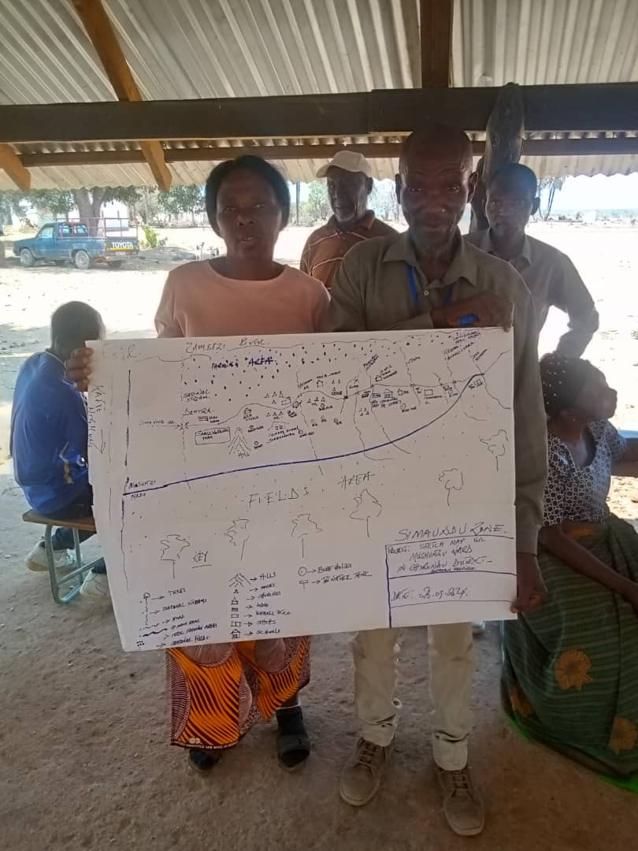 | 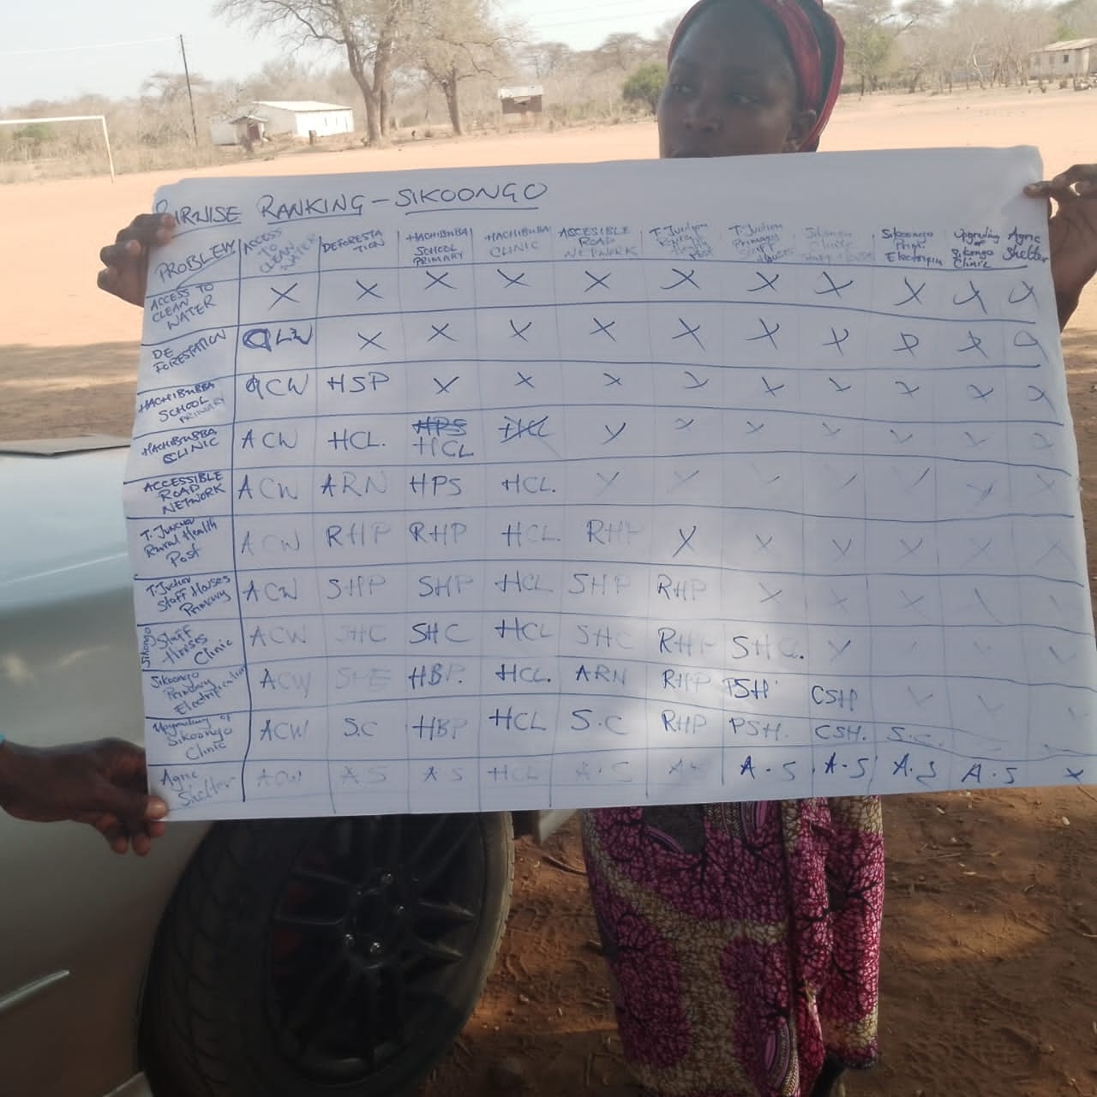
Resource Map for Mushungu ward | Pairwise ranking for Sikoongo ward

