CS 255 Project Two: DriverPass System Design Document

UML Use Case Diagram
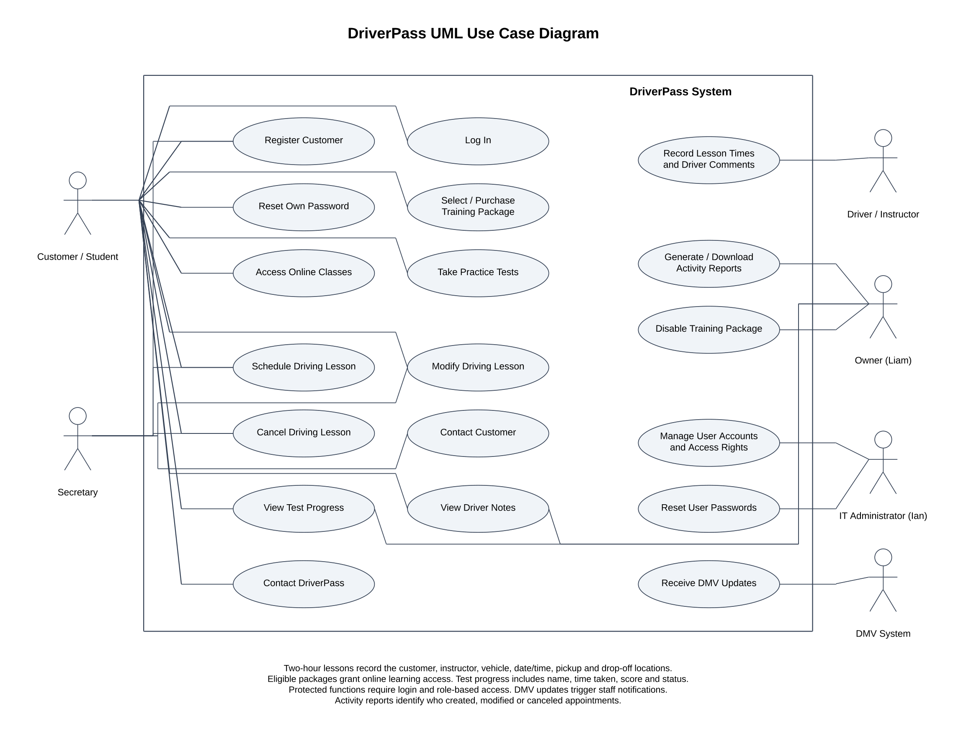
Figure 1. DriverPass use case diagram

UML Activity Diagrams
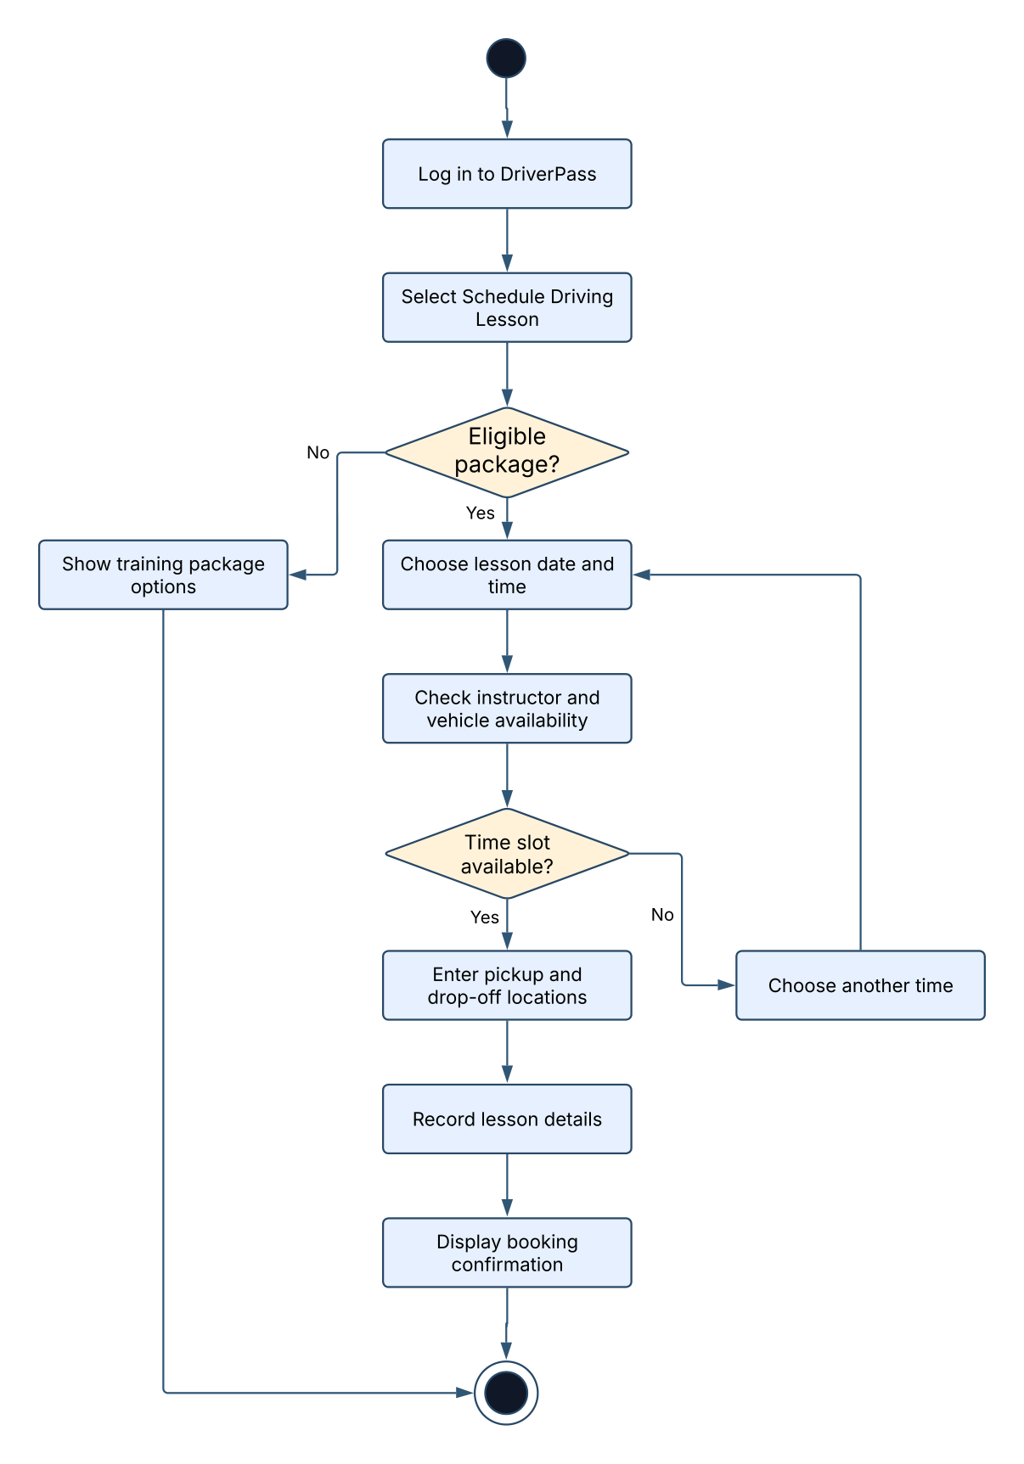
Figure 2. Schedule driving lesson activity diagram
Activity Diagram 2: Take Practice Test
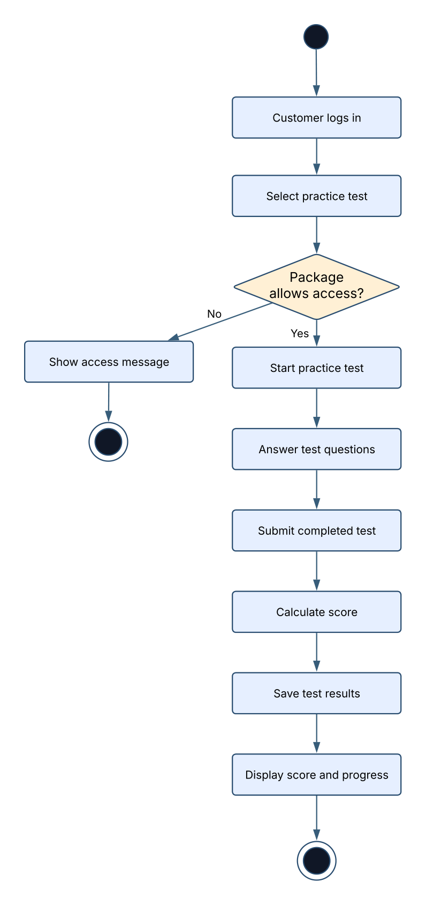
Figure 3. Take practice test activity diagram

UML Sequence Diagram
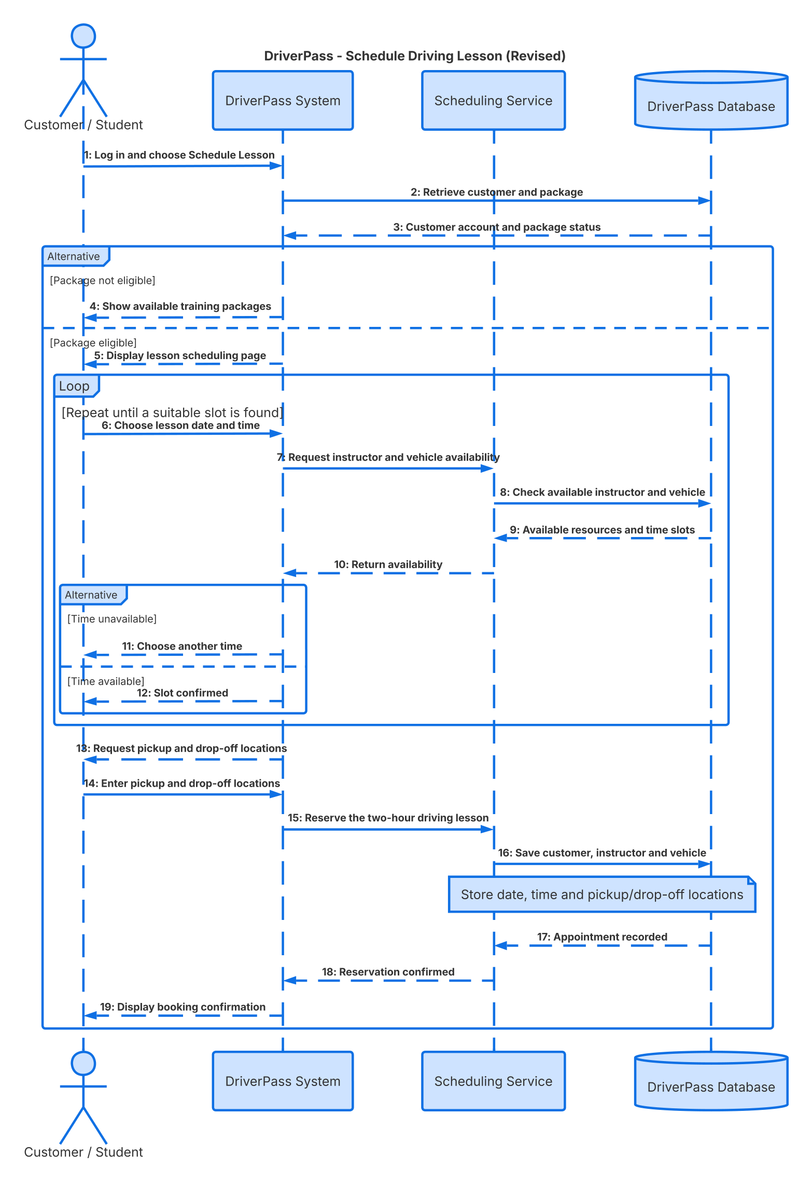
Figure 4. Schedule driving lesson sequence diagram

UML Class Diagram
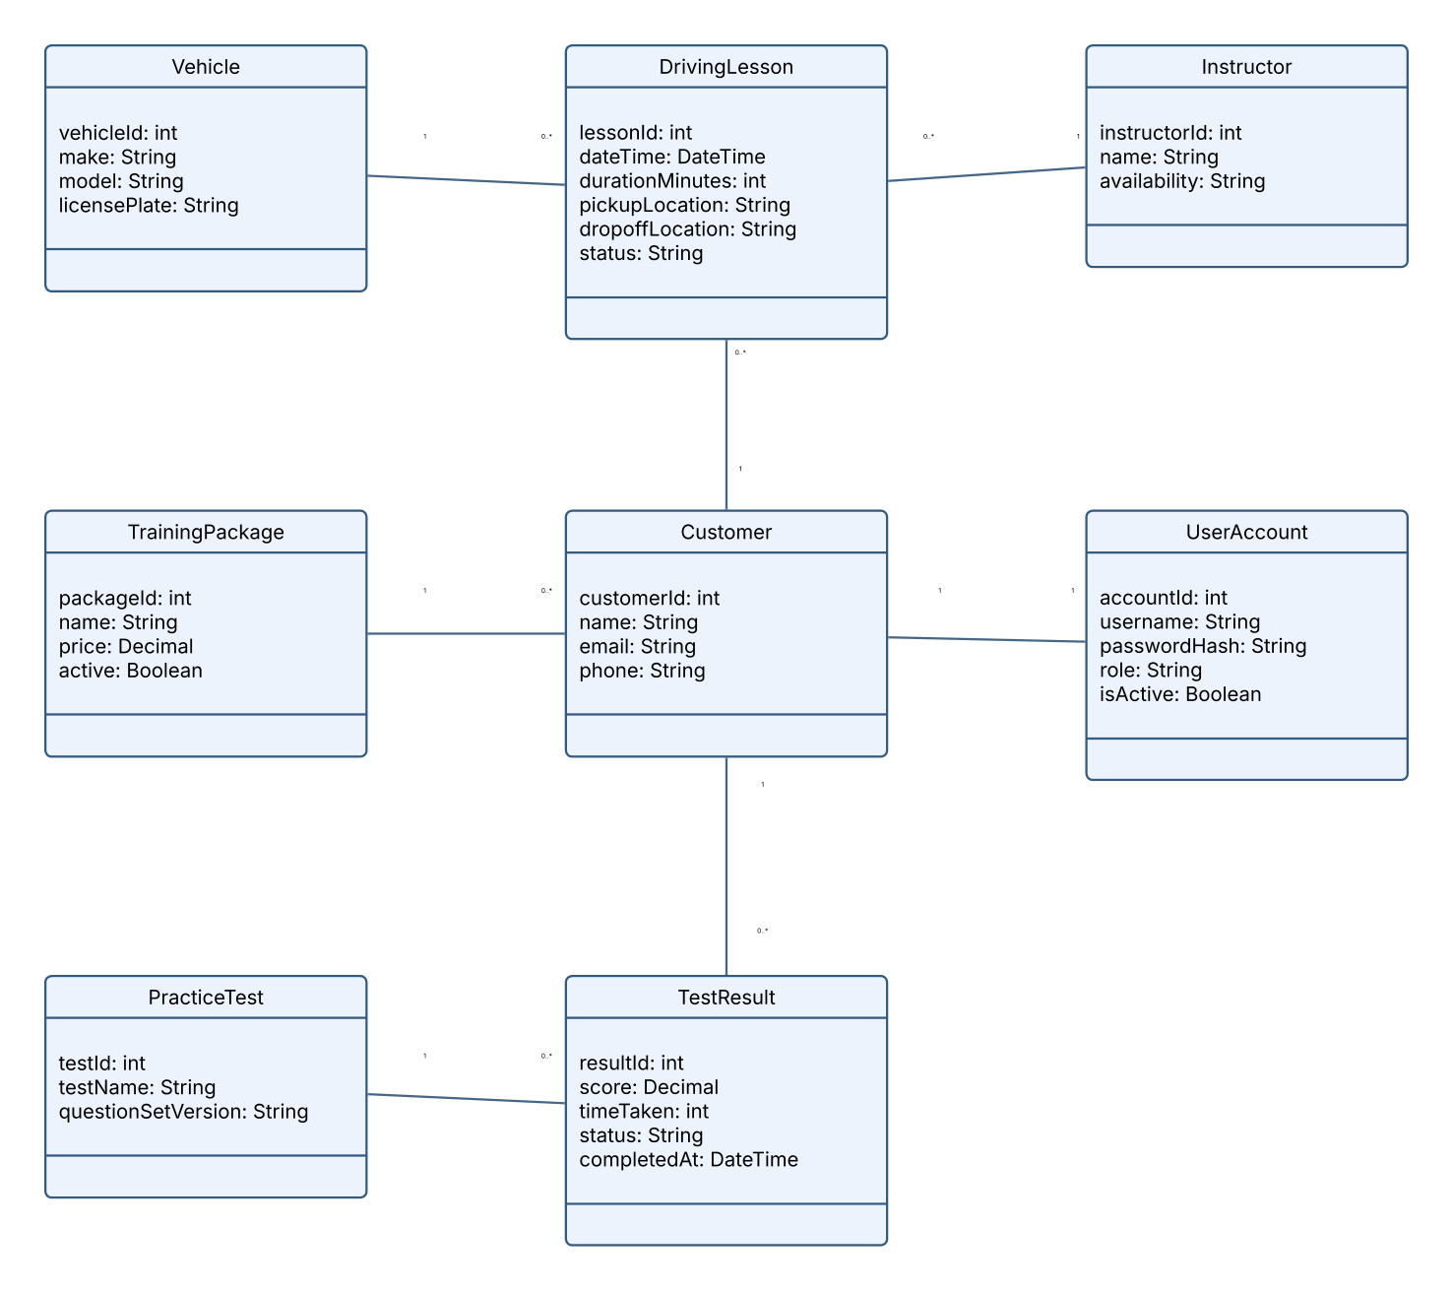
Figure 5. DriverPass class diagram

Technical Requirements
The DriverPass system will be web-based so customers and employees can use it from their computers, tablets, or phones. The system will allow customers to take online classes, complete practice tests, and schedule driving lessons. It will also help DriverPass employees manage appointments, customer information, and other daily tasks.
Hardware
• Customers will need a computer, tablet, or smartphone with internet access to use DriverPass and access their accounts.
• DriverPass employees will need computers and a reliable internet connection to manage customer information, reservations, instructor schedules, vehicles, and reports. A printer may be used when paper reports are needed.
• Since DriverPass will use cloud hosting, the company won’t need to worry about maintaining its own servers.
Software and Tools
• The system will need a website that allows customers and employees to log in and access different features depending on their roles.
• DriverPass will need a database to store customer accounts, training packages, appointments, instructors, vehicles, and driver comments.
• The scheduling system will need to check if an instructor and vehicle are available before allowing a customer to book a lesson. It should also keep track of any appointment changes or cancellations.
• DriverPass will need to support its three training packages, online classes, practice tests, reports, and updated DMV information.
• Developers will need the right tools to create the website and make sure everything works properly before customers start using it.
Infrastructure and Reliability
• I think cloud hosting would be a good option for DriverPass because it would allow customers and employees to access the system online without the company having to manage its own servers.
• The system will need a reliable internet connection to work properly.
• Customers and employees should only be able to make changes when they are connected to the internet. This will help prevent scheduling mistakes.
• Whenever someone makes a change, the system should update the information so everyone sees the correct details.
• The system should also be able to receive updated rules, policies, and sample questions from the DMV. Employees should be notified when new information becomes available.
Security and Access
• Customers and employees will need to log in before accessing personal or protected information.
• Different users should have different levels of access. For example, customers should only be able to view their own information, while employees can access the features they need for their jobs.
• Passwords and customer information should be stored securely. Payment information should also be protected when customers purchase training packages.
• If someone enters the wrong password too many times, the system should temporarily lock the account to help keep it secure.
• Users should also be able to reset their passwords when needed.
• DriverPass should regularly back up its information so important records aren't lost if something goes wrong.
• DriverPass should also keep track of who creates, changes, or cancels appointments.
Design Considerations
• One limitation of DriverPass is that customers and employees will need internet access to use the system properly.
• The system will also depend on the cloud provider to help keep information secure and backed up.
• DriverPass will need the DMV to provide updated information in a format the system can use.
• If DriverPass wants to add more features in the future, the company may need help from developers. Employees will also need some training to understand how to use the system.

