GetSupport() - Algorithm

requirements:
- Function must return a polygon, which is the most likely to break out, which depends on:
- the total area of the Polygon
- the length of cracks, needed to be add
- the distance to the concrete cracks (?)

Get the cost of the smallest SP (thats the supportPolygon that is build by generating all cracks newly in the smallest possible area around the OP)

A) Get the max distance, that any crack in a SP is allowed to have to OP (depends on force).

Step 1: Get the rational transitions for every crack and the following graph

Foreach possible crack:
Get smallest distance to other possible cracks.
Therefore preselect the ones that make sense:

List <crack> rational
List <crack> checked
List<square> GridToCheck
- For all cracks C1 in GridToCheck:
- GetSpannweite() of C1 (all squares that are reached)
- check cracks 'CX' on all reached squares.
- For all are squares SQ_X with: Distance(SQ(C1) , SQ_X) > Distance (SQ(CX) , SQ_X)
{add CX to "rational" and mark squares}
- else: Go to next crack.
- Check cracks on nearest unmarked squares
- Repeat until there are no more unmarked + unchecked squares

Beware: Only travel from left to right (or right to left). Squares left of the current Position therefore do not need to be checked.
Return travelGraph (set of all rational transitions). It could look like this (but weighted)

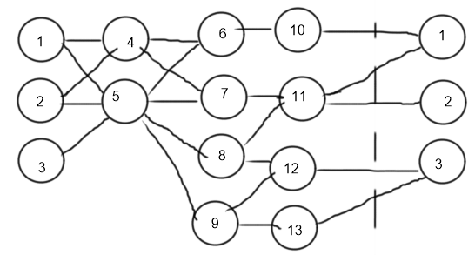

Step 2: Find x:(x -->...--> x) with the smallest cost
.
.
.
return this path (or the x smallest)
Step 3:

toDo:
- Step 2&3
- Add to Step 1: Consider travelling to OP (with cost constant because there is no hole/crack)
- Optimize Step 1: See A) and by considering the strict direction of travel (to the right around OP)
-

SP = SupportPolygon
OP = OriginofforcePoint

