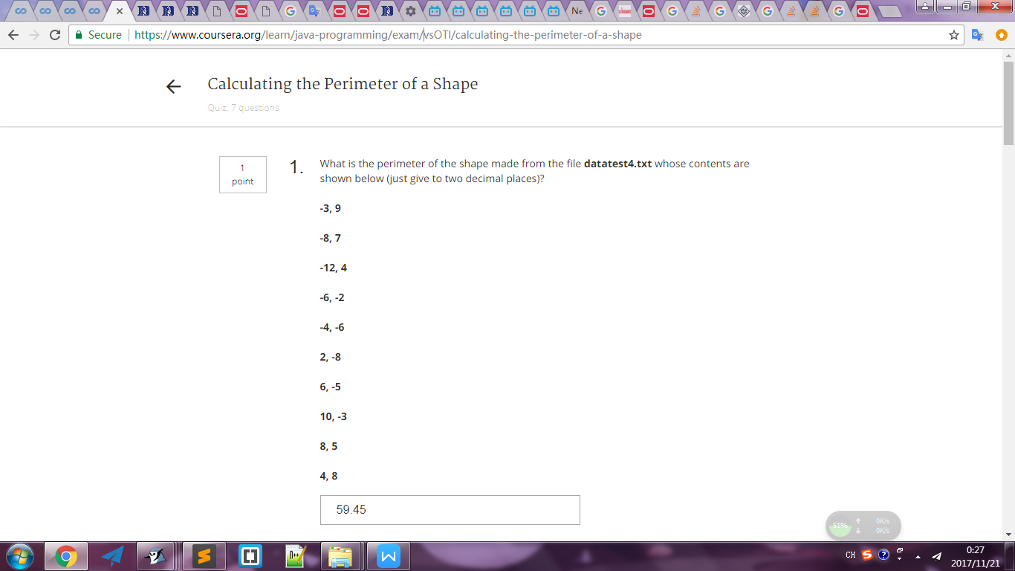

getNumPoints = 10 10

getAverageLength = 5.945655247480979 5.95

getLargestSide = 16.492422502470642 16.49

getLargestX = 10.0 10

getPerimeter = 59.45655247480979 59.46

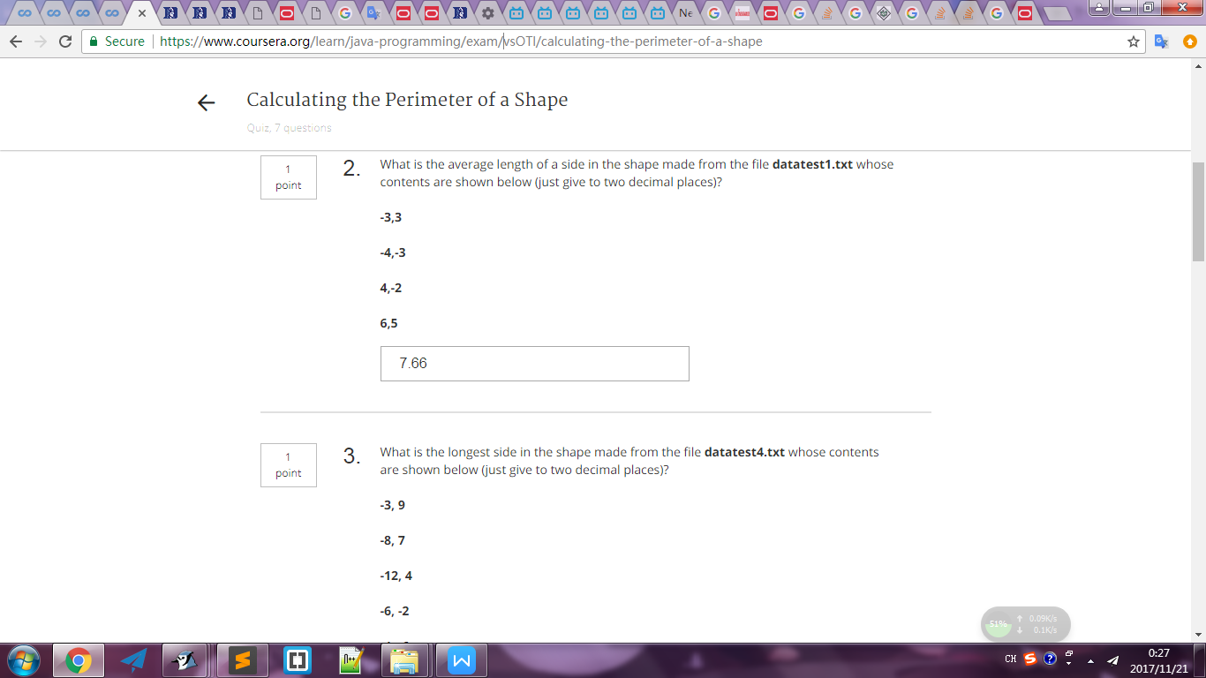

getNumPoints = 4 4

getAverageLength = 7.661168656292543 7.66

getLargestSide = 12.806248474865697 12.81

getLargestX = 6.0 6

getPerimeter = 30.644674625170172 30.64

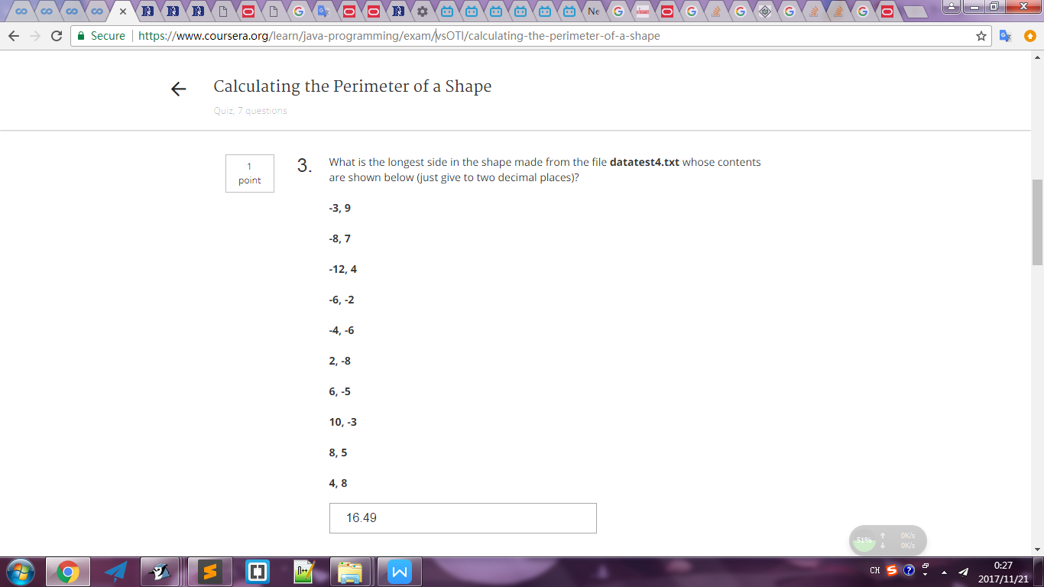

getNumPoints = 10 10

getAverageLength = 5.945655247480979 5.95

getLargestSide = 16.492422502470642 16.49

getLargestX = 10.0 10

getPerimeter = 59.45655247480979 59.46

--new

getNumPoints = 10 10

getAverageLength = 5.945655247480979 5.95

getLargestSide = 8.48528137423857 8.49

getLargestX = 10.0 10

getPerimeter = 59.45655247480979 59.46

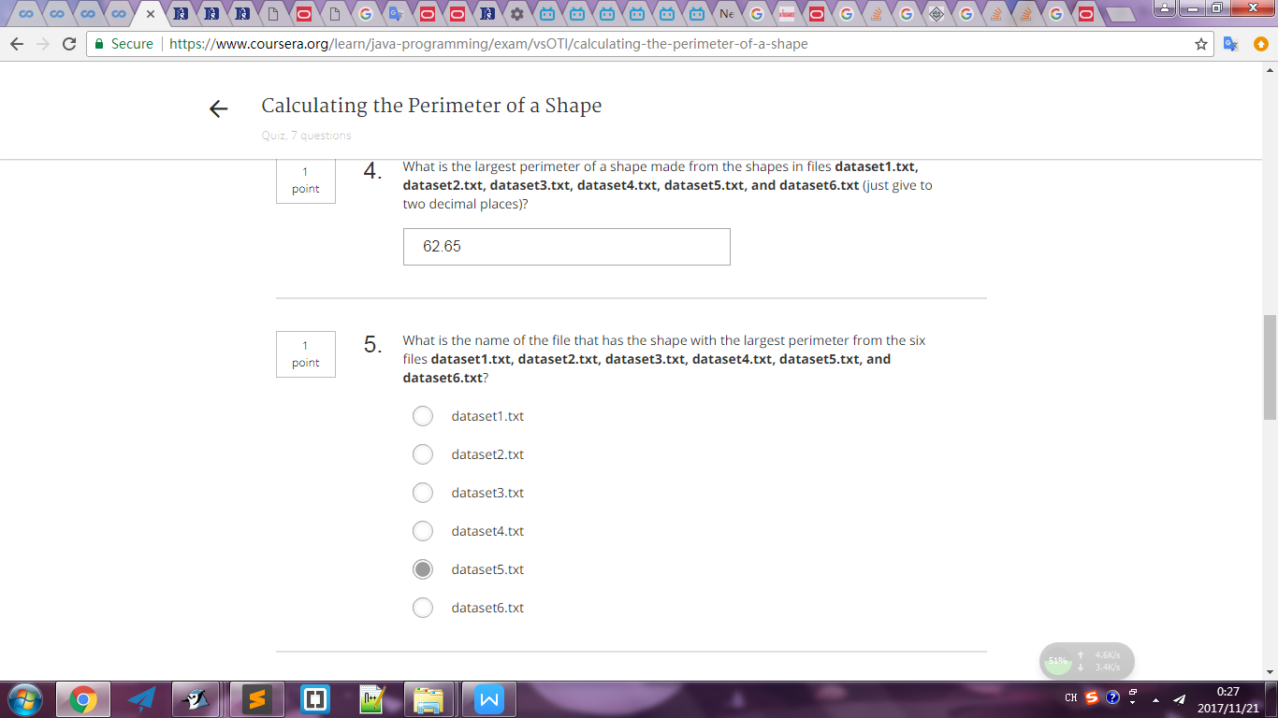

getLargestPerimeterMultipleFiles = 62.650940590154335 62.65

getFileWithLargestPerimeter = datatest5.txt

