# Word to PDF Converter

This is a SharePoint standalone feature to allow users to convert their Word document (*.docx) into a PDF file. The default destination location of the target PDF file will be stored in the same location in the document library where the origin Word document is found.

There are two version of Word to PDF converter as specified below. Choose which one is appropriate for the client’s requirement.

|  |  |  |
| --- | --- | --- |
| **Title** | **Solution Package Filename** | **Description** |
| Custom Menu PDF Converter | rcr.wordpdfconverter.wsp | Converts a Word document to a PDF file by invoking this feature from the custom menu |
| Sequential Workflow PDF Converter | rcr.wf.pdfconverter.wsp | Workflow that runs in the background to convert Word document to a PDF file either by:   * New word document is added * Existing word document is updated * Manually run the workflow |

# Installation

**Pre-requisite**

Prior to installing the Word to PDF Converter, the SharePoint Framework Windows solution package (WSP) MUST be installed in Central Administration:

Run a PowerShell script that will deploy the Windows Solution Package (WSP) file called

* **rcr.sp.framework.wsp**

A successful installation on the SharePoint farm will deploy these WSP file below in Central Administration:



For more details, read: [http://webservices.rcrtom.com.au/corporate-it/spprojects/Solutions%20Documentation/SharePointFrameWork.docx](http://webservices.rcrtom.com.au/corporate-it/spprojects/Solutions%20Documentation/SharePointFrameWork-AsBuilt.docx)

**Installing PDF Converter**

Run a PowerShell script that will deploy either Windows Solution Package (WSP) file called

* **rcr.wordpdfconverter.wsp** or
* **rcr.wf.pdfconverter.wsp**

A successful installation on the SharePoint farm will deploy these WSP file below in Central Administration:

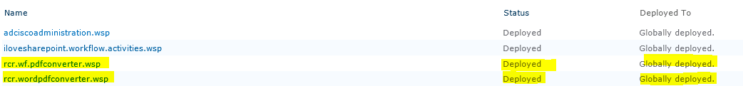

## Feature Activation

After installing the solution package in section 2.0, activate either one of the PDF conversion feature from RCR site.

**Custom Menu PDF Converter**

If custom menu PDF converter was installed, then:

1. Go to the RCR site where the Word to PDF converter feature will be activated.
2. Go to Site Actions->Site Settings->Manage site features
3. Activate **Document to PDF Converter** feature



**Sequential Workflow PDF Converter**

If sequential workflow PDF converter was installed, then:

1. Go to the RCR site where the Word to PDF converter feature will be activated.
2. Go to Site Actions->Site Settings->Site Collection Features
3. Activate two features:
   * **Document to PDF Converter List** – Deploy two custom SharePoint lists i.e. *PDF Settings* and *PDF Notification Log* (more details explained in section 3.2)
   * **Document to PDF Converter Workflow** – Deploy the workflow



## 2.2 Word Automation Service

In order for the PDF conversion feature to run, ensure that **Word Automation Services Timer Job** is running. In Central Administration

1. Go to: Monitoring->Job Definitions->Scheduled Jobs
2. Double click “Word Automation Services Timer Job”
3. Review the recurring schedule and update the schedule as needed to run in 15 minutes (out of the box default settings) or less

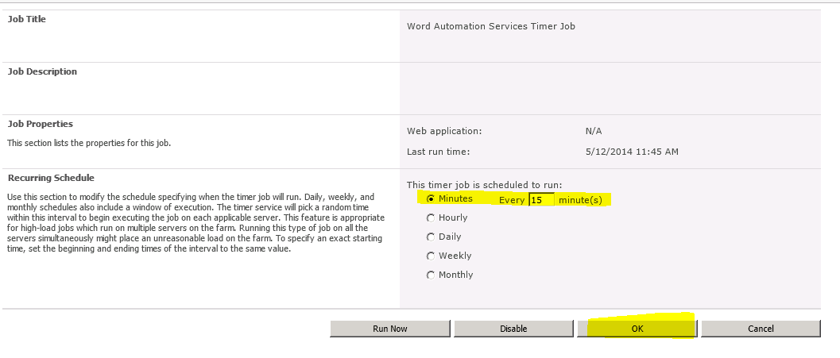

1. Click “OK” button to update the changes.

# How to Use the PDF Converter

## 3.1 Custom Menu PDF Converter

If custom Menu PDF converter was installed, follow the instruction below on how to use it:

1. Go to the document library on the RCR site and select a Word document that is needed for PDF conversion.
2. Click on the down arrow and select “Convert docx to PDF” from the custom action menu.



1. A new window dialog box will pop up. Click “Convert” button to confirm conversion

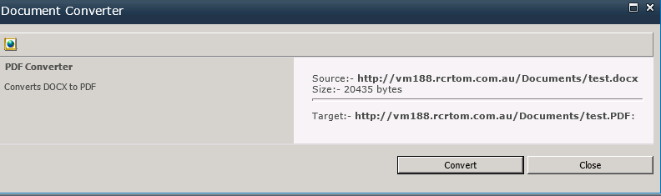

1. If PDF conversion was successful, a message will appear below:

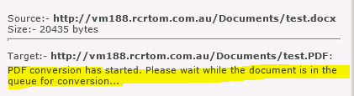

1. Click “Close” button to close the window dialog box
2. Wait for about 15 minutes or less, depending on how often the **Word Automation Services Timer Job** runs in section 2.2
3. The new PDF file will soon be generated.



**Multiple PDF Conversions**

There is also the ability to convert multiple Word documents to PDF instead of converting each individual document. To do this:

1. Tick the check-box on each document that needs to be converted



1. Click the **PDF Conversion button** on the ribbon bar

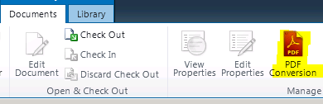

1. A window dialog box will pop up to confirm the list of multiple documents pending conversion. Click the **Convert button** to confirm the selected documents for PDF conversion

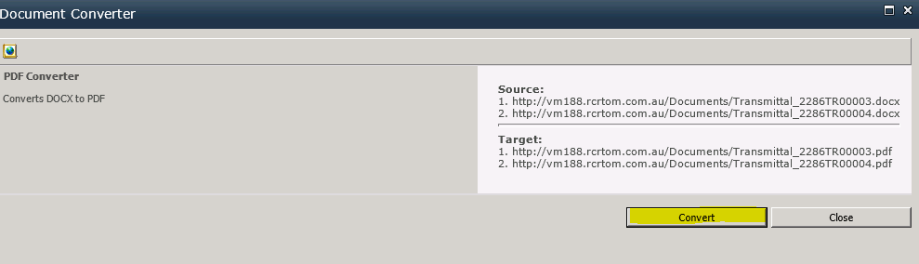

1. A message will be displayed that the selected multiple documents are now in progress of PDF conversion.

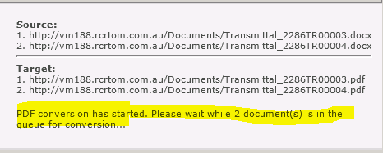

1. Click the **Close button** to close the window dialog box
2. The selected multiple documents will eventually be converted to its PDF file

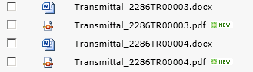

**NOTE:**

Only word document in *.docx format type will be converted into PDF file. If other invalid documents were attempted to be converted into a PDF file, a warning message will be displayed e.g.



## 3.2 Workflow PDF Converter

Follow the instruction below on how to use it, if sequential workflow PDF converter was installed:

**Setting up the workflow**

1. Go the document library of the RCR site where PDF feature will be used
2. Go to Library tab on the ribbon bar and click on Workflow Settings icon->WorkflowSettings

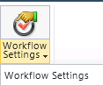

1. Click “Add a workflow” link
2. Do the following:
   1. Select PDFConversionWorkflow from the **workflow dropdown menu**.
   2. Enter a description **name**
   3. Tick the following checkbox:
      1. “Allow this workflow to be manually started..”
      2. Start this workflow when a new item is created – optional depending on requirement
      3. Start this workflow when a new item is changed - optional depending on requirement
   4. Click “OK” button when finish

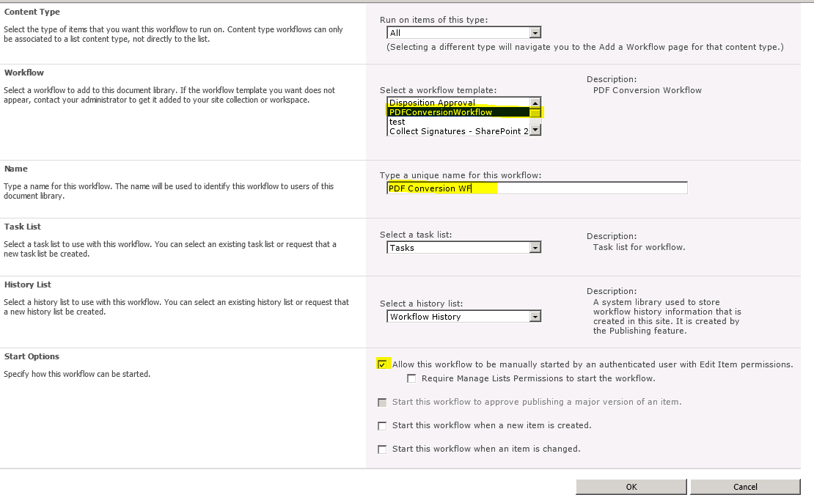

1. Review the ***PDF Settings*** custom list and update the default *setting values* if required. These settings are used by the workflow to log results on the status of PDF conversion workflow and send email.

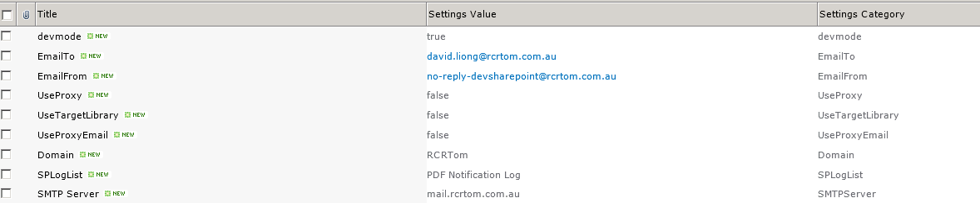

**Starting the Workflow**

1. To manually start PDF conversion workflow, select the document. Then go to custom menu drop down and select *Workflows*

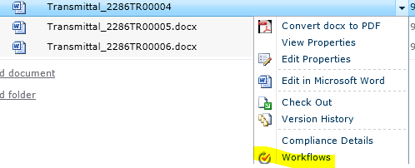

1. Click on PDF Conversion Workflow button to start it.



1. Wait for the workflow to finish. The workflow will:
   1. Send an email to the user who generated the PDF; and

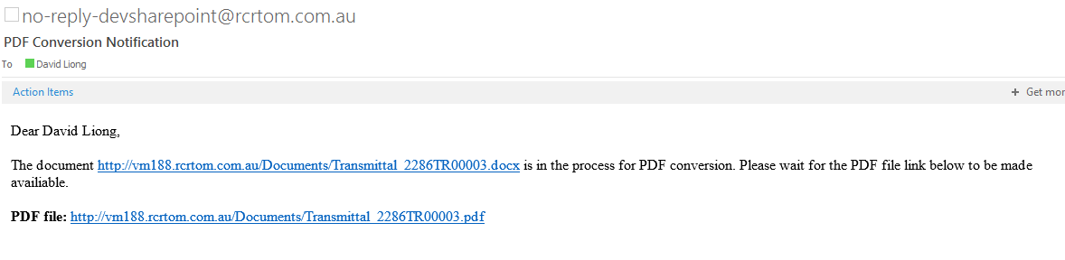

* 1. Logged all workflow activities onto the custom **PDF Notification Log** List

