Software Design Description

Version <number>
<date>

<Project Title>

<Author>

Submitted in partial fulfillment
Of the requirements of
Masters Studio Project
Jacksonville State University

Table of Contents
Type chapter title (level 1) 1
Type chapter title (level 2) 2
Type chapter title (level 3) 3
Type chapter title (level 1) 4
Type chapter title (level 2) 5
Type chapter title (level 3) 6

1.0. Introduction

1.1. Purpose
< Clearly state the purpose of this document and its intended audience. >

1.2. Scope
< State the dominant design methodology. Overview the architecture of the product briefly. Describe the external systems with which this system must interface. >

1.3. Glossary
< Define the technical terms used in this document. Do not assume the experience or expertise of the reader. >

1.4. References
< List here any references to other documents cited anywhere in this document including references to related project documents, especially the SRS. Add references here when other project documents are created. This is usually the only Bibliography in the document. >

1.5. Overview of Document
< Describe the contents and organization of the rest of this document. Since there is already a Table of Contents, this overview will be less formal but more informative. Describe the remaining sections. >

2.0. Deployment Diagram

The deployment is completed on a windows desktop using Microsoft’s ClickOnce deployment system as described in:
https://msdn.microsoft.com/en-us/library/ff699204.aspx
A single self-executing zip file called StockScreenerSetup.exe will be provided to the user to run. Upon running it will install the program inside the users AppData folder per ClickOnce’s deployment system. The user can then start via the Start menu and uninstall if desired via the control panel. The Files installed on the computer will look as so:
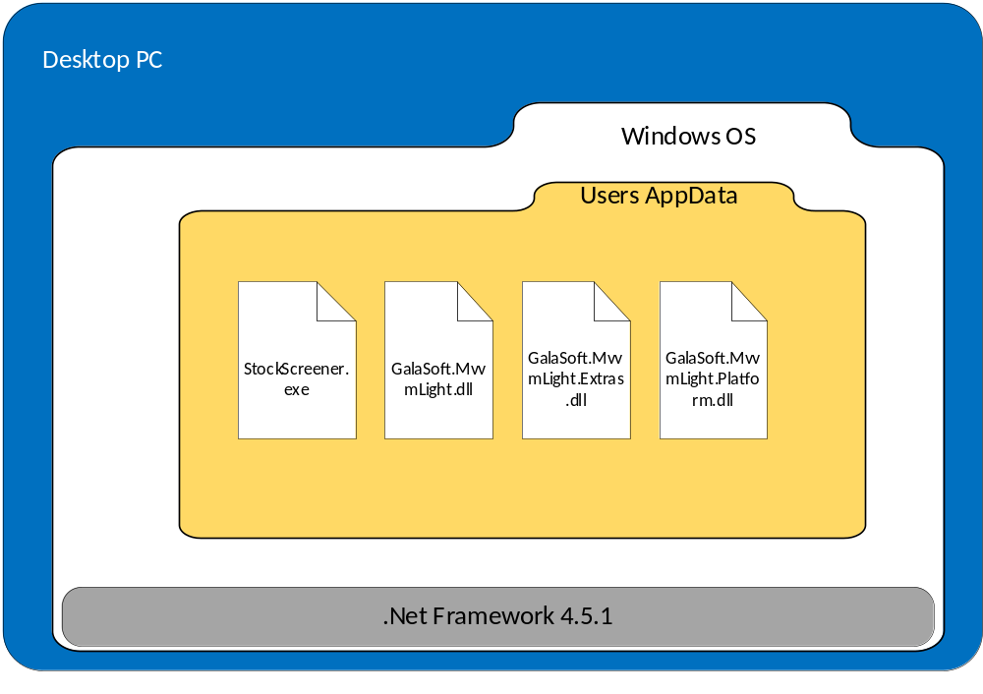

3.0. Architectural Design

The application is a windows desktop application using C# and wpf technologies. The main design pattern is a Model View View-Model design which uses an Observable design pattern to communicate to the UI. It also leverages the Mvvm Light package to allow for an already created template for passing data between the layers. Documentation on Mvvm Light along with explanation of MVVM patterns are found here: http://www.mvvmlight.net/doc/
Below is a common diagram of the MVVM design pattern.
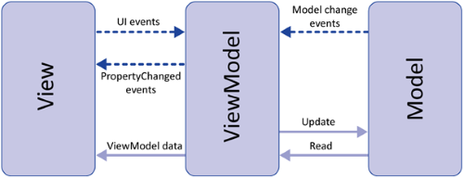
This creates three distinct layers. The View is a light weight layer which communicates to a view model via an interface abstraction. This allows multiple implementations of view models to exists as long as they implement the interface the view is expecting. The View Model Layer communicates between the view and the model layers. It implements the interface the view is expecting and interacts with the Model. Its main purpose is to convert button clicks, textboxes, etc. from a View into commands to talk to the Model. The Model has no concept of a UI and can live by itself and be re-used generically for other applications. Any one of the three layers can have its implementation changed and the code will not break if the interfaces are followed. Our interfaces will be explained in more details in section 4 but from a high level the data communication appears as so:
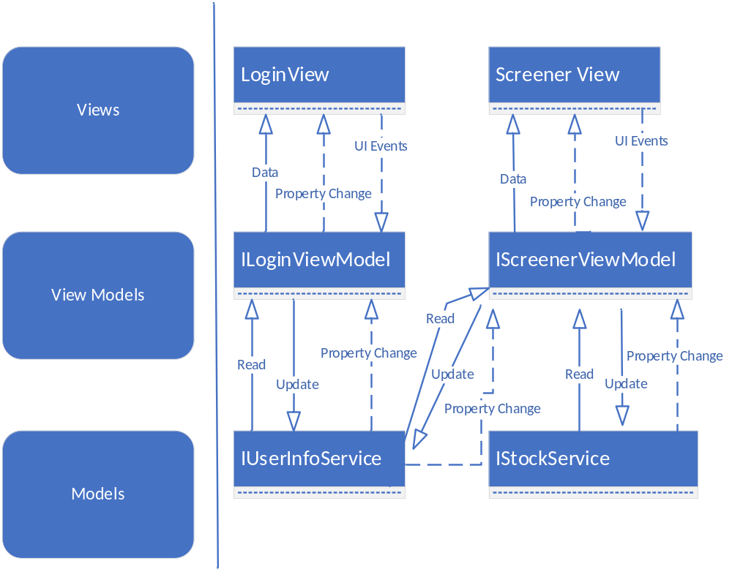
The Stock service implementation will now use Alpha Vantage’s API calls over http to retrieve individual stock data. https://www.alphavantage.co/ The Stock Service implements the IStockService interface, so if this method of retrieving stocks needs to be changed, a different implementation can be created implementing the IStockService and all other view and view models will still work fine.
Two different files will be created, written to, and read from. The Users.xml will contain a list of known users and their settings in an xml format. The class implementing the IUser interface seen in section 4 will be able to serialize and deserializing from the file. It will be stored on the user’s PC at the environment variables path for PROGRAMDATA. This way it is accessible to any user logged into the Windows Operating System. This file will contain all the known user names and their last used settings. The second file is still to be determined. Potentially we will need to store the last known stock values for all the known stocks. This will be either xml, or binary depending on the found performance of the 6000 stocks over xml. At the time we are unsure if this file will be needed or not. It is still to be determined the time it takes to gather all the stock information initially from Alpha Vantage using multiple threads. If the time is under 10 seconds, then we will initialize on each launching of the app. If it is more, we may store the last values to a file that is read on launch and have the newer values trickle in as available. See section 5 for the use cases and the sequential interaction between the implementations.

4.0. Data Structure Design
< If not already covered above, design in detail and specify the data structures to be used in the implementation. If these include databases, define the table structure of all databases including full field descriptions and all relations. Graphical languages are appropriate. Note that a database is an object and may have been fully described in the previous section. If the material is covered under Architectural Design, this section is omitted. >

5.0 Use Case Realizations

Use case from SRS document section 4.1:
Login Button Case:
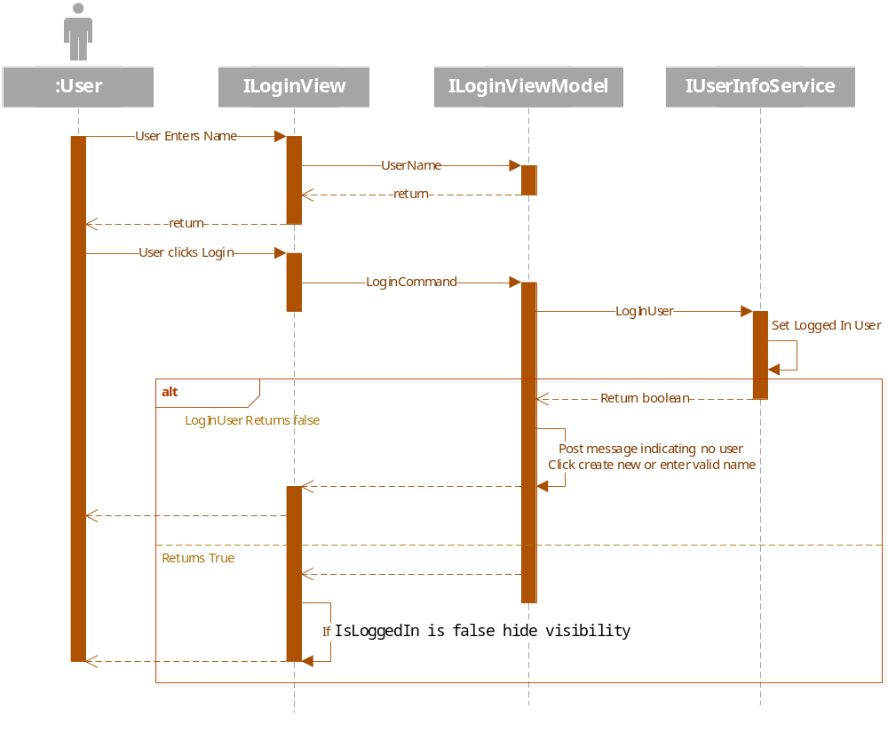
Create New Button Case:

6.0 User Interface Design

< Refer to User Interface material in the SRS and supplement with any design considerations not mentioned there. You should discuss the expected effectiveness of your design. >

7.0 Help System Design
< Describe the structure of the help system and how it is to be accessed. Will it be context sensitive? Will there be a system reference capability? >

Index

< generate here >

