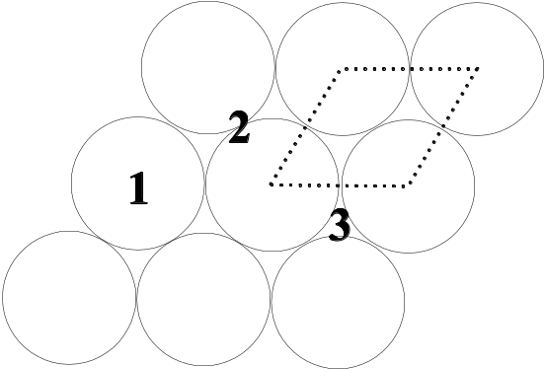
Figure 1. Lattice structure of Pt(111), showing potential sites for chemisorption (1-3) and primitive unit cell (dotted line)
 | Diagonal attachment
Seed | Yes |  | No
0 | 1.661 | 0.006 | 1.706 | 0.005
1 | 1.644 | 0.005 | 1.670 | 0.004
2 | 1.690 | 0.004 | 1.642 | 0.005
3 | 1.675 | 0.004 | 1.680 | 0.005
4 | 1.654 | 0.004 | 1.632 | 0.005
Effect | Likelihood score | Impact score | Overall | Mitigation
Delays whilst waiting for repair | 1 | 10 | 10 | None possible
Short delays | 4 | 5 | 20 | Check maintenance dates in advance to ensure codes were not shceduled to be run then
Potentially massive amount of work to repeat | 3 | 9 | 27 | Regular backups
Loss of individual run data | 6 | 2 | 12 | Check for updates regularly
Unable to fully reproduce Alexandrowicz 2008 | 6 | 3 | 18 | None possible
Incorrect results | 5 | 4 | 20 | Make sure code is understood fully, check results qualitatively after each run
Table I. Calculated fractal dimensions for aggregates with different seed types and attachment algorithms, as well as associated errors (smaller values)

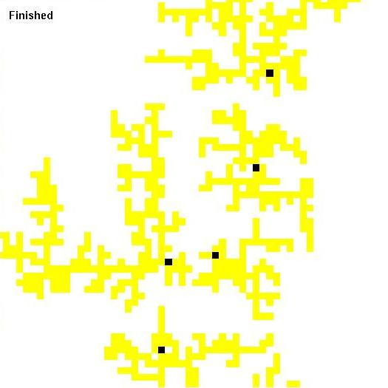
Figure 9. Close up of region highlighted on fig. 8, to show gaps between aggregates

Figure 8. Simulation of LiF growth on Ag(111) using periodic boundary conditions and 80 single-particle seeds
 | Diagonal attachment
Seed | No |  | Yes
0 | 1.661 | 0.004
1 |  |  | 1.715 | 0.004
3 |  |  | 1.682 | 0.004
4 | 1.682 | 0.003
Table II. Calculated fractal dimensions for aggregates with different seed types and attachment algorithms, with a larger grid size (only some results calculated)
Sticking | PBCs |  | SBCs
Probability | Result | Error | Result | Error
1.0 | 1.711 | 0.003 | 1.680 | 0.005
0.5 | 1.736 | 0.003 | 1.663 | 0.003

Table III. Fractal dimensions found under periodic and standard boundary conditions, with two different sticking probabilities

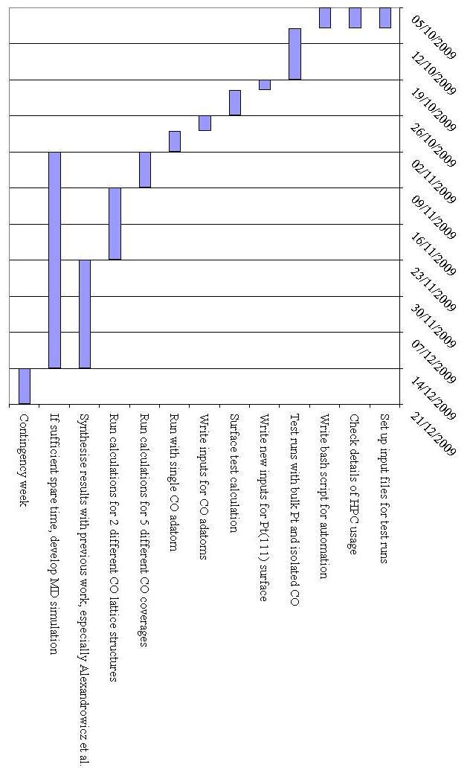
Figure 3. Gantt chart showing programme of work for the project, over its 11 week duration. Weeks start on a Monday, hence the last two days of any week are not actually used.

