Міністерство освіти і науки України

Національний університет «Львівська політехніка»

Кафедра ЕОМ



Звіт

до лабораторної роботи № 3

з дисципліни «Моделювання комп’ютерних систем»

на тему:

«Поведінковий опис цифрового автомата Перевірка роботи автомата за допомогою стенда Elbert V2 – Spartan 3A FPGA»

**Варіант №10**

Виконав:

ст. гр. КІ-201

Гришканич А. М.

Прийняв:  
Козак Н. Б.

Львів 2024

**Мета роботи**: На базі стенда реалізувати цифровий автомат для обчислення значення виразів.

**Виконання роботи:**

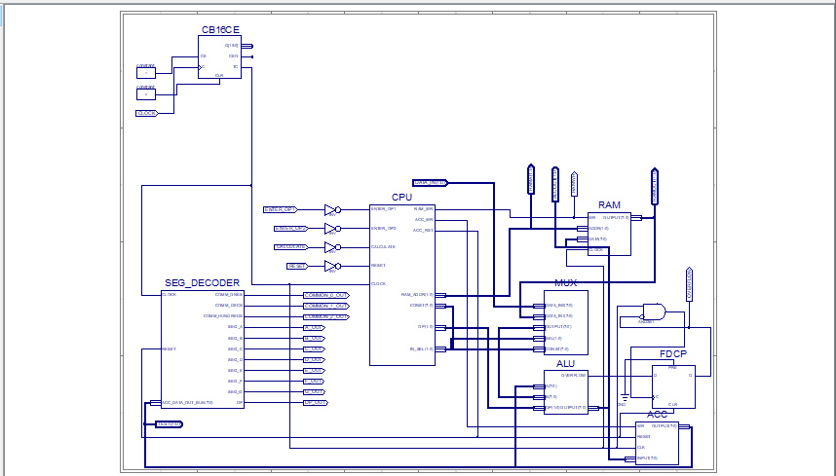

*Рис. 1 – Top Level*

| Файл ACC.vhd   1. library IEEE; 2. use IEEE.STD_LOGIC_1164.ALL; 3. -- Uncomment the following library declaration if using 4. -- arithmetic functions with Signed or Unsigned values 5. --use IEEE.NUMERIC_STD.ALL; 6. -- Uncomment the following library declaration if instantiating 7. -- any Xilinx primitives in this code. 8. --library UNISIM; 9. --use UNISIM.VComponents.all; 10. entity ACC is 11. Port ( WR : in STD_LOGIC; 12. RESET : in STD_LOGIC; 13. CLK : in STD_LOGIC; 14. INPUT : in STD_LOGIC_VECTOR (7 downto 0); 15. OUTPUT : out STD_LOGIC_VECTOR (7 downto 0)); 16. end ACC; 17. architecture ACC_arch of ACC is 18. signal DATA : STD_LOGIC_VECTOR (7 downto 0); 19. begin 20. process (CLK) 21. begin 22. if rising_edge(CLK) then 23. if RESET = '1' then 24. DATA <= (others => '0'); 25. elsif WR = '1' then 26. DATA <= INPUT; 27. end if; 28. end if; 29. end process; 31. OUTPUT <= DATA; 32. end ACC_arch; |
| --- |

| Файл ALU.vhd   1. library IEEE; 2. use IEEE.STD_LOGIC_1164.ALL; 3. -- Uncomment the following library declaration if using 4. -- arithmetic functions with Signed or Unsigned values 5. use IEEE.NUMERIC_STD.ALL; 6. use IEEE.STD_LOGIC_UNSIGNED.ALL; 7. -- Uncomment the following library declaration if instantiating 8. -- any Xilinx primitives in this code. 9. --library UNISIM; 10. --use UNISIM.VComponents.all; 11. entity ALU is 12. Port ( A : in STD_LOGIC_VECTOR(7 downto 0); 13. B : in STD_LOGIC_VECTOR(7 downto 0); 14. OP : in STD_LOGIC_VECTOR(1 downto 0); 15. OUTPUT : out STD_LOGIC_VECTOR(7 downto 0); 16. OVERFLOW: out STD_LOGIC); 17. end ALU; 18. architecture ALU_Behavioral of ALU is 19. signal ALUR: STD_LOGIC_VECTOR(15 downto 0) := (others => '0'); 20. signal Carry: STD_LOGIC := '0'; 21. begin 22. process(A, B, OP) 23. begin 24. case (OP) is 25. when "01" => ALUR <= ("00000000" & A) + ("00000000" & B); 26. when "10" => ALUR <= ("00000000" & A) + ("11111111" & not B) + "0000000000000001"; 27. when "11" => 28. case(B) is 29. when x"00" => ALUR <= std_logic_vector(unsigned(("00000000" & A)) sll 0); 30. when x"01" => ALUR <= std_logic_vector(unsigned(("00000000" & A)) sll 1); 31. when x"02" => ALUR <= std_logic_vector(unsigned(("00000000" & A)) sll 2); 32. when x"03" => ALUR <= std_logic_vector(unsigned(("00000000" & A)) sll 3); 33. when x"04" => ALUR <= std_logic_vector(unsigned(("00000000" & A)) sll 4); 34. when x"05" => ALUR <= std_logic_vector(unsigned(("00000000" & A)) sll 5); 35. when x"06" => ALUR <= std_logic_vector(unsigned(("00000000" & A)) sll 6); 36. when x"07" => ALUR <= std_logic_vector(unsigned(("00000000" & A)) sll 7); 37. when others => ALUR <= std_logic_vector(unsigned(("00000000" & A)) sll 0); 38. end case; 39. when others => ALUR <= ("00000000" & B); 40. end case; 41. end process; 42. OUTPUT <= ALUR(7 downto 0); 43. OVERFLOW <= ALUR(8) OR ALUR(9) OR ALUR(10) OR ALUR(11) OR ALUR(12) OR ALUR(13) OR ALUR(14) OR ALUR(15); 44. end ALU_Behavioral; |
| --- |

| Файл CPU.vhd   1. library IEEE; 2. use IEEE.STD_LOGIC_1164.ALL; 3. entity CPU is 4. port( ENTER_OP1 : IN STD_LOGIC; 5. ENTER_OP2 : IN STD_LOGIC; 6. CALCULATE : IN STD_LOGIC; 7. RESET : IN STD_LOGIC; 8. CLOCK : IN STD_LOGIC; 9. RAM_WR : OUT STD_LOGIC; 10. RAM_ADDR : OUT STD_LOGIC_VECTOR(1 DOWNTO 0); 11. CONST : OUT STD_LOGIC_VECTOR(7 DOWNTO 0); 12. ACC_WR : OUT STD_LOGIC; 13. ACC_RST : OUT STD_LOGIC; 14. IN_SEL : OUT STD_LOGIC_VECTOR(1 downto 0); 15. OP : OUT STD_LOGIC_VECTOR(1 DOWNTO 0)); 16. end CPU; 18. architecture CPU_arch of CPU is 19. type STATE_TYPE is (RST, IDLE, LOAD_OP1, LOAD_OP2, RUN_CALC0, RUN_CALC1, RUN_CALC2, RUN_CALC3, RUN_CALC4, FINISH); 20. signal CUR_STATE : STATE_TYPE; 21. signal NEXT_STATE : STATE_TYPE; 22. begin 23. SYNC_PROC: process (CLOCK) 24. begin 25. if (rising_edge(CLOCK)) then 26. if (RESET = '1') then 27. CUR_STATE <= RST; 28. else 29. CUR_STATE <= NEXT_STATE; 30. end if; 31. end if; 32. end process;  35. NEXT_STATE_DECODE: process (CLOCK, ENTER_OP1, ENTER_OP2, CALCULATE) 36. begin 37. NEXT_STATE <= CUR_STATE; 39. case(CUR_STATE) is 40. when RST => 41. NEXT_STATE <= IDLE; 42. when IDLE => 43. if (ENTER_OP1 = '1') then 44. NEXT_STATE <= LOAD_OP1; 45. elsif (ENTER_OP2 = '1') then 46. NEXT_STATE <= LOAD_OP2; 47. elsif (CALCULATE = '1') then 48. NEXT_STATE <= RUN_CALC0; 49. else 50. NEXT_STATE <= IDLE; 51. end if; 52. when LOAD_OP1 => 53. NEXT_STATE <= IDLE; 54. when LOAD_OP2 => 55. NEXT_STATE <= IDLE; 56. when RUN_CALC0 => 57. NEXT_STATE <= RUN_CALC1; 58. when RUN_CALC1 => 59. NEXT_STATE <= RUN_CALC2; 60. when RUN_CALC2 => 61. NEXT_STATE <= RUN_CALC3; 62. when RUN_CALC3 => 63. NEXT_STATE <= RUN_CALC4; 64. when RUN_CALC4 => 65. NEXT_STATE <= FINISH; 66. when FINISH => 67. NEXT_STATE <= FINISH; 68. when others => 69. NEXT_STATE <= IDLE; 70. end case; 71. end process; 72. OUTPUT_DECODE: process (CUR_STATE) 73. begin 74. case (CUR_STATE) is 75. when RST => 76. RAM_WR <= '0'; 77. RAM_ADDR <= "00"; 78. CONST <= "00000000"; 79. ACC_WR <= '0'; 80. ACC_RST <= '1'; 81. IN_SEL <= "00"; 82. OP <= "00"; 83. when LOAD_OP1 => 84. RAM_WR <= '1'; 85. RAM_ADDR <= "00"; 86. CONST <= "00000000"; 87. ACC_WR <= '0'; 88. ACC_RST <= '1'; 89. IN_SEL <= "00"; 90. OP <= "00"; 91. when LOAD_OP2 => 92. RAM_WR <= '1'; 93. RAM_ADDR <= "01"; 94. CONST <= "00000000"; 95. ACC_WR <= '0'; 96. ACC_RST <= '1'; 97. IN_SEL <= "00"; 98. OP <= "00"; 99. when RUN_CALC0 => 100. RAM_WR <= '0'; 101. RAM_ADDR <= "01"; 102. CONST <= "00000000"; 103. ACC_WR <= '1'; 104. ACC_RST <= '0'; 105. IN_SEL <= "01"; 106. OP <= "00"; 107. when RUN_CALC1 => 108. RAM_WR <= '0'; 109. RAM_ADDR <= "00"; 110. CONST <= "00000000"; 111. ACC_WR <= '1'; 112. ACC_RST <= '0'; 113. IN_SEL <= "01"; 114. OP <= "10"; 115. when RUN_CALC2 => 116. RAM_WR <= '0'; 117. RAM_ADDR <= "00"; 118. CONST <= "00000001"; 119. ACC_WR <= '1'; 120. ACC_RST <= '0'; 121. IN_SEL <= "10"; 122. OP <= "11"; 123. when RUN_CALC3 => 124. RAM_WR <= '0'; 125. RAM_ADDR <= "00"; 126. CONST <= "00000000"; 127. ACC_WR <= '1'; 128. ACC_RST <= '0'; 129. IN_SEL <= "01"; 130. OP <= "01"; 131. when RUN_CALC4 => 132. RAM_WR <= '0'; 133. RAM_ADDR <= "00"; 134. CONST <= "00001010"; 135. ACC_WR <= '1'; 136. ACC_RST <= '0'; 137. IN_SEL <= "10"; 138. OP <= "01"; 139. when IDLE => 140. RAM_WR <= '0'; 141. RAM_ADDR <= "00"; 142. CONST <= "00000000"; 143. ACC_WR <= '0'; 144. ACC_RST <= '0'; 145. IN_SEL <= "00"; 146. OP <= "00"; 147. when others => 148. RAM_WR <= '0'; 149. RAM_ADDR <= "00"; 150. CONST <= "00000000"; 151. ACC_WR <= '0'; 152. ACC_RST <= '0'; 153. IN_SEL <= "00"; 154. OP <= "00"; 155. end case; 156. end process; 157. end CPU_arch; |
| --- |

| Файл MUX.vhd   1. library IEEE; 2. use IEEE.STD_LOGIC_1164.ALL; 3. entity MUX is 4. PORT( 5. SEL: in STD_LOGIC_VECTOR(1 downto 0); 6. CONST: in STD_LOGIC_VECTOR(7 downto 0); 7. --CONST1: in STD_LOGIC_VECTOR() 8. DATA_IN0: in STD_LOGIC_VECTOR(7 downto 0); 9. DATA_IN1: in STD_LOGIC_VECTOR(7 downto 0); 10. OUTPUT: out STD_LOGIC_VECTOR(7 downto 0) 11. ); 12. end MUX; 13. architecture Behavioral of MUX is 14. begin 15. process (SEL, DATA_IN0, DATA_IN1, CONST) 16. begin 17. if (SEL = "00") then 18. OUTPUT <= DATA_IN0; 19. elsif (SEL = "01") then 20. OUTPUT <= DATA_IN1; 21. else 22. OUTPUT <= CONST; 23. end if; 24. end process; 25. end Behavioral; |
| --- |

| Файл RAM.vhd   1. library IEEE; 2. use IEEE.STD_LOGIC_1164.ALL; 3. use IEEE.NUMERIC_STD.ALL; 4. use IEEE.STD_LOGIC_UNSIGNED.ALL; 5. entity RAM is 6. port( 7. WR : IN STD_LOGIC; 8. ADDR : IN STD_LOGIC_VECTOR(1 DOWNTO 0); 9. DATA : IN STD_LOGIC_VECTOR(7 DOWNTO 0); 10. CLOCK: IN STD_LOGIC; 11. OUTPUT : OUT STD_LOGIC_VECTOR(7 DOWNTO 0) 12. ); 13. end RAM; 14. architecture RAM_arch of RAM is 15. type ram_type is array (3 downto 0) of STD_LOGIC_VECTOR(7 downto 0); 16. signal UNIT : ram_type; 17. begin 18. process(ADDR, CLOCK, UNIT) 19. begin 20. if(rising_edge(CLOCK)) then 21. if (WR = '1') then 22. UNIT(conv_integer(ADDR)) <= DATA; 23. end if; 24. end if; 25. OUTPUT <= UNIT(conv_integer(ADDR)); 26. end process; 27. end RAM_arch; |
| --- |

| Файл SEG_DECODER.vhd   1. library IEEE; 2. use IEEE.STD_LOGIC_1164.ALL; 3. use IEEE.STD_LOGIC_ARITH.ALL; 4. use IEEE.STD_LOGIC_UNSIGNED.ALL; 5. entity SEG_DECODER is 6. port( CLOCK : IN STD_LOGIC; 7. RESET : IN STD_LOGIC; 8. ACC_DATA_OUT_BUS : IN STD_LOGIC_VECTOR(7 DOWNTO 0); 9. COMM_ONES : OUT STD_LOGIC; 10. COMM_DECS : OUT STD_LOGIC; 11. COMM_HUNDREDS : OUT STD_LOGIC; 12. SEG_A : OUT STD_LOGIC; 13. SEG_B : OUT STD_LOGIC; 14. SEG_C : OUT STD_LOGIC; 15. SEG_D : OUT STD_LOGIC; 16. SEG_E : OUT STD_LOGIC; 17. SEG_F : OUT STD_LOGIC; 18. SEG_G : OUT STD_LOGIC; 19. DP : OUT STD_LOGIC); 20. end SEG_DECODER; 21. architecture Behavioral of SEG_DECODER is 22. signal ONES_BUS : STD_LOGIC_VECTOR(3 downto 0) := "0000"; 23. signal DECS_BUS : STD_LOGIC_VECTOR(3 downto 0) := "0001"; 24. signal HONDREDS_BUS : STD_LOGIC_VECTOR(3 downto 0) := "0000"; 25. begin 26. BIN_TO_BCD : process (ACC_DATA_OUT_BUS) 27. variable hex_src : STD_LOGIC_VECTOR(7 downto 0) ; 28. variable bcd : STD_LOGIC_VECTOR(11 downto 0) ; 29. begin 30. bcd := (others => '0') ; 31. hex_src := ACC_DATA_OUT_BUS; 32. for i in hex_src'range loop 33. if bcd(3 downto 0) > "0100" then 34. bcd(3 downto 0) := bcd(3 downto 0) + "0011" ; 35. end if ; 36. if bcd(7 downto 4) > "0100" then 37. bcd(7 downto 4) := bcd(7 downto 4) + "0011" ; 38. end if ; 39. if bcd(11 downto 8) > "0100" then 40. bcd(11 downto 8) := bcd(11 downto 8) + "0011" ; 41. end if ; 43. bcd := bcd(10 downto 0) & hex_src(hex_src'left) ; -- shift bcd + 1 new entry 44. hex_src := hex_src(hex_src'left - 1 downto hex_src'right) & '0' ; -- shift src + pad with 0 45. end loop ; 46. HONDREDS_BUS <= bcd (11 downto 8); 47. DECS_BUS <= bcd (7 downto 4); 48. ONES_BUS <= bcd (3 downto 0); 50. end process BIN_TO_BCD; 52. INDICATE : process(CLOCK) 53. type DIGIT_TYPE is (ONES, DECS, HUNDREDS); 55. variable CUR_DIGIT : DIGIT_TYPE := ONES; 56. variable DIGIT_VAL : STD_LOGIC_VECTOR(3 downto 0) := "0000"; 57. variable DIGIT_CTRL : STD_LOGIC_VECTOR(6 downto 0) := "0000000"; 58. variable COMMONS_CTRL : STD_LOGIC_VECTOR(2 downto 0) := "000"; 60. begin 61. if (rising_edge(CLOCK)) then 62. if(RESET = '0') then 63. case CUR_DIGIT is 64. when ONES => 65. DIGIT_VAL := ONES_BUS; 66. CUR_DIGIT := DECS; 67. COMMONS_CTRL := "001"; 68. when DECS => 69. DIGIT_VAL := DECS_BUS; 70. CUR_DIGIT := HUNDREDS; 71. COMMONS_CTRL := "010"; 72. when HUNDREDS => 73. DIGIT_VAL := HONDREDS_BUS; 74. CUR_DIGIT := ONES; 75. COMMONS_CTRL := "100"; 76. when others => 77. DIGIT_VAL := ONES_BUS; 78. CUR_DIGIT := ONES; 79. COMMONS_CTRL := "000"; 80. end case; 82. case DIGIT_VAL is --abcdefg 83. when "0000" => DIGIT_CTRL := "1111110"; 84. when "0001" => DIGIT_CTRL := "0110000"; 85. when "0010" => DIGIT_CTRL := "1101101"; 86. when "0011" => DIGIT_CTRL := "1111001"; 87. when "0100" => DIGIT_CTRL := "0110011"; 88. when "0101" => DIGIT_CTRL := "1011011"; 89. when "0110" => DIGIT_CTRL := "1011111"; 90. when "0111" => DIGIT_CTRL := "1110000"; 91. when "1000" => DIGIT_CTRL := "1111111"; 92. when "1001" => DIGIT_CTRL := "1111011"; 93. when others => DIGIT_CTRL := "0000000"; 94. end case; 95. else 96. DIGIT_VAL := ONES_BUS; 97. CUR_DIGIT := ONES; 98. COMMONS_CTRL := "000"; 99. end if; 101. COMM_ONES <= not COMMONS_CTRL(0); 102. COMM_DECS <= not COMMONS_CTRL(1); 103. COMM_HUNDREDS <= not COMMONS_CTRL(2); 105. SEG_A <= not DIGIT_CTRL(6); 106. SEG_B <= not DIGIT_CTRL(5); 107. SEG_C <= not DIGIT_CTRL(4); 108. SEG_D <= not DIGIT_CTRL(3); 109. SEG_E <= not DIGIT_CTRL(2); 110. SEG_F <= not DIGIT_CTRL(1); 111. SEG_G <= not DIGIT_CTRL(0); 112. DP <= '1'; 114. end if; 115. end process INDICATE; 116. end Behavioral; |
| --- |

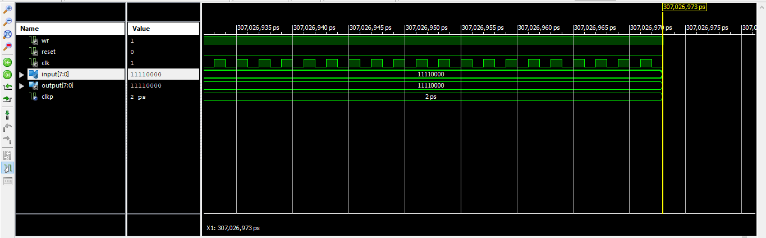

*Рис. 2 – Часова діаграма ACC*

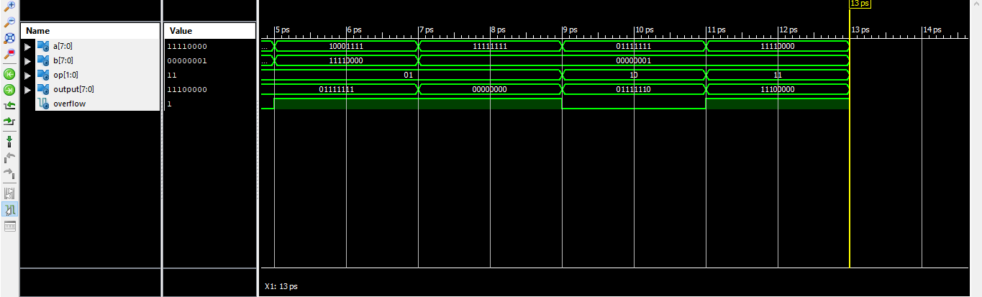

*Рис. 3 – Часова діаграма ALU*

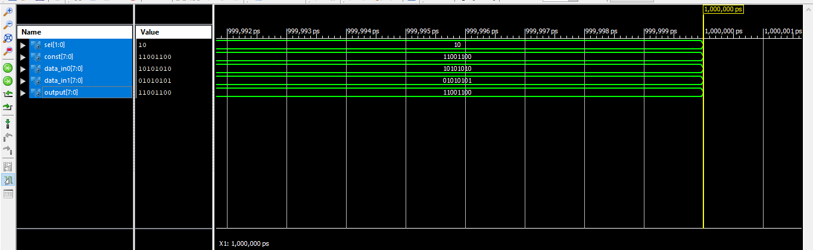

*Рис. 4 – Часова діаграма MUX*

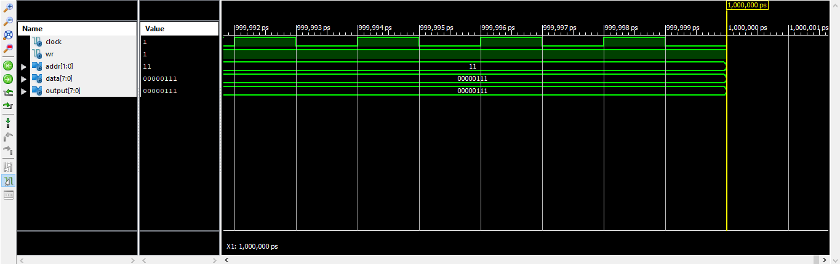

*Рис. 5 – Часова діаграма RAM*

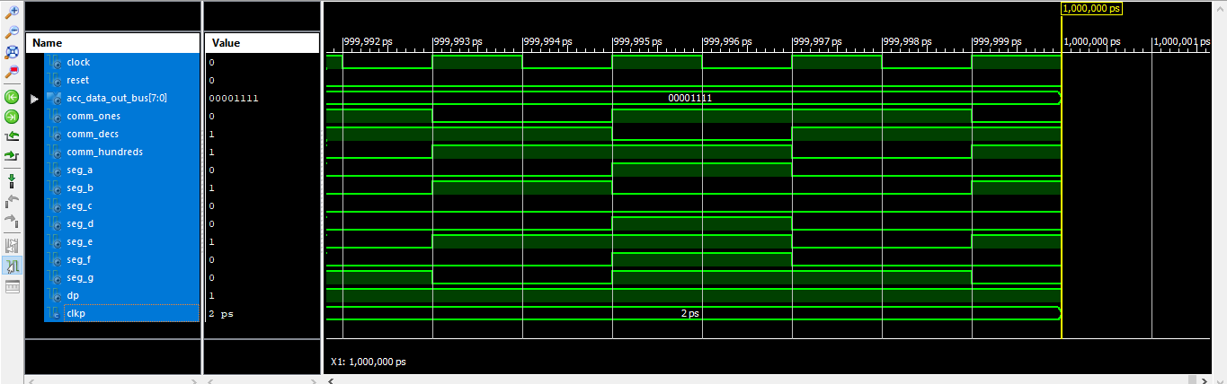

*Рис 6. – Часова діграма SEG_DECODER*

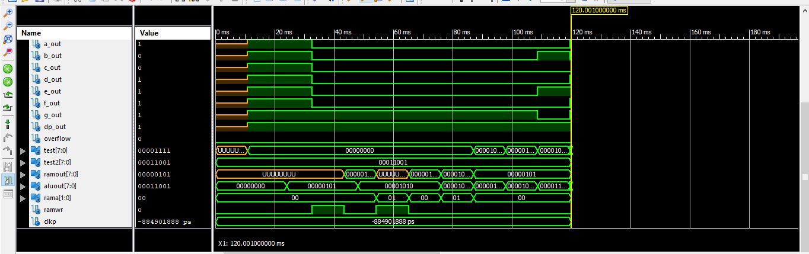

*Рис 7. – Часова діграма TopLevel*

| *Файл TopLevelTest.vhd*   1. LIBRARY ieee; 2. USE ieee.std_logic_1164.ALL; 3. USE ieee.numeric_std.ALL; 4. LIBRARY UNISIM; 5. USE UNISIM.Vcomponents.ALL; 6. ENTITY TopLevel_TopLevel_sch_tb IS 7. END TopLevel_TopLevel_sch_tb; 8. ARCHITECTURE behavioral OF TopLevel_TopLevel_sch_tb IS 9. COMPONENT TopLevel 10. PORT( CLOCK : IN STD_LOGIC; 11. RESET : IN STD_LOGIC; 12. ENTER_OP1 : IN STD_LOGIC; 13. ENTER_OP2 : IN STD_LOGIC; 14. CALCULATE : IN STD_LOGIC; 15. DATA_IN : IN STD_LOGIC_VECTOR (7 DOWNTO 0); 16. COMMON_0_OUT : OUT STD_LOGIC; 17. COMMON_1_OUT : OUT STD_LOGIC; 18. COMMON_2_OUT : OUT STD_LOGIC; 19. TEST: OUT STD_LOGIC_VECTOR(7 downto 0); 20. A_OUT : OUT STD_LOGIC; 21. B_OUT : OUT STD_LOGIC; 22. C_OUT : OUT STD_LOGIC; 23. D_OUT : OUT STD_LOGIC; 24. E_OUT : OUT STD_LOGIC; 25. F_OUT : OUT STD_LOGIC; 26. G_OUT : OUT STD_LOGIC; 27. DP_OUT : OUT STD_LOGIC; 28. RAMOUT: OUT STD_LOGIC_VECTOR(7 downto 0); 29. ALUOUT: OUT STD_LOGIC_VECTOR(7 downto 0); 30. RAMA: OUT STD_LOGIC_VECTOR(1 downto 0); 31. RAMWR: OUT STD_LOGIC; 32. OVERFLOW : OUT STD_LOGIC); 33. END COMPONENT; 34. SIGNAL CLOCK : STD_LOGIC := '0'; 35. SIGNAL RESET : STD_LOGIC; 36. SIGNAL ENTER_OP1 : STD_LOGIC; 37. SIGNAL ENTER_OP2 : STD_LOGIC; 38. SIGNAL CALCULATE : STD_LOGIC; 39. SIGNAL DATA_IN : STD_LOGIC_VECTOR (7 DOWNTO 0); 40. SIGNAL COMMON_0_OUT : STD_LOGIC; 41. SIGNAL COMMON_1_OUT : STD_LOGIC; 42. SIGNAL COMMON_2_OUT : STD_LOGIC; 43. SIGNAL A_OUT : STD_LOGIC; 44. SIGNAL B_OUT : STD_LOGIC; 45. SIGNAL C_OUT : STD_LOGIC; 46. SIGNAL D_OUT : STD_LOGIC; 47. SIGNAL E_OUT : STD_LOGIC; 48. SIGNAL F_OUT : STD_LOGIC; 49. SIGNAL G_OUT : STD_LOGIC; 50. SIGNAL DP_OUT : STD_LOGIC; 51. SIGNAL OVERFLOW : STD_LOGIC; 52. SIGNAL TEST: STD_LOGIC_VECTOR(7 downto 0); 53. SIGNAL TEST2: STD_LOGIC_VECTOR(7 downto 0); 54. signal RAMOUT: STD_LOGIC_VECTOR(7 downto 0); 55. signal ALUOUT: STD_LOGIC_VECTOR(7 downto 0); 56. signal RAMA: STD_LOGIC_VECTOR(1 downto 0); 57. signal RAMWR: STD_LOGIC; 59. -- constant CLOCK_period : time := 166ns; 60. constant CLKP: time := 12ms;--24ms; 61. BEGIN 62. UUT: TopLevel PORT MAP( 63. CLOCK => CLOCK, 64. RESET => RESET, 65. ENTER_OP1 => ENTER_OP1, 66. ENTER_OP2 => ENTER_OP2, 67. CALCULATE => CALCULATE, 68. DATA_IN => DATA_IN, 69. COMMON_0_OUT => COMMON_0_OUT, 70. COMMON_1_OUT => COMMON_1_OUT, 71. COMMON_2_OUT => COMMON_2_OUT, 72. A_OUT => A_OUT, 73. B_OUT => B_OUT, 74. C_OUT => C_OUT, 75. D_OUT => D_OUT, 76. E_OUT => E_OUT, 77. F_OUT => F_OUT, 78. G_OUT => G_OUT, 79. DP_OUT => DP_OUT, 80. OVERFLOW => OVERFLOW, 81. TEST => TEST, 82. RAMOUT => RAMOUT, 83. ALUOUT => ALUOUT, 84. RAMA => RAMA, 85. RAMWR => RAMWR 86. ); 88. CLOCK_process: process 89. begin 90. CLOCK <= '0'; 91. wait for 83ns; 92. CLOCK <= '1'; 93. wait for 83ns; 94. end process; 95. -- *** Test Bench - User Defined Section *** 96. tb : PROCESS 97. BEGIN 98. lp1: for i in 2 to 2 loop 99. lp2: for j in 4 to 4 loop 100. TEST2 <= std_logic_vector((to_signed(j - i, 8) sll 1) + i + 10); 101. ENTER_OP1 <= '1'; 102. ENTER_OP2 <= '1'; 103. CALCULATE <= '1'; 104. DATA_IN <= (others => '0'); 105. RESET <= '0'; 106. wait for CLKP; 107. RESET <= '1'; 108. wait for CLKP; 109. DATA_IN <= std_logic_vector(to_unsigned(i, 8)); -- A 110. ENTER_OP1 <= '0'; 111. wait for CLKP; 112. ENTER_OP1 <= '1'; 113. wait for CLKP; 114. DATA_IN <= std_logic_vector(to_unsigned(j, 8)); -- B 115. ENTER_OP2 <= '0'; 116. wait for CLKP; 117. ENTER_OP2 <= '1'; 118. wait for CLKP; 119. CALCULATE <= '0'; -- START CALCULATION 120. wait for CLKP* 7; 121. assert TEST = TEST2 severity FAILURE; 122. wait for CLKP; 123. end loop; 124. end loop; 126. WAIT; -- will wait forever 127. END PROCESS; 128. -- *** End Test Bench - User Defined Section *** 129. END; |
| --- |

*Рис.8 – 7-сегментний індикатор*

*Рис.9 – Успішна прошивка*

**Висновок:** Виконуючи дану лабораторну роботу я навчився реалізовувати цифровий автомат для обчислення значення виразів використовуючи засоби VHDL.