

Southern University of Science and Technology

Speech Signal Processing

# Lab 2 Report

11510478 郭锦岳

### Equal loudness contour

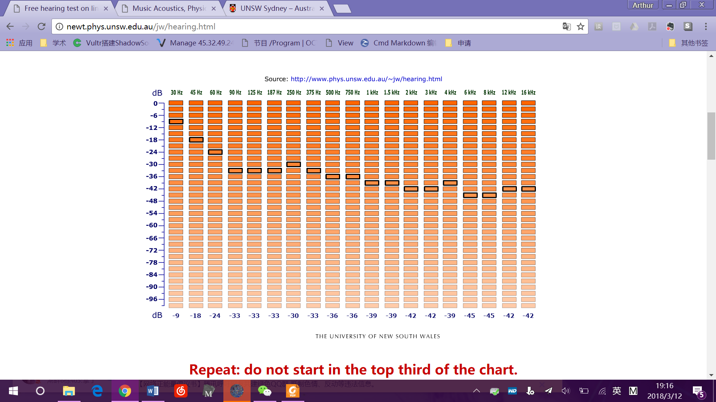

### Objective Quality Measurement

% question 2

clear;clc;

[data,fs] = audioread('C_01_01.wav');

noise = zeros(6,length(data));

score = zeros(6,1);

%when dB set as [-5, 5], the score is almost the same,

%so I extended the dB range to get a clearer result.

db = [-50, -30, -10, 10, 30, 50];

for i = 1:6

%generate the awgn noise signal with a certain SNR

noise(i,:) = awgn(data,db(i),'measured');

%write 6 audio files with correct filname 1-6

audio_order = 'noisedsignal_%d.wav';

A = i;

audio_name = sprintf(audio_order,A);

audiowrite(audio_name,noise(i,:),fs);

end

for i = 1:6

%read 6 audio files with correct filname 1-6

audio_order = 'noisedsignal_%d.wav';

A = i;

audio_name = sprintf(audio_order,A);

%use the PESQ to compare the original signal and the noised signal

score(i,1) = pesq('C_01_01.wav',audio_name);

end



It can be seen that when SNR is less than 5dB, the score is almost the same. But when SNR keeps gets higher, we can have a much better score.

### Masking release

Code:

clear;clc

signal = audioread('C_01_01.wav')';

noise_3 = awgn(signal,-3,'measured');

compete = audioread('C_01_02.wav');

compete = [compete' zeros(1,length(signal)-length(compete))];

compete_3 = compete*1.873;% reamplitude to make snr=-3db

sound(noise_3，16000);

sound(signal+compete_3，16000);

noise_6 = awgn(signal,-6,'measured');

compete_6 = compete*2.645;% reamplitude to make snr=-6db

sound(noise_6，16000);

sound(signal+compete_6，16000);

It sounds that with the same SNR, when the noise signal is a competing voice, it has better quality, but lower intelligibility of the signal.

When SNR decreased to -6dB, the AWGN noise sounds much louder than the competing voice.