Logic Synthesis & Verification PA1 report

R11943172 黃冠瑋

2.

(b).

1.



2.



3.

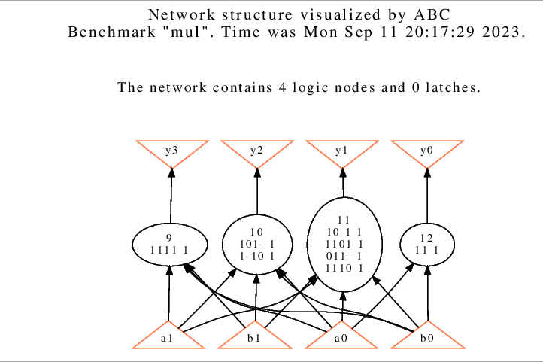

4.

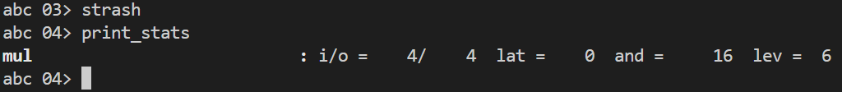

5.

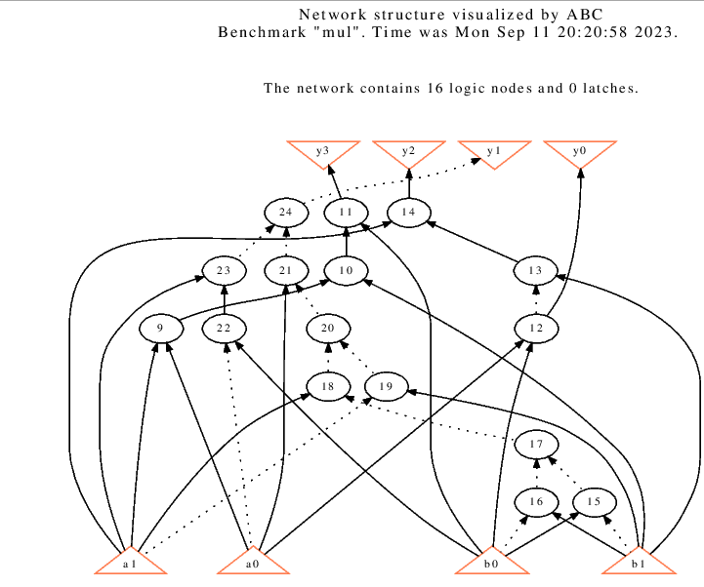

6.



7.

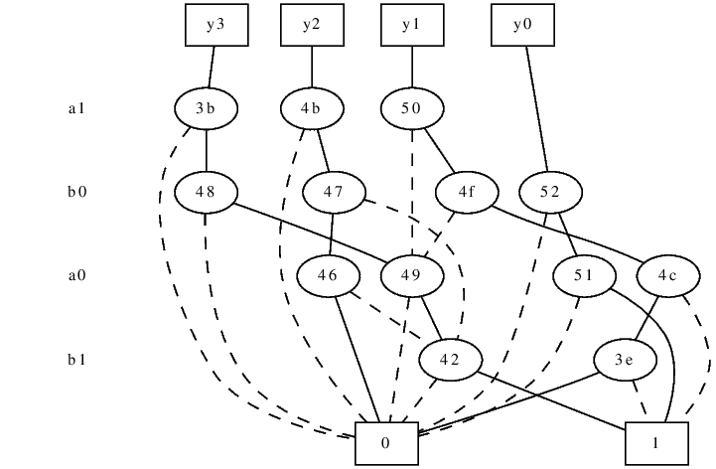

3.

(a)

reference: https://people.eecs.berkeley.edu/~alanmi/abc/

(1)

|  |  |
| --- | --- |
| Command “aig” | Command “strash” |
| Only converts local functions of nodes to AIG | Transforms the current network into an AIG by one-level structural hashing. The resulting AIG is a logic network composed of two-input AND gates and inverters represented as complemented attributes on the edges. |
|  |  |

(2)

|  |  |
| --- | --- |
| Command “bdd” | Command “collapse” |
|  | Recursively composes the fanin nodes into the fanout nodes resulting in a network, in which each CO is produced by a node, whose fanins are CIs. Collapsing is performed by building global functions using BDDs and is, therefore, limited to relatively small circuits. After collapsing, the node functions are represented using BDDs. |
|  |  |

(b)