Logic Synthesis and Verification PA1 Report

R10943101

Chia-Hsuan Su

1.

fig.1 The network structure of 4-number serial adder

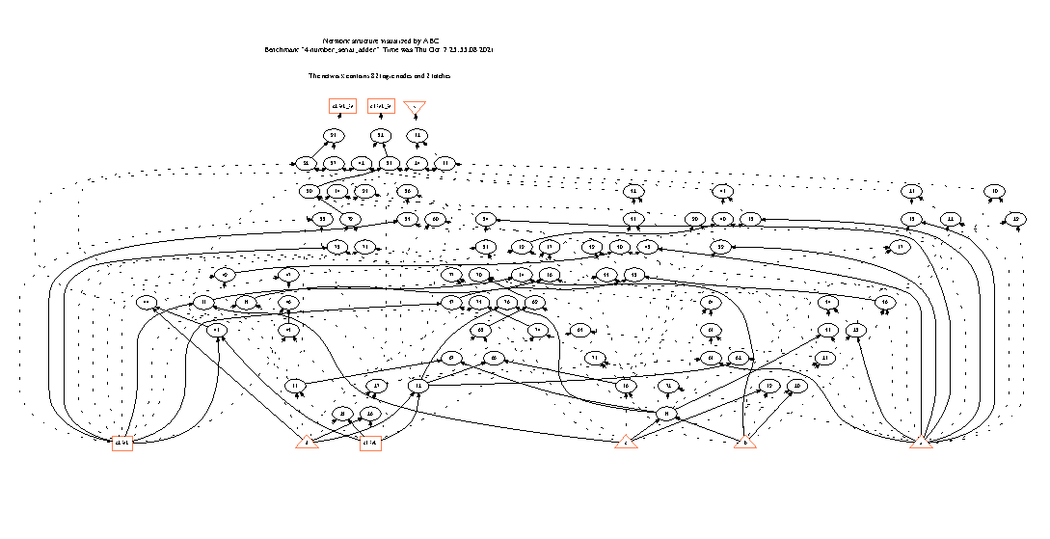

fig. 2 The structure of AIG

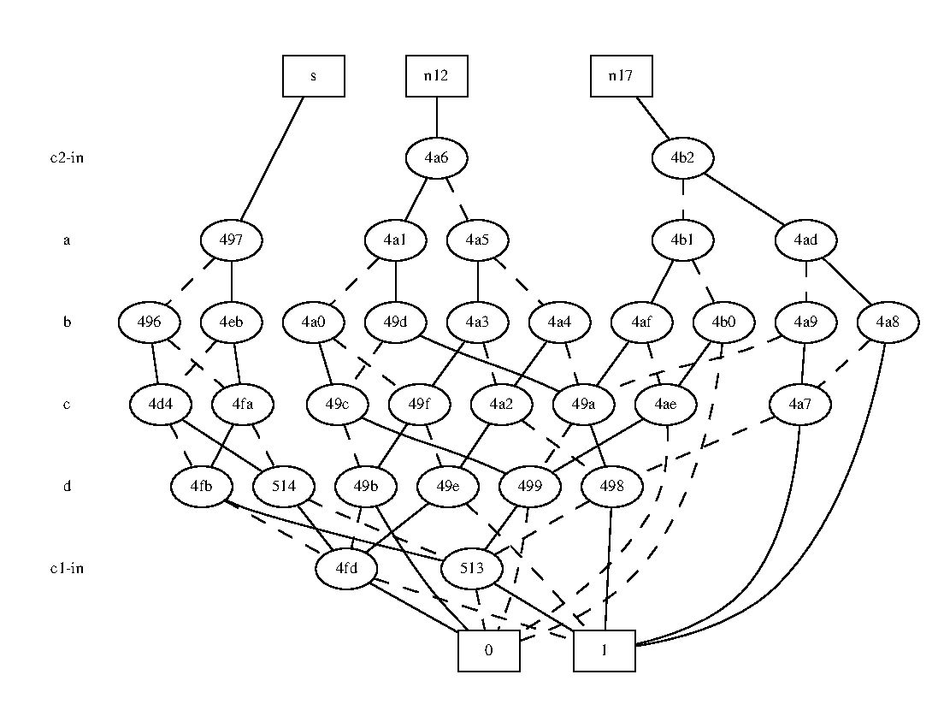

fig. 3 The structure of BDD

2. (a)

The command “aig” will convert local functions of the nodes to AIGs, while “strash” will convert the whole circuit into an AIG.

Similarly, command “bdd” will convert local functions of the nodes to BDDs, while “collapse” will convert the whole circuit into a BDD.

(b) logic