Department of Interior

U.S. Geological Survey

**Algorithm Description Document**

**Land Change Monitoring Assessment and Projection (LCMAP)**

**Python Implementation of Continuous Change Detection (pyccd)**

**Version 1.0**

**January 2017**

Brian Davis

Song Guo

Kelcy Smith



Contents

Executive Summary

Document History

Introduction

Dependencies

Inputs

Outputs

Prototype Code

Verification Methods

Maturity

User Services

Pre-Processing of Observations

Terminology

Exception Processing Procedures

Standard Processing Procedure

References - CCDC

References - ARD

References - Mathematical Models

Acronyms

# Executive Summary

The Continuous Change Detection (CCD) algorithm developed at the Center for Remote Sensing, Department of Geography and Environment, Boston University is under consideration as a primary application demonstrating the value of Land Change Monitoring Assessment and Projection. The U.S. Geological Survey (USGS) Earth Resources Observation and Science Center (EROS) has translated the original algorithm to open source platforms. This document provides a high level overview of the code characteristics and functions, and will be updated as the CCD algorithm becomes more clearly understood in the context of its performance as an open source capability.

# Document History

|  |  |  |
| --- | --- | --- |
| **Document Version** | **Publication Date** | **Change Description** |
| 0.1 | July 22, 2015 | First draft |
| 1.0 | July 29, 2015 | Final draft for USGS review |
| 1.1 | August 11, 2015 | Updated after developer review |
| 1.2 | August 31, 2015 | Added Classification module information |
| 1.3 | September 24, 2015 | Added updated reference |
| 1.4 | January 5, 2015 | pyccd implementation |

# Introduction

The Continuous Change Detection and Classification (CCDC) algorithm was developed at the Center for Remote Sensing, Department of Geography and Environment, Boston University as a robust methodology for identifying when and how a land surface location changes through time. Every clear observation in a time series of Landsat data is used to model reflectance values to determine whether and when a change has occurred. Subsequent algorithms can further classify pixel locations to indicate what land cover types were observed before and after a detected change.

The original implementation of the CCD algorithm, written in Matrix Laboratory (MATLAB), has since been translated into an open source package as C code (C-CCD). Subsequently, the algorithm has also been ported to the python language to become the primary application used to test the development and implementation of a real-time system to support the U.S. Geological Survey (USGS) Land Change Monitoring Assessment and Projection (LCMAP) initiative.

This document provides a high level overview of the code characteristics and functions, and will be updated as the pyccd algorithm becomes more clearly understood in the context of its performance as an open source science function.

# 

# Dependencies

Due to the necessity to identify change based solely on spectral responses, pyccd requires a certain level of data consistency. Processing is dependent on the following conditions.

* All scenes are projected to a uniform mapping grid
* Scenes are spatially clipped to include the maximum coverage within a path/row time series
* Input data is retrieved interactively through the LCMAP Information Warehouse and Data Store (IW+DS) Applications Programming Interface (API)
* No cloud, cloud shadow, or snow pixels are present
* No Landsat data prior to 1984 is included (Thematic Mapper (TM), Enhanced Thematic Mapper Plus (ETM+), and Operational Land Imager (OLI)/Thermal Infrared Sensor (TIRS) only)
* http or web-gis access to the LCMAP API is assumed

# 

# Inputs

The current pyccd acquires inputs from the USGS EROS Science Processing Architecture (ESPA), which provides the following.

* Landsat Level 2 Surface Reflectance for TM, ETM+, and OLI
* Landsat Level 2 Brightness Temperature for TM, ETM+ and OLI
* Landsat C version of Function of Mask (CFmask) for TM, ETM+, and OLI

Preprocessing includes:

* ESPA data loaded as tiles to the IW+DS, accessible through the API
* Reprojection and spatial subsetting to gridded tiles

# 

# Outputs

The output from pyccd for each location in the data stack includes the coefficients used to model a time series and detect change. The variables include the following.

* Date of the time series model start
* Date of the time series model end
* Date of observed trend deviation (change)
* Coefficients for each time series model for each spectral band
* Position of each time series model (x/y location in the tile/grid)
* Probability (0-100) that a pixel has changed
* Number of "good" observations used for model estimation
* Quality of the model estimation (based on what model and process is used)
* Magnitude of change (difference between model prediction and observation for each spectral band)

In order to provide products adequate for the evaluation of pyccd results, classification can be applied to pyccd outputs and ancillary data (including: aspect, change number, DEM, Fmask_stat, MPW, slope, and sinks) to generate annual maps as itemized below:

* Land Cover
* Land Cover Confidence
* Land Cover Condition
* Timing of Land Cover Change
* Change Magnitude
* Procedure Quality Assurance (QA)

# Prototype Code

The source algorithm software was delivered by its principal investigators from Boston University. The MATLAB-based code and associated Wiki are advertised as available on the following Web sites.

[https://code.google.com/p/ccdc](https://code.google.com/p/ccdc/)

<https://github.com/prs021/ccdc>

The pyccd implementation encompasses only the change detection aspect of the algorithm suite contained within the above repositories. Pre-processing and land cover classification algorithms are comprised of separate code sets. The completed python versions of the change detection function, pseudo-code, and documentation are publicly available for review and comment on the following Web site.

[https://github.com/USGS-EROS/lcmap-pyccd](https://github.com/USGS-EROS/lcmap-change-detection)

The classification process is currently distributed as a stand-alone module which executes on the output from the preceding processes. It will be integrated into LCMAP infrastructure separately.

# 

# Verification Methods

The MATLAB code and its results have been published successfully by the principal investigators. Their methodologies are described in the references listed in this document.

Results from the USGS python code were verified against outputs from the original Matlab source to ensure process translations produced the same results as the original algorithm implementation. pyccd is peer-reviewed by Landsat and EROS Science developers, and external collaborators. Subsequent revisions will be included in the repository. Scientific validation of pyccd is underway.

# 

# Maturity

In the context of the USGS adaptation of the National Oceanic and Atmospheric Administration (NOAA) Climate Data Record (CDR) Maturity Matrix (<http://www1.ncdc.noaa.gov/pub/data/sds/cdr/Guidelines/Maturity_Matrix_Template.xlsx>), pyccd falls within the early research stage. The pyccd maturity definition is listed below in **Table 1**, and is described without regard to the potentially higher maturity levels in the heritage MATLAB CCD implementation.

|  |  |  |
| --- | --- | --- |
| **Criteria** | **Level** | **Definition** |
| Software Readiness | 3 | Moderate code changes expected |
| Metadata | 1 | Little or none |
| Documentation | 2 | Draft Algorithm Description Document (ADD) in progress |
| Product Validation | 2 | Underway |
| Public Access | 2 | Limited data availability to develop familiarity |
| Utility | 2 | Limited or ongoing |

**Table 1: pyccd Product Maturity Matrix**

# 

# User Services

All higher level Landsat products, services and interfaces are supported by User Services staff at USGS EROS. Any questions, comments, or concerns are welcomed through the Landsat “Contact Us” online correspondence form. Please indicate “Surface Reflectance Data Request” as the topic of regard. Electronic mail can also be sent to the customer service address included below, with the same indication of topic.

USGS User Services

<http://landsat.usgs.gov/contactus.php>

[mailto:custserv@usgs.gov?subject=Surface Reflectance Data](mailto:custserv@usgs.gov?subject=Surface%20Reflectance%20Data)

User support is available Monday through Friday from 8:00 a.m. – 4:00 p.m. Central Time. Inquiries received outside of these hours will be addressed during the next business day.

# 

# Pre-Processing of Observations

The general workflow of pyccd begins with the assumption that tiled/gridded time series observations are available from the IW+DS API. All data ordering, pre-processing and loading into the LCMAP infrastructure must be completed before the necessary observations can be presented to pyccd. To accomplish the necessary processing, USGS EarthExplorer (<https://earthexplorer.usgs.gov>) can used to generate a list of scenes in the path/row and temporal range of interest. The scene list is submitted to the ESPA on-demand interface (<https://espa.cr.usgs.gov>) to order processing of Landsat data. The data is then fed into the appropriate LCMAP utilities for loading into the IW+DS to create Analysis Ready Data (ARD). Characteristics of ARD include:

* Pixel Alignment
* Consistent Projection
* Standardized Extents (tiles)
* Standard Level 2 Products Suite
* Eliminates Swath Overlap
* Adds Side-lap, (Temporal Density)
* User-defined Area of Interest (AOI)
* ARD Named Future Standard Landsat Product

The data stored in the IW+DS takes advantage of the side-lap of the World Reference System-2 (WRS-2) path/row definition to obtain increased temporal density for time series observations. For the Conterminous U.S. (CONUS), an increase of nearly 40% temporal density can be expected, using the definitions from the Landsat 7 Data Users Handbook included in **Table 2**, and the approximations for CONUS in Table 3.

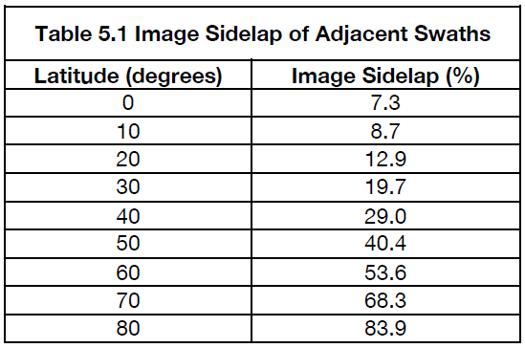

**Table 2: Table 5.1 of Landsat 7 Data Users Handbook**

|  |  |
| --- | --- |
| **CONUS Extents** | **Percent Sidelap** |
| TX/FL240 N | 15.62% |
| WA/ME360 N | 20.28% |
| Avg.300 N | 19.70% |

**Table 3: Average Percent Sidelap for CONUS**

**Figure 2** presents a graphical depiction of the increased spatial and temporal density of ARD.

# 

Figure 2: Graphical Depiction of ARD Temporal Density

**Table 4** lists the Landat Surface Reflectance (SR) and Thermal bands used as input the the pyccd algorithm, and pre-processed to ARD specifications.

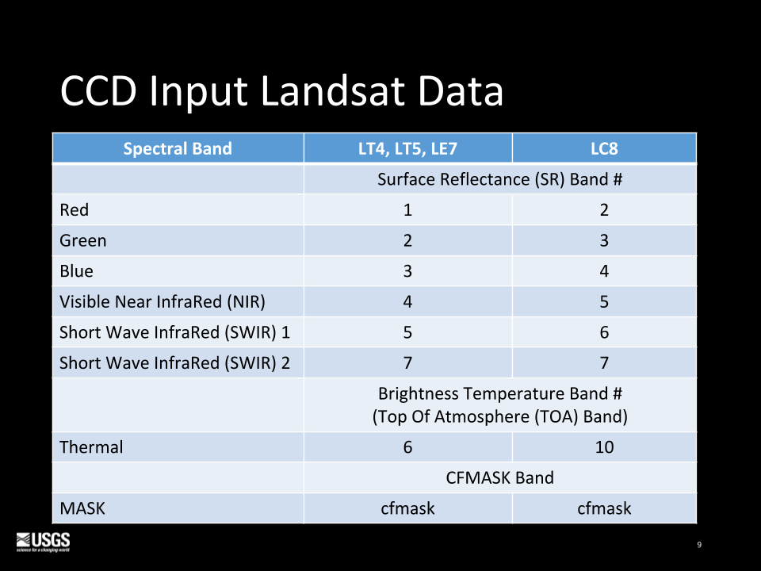

**Table 4: pyccd Input Landsat Data**

# 

# Terminology

To aid in the description of the processing steps, the following generic terms are introduced to clarify definitions. These terms are intended to avoid the jargon of software engineers, which may not be understood by earth science researchers, and, conversely, avoid the jargon of earth science researchers, which may be misinterpreted by software engineers.

Model regression fit of points to a curve

Variogram Variogram is a description of the spatial continuity of the data, usually the squares of the differences.Madogram is instead the abs of the diffs, and the “distance” between points is ignored.

MEOW Minimum Expected Observation Window ( number of coefficients * 3 )

Tmask time-series mask, outliers determined by regression fit using green ( SWIR1) band

Window current sliding array of X # number of observations (model window, peek window, fit window)

Fit Window observations that are used to fit a regression model to, subset of the model window

Model Window observations that are currently represented by a fitted regression model

Peek Window observations that are currently being analyzed / under statistical scrutiny

Stable Model generalized fit 4 coefs (min) from LASSO Regression

Detection Bands subset of spectral bands used to determine outliers and detect change: red, green, NIR, SWIR1, SWIR2

LASSO Regression Initial first attempt at fitting points to curve, and subsequent start detection, change detection

Robust Regression more general purpose curve fitting for identifying outliers

Residual predicted value from a curve fit - actual value, used as a measure of error

Persistent Processing Mask Application of Tmask, cfmask, etc., to mask, not eliminate data from input arrayseliminate values from input arrays

Additionally, explanation of the mathematical models used to calculate medians and curve fitting will increase understanding of the processing procedure descriptions. Figure 4 depicts the variogram used to filter outliers in the observation data. A variogram is a generral description of the spatial continuity of the data, usually the squares of the differences of adjacent values. A specific type of variogram, a madogram, is instead the abs of the diffs. In the case of pyccd the distance between points is irrelevant, and not included in the simplified calculations.

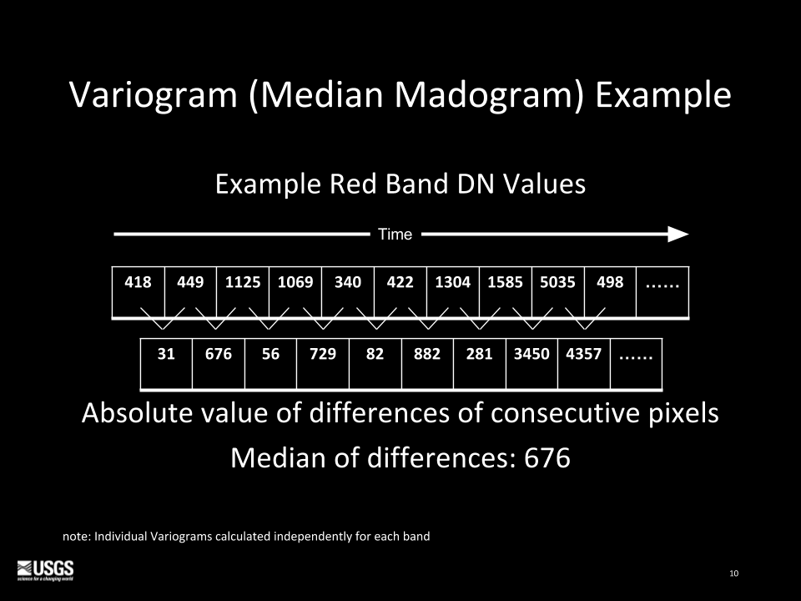

**Figure 3: Variogram Example.**

Least Absolute Shrinkage and Selection Operator (LASSO) regression is mathematical model used to do curve fitting of points. LASSO regression is used because the python module used is a standard all python applications can adhere to. Calculations are documented and consistent across platforms and applications. LASSO regression gives much better output than traditional step-wise regression, requiring fewer parameters and can be automated to a large extent. It is also referred to as “regression with regularization”. This means the size of coefficients are penalized, in an effort to avoid both underfitting or overfitting a curve to the observations. **Figure 4** lays out the LASSO Regression formula.

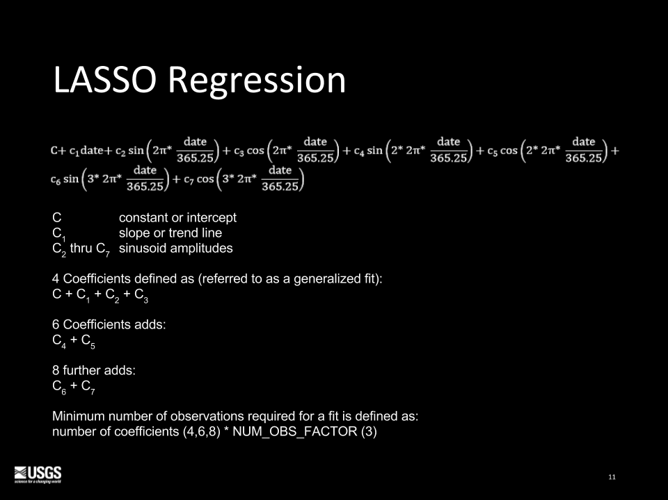

**Figure 4: LASSO Regression**

The Robust regression used by pyccd is a Ordinary Least Squares (OLS) implementation, also a standard python module which is well documented and platform-independent. This equation, laid out in **Figure 5**, is used to determine outliers from a previously-defined model curve, because it is a more general purpose curve-fitting algorithm, and more appropriate for determining an acceptable distance away from an established curve. It also incorporates a consideration for the temporal span of the points.

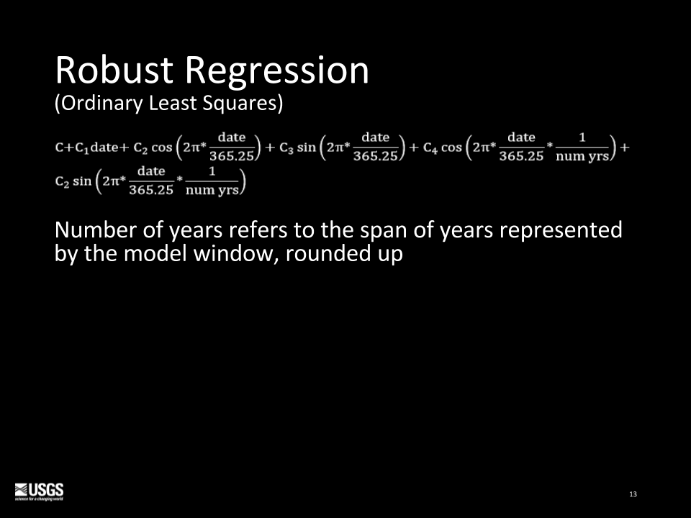

**Figure 5: Robust Regression**

The time series observations are filtered for clouds, cloud shadows, and snow using “Tmask,” a Robust regression model, which generates time series curves of the green and shortwave infrared bands for the pixels CFmask determined are clear. Tmask model results are compared to observations to remove outliers CFmask may have missed. The pseudo-code for Tmask is include here:

use the Robust Regression method to fit curves for the green and SWIR1 bands, for a given observation window

If any residual is > the Tmask Threshold ( 4.89 * variogram value),

mark the observation as an outlier and update the Persistent Processing Mask

# 

# Exception Processing Procedures

Two processing scenarios result in the inability to determine automated change detection: persistent snow; and insufficient clear observations. After determining either of these two cases, processing is completed after the processing the valid observations.

1. If > 75% of valid data observations are snow, then the observation set is considered permanent snow. For this minimal set of observations, perform a generalized curve fit (if > 12 valid observations) or from median values (if < 12 points).
2. if insufficient clear observations, mask observations exceeding median of the green band + 400, then do a generalized curve fit for the remaining observation set.

The pseudo-code for determining which processing scenario to use is very simple:

if the percentage of clear pixels < clear threshold:

if the percentage of snow > snow threshold:

Persistent Snow Procedure

else:

Insufficient Clear Procedure

else:

Standard Procedure

# 

# Standard Processing Procedure

If enough clear observations exist in the time series (greater than 25% of the total) to possibly detect change, some initial change detection setup is performed.

Mask out duplicate observations using first of two swath overlap observations

Sort temporally

Convert thermal values from degrees Kelvin to Celsius:

value = value * 10 – 27315

Create mask(s) of values that fall outside of acceptable ranges, which are considered saturated if > acceptable maximum :

Reflectance acceptable range: 0 -> 10,000

Thermal acceptable range: -9,320 -> 7,070

Create Variogram (madogram) for each band

**Figure 1** illustrates the major steps in standard processing executed by pyccd when sufficient clear observations have been determined. The standard processing steps depicted in **Figure 1** are described in more detail in the subsequent narrative, examples, and graphics. Pseudo-code from the code repository will also be incorporated to aid description of processing details.

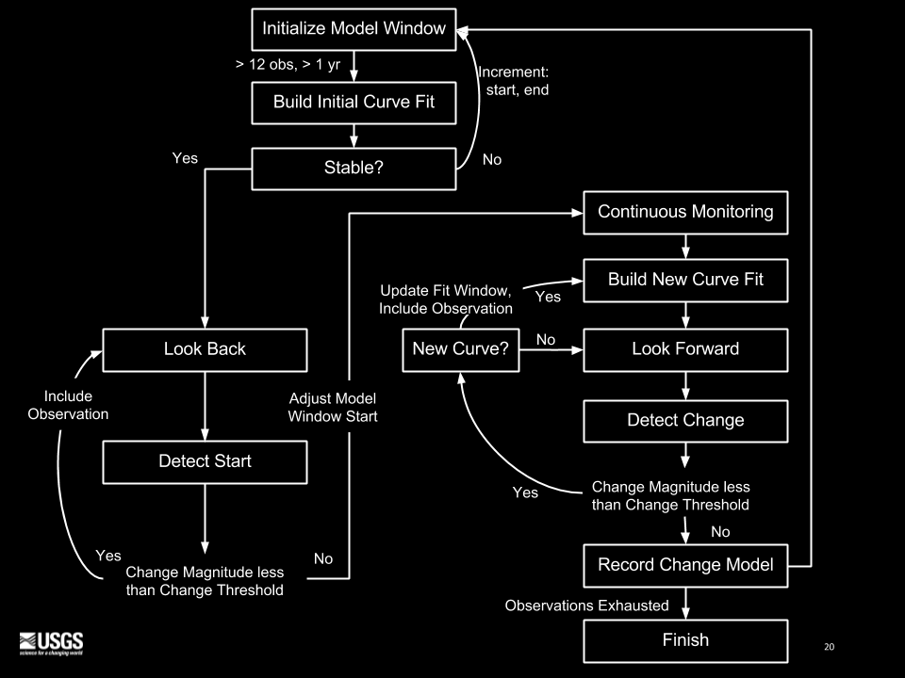

**Figure 1: pyccd Work Flow**

**Initialize Model Window**

initialize first model window

(start is set to previous break point; window size set to contain 12 observations)

while there are clear observations:

mask outliers in current window as defined by tmask

if not enough observations (12) and minimum temporal span (1 year) in the window:

increase window size by 1 continue to the next observation

**Build Initial Curve Fit**

perform LASSO Regression using 4-coefficient model

**Stable?**

for each of the detection bands ( r, g, n, s1, s2)

model slope coef * diff ( end – start dates )

check_vals = ( |slope| + |first model residual| + |last model residual| ) / MAX

(where MAX = max (variogram, model RMSE) )

if summation of ( check_vals )2 < change threshold:

stable

else:

increment model window start and end by 1

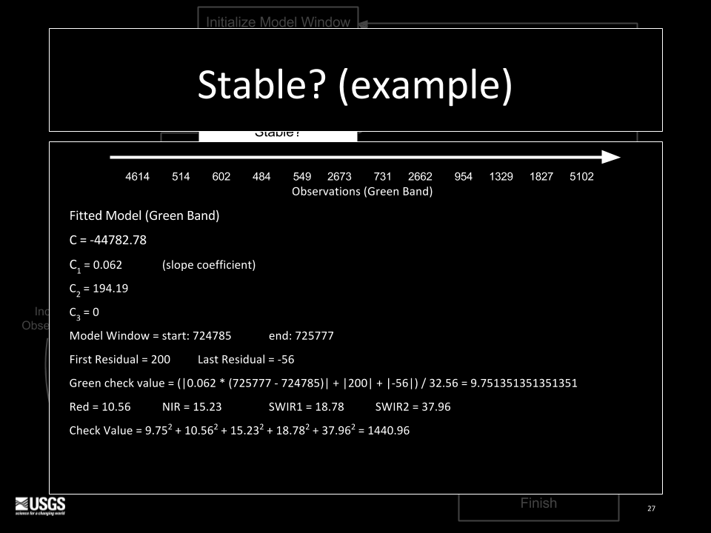

**Figure 6: Stable Model Example**

**Look Back**

for each observation preceding current model window start and end of previous model window:

If change magnitude < change threshold:

add observation to current model window

else:

proceed with continuous monitoring

note: when look-back is complete, if this is the very first model window, and there 6 or more unused observations, do a general curve fit on them

**Detect Start**

using the observations in the Peek Window, calculate a change magnitude per observation:

for each of the detection bands ( r, g, n, s1, s2):

difference magnitude = residuals / MAX

(where MAX = max ( variogram, model RMSE ) )

change magnitude = sum ( difference magnitude ^2 )

if the minimum ( change magnitude ) > change threshold:

change detected

if the first change magnitude > outlier threshold:

update Persistent Processing Mask

else:

include the observation in the Model Window

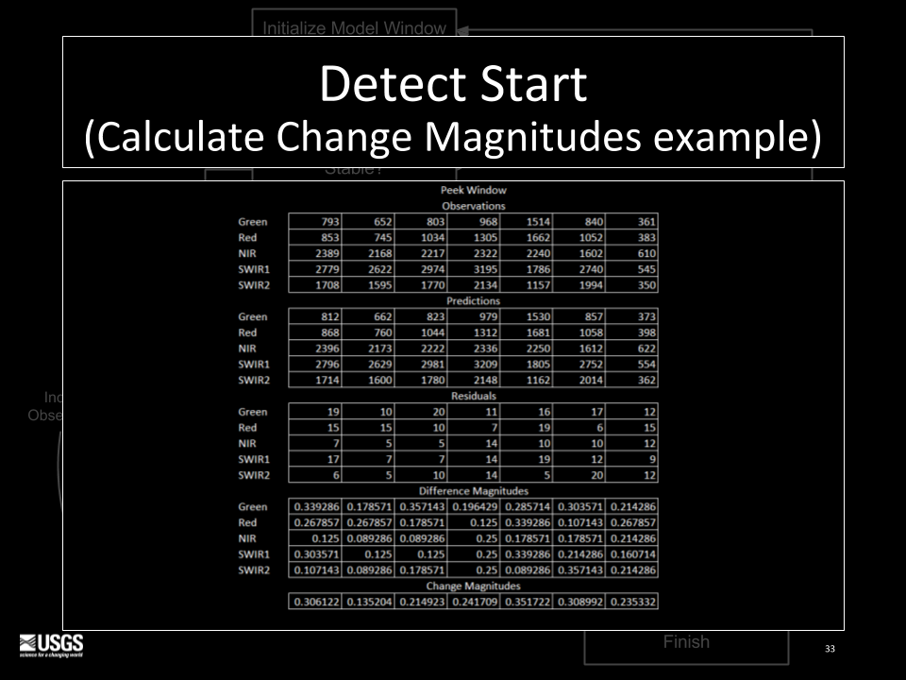

**Figure 7: Detect Start Example Calculations**

**Change Magnitude less than Change Threshold**

if Change Magnitude less than Change Threshold:

include observation

continue with Look Back

else:

adjust Model Window start

proceed with Continuous Monitoring

**Continuous Monitoring**

loop through remaining observations until change is detected or observations are exhausted

**Build New Curve Fit**

utilize LASSO Regression with a set number of coefficients based on the number of observations encompassed by the model window  
  
Number of Coefficents per Model Window size:  
# coefficents observation count*  
 4 12  
 6 18  
 8 24  
  
*number of coefficient times the NUM_OBS_FACTOR (3)

**Look Forward**

Look Forward is similar to Look Back, but assessing observations to the right of the existing model curve (forward in time)

**Detect Change**

using the observations in the Peek Window

if the Model Window > 24 observations:

model RMSE used is recalculated using the closest 24 observations temporally to the Peek Window

calculate a change magnitude per observation

for each of the detection bands ( r ,g, n, s1, s2):

difference magnitude = residuals / MAX

( where MAX = max ( variogram, model RMSE) )

change magnitude = sum ( difference magnitude ^2 )

if the minimum ( change magnitude ) > change threshold:

change detected

if the first change magnitude > outlier threshold:

update persistent processing mask

else:

include the observation in the model window

**Change Magnitude less than Change Threshold**

if Change Magnitude less than Change Threshold

proceed with New Curve?

else:

Record Change Model

**New Curve?**

**Record Change Model**

start  
end  
break  
per band coefficients  
per band RMSE’s  
per band median of the last used Peek Window residuals  
number of observations  
number of fitted coefficients  
change probability

**Finish**

if the number of remaining observations is < MEOW size but >= Peek Size:

fit a generalized model is for remaining observations

send/save output results

exit

# 

# References - CCDC

Zhu, Z., Woodcock, C. E., Holden, C., & Yang, Z., Generating synthetic Landsat images based on all available Landsat data: Predicting Landsat surface reflectance at any given time. *Remote Sensing of Environment*, *162*, 67-83, 2015, [doi:10.1016/j.rse.2015.02.009](http://dx.doi.org/10.1016/j.rse.2015.02.009)

Zhu, Z. & C.E. Woodcock, Continuous change detection and classification of land cover using all available Landsat data, *Remote Sensing of Environment*, 144, 152-171, 2014, [doi:10.1016/j.rse.2014.01.011](http://dx.doi.org/10.1016/j.rse.2014.01.011)

Zhu, Z., C.E. Woodcock, & P. Olofsson, Continuous monitoring of forest disturbance using all available Landsat imagery, *Remote Sensing of Environment*, 122, 75-91, 2012, doi:10.1016/j.rse.2011.10.030

# 

# References - ARD

<https://drive.google.com/drive/folders/0B5wwu78kdogOfmZIWGI1S2dNRE5LeDVNeGxDU1phUndyTHpMbUVuNFdFNTZBV2RsbVhqMjQ>

<https://drive.google.com/a/doi.gov/file/d/0B5wwu78kdogONnN5N1BGTjFvdGM/view?usp=sharing>

<http://landsat.gsfc.nasa.gov/landsat-7-science-data-users-handbook/>

# 

# References - Mathematical Models

<http://www.gammadesign.com/gswinhelp/other_autocorrelation_measures/madograms.htm>

<https://www.analyticsvidhya.com/blog/2016/01/complete-tutorial-ridge-lasso-regression-python/>

# 

# Acronyms

|  |  |
| --- | --- |
| **Acronym** | **Description** |
| ADD | Algorithm Description Document |
| AOI | Area Of Interest |
| API | Applications Programming Interface |
| ARD | Analysis Ready Data |
| BIP | Band Interleaved by Pixel |
| CCD | Continuous Change Detection |
| CDR | Climate Data Record |
| CFmask | C version of Function of Mask |
| CSV | Comma Separated Values |
| DN | Digital Number |
| DOI | Department of Interior |
| EROS | Earth Resources Observation and Science Center |
| ESPA | EROS Science Processing Architecture |
| ETM+ | Enhanced Thematic Mapper Plus |
| GeoTIFF | Georeferenced Tagged Image File Format |
| IW+DS | Information Warehouse & Data Store |
| LASSO | Least Absolute Shrinkage and Selection Operator |
| LCMAP | Land Change Monitoring Assessment and Projection |
| MATLAB | MATrix LAboratory |
| MEOW | Minimum Expected Observation Window |
| NIR | Near InfraRed |
| NOAA | National Oceanic and Atmospheric Administration |
| OLI | Operational Land Imager |
| RFC | Random Forest Classifier |
| RIRLS | Robust Iteratively Reweighted Least Squares |
| RMSE | Root mean square error |
| SR | Surface Reflectance |
| SWIR | Short Wave InfraRed |
| TOA | Top Of Atmosphere |
| TM | Thematic Mapper |
| USGS | U.S. Geological Survey |