Customer Documentation

for

Copy Print Department

Automated Order

Printing

Version 20200801

Prepared by Arthur Vardevanyan

Table of Contents

1. Introduction 1

1.1 Purpose 1

1.2 Intended Audience 1

1.3 Requirements 1

2. Order Submission Procedure 2

2.1 Notes 2

2.2 Custom Orders 2

2.3 Form Header 2

2.4 Contact Info 3

2.4.1 Email Address 3

2.4.2 Last Name 3

2.4.3 First Name 3

2.4.4 Phone Number 3

2.4.5 Job Description 3

2.4.6 File Attachment 4

2.5 Printing Setup 5

2.5.1 Copies Needed 5

2.5.2 Printing Setup (Double-Sided) 5

2.5.3 Collation 5

2.5.4 Paper Size, Type, and Color 6

1.1 Print Finishing 6

2.5.5 Stapling 6

2.5.6 Drilling – Three Hole Punch 6

2.5.7 Folding 7

2.5.8 Cutting 7

2.5.9 Front Cover 7

2.5.10 Back Cover 8

2.5.11 Booklet Fold and Staple 8

2.5.12 Slip Sheets and / or Shrink Wrap 8

2.5.13 Special Instructions 8

2.6 Delivery 9

2.6.1 Deliver To (Person): 9

2.6.2 Deliver To (Address): 9

2.7 Feedback 9

2.8 Email Response 10

# Introduction

## Purpose

This document describes how a customer can submit an order.

The document also describes if there any extra considerations when placing an order.

## Intended Audience

The intended audience is the customer.

## Requirements

* A Modern Web Browser
* Google Account
* Ability to convert to PDF if need be.
* Ability to Scan documents if required.

# Order Submission Procedure

This form is used to place the order that gets submitted to the production team.

## Notes

* If the Field is not used, and is not required, skip it.
* Turnaround time is 3 to 5 business days, not including weekends.
* Rush orders can be placed, turnaround time will be determined case by case.
* Please verify all information and integrity of your document before placing the order.
* After the order is placed, assume it is final, you may contact us, and if the order is not produced, we will make the modifications, otherwise you will be charged for both orders.
* We will hold the order and contact you if we believe that there may be an issue.

## Custom Orders

* If you have a custom order that you would like to discuss with us, please email us directly with the information and the files.
  + For example, custom organized packets, or spiral (coiled) bound books.

## Form Header

Enter your copy job(s) below. Up to ten (10) PDF files can be attached to one order form AS LONG AS THE SELECTIONS BELOW ARE THE SAME FOR EACH FILE.

For instance, number of copies, collated, white paper, etc.

ALL of your choices on the order form will apply to ALL FILES* attached.

All Jobs are ran in BLACK & WHITE unless otherwise specified in the Special Instructions.

*Expectations can be made if listed in special instructions

*Automatic exceptions will be applied.

* Example, 10 Files, all stapled, but only 5 are greater than 1 sheet of paper, documents that are only one sheet won’t be stapled.

## Contact Info

### Email Address

Required

Enter you Email Address Here

Shipment Tracking information will be sent to this email address, we may also contact you if there is an issue or a concern with your order.

### Last Name

Required

Enter Your Last Name Here

This is the last name of who will be billed for the order, usually this is you, the person placing the order, their will be an option to send the order to a different person later on.

### First Name

Required

Enter Your First Name Here

This is the last name of who will be billed for the order, usually this is you, the person placing the order, there will be an option to send the order to a different person later on.

### Phone Number

Required

Enter Your Phone Number Here

We will use the number to contact you if there is an issue or a concern with your order.

### Job Description

Required

Please enter a title or description of your copy job. This will show up in the email confirmation and subject header of the Email. Example: Science Chapter 2 Vocabulary.”

### File Attachment

Required

Please note that ALL attached files will be copied as per choices below.

Click "ADD FILE" below, then DRAG or your files from your computer, then click "Upload." *You can upload up to 10 files*

* Files must be uploaded as a PDF
* If converting to PDF from the built in Mac converter, please verify the file appears correct on your computer, and the first time you receive the job using that file. If you notice there is an issue, please let us know, also mention for similar files that you have converted a document using the Mac converter. Apple does not appear to adhere to proper pdf standards. A potential solution is to use Adobes converter. Systems are in place to mitigate this issue, but it may still occur.
* If you are unable to remove unwanted pages, please let us know in the special instructions and we can do that for you, we can then send you back the file for future orders
* If you are unable to combine documents, please let us know in the special instructions and we can do that for you, we can then send you back the file for future orders
* If you want any modification done to your files, go ahead and ask, if we are able to do so, we will and send you back the file. (Example, cleaned up, retyped, etc.)

## Printing Setup

### Copies Needed

Required

Please note that the quantity entered will be the quantity applied to EACH file uploaded within this copy job submission.

### Printing Setup (Double-Sided)

Required

* One-Sided
* Two-sided (back to back)

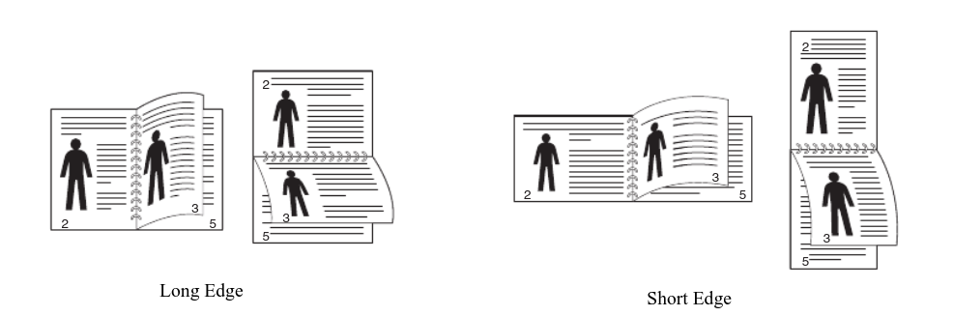

Please Note:

For two-sided printing, the default flipping method is on the long side of the paper.

If you would like it to be slipped on the short-sided, (for landscape prints),

please specify in the special instructions below.

### Collation

Required

Choosing "Collated" below will print your pages as sets in page order.

Choosing "Uncollated" below will print your pages as sets of the same page. Please see figure below for the difference between the two methods.

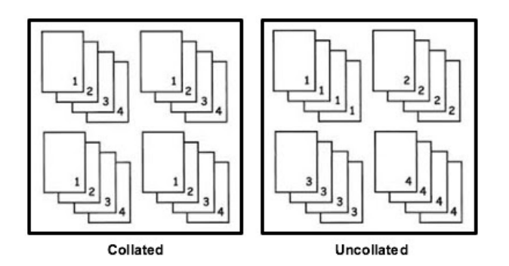

Options for Printing are:

* Collated
* Uncollated

### Paper Size, Type, and Color

Required

These are currently the available paper options for order. If you require a custom stock, please specify in the special instructions.

* 8.5 x 11 Paper – White
* 8.5 x 11 Paper – Ivory
* 8.5 x 11 Paper – Canary
* 8.5 x 11 Paper – Goldenrod
* 8.5 x 11 Paper – Pink
* 8.5 x 11 Paper – Blue
* 8.5 x 11 Paper – Green
* 8.5 x 11 Card Stock – White
* 8.5 x 11 Card Stock – Ivory
* 8.5 x 11 Card Stock – Blue
* 8.5 x 11 Card Stock – Green
* 8.5 x 14 Paper – White
* 8.5 x 14 Card Stock – White
* 11 x 17 Paper - White
* 11 x 17 Paper – Ivory
* 11 x 17 Paper – Canary
* 11 x 17 Paper – Blue
* 11 x 17 Card Stock – White
* 11 x 17 Card Stock – Ivory

## Print Finishing

### Stapling

If you need stapling, click your choice below. IF NOT, SKIP THIS OPTION.

See Figure below for samples.

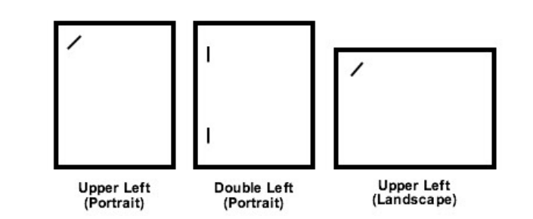

* Upper Left - portrait
* Double Left - portrait
* Upper Left - landscape

Please make sure your document is in the correct orientation, there is a possibility that the staple will be in the incorrect spot, usually only occurs with landscape documents, and usually the document is correct, however the wrong option was chosen.

However sometimes the document may be rotated incorrectly, usually occurs when a document is scanned in incorrectly.

### Drilling – Three Hole Punch

If you need three holes punched on the left side of the paper, click "Yes" below.

IF NOT, SKIP THIS OPTION.

* Yes

Drilling is Three-Hole Drilling, if you need a custom drilling count, or nonstandard positions, please let us know in the special instructions.

### Folding

If you need folding done, make your selection below. IF NOT, SKIP THIS OPTION.

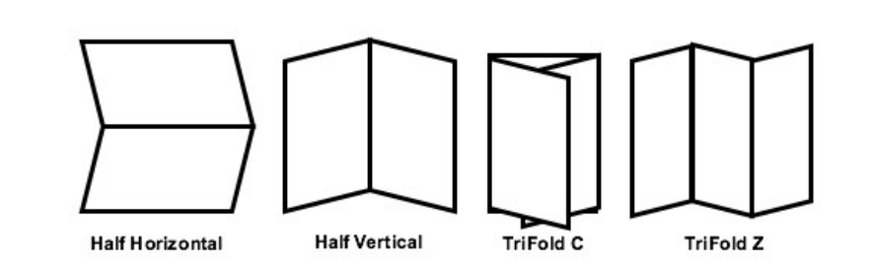

* Half Horizontal
* Half Vertical
* Trifold C
* Trifold Z

If pages need to be folded together, or nonstandard folding is required please let us know in the special instructions.

### Cutting

If you need cutting done, select from the list below which will yield three per page, four per page or half pages. IF NOT, SKIP THIS OPTION.

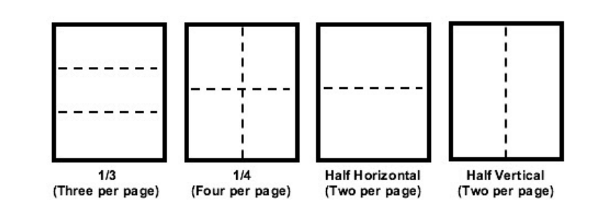

If nonstandard cutting is required please let us know in the special instructions.

* 1/3 (yields three per page)
* 1/4 (yields four per page)
* Half Horizontal
* Half Vertical

### Front Cover

If you choose to have a front cover, make a selection below. IF NOT, SKIP THIS OPTION.

* 8.5 x 11 Paper – White
* 8.5 x 11 Paper – Ivory
* 8.5 x 11 Paper – Canary
* 8.5 x 11 Paper – Goldenrod
* 8.5 x 11 Paper – Pink
* 8.5 x 11 Paper – Blue
* 8.5 x 11 Paper – Green
* 8.5 x 11 Card Stock – White
* 8.5 x 11 Card Stock – Ivory
* 8.5 x 11 Card Stock – Blue
* 8.5 x 11 Card Stock – Green
* 8.5 x 14 Paper – White
* 8.5 x 14 Card Stock – White
* 11 x 17 Paper - White
* 11 x 17 Paper – Ivory
* 11 x 17 Paper – Canary
* 11 x 17 Paper – Blue
* 11 x 17 Card Stock – White
* 11 x 17 Card Stock – Ivory

### Back Cover

If you choose to have a back cover, make a selection below. IF NOT, SKIP THIS OPTION.

* 8.5 x 11 Paper – White
* 8.5 x 11 Paper – Ivory
* 8.5 x 11 Paper – Canary
* 8.5 x 11 Paper – Goldenrod
* 8.5 x 11 Paper – Pink
* 8.5 x 11 Paper – Blue
* 8.5 x 11 Paper – Green
* 8.5 x 11 Card Stock – White
* 8.5 x 11 Card Stock – Ivory
* 8.5 x 11 Card Stock – Blue
* 8.5 x 11 Card Stock – Green
* 8.5 x 14 Paper – White
* 8.5 x 14 Card Stock – White
* 11 x 17 Paper - White
* 11 x 17 Paper – Ivory
* 11 x 17 Paper – Canary
* 11 x 17 Paper – Blue
* 11 x 17 Card Stock – White
* 11 x 17 Card Stock – Ivory

### Booklet Fold and Staple

If you need your job(s) in booklet format and stapled on the spine, click "Yes" below.

IF NOT, SKIP THIS OPTION.

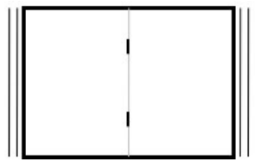

* Yes

### Slip Sheets and / or Shrink Wrap

If you want slip sheets and/or shrink wrap, clearly explain your selection below.

Colored SLIP SHEETS can be inserted in your job between sets or pages for ease of disbursement.

For example, "Insert slip sheet between every 30 copies." SHRINK WRAP should only be used for wrapping large bundles of copies together. For example, "Shrink wrap into four bundles of 25 (100 copies)."

Please select Shrink Wrap only if necessary, as this is a more costly procedure and takes additional time to process your copy job.

IF NOT, SKIP THIS OPTION.

### Special Instructions

Describe any further instructions or detail as it applies to your file(s). Be specific.

## Delivery

### Deliver To (Person):

Required

Please enter a person you would like the order to be delivered too.

You may enter another person, however, only one person should be listed.

### Deliver To (Address):

Required

The deliver to addresses is predefined for your contract.

Pick an Address to Ship to from the list Below:

* Address 1
* Address 2
* Address Etc.

## Feedback

Please feel free to email us any feedback or requests.

We are always looking for ways to improve the experience

## Email Response

You will receive an email with all of your chosen options after ordering. If you don’t receive an email within five to ten minutes, please contact us directly.

