Operator Documentation

for

Copy Print Department

Automated Order

Printing

Version 20200801

Prepared by Arthur Vardevanyan

Table of Contents

1. Introduction 1

1.1 Purpose 1

1.2 Intended Audience 1

1.3 References 1

2. Overall Description 2

2.1 Product Perspective 2

2.2 Product Features 2

2.2.1 Core Features: 2

2.2.2 Included Features: 2

2.2.3 Excluded Features: 2

3. Environment Setup 3

3.1 Operating Environment 3

3.2 Customer Form Configuration 4

3.2.1 Gmail Account 4

3.2.2 Google Form 4

3.2.3 Google Drive Spreadsheet and File Storage 4

3.2.4 Google Form Email Sender 4

3.2.5 Enable the Google Drive API 5

3.2.6 Create a New Project 5

3.2.7 Create the OAuth Consent Screen 5

3.2.8 Credentials Tab 6

3.2.9 First Run Authorization. 7

3.3 Network Environment Configuration 8

3.4 Software Environment Configuration 9

3.5 Printer Driver Installation 11

3.6 Printer Environment Configuration 12

4. Software Operation 14

4.1 Job Retrieval 14

4.2 Ticket Printing 15

4.2.1 Open the Email Printer.bat Shortcut from the desktop. 15

4.2.2 Choose a Printer 15

4.2.3 Choose Which Tickets to Print 15

4.3 Job Printing 16

4.3.1 Open the Print.bat Shortcut 16

4.3.2 Follow the Onscreen Instructions 16

4.3.3 Emails 17

4.3.4 Colored Paper 17

4.3.5 Booklets 17

# Introduction

It is required for an operator to read the customer documentation before reading this document.

## Purpose

This document describes how to setup the environment and how to use the software.

## Intended Audience

The intended audience is the operators of software using it to produce customer jobs, and to whoever is intentionally setting the environment up.

This document will also be useful for developers to help setup their environment to develop and test.

There will be an overview of all the required dependencies, as well as detailed instructions.

## References

* Project Source: https://github.com/ArthurVardevanyan/CPD_SO_Automated_Printing
* Printer: https://www.xerox.com/en-us/digital-printing/digital-presses/xerox-d95-d110-d125
* Dependency Requirements:
* ansi183 : https://github.com/adoxa/ansicon/releases
* wkhtmltopdf : https://wkhtmltopdf.org/downloads.html
* ghostscript : https://www.ghostscript.com/download.html
  + https://myaccount.google.com/lesssecureapps
  + https://console.developers.google.com/apis/library/drive.googleapis.com?q=google%20drive&id=e44a1596-da14-427c-9b36-5eb6acce3775&project=rugged-feat-405
  + https://www.support.xerox.com/support/xerox-d95-d110-d125/downloads/enus.html?associatedProduct=XRIP_D95_base&operatingSystem=win10x64&fileLanguage=en

# Overall Description

## Product Perspective

This software automates order retrieval, preflight, and production of orders.

## Product Features

### Core Features:

* Automatically Download all Customer Emails and Jobs.
* Automatically Prepare and Print all Email Tickets for Jobs.
* Automatically Prepare and Print nearly all Customer Jobs.

### Included Features:

* Set Separation / Job Subdividing, (ex. 5 groups 30 per file)
* Single & Double-Sided Printing.
* Standard Finishing Options
  + Stapling
    - Top Left Portrait
    - Top Left Landscape
    - Double left Portrait
    - Double Top Landscape
  + 3-Hole Punching
* Order Integrity Checking
  + Verifies the orders are valid, and if there is an issue, attempts to recover.
    - (Example: Internet cut during order retrieval)
* Multi Printer Support, and Printer Load Balancing
* Colored Paper and Cardstock
* Saddle Stitched Booklet Printing
* Automatic Order Removal

### Excluded Features:

* Front/Back Cover Jobs,
  + Files will be downloaded
  + Ticket will be Printable
* Color Jobs
  + Files will be downloaded
  + Ticket will be Printable
* Cutting, Folding, Shrink Wrapping, etc.

# Environment Setup

## Operating Environment

Hardware Requirements:

* A Xerox D-Series Printer
  + https://www.xerox.com/en-us/digital-printing/digital-presses/xerox-d95-d110-d125
  + Required Attachments
    - Booklet Maker Finisher
    - 2 Tray High Capacity Feeder (HCF-2 Tray)
* An Internet Connection
  + ~10mbps minimum
* A Modern Computer
  + Minimum
    - CPU: i3-2130
    - RAM: 4GB
    - Ethernet Port
  + Recommended
    - CPU: i5-6600
    - RAM: 8GB
    - SSD

Software Requirements:

* Windows Features: LPR (Line printer Daemon) Enabled
* [CPD_SO_Automated_Printing Executables](https://github.com/ArthurVardevanyan/CPD_SO_Automated_Printing/releases):
  + Email.exe
  + EmailPrint.exe
  + Print.exe
* ansi183 : <https://github.com/adoxa/ansicon/releases>
* wkhtmltopdf : <https://wkhtmltopdf.org/downloads.html>
* ghostscript : [https://www.ghostscript.com/download.html](https://www.ghostscript.com/download.html%20)
* Adobe Reader
  + Adobe Acrobat (Preferred)

Other Requirements:

* Gmail account
* Google Form
* Google Drive Storage
  + (100GB minimum, or use a G-Suite Account with unlimited Storage)
* Gmail API – Insecure App Should be Enabled
* Google Drive API

## Customer Form Configuration

### Gmail Account

* You will want a dedicated Gmail account to receive orders.
* Either Enable [Less Secure Apps](https://myaccount.google.com/lesssecureapps%20) or use App Passwords
  + If you use 2 Step Verification, App Passwords will be required.

### Google Form

The [Google Form](https://support.google.com/docs/answer/6281888?co=GENIE.Platform%3DDesktop&hl=en) needs to be setup for the customer from the provided template.

/googleform/CPD Order Form - Google Forms.pdf

* Customer Name needs to be added to the header.
* Customer Addresses for shipping need to be added.

### Google Drive Spreadsheet and File Storage

* The [Spreadsheet](https://support.google.com/docs/answer/6281888?co=GENIE.Platform%3DDesktop&hl=en) and File Folder should have their own folder in the drive.
  + These will get automatically generated.
* The minimum tier plan for storage should be sufficient.
  + 100 GB @ $20 / Year
* A G-Suite Account with Unlimited Storage is also an option

### Google Form Email Sender

* The /googleform/[emailsender.js](https://github.com/ArthurVardevanyan/CPD_SO_Automated_Printing/blob/production/googleform/emailsender.js) file needs to be added to the Google Spreadsheets scripts
  + Tools -> Script Editor
  + Copy Paste the Contents into the code window and save it.
* The event trigger for the script needs to be enabled (Edit -> Project Triggers, then Add Trigger)
* Below is a screenshot of the options should look like.

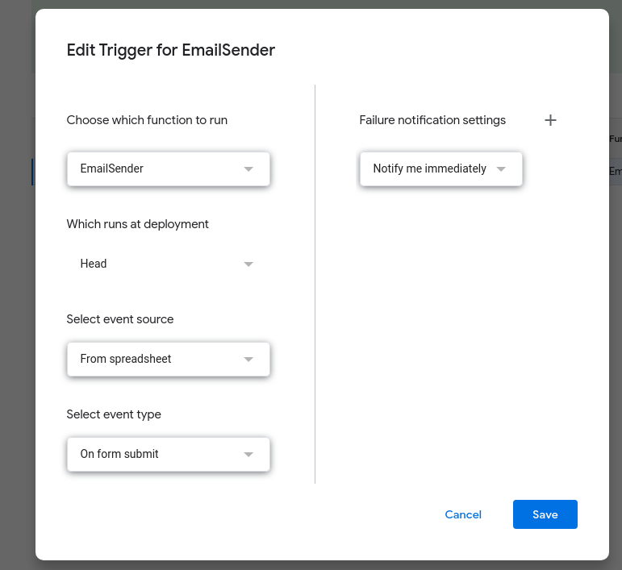

### Enable the Google Drive API

* Create a project under the [Google Developers Console](https://console.developers.google.com/), enable the Google Drive API, setup the required credentials, and save the Json File. Under Credentials/credentials.json a Token file will be generated the first time the account is ran.

### Create a New Project

* From the top of the window, Next to the Google API logo, “select a project.”
* You will get a window like the image to the right, choose

“New Project”

* 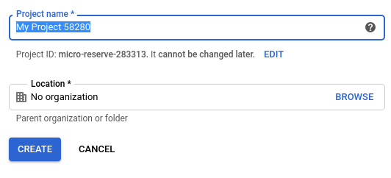A new window will appear.
* You may type in any name for the Project Name
* “Create” the project.

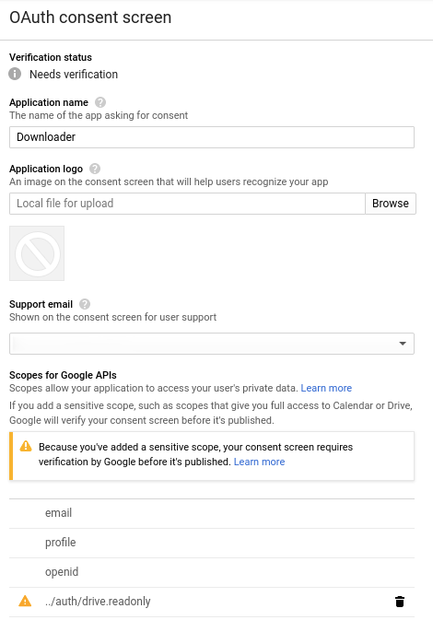

### Create the OAuth Consent Screen

* Go to the “OAuth consent screen” Tab
* For the “Application Name”, enter any name you like.
* Click, “Add Scopes”, Scroll down.
* Add the /auth/drive.readonly Scope.

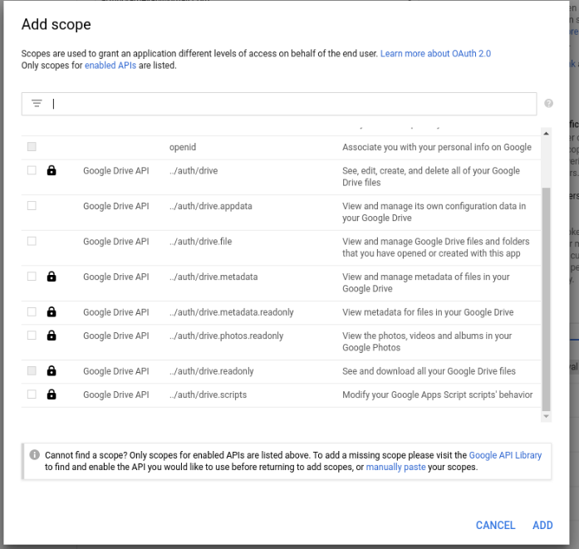

### Credentials Tab

* Create an “OAuth client ID”
* Application type should be set to “Web application”
* The Name doesn’t matter.
* The Authorized JavaScript Origins should be: http://localhost:8080
* 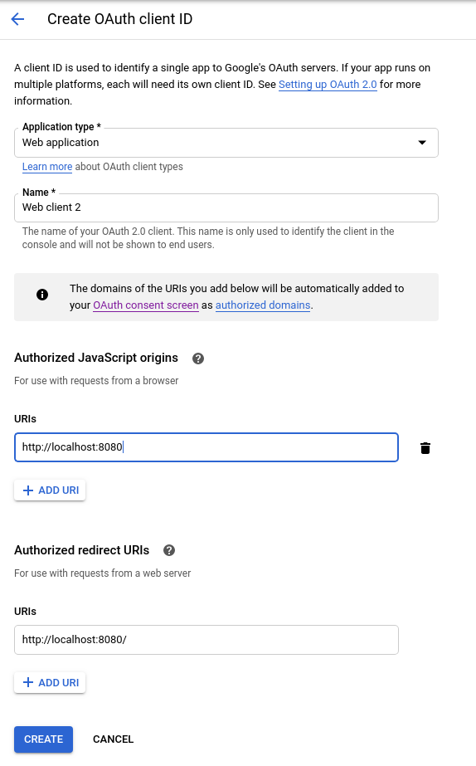The Authorized Redirect URL should be: http://localhost:8080/ (Please note the / at the end of the redirect URL)
* Save the Configuration and Download the JSON File.
* If not already created, please create a folder in the program directory called “Credentials”.
* Rename the JSON file to “credentials.json” and place inside that folder.
* Upon first run of the program you will asked to authorize the Google Project with your Google Account.

### First Run Authorization.

* Accept Everything that comes up.
* For the “This app isn’t verified”, click advance and click “Go To”
* To the Right are all the screens that appear.

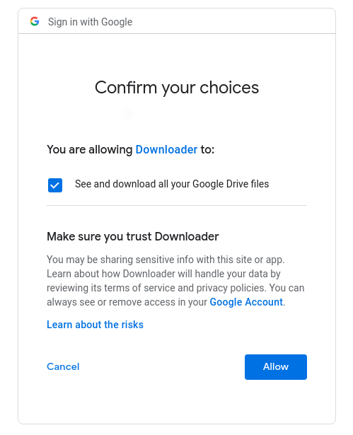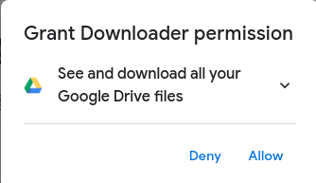

## Network Environment Configuration

In most cases, the network settings can all remain as is without any modifications.

However, in our environment, our machine running the software is not on the same network due to environmental limitations. Because of that we unplug our printers from one network and into a custom network when using the software.

If your configuration results in a similar experience see below.

* The machine that the system is operated on cannot use the internal corporate network
* The System must be able to access the internet on one network interface and interact with the printer on-another.
* Most Printers get setup with static IP addresses so replace IP addresses below with your environment.
* Network Structure
  + Ethernet (Layer 2 Switched Network)
    - Network Switch (IP 10.56.54.1 <- Used as Gateway IP for all other devices)
      * Computer (IP 10.56.54.X)
      * Printer 1 (IP 10.56.54.162)
      * Printer 2 (IP 10.56.54.156)
  + Wireless
    - Internet

## Software Environment Configuration

Steps to make sure software environment is setup correctly.

* Default, folder should be located at, C:\S.
  + Executables can be obtained from the GitHub Link under [Releases](https://github.com/ArthurVardevanyan/CPD_SO_Automated_Printing/releases).
  + Windows is extremely limited in the total length of file paths. The software should be deployed into a single letter folder at root.
  + The Credentials folder will be autogenerated if it doesn’t exist, however the contents inside it will still need to be placed inside it. (See Below)
  + Logs and SO will be automatically generated.
  + Contents of the shortcuts folder can be found [here](https://github.com/ArthurVardevanyan/CPD_SO_Automated_Printing/tree/production/shortcuts), this folder will need to be manually generated.

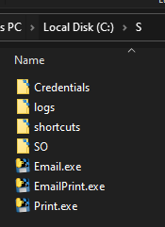

* + Copy the contents of shortcuts from the shortcut folder to the desktop or somewhere else with easy access.
  + Inside the Credentials Folder there will be three files.
  + 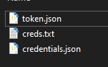
  + Credentials is created when you create the Google Drive API and should be placed inside here.
  + The Token file is autogenerated every time you run the software.
  + And the creds file
    - Line 1 is the prefix to the Gmail address (no @gmail.com)
    - Line 2-4 are what get printed onto the banner sheet, In our case
      * Business Name
      * Department
      * Store Number
* 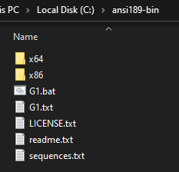Download ansi183 into the C:\ and run it. (https://github.com/adoxa/ansicon/releases)
  + (Provides color to command prompt)
  + Extract to C:\ansi189-bin\
  + In the x64 open an elevated command prompt window and run “ansicon.exe -I”
  + Do not delete these files.
* Download and Install Wkhtmltopdf (https://wkhtmltopdf.org/downloads.html)
* Download and Install ghostscript (https://www.ghostscript.com/download.html )

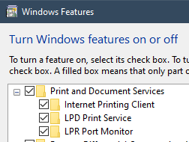

* Enable LPR and LPD: “Control Panel” -> “Program and Features” -> "Turn Windows Features on or off" -> “Print and Document Services”
  + Enable “LPR Port Monitor"
  + Enable “LPD Print Service”
  + Internet Printing Client is Optional
* Adobe Reader (Acrobat preferred) or some other PDF viewer / manipulation software is also nice to have installed.
* Under the power options turn sleep on the Computer to never.

## Printer Driver Installation

* Install the Printer Driver, [Link](https://www.support.xerox.com/support/xerox-d95-d110-d125/file-download/enus.html?operatingSystem=win10x64&fileLanguage=en&&associatedProduct=XRIP_D95_base&contentId=123564&from=downloads&viewArchived=false)
* Choose the IP Mode for adding the printer (see screenshot below).
* By default, the printer uses network search mode, and on most networks it just spins forever.
* Enter The IP Address and then click search.
* The Defaults for all the other screens are fine.
* Don’t worry about registering the printer.

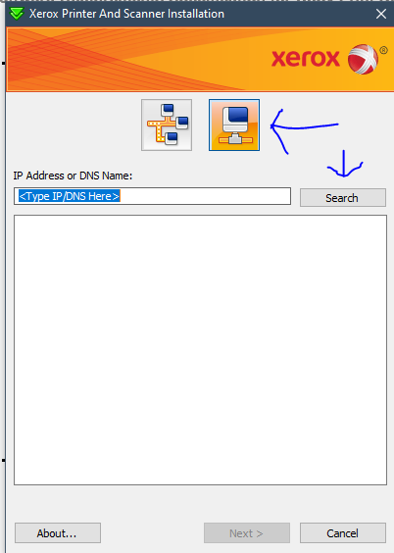

## Printer Environment Configuration

* In Your Browser, head over to the IP Address of your printer
* You must know the admin credentials for the web interface for your printer.
* For the screen shots below, ensure that the settings match up correctly.
* 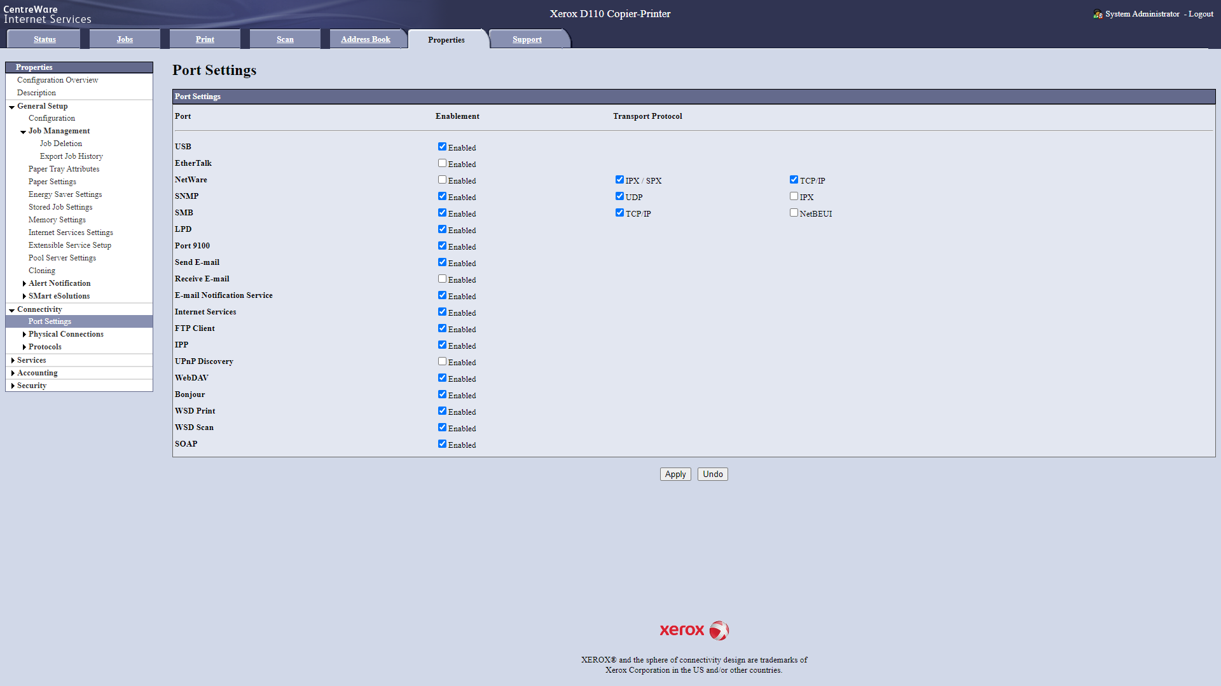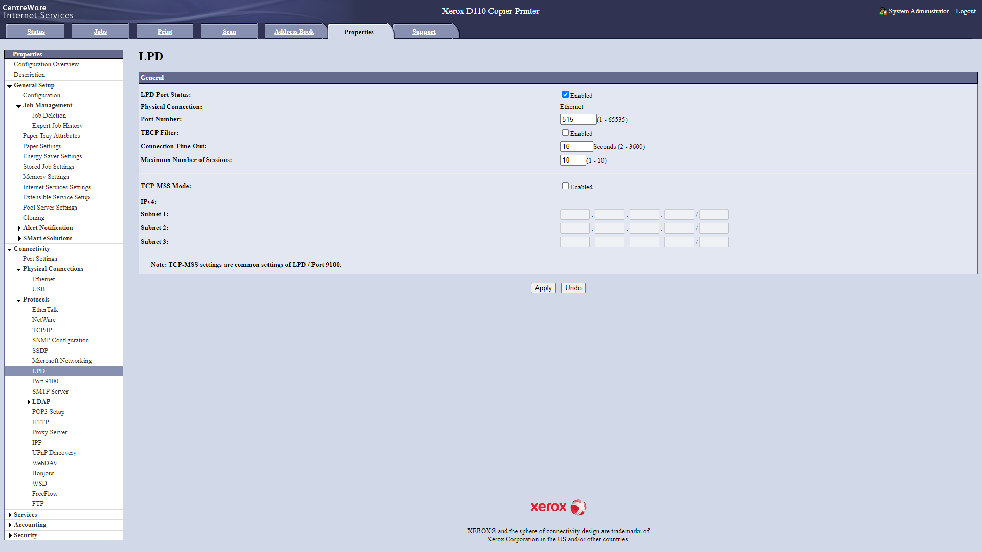All other settings can remain the same, as originally setup when you received the printer.
* Note: Banner Sheet Section, and Enabling PJL support.

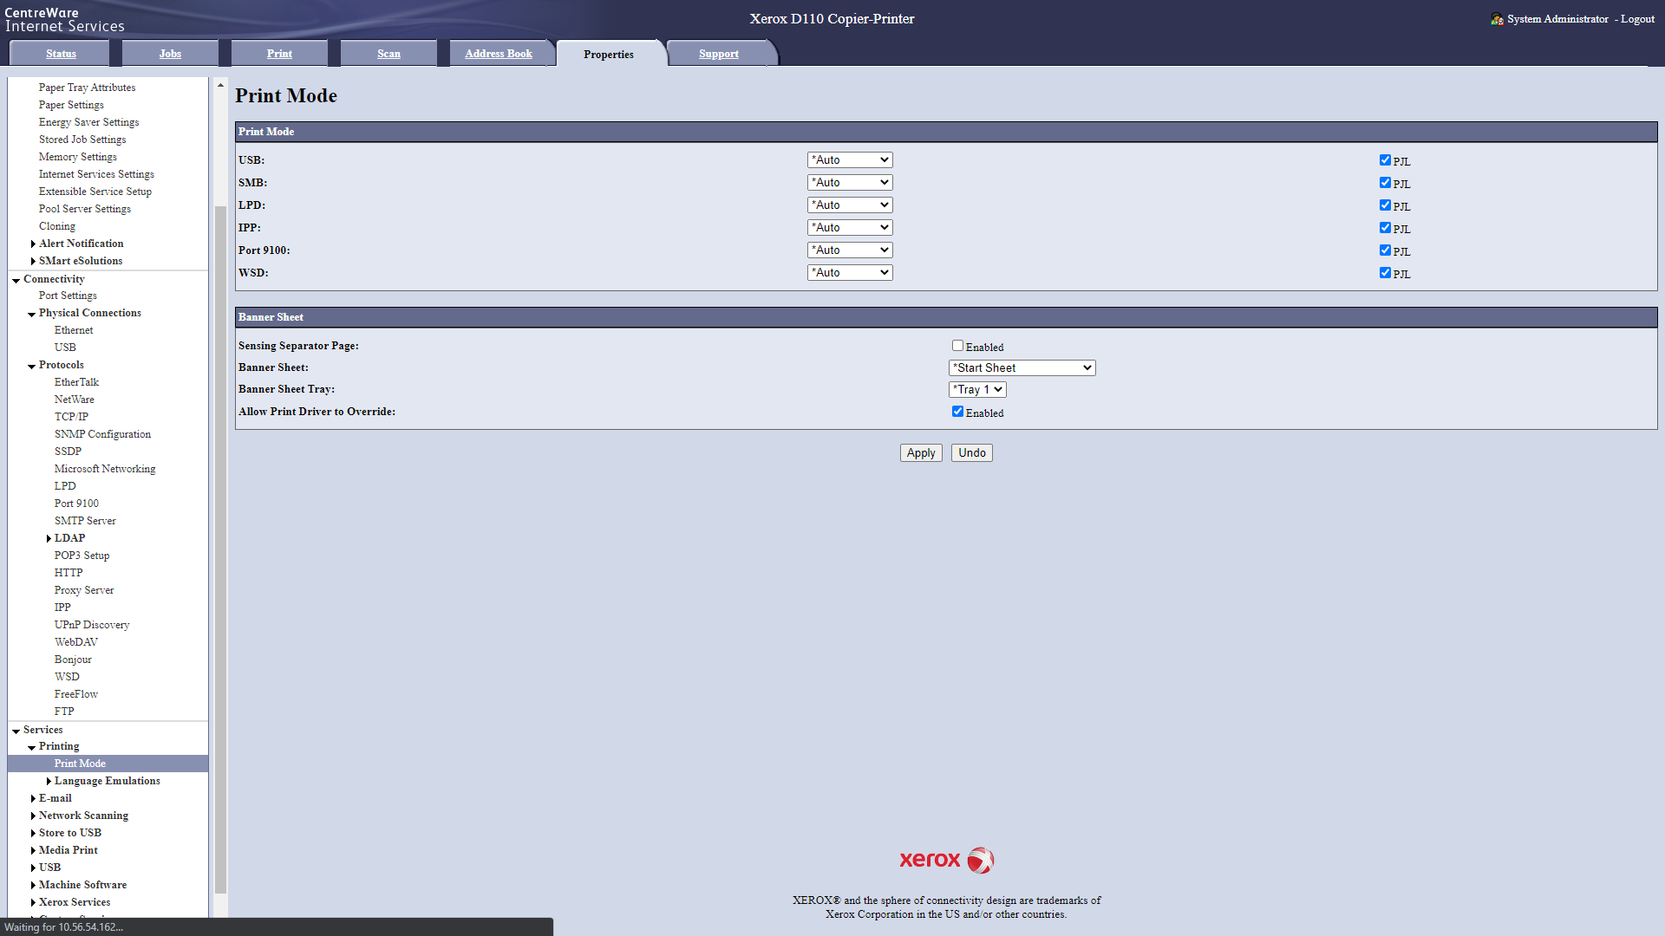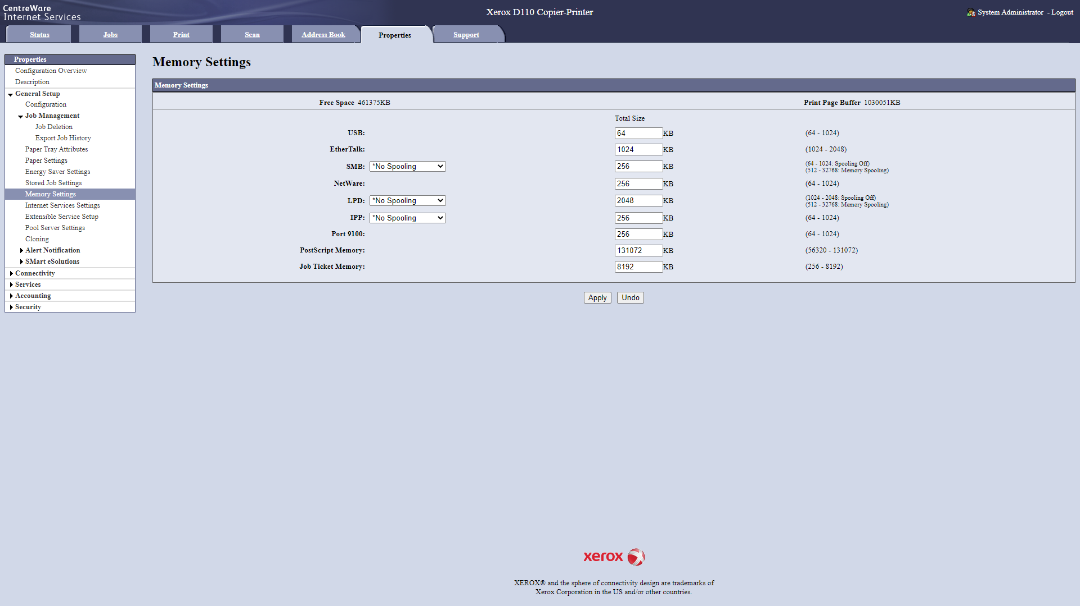

# Software Operation

## Job Retrieval

* Open the Email.bat Shortcut
* Choose No for Autorun Printing
  + Autorun is used to print orders as they download, this can work for low volume days, however, high volume can overwhelm operators and machines.
* Enter Gmail Password

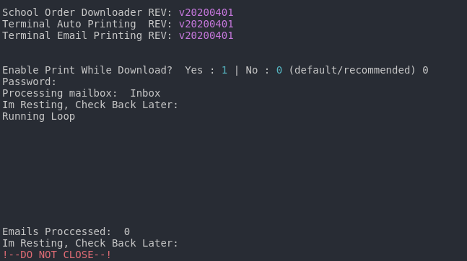

Do not close this. This must run in the background to retrieve new jobs as orders are placed.

## Ticket Printing

### Open the Email Printer.bat Shortcut from the desktop.

### Choose a Printer

* Ability to Choose between one of two pre-defined printers.
* Ensure the printer is on, networked, and able to print!

### Choose Which Tickets to Print

* Choose 0 for both Start & End Numbers to automatically print unprinted tickets.
* If a specific range is required and known Type in a Start # and an End #.

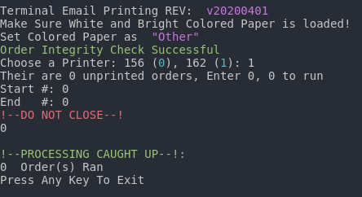

## Job Printing

### Open the Print.bat Shortcut

### Follow the Onscreen Instructions

* General workflow:
* No Emails (Generally Emails, should already be printed)
* No Colored Paper (Unless using colored paper, or cardstock)
* No Booklets (Unless running booklets), Booklet workflow will be demonstrated below.
* System will pause to confirm each inputted order.
* System will pause if inputted is needed.

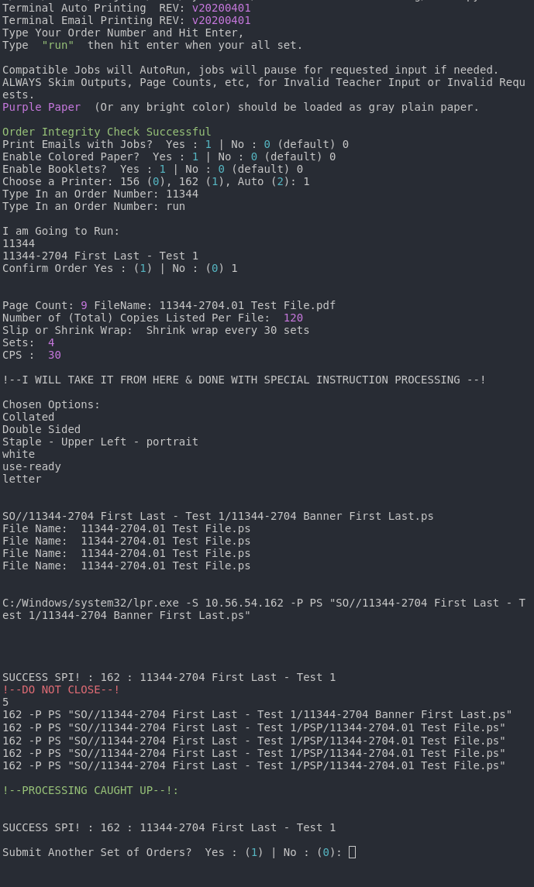

### Emails

* Allows the Email Tickets to be (re)printed when the order gets ran.

### Colored Paper

* Enables the use of colored paper
* Enables the use of cardstock paper
* The use of paper larger than letter (8.5 by 11) is not supported

### Booklets

* No Bulk Printing for Booklet Orders. Can only be done one at a time.
* 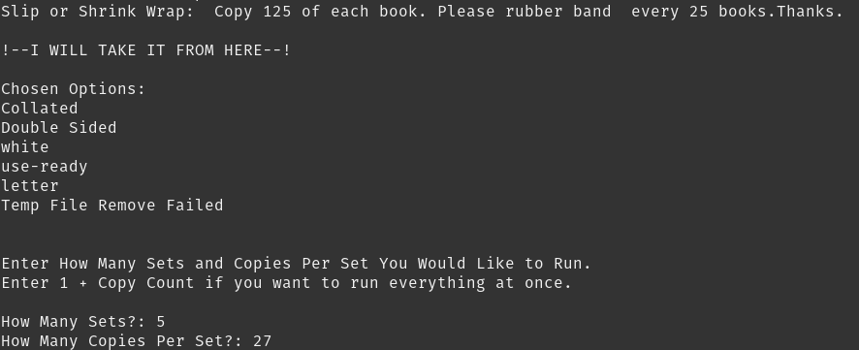This portion of the menu allows you to run the entire job at once, or split the job in sections.
* 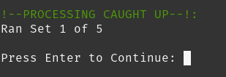Most of the time, the job needs to ran as sets. To avoid having to count each file after printing. It can print one set a time. It will prompt to the user to start the next set once they are ready.
* Before the Job Runs, one copy of each file prints to verify orientation. There is little consistency to how these files get uploaded, so proofing the output is a must.
* You have the options of Approving what you see, flipping all the files, or flipping some of the files. You will get another proof after making your choice.

