Cointegration trading

# Motivation :

Some financial products prices might move together because they are linked. For example if the price of crude oil rises then it is going to cost more to refine it and the price of gasoline will also go up. Therefore the spread between the two can be thought of being stationary, moving around a defined mean. However it happens that the spread moves away from the mean, this is when there are trading opportunities as the spread will mean revert. If the spread is far above its long term mean we can short it and if far below, buy it.

# Methodology:

Here we consider two assets with prices and and we want to see if there is a linear dependency:

Defining the spread by we get

So we expect the value of the spread to be equal to on average to which the serie will mean-revert.

To estimate we conduct a regression analysis, and then we test if the spread is stationary. In order to get the most stationary spread series we test both and . Then we conduct a stationarity test (augmented Dickey Fuller Test) on each of the spread and we select the most stationary one.

Now that we have the spread time series we need to implement the trading signals, when to buy and when to sell it. A simple strategy would be to the following.

Given a period we compute the moving average over and define an upper and lower band where is a moving standard deviation. The choice of is entirely discretionary though we could optimize it (while being aware of not overfitting).

Here we are going to use Bollinger bands not only for entering the position but also for exiting. On the graph below, the red line represents the closing bands while the green lines the entering bands. The spread is represented in blue. If the spread is above the upper green band (entering short) we short it, and we keep a short position until the spread cross down the upper red band (closing short). Inversely if the price is below the lower green band (entering long) it means we believe it will mean revert back up so we buy it and hold it until we cross up the lower red line (closing long). Following is a graph of the spread Brent/WTI and its Bollinger bands.

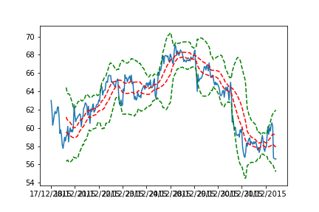

# Code structure

In a file *trading_strategies* we define all our trading strategies (here only a long, a short and the cointegration strategy). A strategy is defined over a certain period and for some underlyings, we can test it over the in sample or over the out of sample.

We get the data from csv files, and clean them in order to have useful data, ie we check that all underlyings have the same dates, that there is no data missing etc

For the cointgration strategy, we define the in and the out of samples and use the in samples to get the hedge ratio using the methodology described earlier. Then at each date of the out of sample we compute a z-score

Depending on the value of this z-score we either open/close a long/short position on the spread as defined above.

Finally we compute the performance of the strategy by using the following indicators:

* Annual returns
* Sharpe ratio
* Max draw down

*NB: The framework is very flexible and allows for future implementations of other strategies.*

# Results

In Europe there are two Gas/Oil indexes: the SXEP and the SXXP. We strongly believe that these two indexes should move together, this is why we tried a spread strategy on them.

Our in sample is from the 09/10/2000 to the 31/12/2015 while the out of sample is from the 01/01/2016 to the 02/02/2017. The parameters for the Bollinger bands are:

* Entry = 1.5
* Close = 0.5
* Window = 15 days

The spread with its Bollinger bands is as follows:

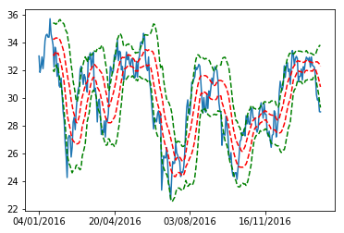

The performance we attained is the following:

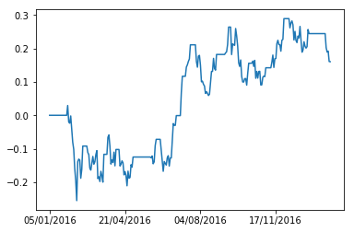

The performance looks great on this chart.

With the following indicators:

* the annual return for year 2016 was 20.11%
* the annual return for year 2017 was -4.07%
* Maximum draw down of -25.34% happened between 29/01/2016 and 11/02/2016
* Sharpe ratio of 0.02

So the strategy was clearly winning in 2016 but lost at the beginning of 2017. The maximum draw down is quite important the Sharpe ratio low, so the strategy might not be as good as it looks like.

And here is a comparison with some other long only strategies:

* S&P500 strategy:

In blue the cointegration strategy returns and in orange the S&P ones.  
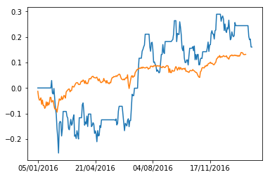

It starts by losing but then the returns are higher than the S&P 500.

* Long only SXEE

In blue the cointegration strategy returns and in orange the S&P ones.

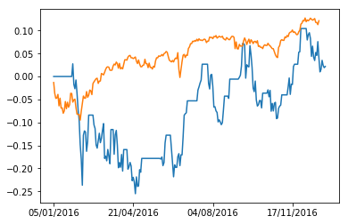

So maybe instead of trading the spread we should have long the SXEE Index.

Conclusion:

The spread strategy is working quite well in 2016 though starting the year with bad returns (-25%). The volatility of the returns is very high, which explains the low Sharpe ratio. It is doing better than the S&P but less than the SXEE. We should test further in the coming years to see if the returns are consistent or not.

# Limits and improvements

This strategy has 3 main limits.

1. The parameters we use for the Bollinger bands (window and enter, close parameters) are purely discretionary.
2. The strategy does not take into account Bid Ask spreads, liquidity, and everything is traded at the closing price.
3. Finally these strategies are nowadays largely used and are not profitable anymore.

We see future improvements for the strategy:

* An intraday framework to look for intraday cointegration.
* Building a multiple cointegration strategy using the Johansen test.
* Optimizing the parameters used for the Bollinger bands.