Food Image Classification
Computer Vision Course, Assignment 1: Dataset and Project Report
Classes: burger, hotdog, pizza, sandwich, sushi

1. Objective
In this project I built a model that sorts food photos into 5 classes: burger, hotdog, pizza, sandwich and sushi. I collected the dataset myself, checked and cleaned it, prepared the images, trained two models (a simple classical baseline and a transfer learning model), compared them, and looked at the mistakes the better model makes.

2. Dataset
At first I had 569 valid images, stored in one folder per class. The automatic check also found one broken file (a DjVu document saved with an image extension), which I removed. Table 1 shows how many images are left in each class after the automatic check and two rounds of manual review (Sections 2.1 and 2.2).
Class | Images
Burger | 112
Hotdog | 98
Pizza | 103
Sandwich | 117
Sushi | 105
Total | 535

The smallest class has 98 images and the biggest has 117, so the difference is 19 images. The script prepare_dataset.py opens every image to check that it is not broken, compares MD5 hashes to find exact copies (none were found), compares perceptual hashes to find near copies, and saves the image sizes for each class. The sizes are very different, from small thumbnails up to 8192x8160, so all images have to be resized before training.
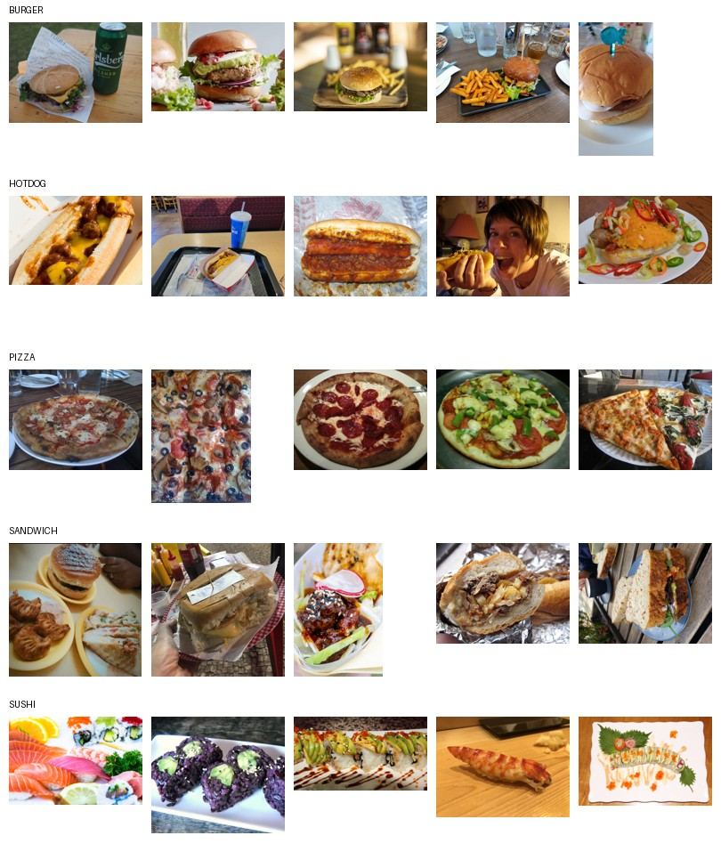
Figure 1. Example images from each class.
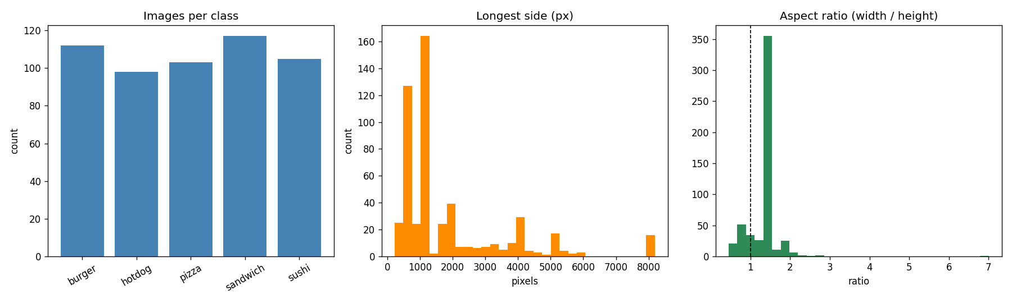
Figure 1b. Number of images per class, image sizes and aspect ratios.

2.1 Manual review: wrong images
The automatic check only looks at technical things: broken files, duplicates and sizes. It cannot tell if a photo really shows the right food. So I went through every class by hand, looking at all the images and not only a random sample. Most problems were in the "sandwich" class. A lot of its images were not food at all: street photos, shop signs, paintings (for example a copy of a Goya painting), comic book covers, an edited picture of the Earth between two slices of bread, cartoon mascots and even a photo of a dog with a toy. Probably this happened because Sandwich is also the name of towns (Sandwich in Kent, UK and Sandwich in Massachusetts, USA), so searching by keyword on sites like Wikimedia Commons also returned pictures of these places.
I removed 30 wrong images from "sandwich" (147 to 117) and 1 from "pizza" (a photo of a restaurant room with no pizza in it; 104 to 103).

2.2 Manual review: duplicates and bad images
The validation report marks near-duplicate pairs and very small images, but it does not delete anything by itself, because not every marked image is really a problem. When I checked the marked images, I found two pairs in "hotdog" that were the same photo saved twice (perceptual hash distance 0) and one 100x100 "burger" thumbnail that was too low quality to use. I removed these 3 images: one copy from each pair and the thumbnail. About 11 other small "burger" photos (around 180-300 px) I kept, because they really show a burger and the model resizes every image to 224x224 anyway. Removing correctly labeled images would only make the dataset smaller without fixing any real mistake.
All 34 removed files (31 from Section 2.1 and 3 from this section) are listed in removed_files.csv in the project folder, with a short reason for each one, so anyone can check or repeat the cleaning.

2.3 Where the images come from
Not all images in the dataset were taken by me. At least one hotdog image (dataset/hotdog/hotdog_077.jpg) has a visible "(C) 2009 Foodnut.com" watermark, which means it was downloaded from a food blog. I mention this here so the dataset is not presented as fully my own photos. Other images may also come from the web, but without a watermark this is hard to tell.

3. Preprocessing and Augmentation
In the end every image is 224x224 and normalized, but train and val/test images are resized in different ways so that the food does not get stretched. Some classes (for example "sandwich" and "sushi") have very large images with unusual shapes, so simply squeezing every image into a square would distort it. The EfficientNet model uses the standard ImageNet mean and std for normalization, because its pretrained weights were trained with them. The SVM baseline does not use these values: it works on grayscale HOG features, which are scaled with StandardScaler. The script also calculates the mean and std of my own dataset, but only for information.
Only the training images get augmentation. It is applied randomly every time an image is loaded (nothing is saved to disk) and helps the model to overfit less on a small dataset:
- Random resized crop of the original image: it takes 80-100% of the image with a random shape and resizes this part to 224x224, so it augments and resizes at the same time without stretching the image
- Random horizontal flip (p = 0.5)
- Random rotation (+/- 15 degrees)
- Color jitter (brightness, contrast, saturation +/- 20%)
Validation and test images use Resize(256) and then CenterCrop(224), which is the usual way to evaluate a model. They get no augmentation, so the results are fair and the images keep their shape.
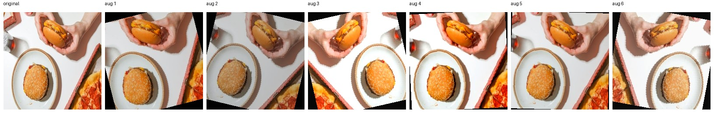
Figure 2. One training image with six different random augmentations.

3.1 Reproducibility
Random seeds are fixed in the whole pipeline (random, numpy, torch and the SVM), so the split, the training and the evaluation give the same or almost the same results every time. Training on the Mac GPU (MPS) is not 100% deterministic, so the numbers can still change a little between runs. The exact package versions are in requirements.txt.

4. Models

4.1 Baseline: HOG + SVM
The baseline does not use deep learning. Each image is turned to grayscale, resized to 128x128 and described with HOG features (Histogram of Oriented Gradients), which capture the direction of edges in small parts of the image. The features are scaled with StandardScaler, and then an SVM with an RBF kernel is trained on them to predict the 5 food classes.

4.2 Improved model: EfficientNet-B0 (transfer learning)
The improved model is EfficientNet-B0 pretrained on ImageNet (1.28 million images, 1000 classes). It is trained in two phases:
- Phase 1 (up to 10 epochs, LR 1e-3): the pretrained backbone is frozen (requires_grad=False) and only the new classifier head is trained. The BatchNorm layers are also kept in eval() mode, so their saved statistics from ImageNet do not change because of my small batches.
- Phase 2 (up to 15 epochs, LR 1e-4 with a cosine schedule, early stopping with patience 5 on validation accuracy): the whole network, including BatchNorm, is unfrozen and trained.
This works well for small datasets. Training a CNN from zero on about 375 training images would overfit very quickly, but a model pretrained on ImageNet already knows general visual features (edges, textures, shapes) and only needs to adapt them to food. Random seeds (random, numpy, torch) are fixed, but as said in Section 3.1, MPS is not fully deterministic, so the numbers can change a little between runs.
In practice, the best checkpoint on validation came from Phase 1 in both runs (with and without augmentation). Training the whole network never beat the best head-only epoch on validation, and in the run without augmentation the validation accuracy even got worse after the backbone was unfrozen. With only 375 training images, changing about 4 million backbone parameters seems to cause overfitting or to damage the useful ImageNet features, at least with the learning rates I tried. So the final model is basically a linear classifier on top of frozen ImageNet features, not a fully fine-tuned network.
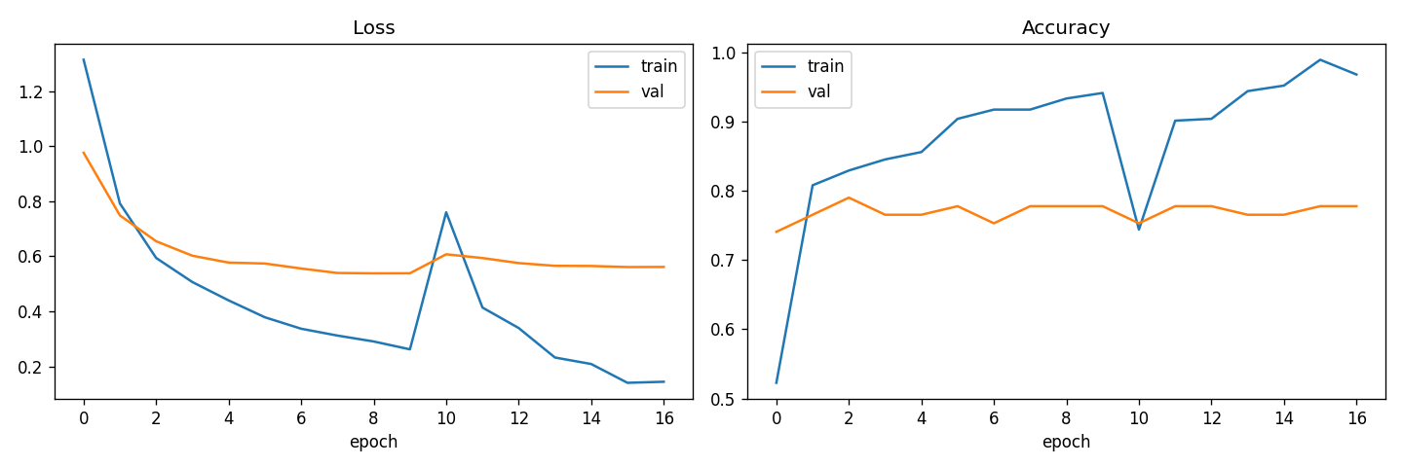
Figure 3. EfficientNet-B0 training and validation loss and accuracy over both phases.

4.3 With and without augmentation
To check if the augmentation from Section 3 really helps, I trained the same model a second time with the same seed, number of epochs and early stopping rule, but without augmentation. In this run the training images use the same Resize(256) and CenterCrop(224) as validation, without random crop, flip, rotation and color jitter.
 | Train acc | Val acc | Test acc | Train-val gap
With augmentation | 0.883 | 0.790 | 0.785 | 0.093
Without augmentation | 0.955 | 0.815 | 0.899 | 0.140

Augmentation reduced overfitting: the gap between train and validation accuracy is 0.093 with augmentation and 0.140 without it. But it did not make the model more accurate. Without augmentation the model scored higher both on validation (0.815 vs 0.790) and on test (0.899 vs 0.785). Possible reasons are the small dataset (375 training images), the frozen backbone in both final models (Section 4.2), and only one run for each setting instead of an average over several seeds. Usually augmentation is expected to help, but here the numbers show something different. It did reduce the train-validation gap, which is its main job, but this did not turn into higher accuracy, at least in one run on a dataset this small. Section 5.1 shows how much these test numbers can change by chance.

5. Evaluation and Results
Both models were tested on the same test set of 79 images. The cleaned dataset was split 70/15/15 into train, validation and test, keeping the same class proportions in each part. I measured accuracy, macro precision, recall and F1, and made confusion matrices.
Metric (test set) | Baseline (HOG + SVM) | Improved (EfficientNet-B0)
Accuracy | 0.53 | 0.78
Precision (macro) | 0.53 | 0.79
Recall (macro) | 0.52 | 0.80
F1 (macro) | 0.50 | 0.78

The improved model has about 1.5 times higher test accuracy than the baseline. The baseline also overfits a lot (100% on train and 53% on test), which shows that hand-made HOG features with an SVM are not good enough for this data. The EfficientNet model has a smaller gap between train and validation (88% vs 79%), so it generalizes better, but it still overfits a bit. Section 4.3 also shows that the test result changes noticeably with and without augmentation and from run to run.
I do not give one exact number for how much the cleaning improved accuracy. Between the first version and the cleaned version, the dataset, the preprocessing and the test set itself (84 to 79 images) all changed at the same time, so it is not possible to separate their effects. What I can say is that every removed image was a real mistake in the data: a painting, a street photo, a duplicate or an unusable thumbnail. Removing them makes the dataset correct, whatever the exact effect on accuracy is.

5.1 Bootstrap confidence intervals
The test set has only 79 images, so one accuracy number does not show how much it could change on a different random sample. I used a bootstrap: I took the 79 right/wrong results, resampled them with replacement 10,000 times and calculated a 95% interval for each model.
Model | Test accuracy | 95% CI
SVM + HOG | 0.53 | 0.42 - 0.65
EfficientNet, with augmentation | 0.78 | 0.70 - 0.87
EfficientNet, without augmentation | 0.90 | 0.82 - 0.96

Both EfficientNet models are clearly better than the SVM baseline, because their intervals do not overlap with the SVM interval. The intervals of the two EfficientNet models overlap, so this small test set cannot reliably tell which of them is better, even though their accuracies differ by more than 10 points.

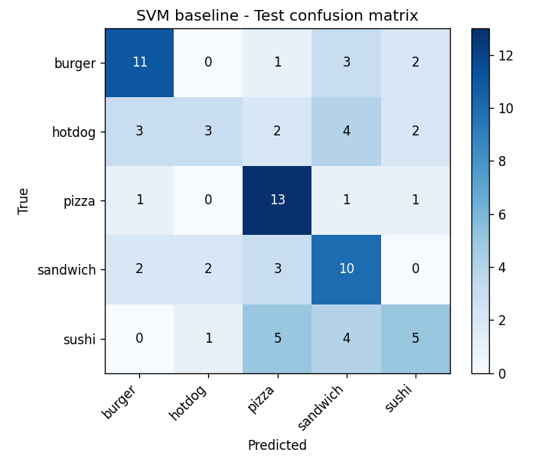 | 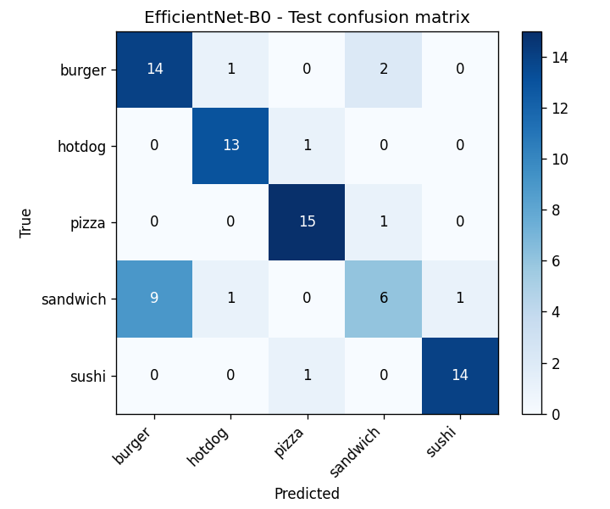
Figure 4. Confusion matrices on the test set: SVM baseline (left) and EfficientNet-B0 (right).

6. Error Analysis and Discussion
The improved model got 17 of the 79 test images wrong (78% accuracy). The confusion matrix (Figure 4) and this list of errors use exactly the same preprocessing as the reported metrics (Resize(256) and CenterCrop(224)), so they match each other. The most common mistakes were:
- sandwich predicted as burger (9 cases), by far the most common mistake
- burger predicted as sandwich (2 cases) and burger predicted as hotdog (1 case)
- hotdog as pizza, pizza as sandwich, sandwich as hotdog, sandwich as sushi and sushi as pizza (1 case each)
Even after removing the wrong images from Sections 2.1 and 2.2, burger vs. sandwich is still the main confusion for EfficientNet, both with and without augmentation. For the SVM baseline the errors are spread more evenly, and its most common mistake is sushi predicted as pizza. In this run the confusion goes mostly one way: sandwiches are taken for burgers much more often than the other way around. This looks like a real visual similarity between the two classes (both are bread with a filling, often served with fries or drinks) and not a problem with the data or the code. Cleaning the data and fixing the preprocessing removed the noise, but they cannot remove this real overlap between the classes.
When I looked at the misclassified images (Figure 5), most of the remaining mistakes were photos taken from unusual angles, photos where side dishes like fries or drinks take most of the frame, and one sandwich served in a way that looks like a taco or a roll. In such photos it is hard to tell a burger from a sandwich even for a person looking quickly at a small picture. One hotdog image also has a web watermark (Section 2.3), which shows that some noise is still left in the data after cleaning (images from the web and unusual servings).
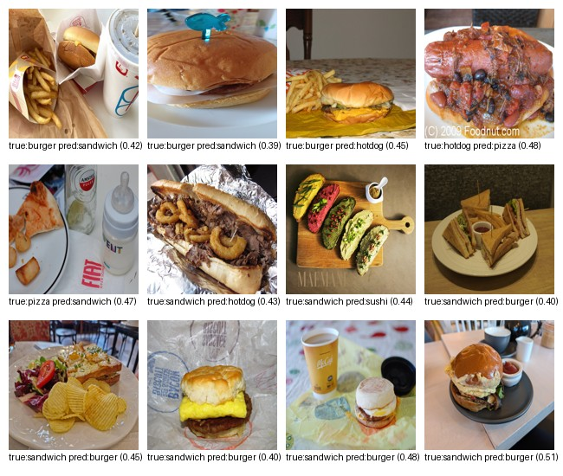
Figure 5. Examples of test images that EfficientNet-B0 got wrong (cleaned dataset).

7. Conclusion
I collected a food dataset with 5 classes (569 images at the start) and checked it automatically and also by hand in two rounds. The first round showed that "sandwich", which is also the name of towns, had 30 wrong images, and "pizza" had 1. The second round found 2 duplicate "hotdog" photos and 1 unusable "burger" thumbnail (the full list is in removed_files.csv). I also mention that at least one hotdog image is a watermarked photo from the web and not my own. After removing these 34 images (535 left), I fixed a preprocessing step that stretched images, kept BatchNorm frozen while the backbone is frozen, and added a cosine learning rate schedule and early stopping for fine-tuning. Then I trained and compared two models on the cleaned data with fixed random seeds.
The HOG + SVM baseline reached 53% test accuracy and overfit a lot. EfficientNet-B0 with transfer learning reached 78.5% test accuracy with augmentation and 89.9% without it, with one run for each. The bootstrap table in Section 5.1 shows that on such a small test set these two results cannot be reliably told apart. In both runs the saved model came from the head-only phase and not from full fine-tuning (Section 4.2): training the whole backbone on 375 images never beat the frozen backbone on validation, and without augmentation it made the results worse. Augmentation made the train-validation gap smaller (0.093 vs 0.140), as expected, but did not improve accuracy here (Section 4.3). The most likely reasons are the small dataset, the frozen backbone and only one run per setting, not that augmentation is useless in general.
Limitations: the test set is small (79 images), and the bootstrap intervals in Section 5.1 show that the two EfficientNet versions cannot be reliably compared on it. The SVM parameters (C and gamma) were fixed and not tuned with a grid search. The exact effect of the data cleaning cannot be separated from the preprocessing fix (Section 5). Fixed seeds make the runs more repeatable, but MPS is not fully deterministic, so the numbers can still change a little. And burger vs. sandwich is still a real visual similarity that the model does not fully solve.
Things that could be improved: collecting more images, especially for "sandwich", which is still one of the hardest classes; making the class sizes more equal; tuning the SVM parameters with a grid search; repeating the augmentation comparison with several seeds instead of one; and trying a bigger pretrained model.

Acknowledgment
I used Claude (Anthropic) as an assistant in this project: to help write and debug the scripts, review the dataset for quality problems, and draft this report and the notebook.

Dataset:
https://drive.google.com/drive/folders/1D6uadjrY0yAQLyzzfscEyOCIu9pm_0kU?usp=sharing

