Game Design Document

Fill up the following document

1. Write the title of your project.

Ash runner

1. What is the goal of the game?

To find the treasure

1. Write a brief story of your game.

A boy named ash is lost in the woods help him find the treasure so it can be easier for him to reach back home

1. Which are the playing characters of this game?

* Playing characters are the ones who respond to the user based on the input from the user.
* Cars, monkeys, dinos, wizards, etc., are the playing characters in the game.

|  |  |  |
| --- | --- | --- |
| Number | Character Name | What can this character do? |
| 1 | Ash | Jump,fly |
| 2 | Anna |  |
| 3 |  |  |
| 4 |  |  |
| 5 |  |  |
| 6 |  |  |
| 7 |  |  |
| 8 |  |  |

1. Which are the Non-Playing Characters of this game?

* Non-Playing characters are the ones that don't have an action or behavior when the user interacts with the game.
* Hurdles, stones, bananas, coins, etc., are non-playing characters in the game.

|  |  |  |
| --- | --- | --- |
| Number | Character Name | What can this character do? |
| 1 | bushes |  |
| 2 | river |  |
| 3 | money |  |
| 4 | Energy booster |  |
| 5 |  |  |
| 6 |  |  |
| 7 |  |  |
| 8 |  |  |

Draw your imagination of this game. What does this game look like?

* Draw the game either on your computer or on paper.
* Add images of the game scenes to show each of the playing and non-playing characters at least once.

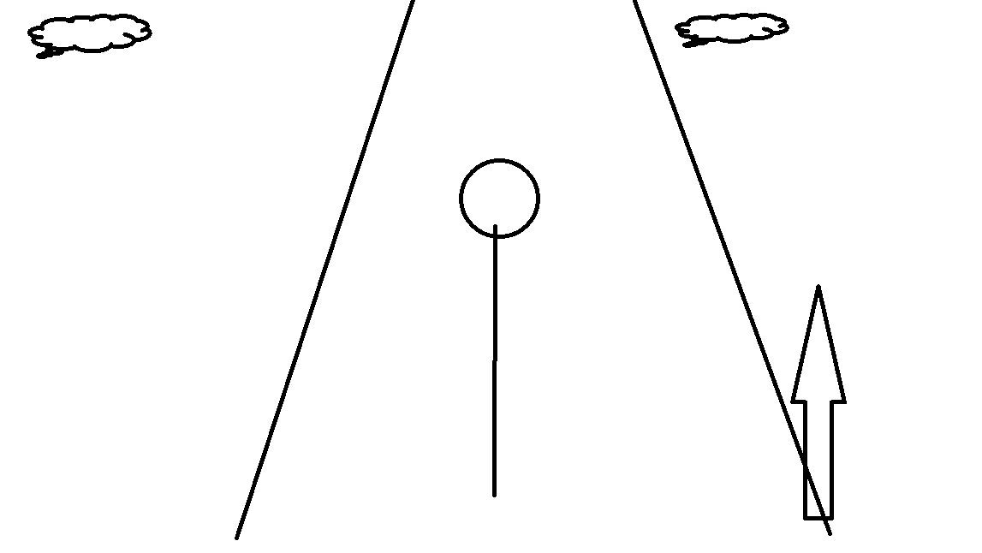

How do you plan to make your game engaging?

sound,animations,score,success for the player so he plays another round