**PRODUCT MANAGEMENT SYSTEM**

(**Spring Boot React Crud)**

Implemented **Crud Operations Using Spring boot and React full stack**

Technologies used:

Spring Boot React Crud Implementation

**Technologies**

**Backend**: Spring Boot, Rest Api

**Frontend**– React (React Hook, React Router 6.0)

**Tools**: STS 4, VS Code Studio

**Database**: MySQL

**Server**: Apache Tomcat Server

### **Product Management System Backend Source Code structure**

STS 4

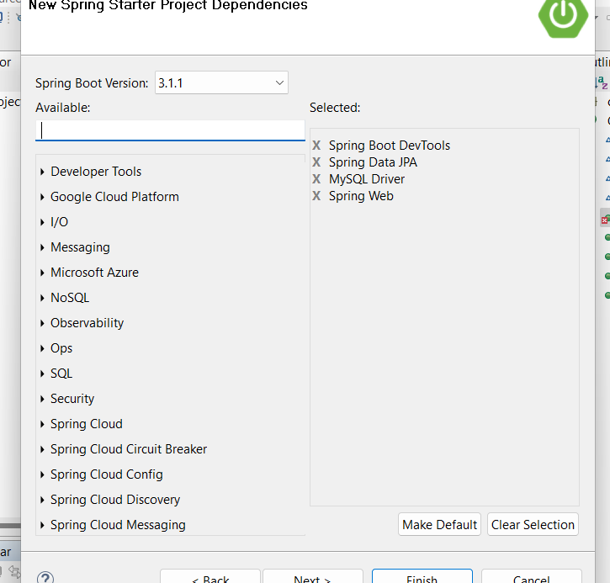

FRONT END

MUST HV NODE.JS istalled

Check W+R> cmd> node -v

Create new folder🡪 Product_Management_Frontend

Open this folder in vscode

In vscode

Open termainal > npx command create react app

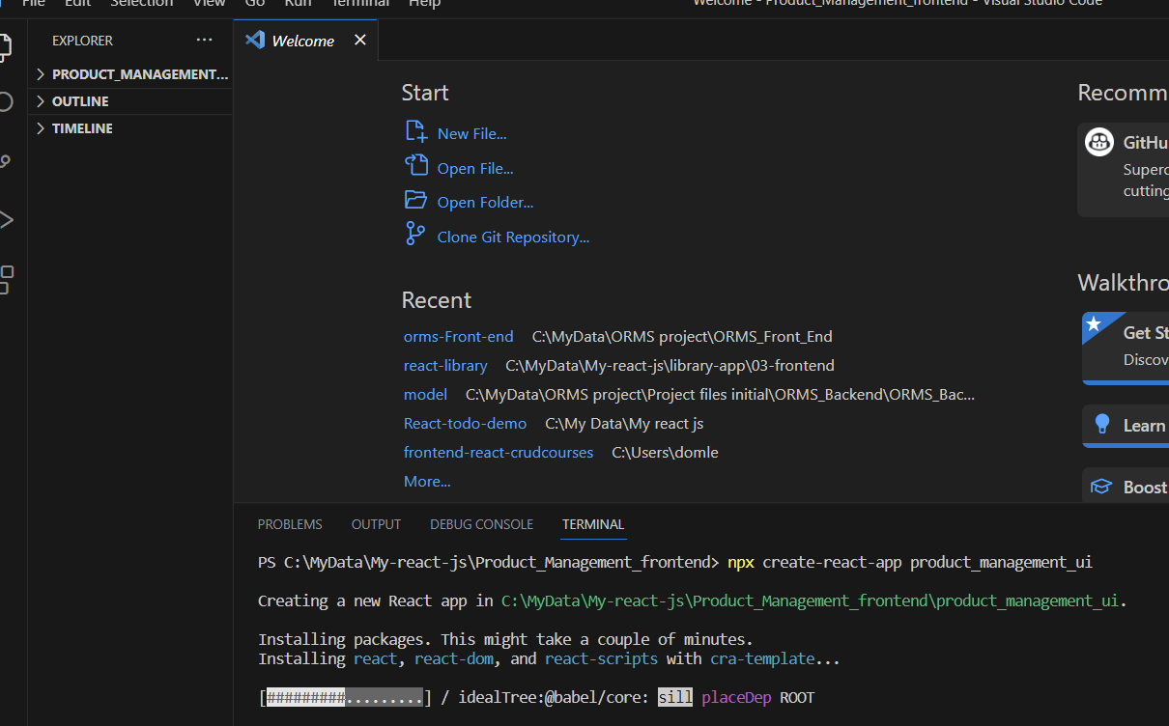

After sussccessfully created project

Open the react-app project folder in vscode that got created by npx

Open terminal> npm start

Remove from outer <div> from app.js

And remove log import

**REACT COMMENTS**

**{/* map used- */}**

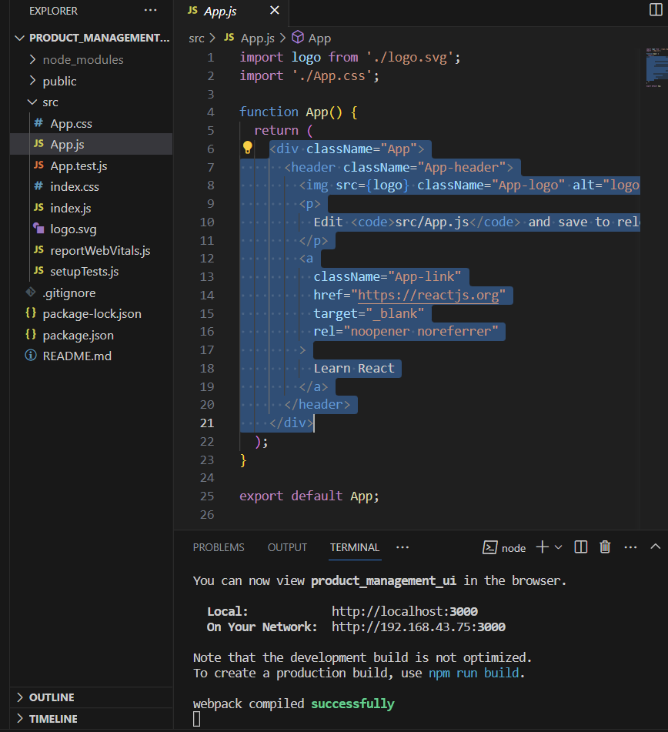

Inside index.html

Add css frop bootstrap 5 inside< head> last

Add js budle from bootstrap 5 inside <body> last

Now create a navbar

Create folder as component in src folder

Component folder> Navbar.js

In Navbar.js

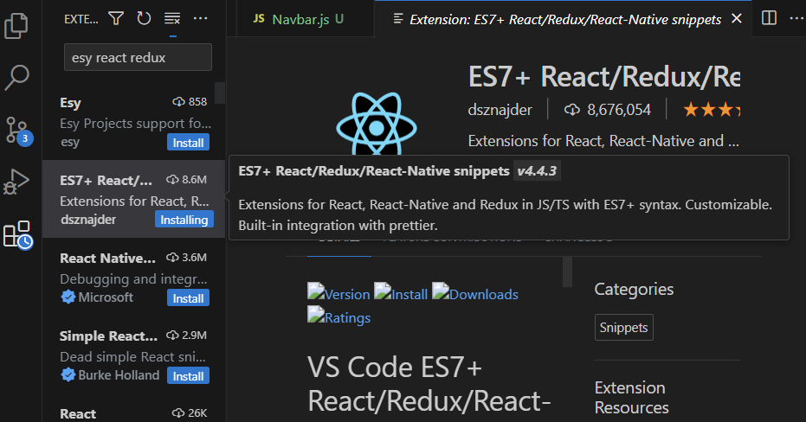

write rafce

Go to bootstrap5 and copy navbar

And paste it in navbar.js

Remove <form> tag at last giving errrr

Clode hr tag />

Open APP.js

<Navbar/> there

Remove un necessary items <li>

Add 2 li

Add more files in src>component folder

With .jsx file extention

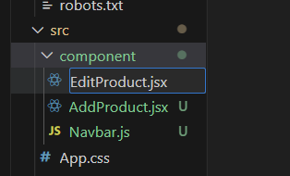

**FOR USING ROUTING CONCEPT**

INSTALL ROUTER

SEARCH REACT ROUTER IN GOOGLE

Reactroiuter.com version 6

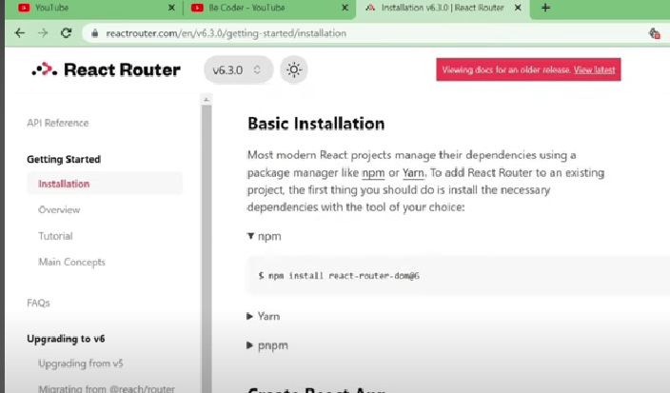

Open new terminal and install by entering cmnd

OPEN index.js

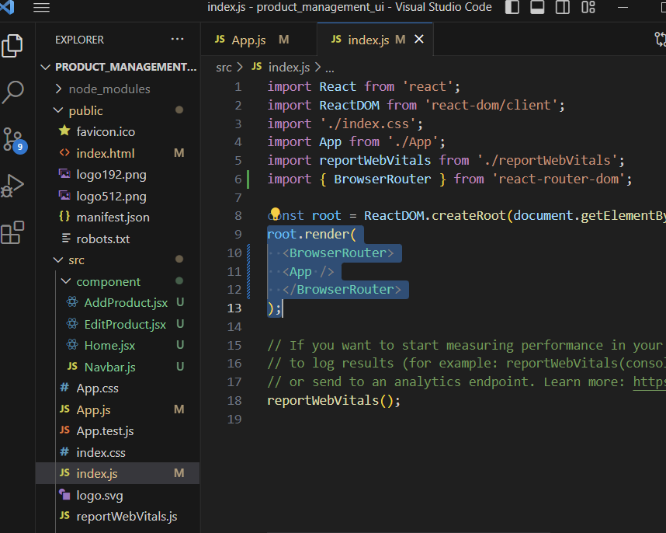

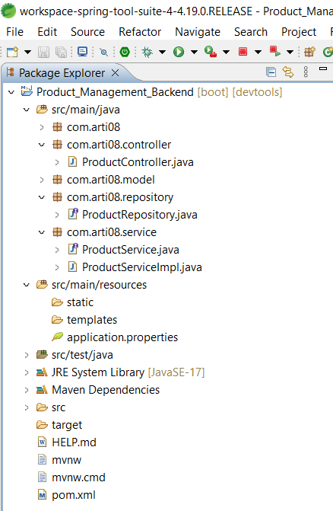

#### **ProductManagementBackendApplication.java**

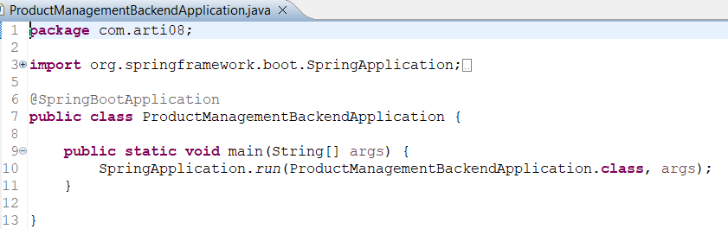

#### **ProductController.java**

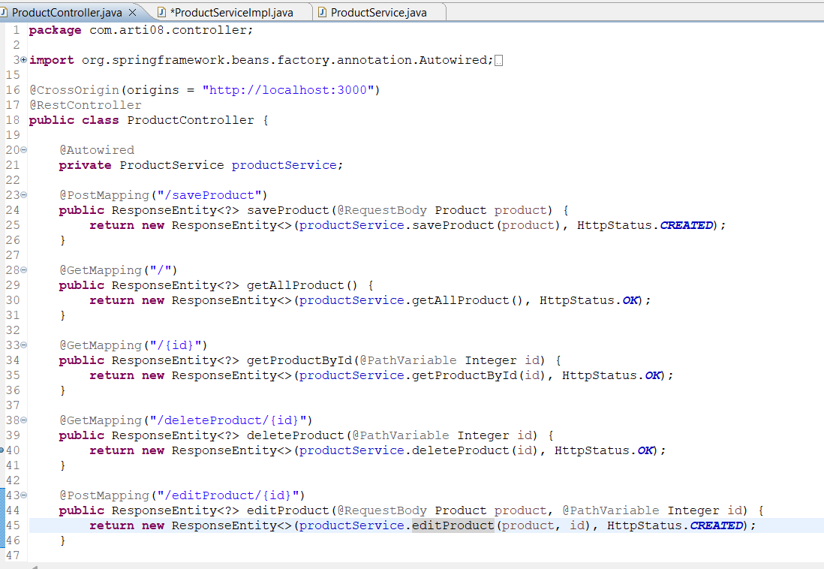

#### **Product.java**

Add getter and setter to all

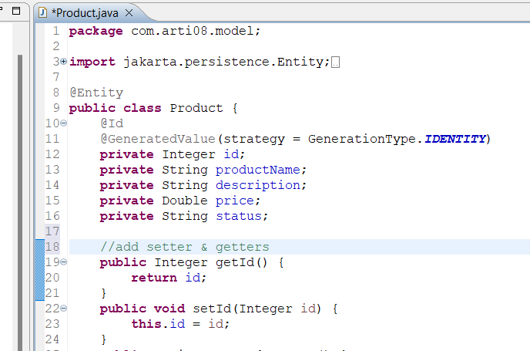

#### **ProductRepository.java**

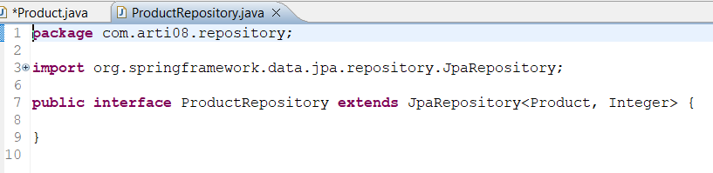

#### **ProductService.java**

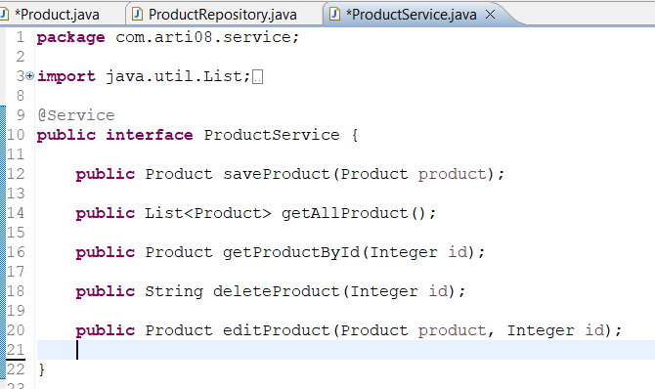

#### **ProductServiceImpl.java**

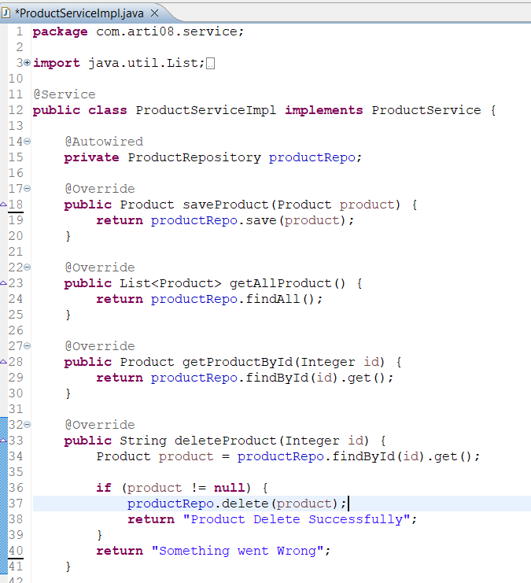

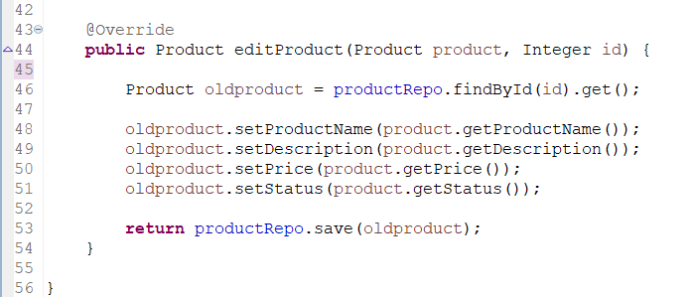

#### **application.properties**

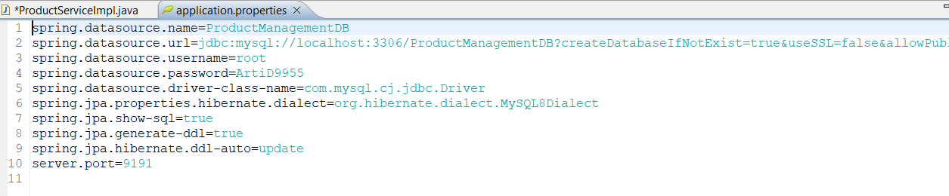

#### **pom.xml**

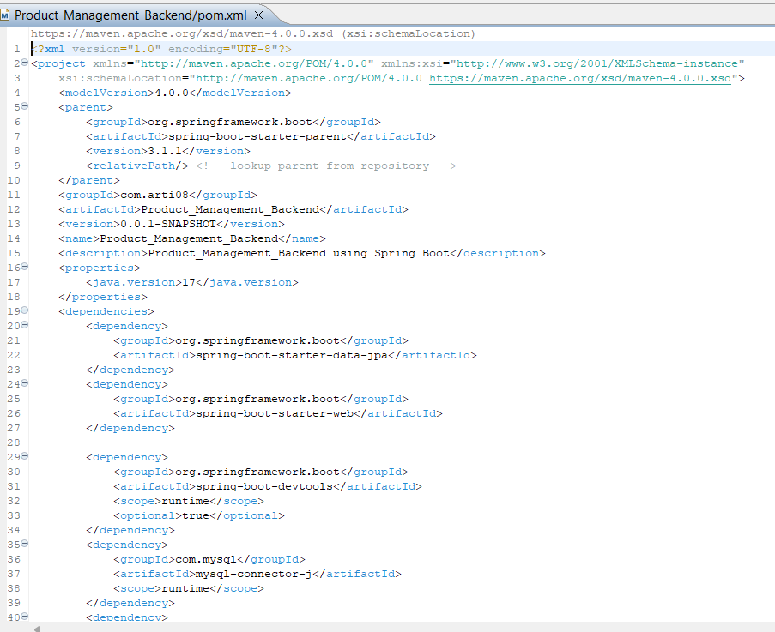

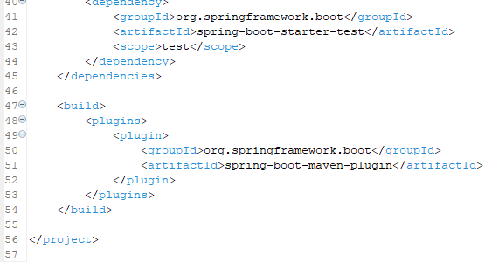

### **Product Management System Frontend Source Code**

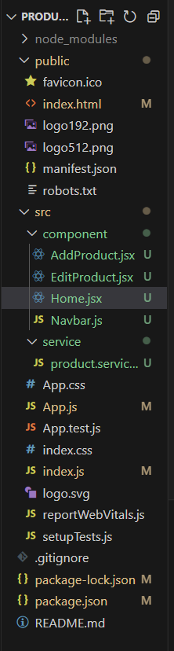

#### **AddProduct.jsx**

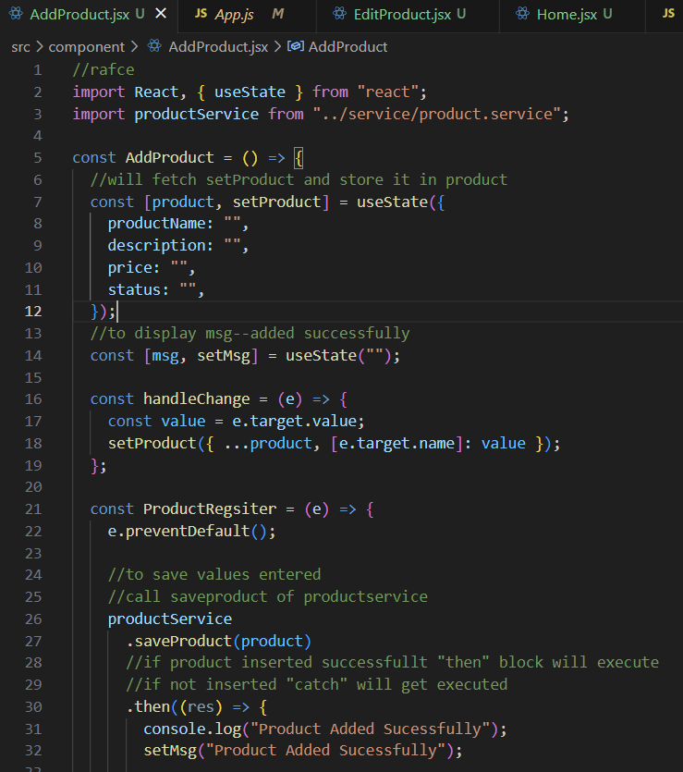

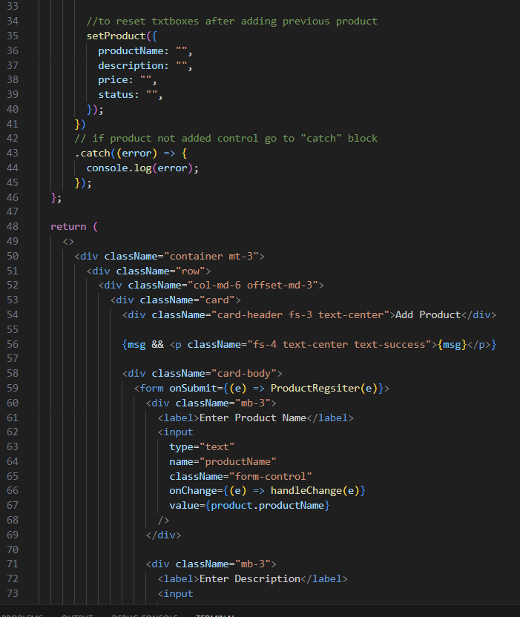

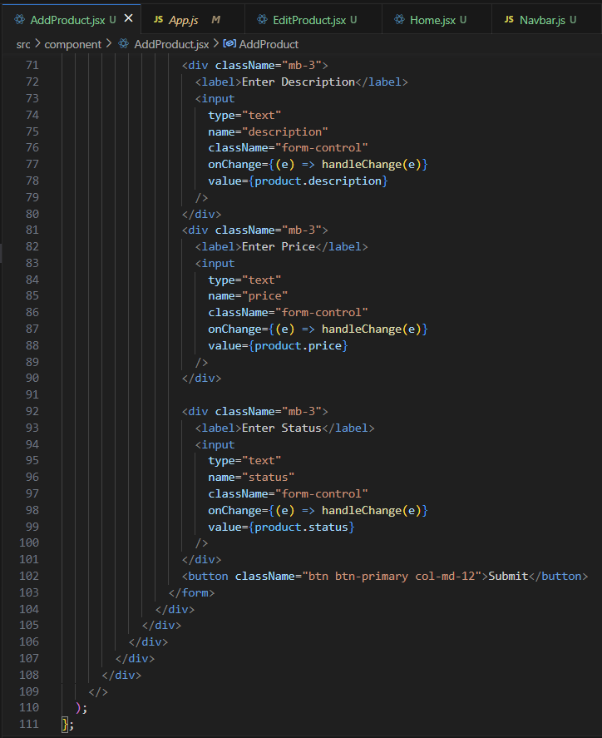

#### **EditProduct.jsx**

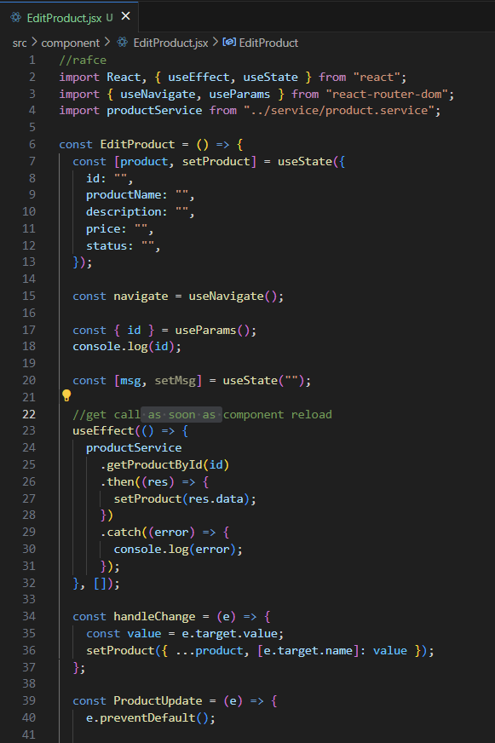

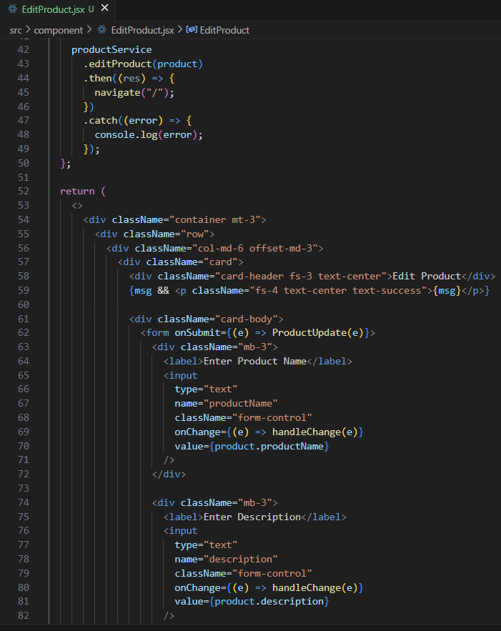

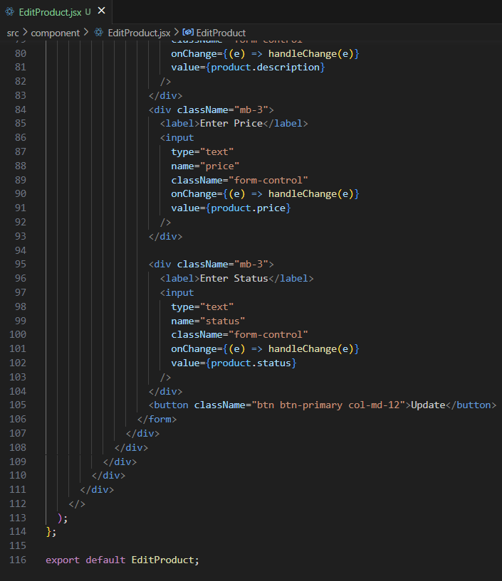

#### **Home.jsx**

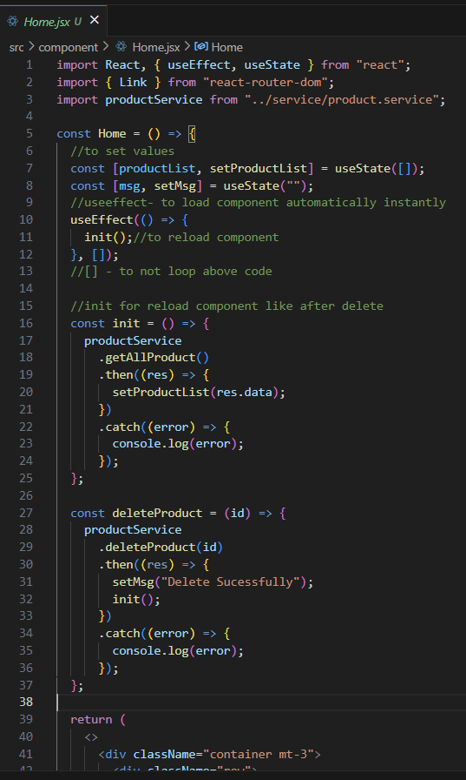

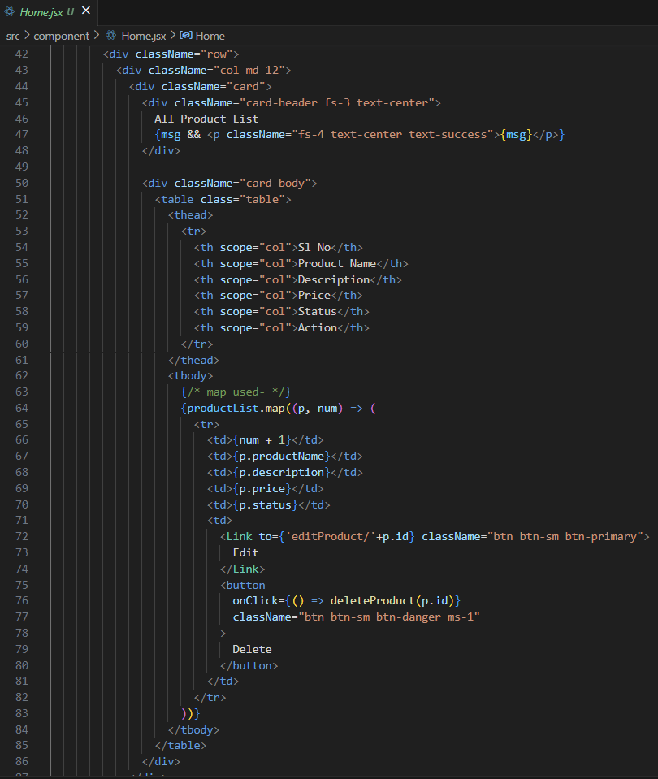

#### **Navbar.js**

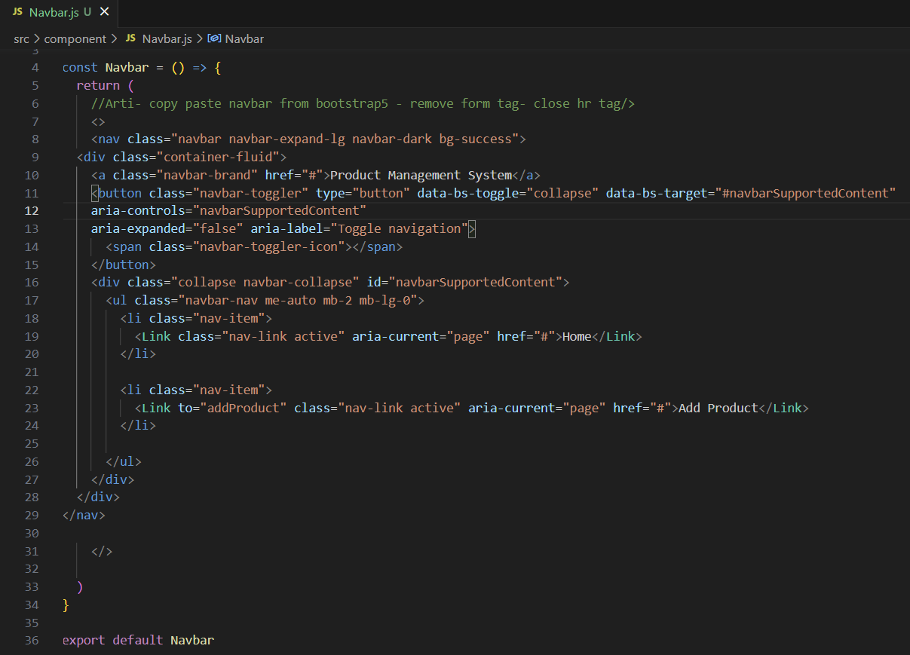

TO CALL REST APIS FROM FRONT END

**INSTALL AXIOS**

**OPEN TERMINAL> npm install axios**

**Create new folder**

**Src>service**

**New file>product.service.js**

#### **product.service.js**

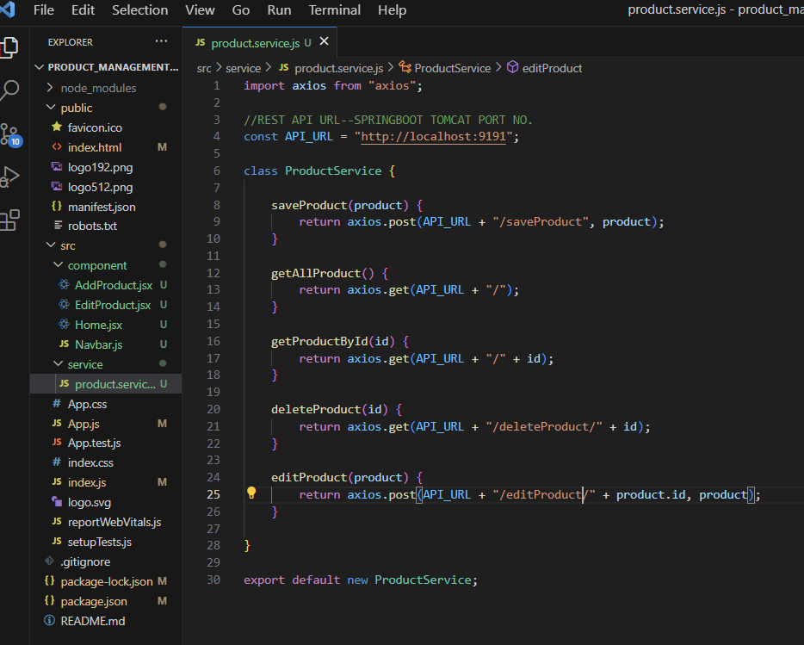

#### **App.js**

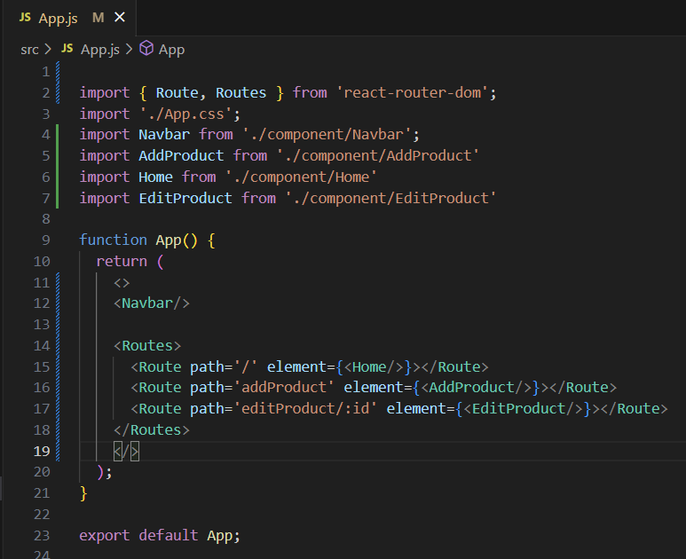

#### **package.json**

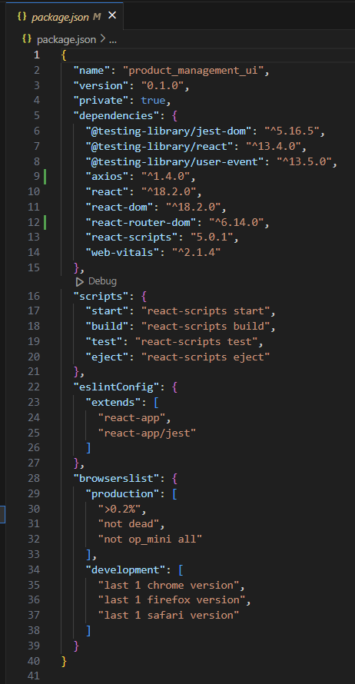

OUTPUT:

POSTMAN TO TEST API

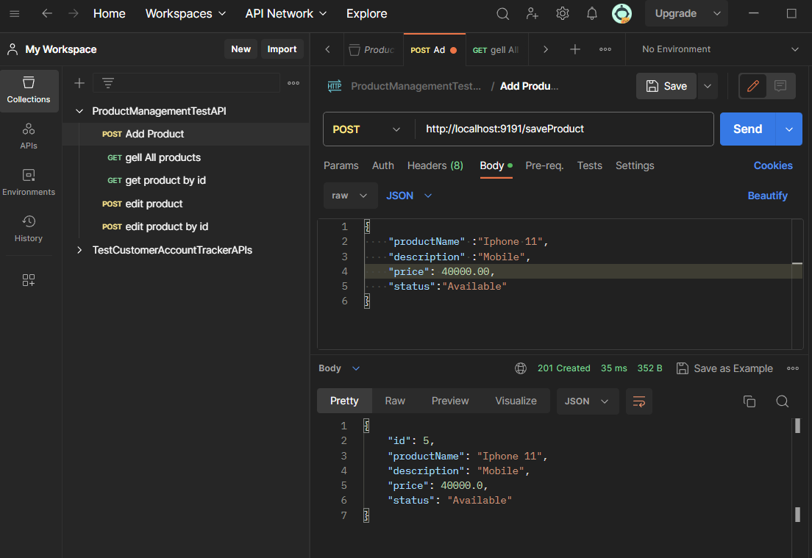

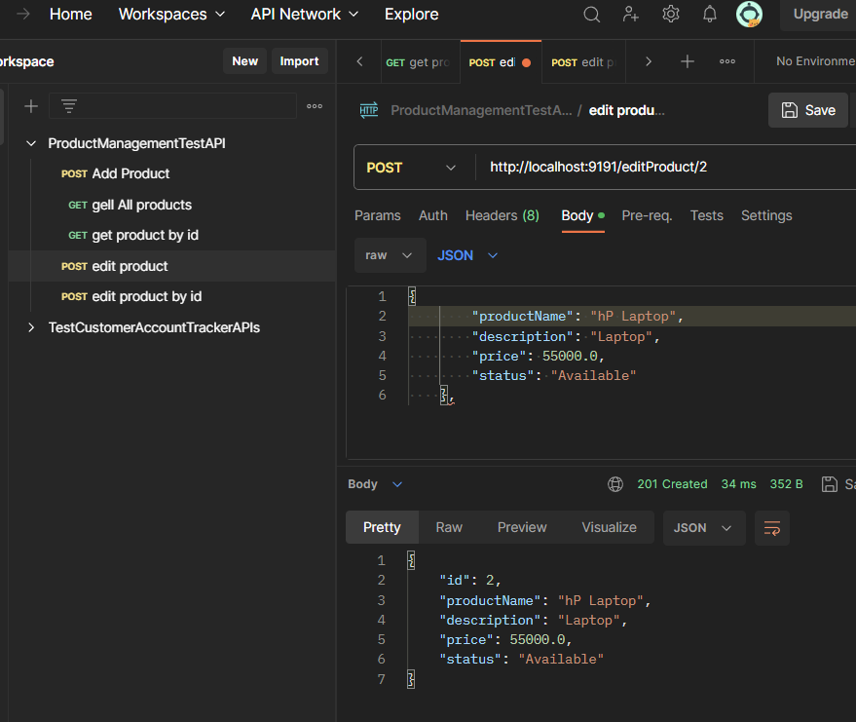

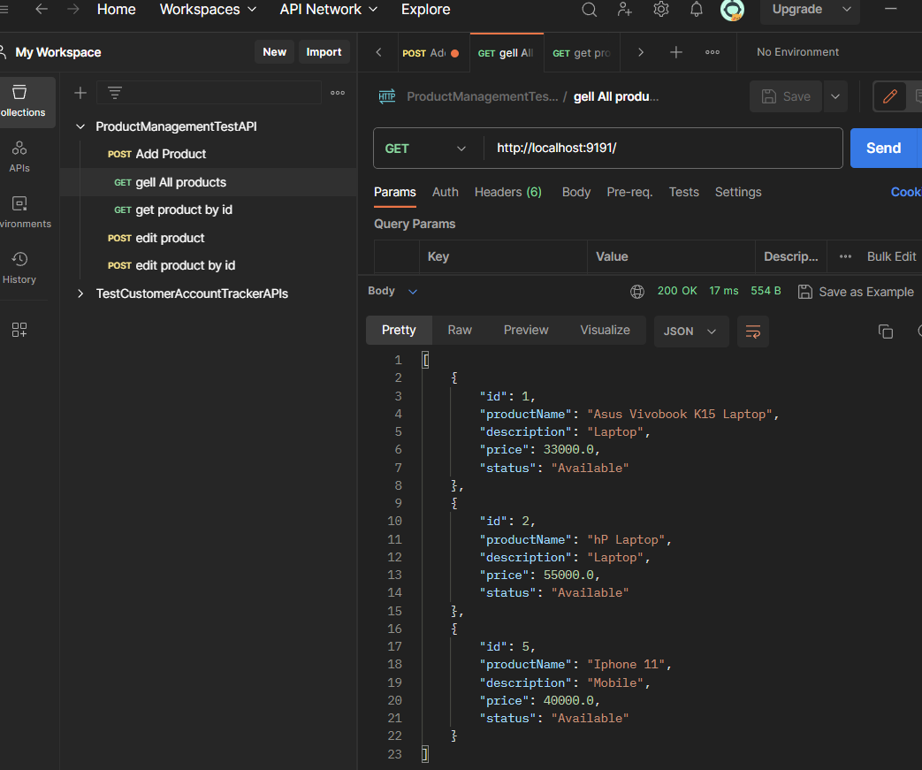

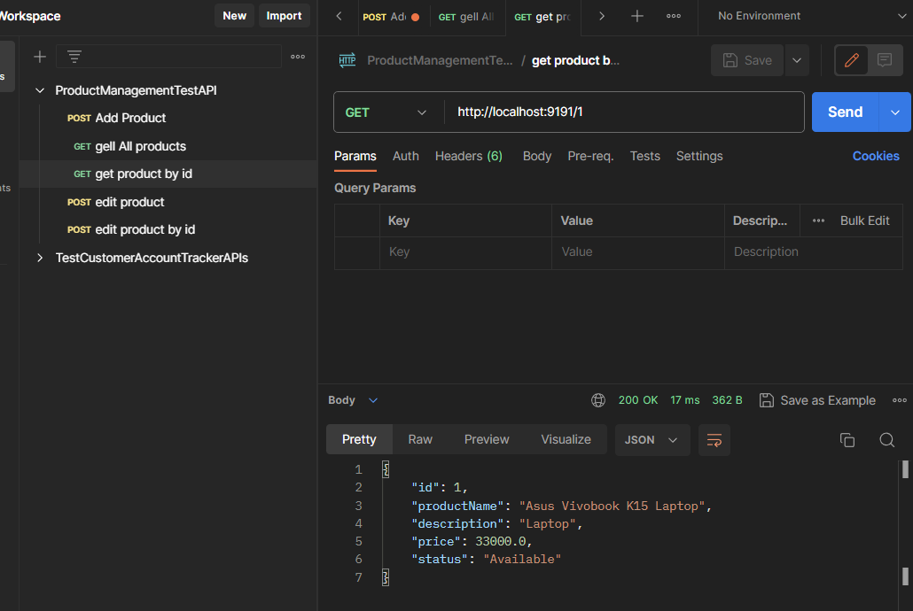

OUTPUT ON BROWSER

LOCALHOST:3000 (REACT APP RUNNING)

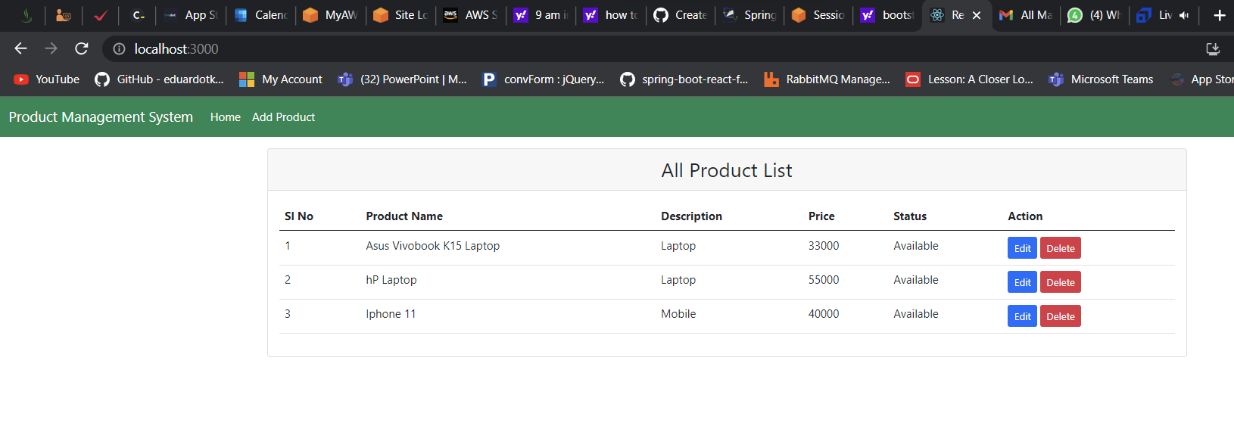

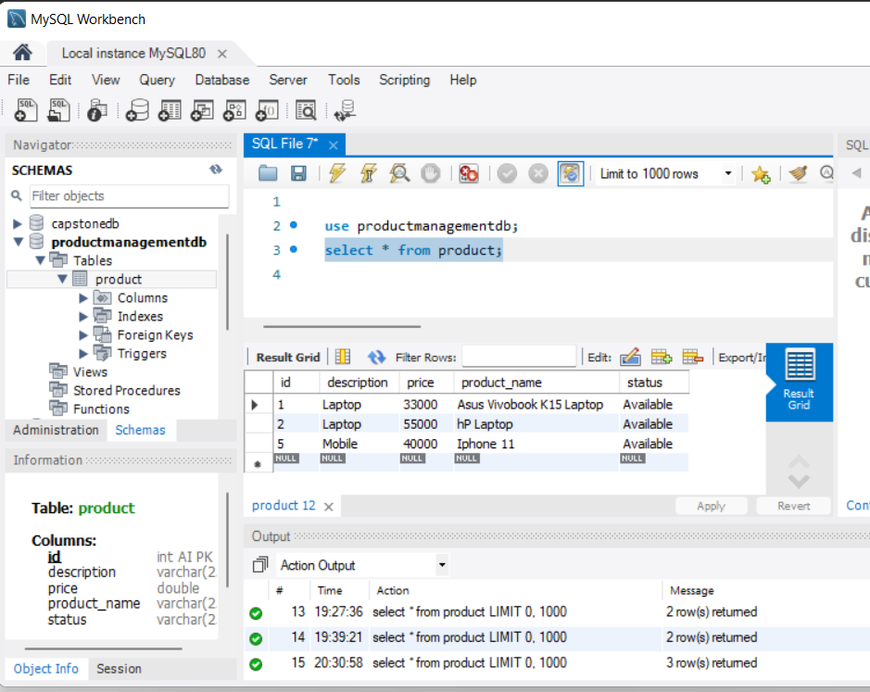

WHEN CLICKED ON Add Product link

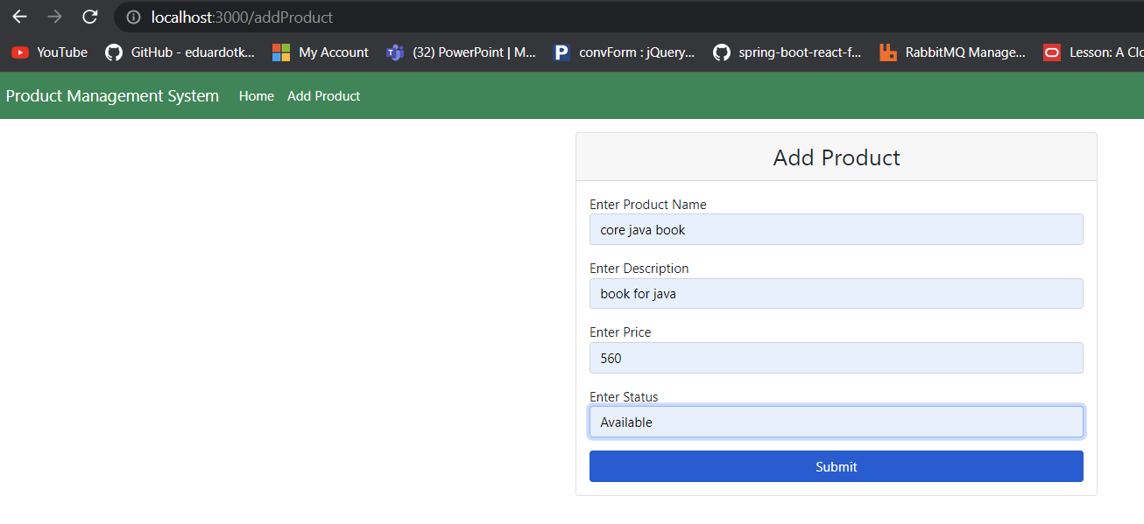

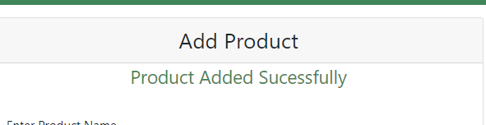

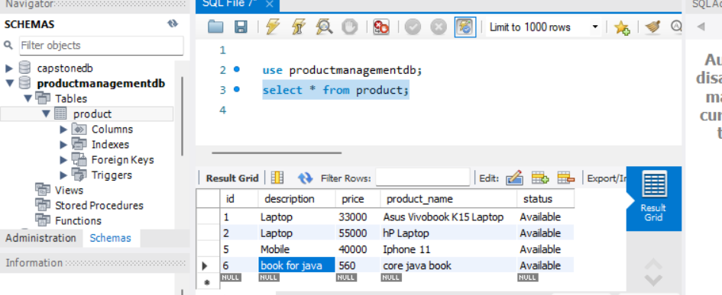

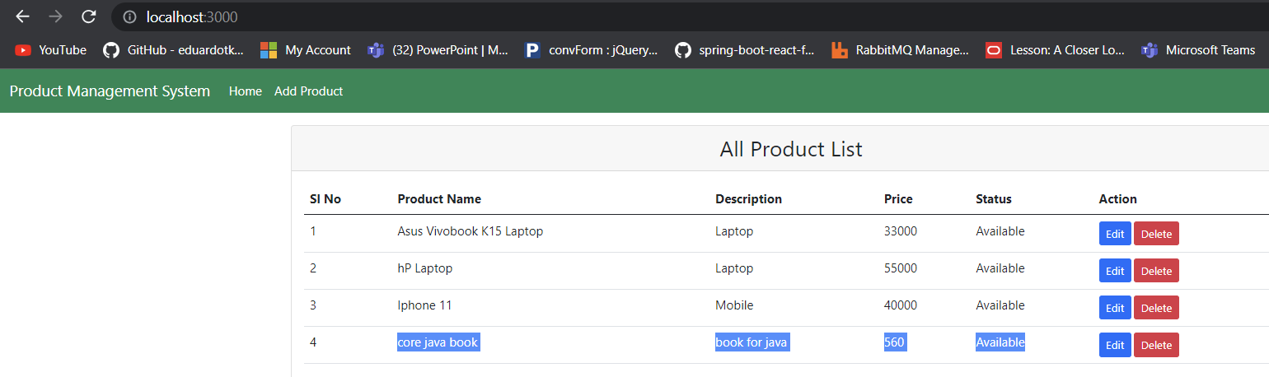

EDIT

