**TICKET MANAGEMENT SYSTEM**

**Task 1: Database Design:**

**1. Create the database named "TicketBookingSystem"**

**QUERY:**

CREATE DATABASE IF NOT EXISTS ticket_booking_system;

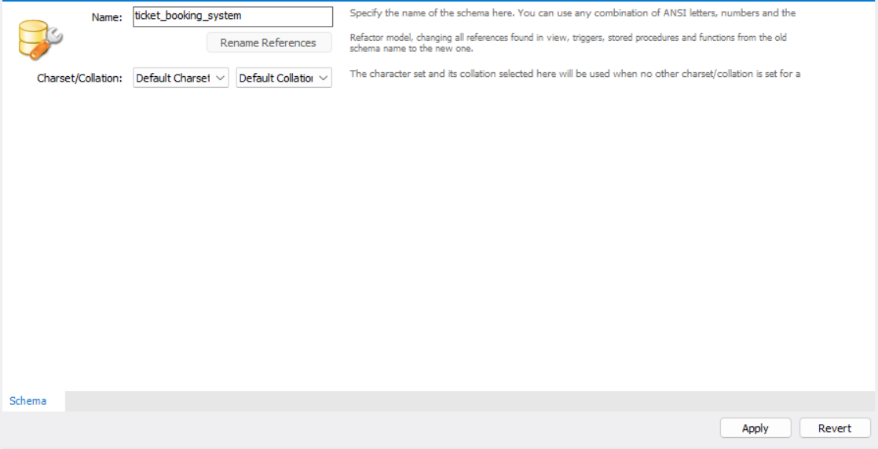

**OUTPUT:**

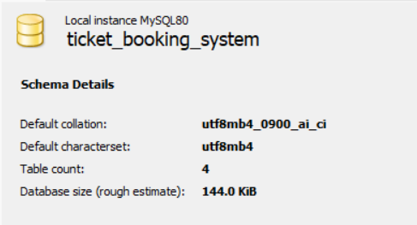

**2. Write SQL scripts to create the mentioned tables with appropriate data types, constraints, and**

**relationships.**

• Venu

• Event

• Customers

• Booking

**A) VENUE TABLE:**

**QUERY:**

CREATE TABLE Venue (

venue_id INT AUTO_INCREMENT PRIMARY KEY,

venue_name VARCHAR(255),

address VARCHAR(255)

);

DESC Venue;

**OUTPUT:**

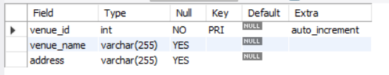

**B) EVENT Table:**

**QUERY:**

CREATE TABLE Event (

event_id INT AUTO_INCREMENT PRIMARY KEY,

event_name VARCHAR(255),

event_date DATE,

event_time TIME,

venue_id INT,

total_seats INT,

available_seats INT,

ticket_price DECIMAL(10, 2),

event_type ENUM('Movie', 'Sports', 'Concert'),

-- FOREIGN KEY (venue_id) REFERENCES ticket_booking_system.Venue(venue_id)

);

DESC Event;

ALTER TABLE ticket_booking_system.Event

ADD COLUMN booking_id INT,

ADD CONSTRAINT fk_event_booking_id FOREIGN KEY (booking_id) REFERENCES ticket_booking_system.Booking(booking_id);

DESC Event;

**OUTPUT:**

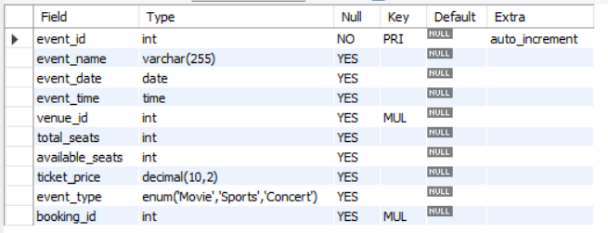

**C) CUSTOMERS Table:**

**QUERY:**

CREATE TABLE Customer (

customer_id INT AUTO_INCREMENT PRIMARY KEY,

customer_name VARCHAR(255),

email VARCHAR(255),

phone_number VARCHAR(15)

--FOREIGN KEY (booking_id) REFERENCES ticket_booking_system.Venue(booking_id)

);

**OUTPUT:**

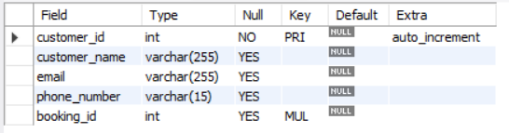

**D) BOOKING Table:**

**QUERY:**

CREATE TABLE Booking (

booking_id INT AUTO_INCREMENT PRIMARY KEY,

customer_id INT,

event_id INT,

num_tickets INT,

total_cost DECIMAL(10, 2),

booking_date DATE,

FOREIGN KEY (customer_id) REFERENCES ticket_booking_system.Customer(customer_id),

FOREIGN KEY (event_id) REFERENCES ticket_booking_system.Event(event_id)

);

DESC customer;

**OUTPUT**:

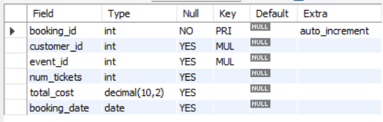

**3. Create an ERD (Entity Relationship Diagram) for the database.**

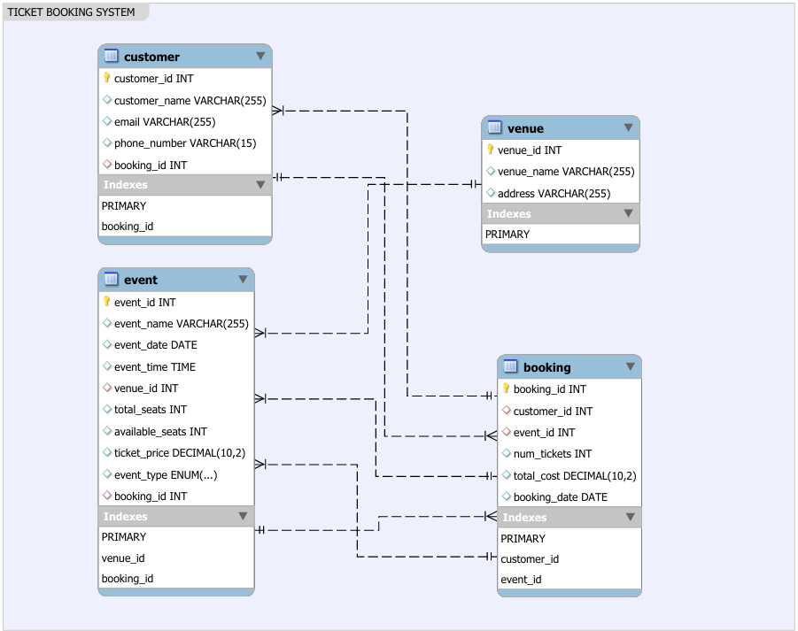

Fig.ER-diagram Ticket Management System

**4. Create appropriate Primary Key and Foreign Key constraints for referential integrity.**

**a) Event Table:**

CREATE TABLE Event (

event_id INT AUTO_INCREMENT PRIMARY KEY,

FOREIGN KEY (venue_id) REFERENCES ticket_booking_system.Venue(venue_id)

* To add booking_id as foreign key from Booking Table in Event Table.

ALTER TABLE ticket_booking_system.Event

ADD CONSTRAINT fk_event_booking_id

FOREIGN KEY (booking_id)

REFERENCES ticket_booking_system.Booking(booking_id);

**OUTPUT:**



**b) Customers Table:**

To add booking_id as foreign key from booking table in Customers Table

ALTER TABLE ticket_booking_system.Customer

ADD FOREIGN KEY (booking_id)

REFERENCES ticket_booking_system.Booking(booking_id);

DESC Customer;

**OUTPUT:**



**c) Booking Table:**

CREATE TABLE Booking (

booking_id INT AUTO_INCREMENT PRIMARY KEY,

.

.

FOREIGN KEY (customer_id) REFERENCES ticket_booking_system.Customer(customer_id),

FOREIGN KEY (event_id) REFERENCES ticket_booking_system.Event(event_id)

);

OUTPUT:



**TASK 2: SELECT, WHERE, BETWEEN, AND, LIKE**

**1. Write a SQL query to insert at least 10 sample records into each table.**

**a) Venue Table**

INSERT INTO Venue (venue_name, address)

VALUES

('ABC Theater', '123 Main Street'),

('XYZ Stadium', '456 Park Avenue'),

('City Hall', '789 Elm Road'),

('Sunset Arena', '101 Sunset Boulevard'),

('Moonlight Hall', '222 Star Avenue'),

('Ocean View Park', '333 Ocean Drive'),

('Mountain Theater', '444 Mountain Road'),

('Valley Stadium', '555 Valley Lane'),

('Riverfront Center', '666 River Street'),

('Lakeside Pavilion', '777 Lakeview Drive');

**OUTPUT:**

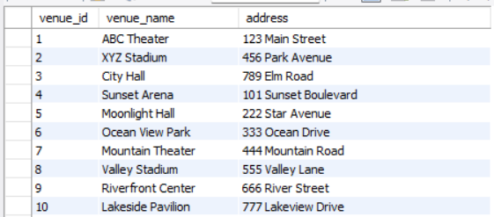

**b) Event Table**

INSERT INTO Event (event_name, event_date, event_time, venue_id, total_seats, available_seats, ticket_price, event_type)

VALUES

('Movie Night', '2024-04-20', '18:00:00', 1, 100, 100, 15.00, 'Movie'),

('Rock Concert', '2024-04-22', '20:00:00', 2, 500, 500, 50.00, 'Concert'),

('Football Match', '2024-04-25', '15:00:00', 3, 10000, 9500, 25.00, 'Sports'),

('Drama Play', '2024-04-28', '19:30:00', 4, 200, 180, 20.00, 'Sports'),

('Live Comedy Show', '2024-04-30', '21:00:00', 5, 300, 290, 30.00, 'Concert'),

('Basketball Game', '2024-05-02', '16:30:00', 6, 8000, 7500, 35.00, 'Sports'),

('Art Exhibition', '2024-05-05', '12:00:00', 7, 50, 40, 10.00, 'Movie'),

('Classical Music Concert', '2024-05-08', '19:00:00', 8, 400, 390, 40.00, 'Movie'),

('Gaming Tournament', '2024-05-10', '14:00:00', 9, 2000, 1900, 20.00, 'Sports'),

('Fitness Workshop', '2024-05-12', '17:30:00', 10, 30, 25, 5.00, 'Sports');

**OUTPUT:**

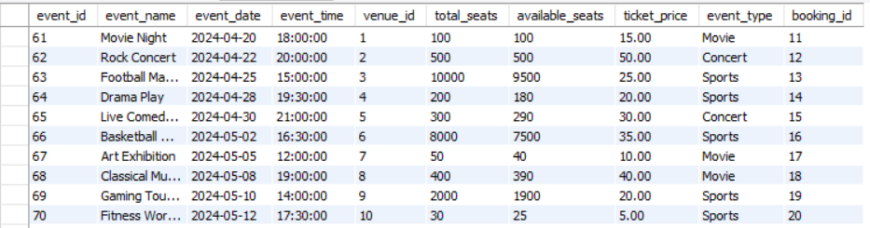

**c) Customer Table**

INSERT INTO Customer (customer_name, email, phone_number)

VALUES

('Alice Johnson', 'alice@example.com', '123-456-7890'),

('Bob Smith', 'bob@example.com', '987-654-3210'),

('John Doe', 'john.doe@example.com', '111-222-3333'),

('Jane Doe', 'jane.doe@example.com', '444-555-6666'),

('Michael Brown', 'michael.brown@example.com', '777-888-9999'),

('Emily Davis', 'emily.davis@example.com', '333-444-5555'),

('David Wilson', 'david.wilson@example.com', '666-777-8888'),

('Jennifer Anderson', 'jennifer.anderson@example.com', '222-333-4444'),

('Matthew Taylor', 'matthew.taylor@example.com', '555-666-7777');

**OUTPUT:**

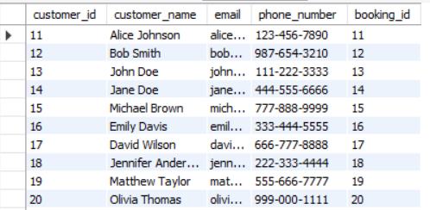

**d) Booking Table**

INSERT INTO Booking (customer_id, event_id, num_tickets, total_cost, booking_date)

VALUES

(11, 61, 2, 40.00, '2024-04-25'),

(12, 62, 3, 150.00, '2024-04-26'),

(13, 63, 1, 20.00, '2024-04-27'),

(14, 64, 4, 80.00, '2024-04-28'),

(15, 65, 2, 30.00, '2024-04-29'),

(16, 66, 1, 15.00, '2024-04-30'),

(17, 67, 3, 90.00, '2024-05-01'),

(18, 68, 2, 50.00, '2024-05-02'),

(19, 69, 1, 25.00, '2024-05-03'),

(20, 70, 4, 100.00, '2024-05-04');

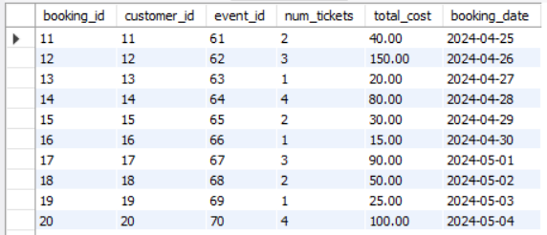

**2. Write a SQL query to list all Events.**

> SELECT * FROM event;

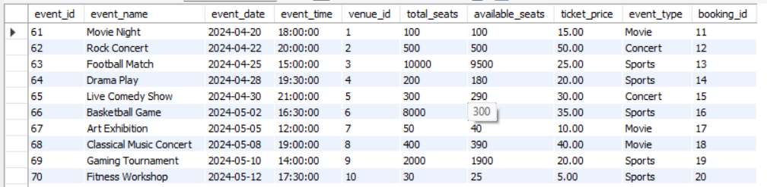

**3. Write a SQL query to select events with available tickets.**

> SELECT *

FROM Event

WHERE available_seats > 0;

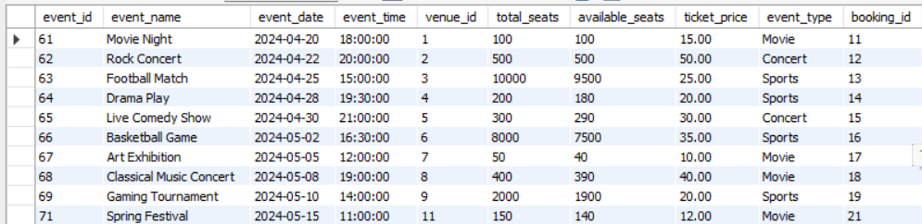

**4. Write a SQL query to select events name partial match with ‘cup’.**

> SELECT *

FROM event

WHERE event_name LIKE '%cup%';



**5. Write a SQL query to select events with ticket price range is between 1000 to 2500.**

> SELECT *

FROM event

WHERE ticket_price BETWEEN 1000 AND 2500;

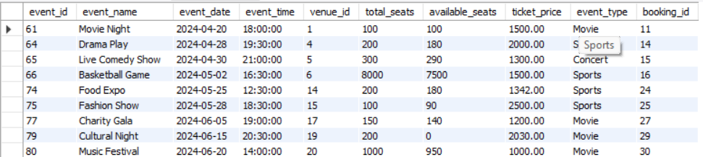

**6. Write a SQL query to retrieve events with dates falling within a specific range.**

> SELECT *

FROM event

WHERE event_date BETWEEN '2024-04-01' AND '2024-04-30';

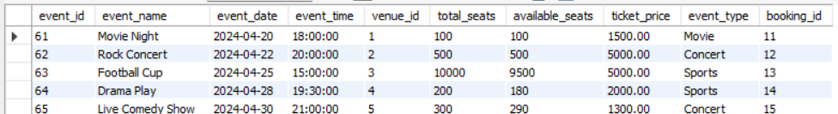

**7. Write a SQL query to retrieve events with available tickets that also have "Concert" in their**

**name.**

> SELECT *

FROM event

WHERE available_seats > 0 AND event_type = 'Concert';



**8. Write a SQL query to retrieve users in batches of 5, starting from the 6th user.**

> SELECT *

FROM Customer

Where customer_id BETWEEN 16 AND 20;

OR

>SELECT * FROM Customer LIMIT 5 OFFSET 5;

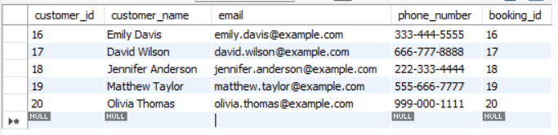

**9. Write a SQL query to retrieve bookings details contains booked no of ticket more than 4.**

> SELECT *

FROM booking

WHERE num_tickets > 4;

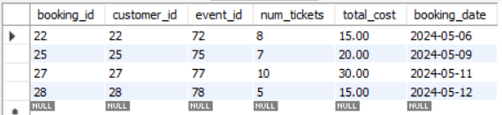

**10. Write a SQL query to retrieve customer information whose phone number end with ‘000’**

> SELECT *

FROM customer

WHERE phone_number LIKE '%000';

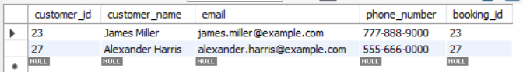

**11. Write a SQL query to retrieve the events in order whose seat capacity more than 15000.**

> SELECT *

FROM event

WHERE total_seats > 15000;

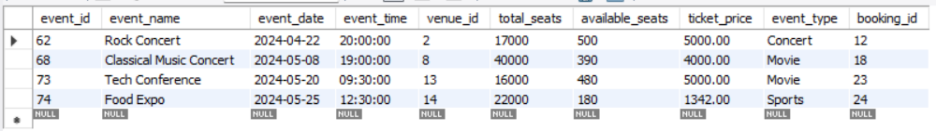

**12. Write a SQL query to select events name not start with ‘x’, ‘y’, ‘z’**

> SELECT *

FROM event

WHERE event_name NOT LIKE 'x%' AND event_name NOT LIKE 'y%' AND event_name NOT LIKE 'z%';

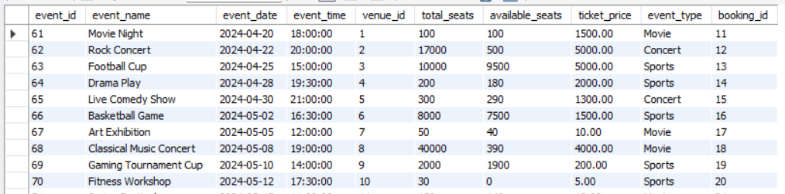

**Tasks 3: Aggregate functions, Having, Order By, GroupBy and Joins**

**1. Write a SQL query to List Events and Their Average Ticket Prices.**

SELECT event_name, AVG(ticket_price) AS avg_ticket_price

FROM event

GROUP BY event_name;

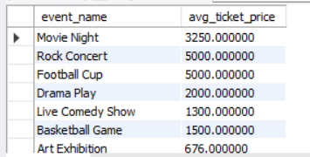

**2. Write a SQL query to Calculate the Total Revenue Generated by Events.**

SELECT SUM(total_cost) AS total_revenue

FROM Booking;

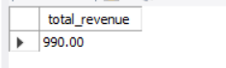

**3. Write a SQL query to find the event with the highest ticket sales.**

> SELECT E.event_id, E.event_name, SUM(B.num_tickets) AS total_tickets_sold

FROM Booking B

Join Event E ON B.event_id = E.event_id

GROUP BY event_id

ORDER BY total_tickets_sold DESC

LIMIT 1;

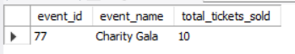

**4. Write a SQL query to Calculate the Total Number of Tickets Sold for Each Event.**

SELECT E.event_id, E.event_name, SUM(num_tickets) AS total_tickets_sold

FROM Event E

LEFT JOIN Booking B ON B.event_id = E.event_id

GROUP BY event_id

ORDER BY total_tickets_sold DESC;

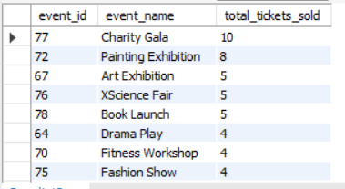

**5. Write a SQL query to Find Events with No Ticket Sales.**

SELECT E.event_id, E.event_name, B.num_tickets

FROM Event E

LEFT JOIN Booking B ON B.event_id = E.event_id

WHERE B.num_tickets = 0;

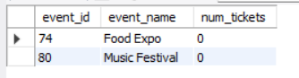

**6. Write a SQL query to Find the User Who Has Booked the Most Tickets.**

SELECT C.customer_id, C.customer_name, MAX(B.num_tickets) AS MAX_TICKETS

FROM Booking B

RIGHT JOIN Customer C ON B.customer_id = C.customer_id

GROUP BY C.customer_id

ORDER BY MAX_TICKETS DESC;

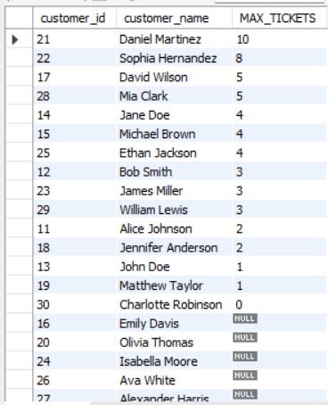

**7. Write a SQL query to List Events and the total number of tickets sold for each month.**

SELECT E.event_id, E.event_name, MONTH(B.booking_date) AS booking_month,

SUM(B.num_tickets) AS total_tickets_sold

FROM Event E

LEFT JOIN Booking B ON B.event_id = E.event_id

GROUP BY booking_month, E.event_id;

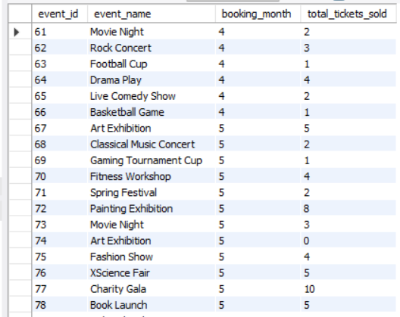

**8. Write a SQL query to calculate the average Ticket Price for Events in Each Venue.**

SELECT V.venue_name, AVG(E.ticket_price) AS avg_ticket_price

FROM Venue V

LEFT JOIN Event E ON E.venue_id = V.venue_id

GROUP BY V.venue_id;

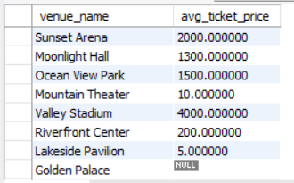

**9. Write a SQL query to calculate the total Number of Tickets Sold for Each Event Type.**

SELECT E.event_type, SUM(B.num_tickets) AS total_tickets

FROM Booking B

JOIN Event E ON E.event_id = B.event_id

GROUP BY event_type;

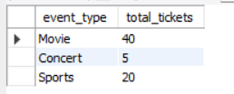

**10. Write a SQL query to calculate the total Revenue Generated by Events in Each Year.**

SELECT YEAR(B.booking_date) AS YEAR, SUM(B.total_cost) AS total_revenue

FROM Booking B

JOIN Event E ON E.booking_id = B.booking_id

GROUP BY YEAR(B.booking_date);

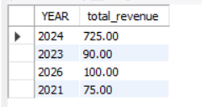

**11. Write a SQL query to list users who have booked tickets for multiple events.**

SELECT B.customer_id, C.customer_name, COUNT(DISTINCT B.event_id) AS total_events_booked

FROM Booking B

JOIN Customer C ON C.customer_id = B.customer_id

GROUP BY B.customer_id

HAVING total_events_booked > 1;

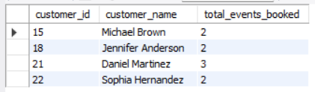

**12. Write a SQL query to calculate the Total Revenue Generated by Events for Each User.**

SELECT C.customer_id, C.customer_name, SUM(B.total_cost) AS Total_Revenue

FROM Booking B

RIGHT JOIN Customer C ON B.customer_id = C.customer_id

GROUP BY C.customer_id, C.customer_name;

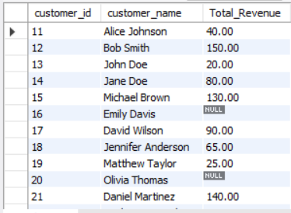

**13. Write a SQL query to calculate the Average Ticket Price for Events in Each Category and Venue.**

SELECT event_type, venue_id, AVG(ticket_price) AS average_ticket_price

FROM Event

GROUP BY event_type, venue_id

ORDER BY event_type;

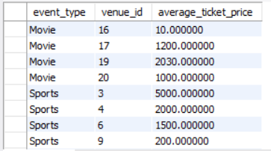

**14. Write a SQL query to list Users and the Total Number of Tickets They've Purchased in the Last 30 Days.**

SELECT B.customer_id, C. customer_name, COUNT(*) AS total_tickets_purchased

FROM Booking B

WHERE B.booking_date >= DATE_SUB(CURDATE(), INTERVAL 30 DAY)

GROUP BY B.customer_id,customer_name;

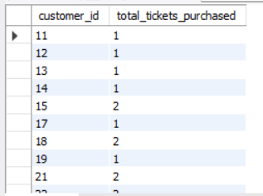

**Tasks 4: Subquery and its types**

**1. Calculate the Average Ticket Price for Events in Each Venue Using a Subquery.**

SELECT V.venue_id,

(SELECT AVG(E.ticket_price)

FROM Event E

WHERE E.venue_id = V.venue_id

) AS average_ticket_price

FROM Venue V;

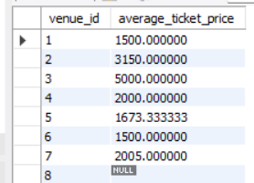

**2. Find Events with More Than 50% of Tickets Sold using subquery.**

SELECT event_id, event_name

FROM Event e

WHERE event_id IN (

SELECT b.event_id

FROM Booking b

JOIN Event e ON b.event_id = e.event_id

GROUP BY b.event_id

HAVING SUM(b.num_tickets) > e.total_seats * 0.5

);

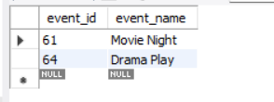

**3. Calculate the Total Number of Tickets Sold for Each Event.**

SELECT event_id, event_name,

(SELECT SUM(b.num_tickets)

FROM Booking b

WHERE b.event_id = e.event_id) AS total_tickets_sold

FROM Event e;

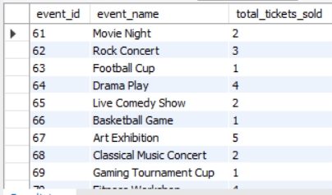

**4. Find Users Who Have Not Booked Any Tickets Using a NOT EXISTS Subquery.**

SELECT *

FROM Customer c

WHERE NOT EXISTS (

SELECT *

FROM Booking b

WHERE b.customer_id = c.customer_id

);

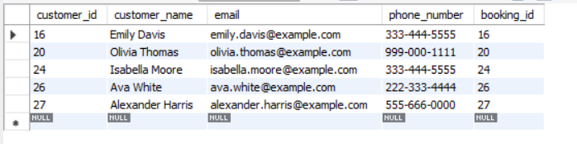

**5. List Events with No Ticket Sales Using a NOT IN Subquery.**

SELECT *

FROM Event e

WHERE e.event_id NOT IN (

SELECT event_id

FROM Booking

);



**6. Calculate the Total Number of Tickets Sold for Each Event Type Using a Subquery in the FROM**

**Clause.**

SELECT event_type, SUM(num_tickets) AS 'Total Tickets'

FROM (

SELECT e.event_type, b.num_tickets

FROM EVENT e

JOIN Booking b

ON b.event_id = e.event_id

) As Subquery

Group By event_type;

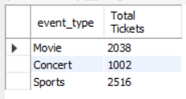

**7. Find Events with Ticket Prices Higher Than the Average Ticket Price Using a Subquery in the**

**WHERE Clause.**

SELECT *

FROM Event e

WHERE e.ticket_price > (

SELECT AVG(ticket_price)

FROM Event

);

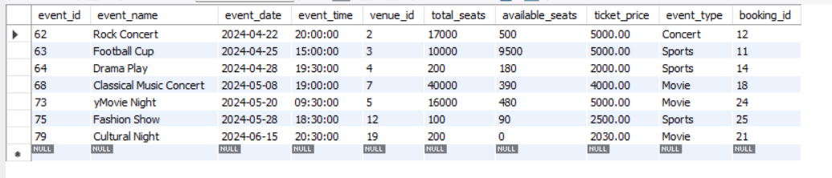

**8. Calculate the Total Revenue Generated by Events for Each User Using a Correlated Subquery.**

SELECT c.customer_id, c.customer_name,

(

SELECT SUM(b.num_tickets * e.ticket_price)

FROM Booking b

JOIN Event e ON b.event_id = e.event_id

WHERE b.customer_id = c.customer_id

) AS total_revenue

FROM Customer c;

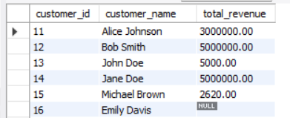

**9. List Users Who Have Booked Tickets for Events in a Given Venue Using a Subquery in the WHERE**

**Clause.**

SELECT *

FROM Customer c

WHERE EXISTS (

SELECT *

FROM Booking b

JOIN Event e ON b.event_id = e.event_id

WHERE b.customer_id = c.customer_id

AND e.venue_id = 1

);

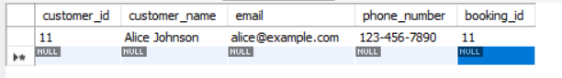

**10. Calculate the Total Number of Tickets Sold for Each Event Category Using a Subquery with**

**GROUP BY.**

SELECT event_type, SUM(num_tickets) AS total_tickets_sold

FROM (

SELECT e.event_type, b.num_tickets

FROM Event e

JOIN Booking b ON e.event_id = b.event_id

) AS subquery

GROUP BY event_type;

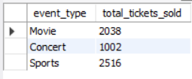

**11. Find Users Who Have Booked Tickets for Events in each Month Using a Subquery with**

**DATE_FORMAT.**

SELECT DISTINCT c.customer_id, c.customer_name, MONTHNAME(b.booking_date) AS booking_month

FROM Customer c

INNER JOIN Booking b ON c.customer_id = b.customer_id

GROUP BY c.customer_id, c.customer_name, MONTHNAME(b.booking_date);

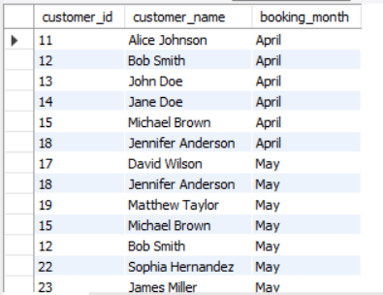

**12. Calculate the Average Ticket Price for Events in Each Venue Using a Subquery**

SELECT v.venue_id, v.venue_name,

(SELECT AVG(ticket_price)

FROM Event

WHERE venue_id = v.venue_id) AS avg_ticket_price

FROM Venue v;

