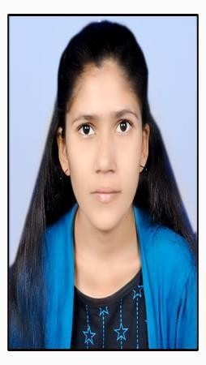

|  |  |
| --- | --- |
| **Ms. Narwade Priyanka Prabhakar** | |
| A/P-Kandli Tq-Kalamnuri Dist-Hingoli | |
| 15/07/1997 | [priyankanarwade835@gm](mailto:priyankanarwade835@gmail.com) [ail.com](mailto:priyankanarwade835@gmail.com) |
| 8766542268 |  |

**Career Objective:**

To acquire employment in a challenging environment that allows me to utilize my data entry skills while providing opportunities for professional growth.

**Educational Qualification: ( HSC- ARTS, B.A-ARTS)**

|  |  |  |  |  |
| --- | --- | --- | --- | --- |
| **Qualification** | **Year** | **College** | **University** | **% / CGPA** |
| Third Year | 2021-22 | Narayanrao Waghmare Mahavidyalay ,  Akhada Balapur | SRTM,Nanded | 7.96 |
| Second Year | 2020-21 | SRTM,Nanded | 8.73 |
| First Year | 2018-19 | SRTM,Nanded | 7.00 |
| HSC | 2017-18 | Rajashree Shau Vidyalay in Akhada Balapur ,  Hingoli | MSBSHSE | 58.77 |
| SSC | 2015-16 | S.S.V. Kandali Tq.  Kalamnuri, Dist.  Hingoli | MSBSHSE | 58.00 |

**Languages:**

|  |  |  |  |  |
| --- | --- | --- | --- | --- |
|  |  |  |  |  |
|  |  |  |  |  |
|  |  |  |  |
|  |  |  |  |
|  |  |  |  |  |
|  |  |  |  |  |

Marathi, Hindi, English

**Strength:**

I do my work Honestly on time , I am Adaptable to the new environment



|  |
| --- |
| **Hobbies:** |
| Listening Music, Reading. |

**Date:**

**Place: Kandli (Ms. Narwade Priyanka Prabhakar)**